KUTUMBA

C1-W6 OLDER TEACHER GUIDE
  - Families Growing in Krishna Consciousness
C1-W6
V12 • Families Growing in Krishna Consciousness
Program Director: Swapnil Patil
Internal founding-cohort teaching material — human/temple review EXTERNAL_OPEN
KUTUMBA | Families Growing in Krishna Consciousness

Week: Integration Night — Who Am I and How Should Our Family Live? Primary: Cycle 1 review chain — ŚB 1.2.18 · BG 2.13 · BG 2.20 · ŚB 11.9.29 · BG 8.15 Session length: ~40 minutes (parallel track ~2:30–3:10) Parents: Remain onsite; reunite at 3:10 Status: Internal founding-cohort teaching material — human/temple review EXTERNAL_OPEN
◆ ◆ ◆

Objective
Students retrieve the Cycle 1 chain without ranking, match each week to its locked primary (W5 = BG 8.15), build a coherent identity–purpose–practice map, and answer: Can our family explain and apply what we learned?

Exact memory phrase
We remember who we are and how our family chooses to live.
Short echo: One chain — hear, identity, soul, chance, shelter.

Teacher background
- KUTUMBA teaching meaning: Identity, purpose, and practice must form one coherent family life — reviewing the Cycle 1 chain with W5 as BG 8.15.
- Review set: W1 ŚB 1.2.18 · W2 BG 2.13 · W3 BG 2.20 · W4 ŚB 11.9.29 · W5 BG 8.15.
- Block: Competition/ranking; loudest = wisest; speed to C2 while confused; wrong Mṛgāri sources.
- Rubric lenses (never placement): understanding, application, teamwork, source accuracy.

Materials
- Review verse strips (five references); worksheets; scenario cards (contest fear; one child dominates; rush to C2 — fictional)
- Necklace / station-map diagram; pencils; OLDER-ANSWER-KEY.md; project half-sheets
- Match cards: week theme ↔ verse reference (including distractors)
◆ ◆ ◆

Minute-by-minute plan

0–5 min — Settle and hook
- Welcome. “Retrieval is mercy, not a quiz show.”
- Hook: “Is drawing-only or one sentence enough tonight?” Yes.
- Essential question: Can our family explain and apply what we learned?

5–14 min — Primary text observation (review chain)
- Display five references; students copy the chain in order.
- Confirm W5 locked primary is BG 8.15 (not a substitute support verse).
- Observation prompts: Which verse steadies hearing practice? Which separates body/self? Which blocks “I am God”? Which teaches rare opportunity without fear? Which names lasting shelter?
- One-sentence synthesis: identity + purpose + practice = coherent family life.
- Paraphrase only; no new ontology.

14–22 min — Worksheet questions
Section A: match week→verse; short paraphrase each; name blocked misconception per week; write one integrated family living sentence.

22–28 min — Scenario cards
Card A — Family fears presenting (thinks contest). Card B — One child dominates every share. Card C — Parents want C2 despite W2–W3 confusion.
Mistaken / principle / response / action / what not to say. Share 60 sec.

28–33 min — Puzzle / game: Chain Match Relay
- Teams quietly match five themes to five locked primaries (plus two distractor verses to reject).
- Bonus: mark Mṛgāri source M24 vs WRONG if a distractor appears.
- One student explains the necklace in 20 seconds — no scores announced.

33–37 min — Diagram task
Fill: Hearing → Body/Self clarity → Soul nature → Rare opportunity → Lasting shelter → Family living practice
Circle Family living practice; write short echo inside.

37–40 min — Project + reflection + handoff
- Project: “Our family can explain Cycle 1 by _______________ and will apply _______________ this week.”
- Reflection: Where might ranking or speed pretend to be progress?
- Parent handoff: invitational share; extend C1 privately if unclear; no public “behind.”

Extension
Build a four-lens checklist (understanding / application / teamwork / source accuracy) for their own share — still no placement scores.

Answer key pointer
activities/OLDER-ANSWER-KEY.md

Behavior and privacy
Rotate speakers; drawing-only OK; no ranking; snack/water on main schedule.

Instructional visuals
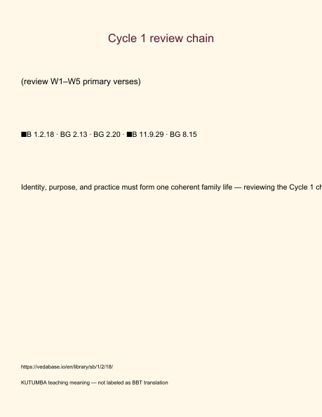
Original KUTUMBA visual: verse-card.png
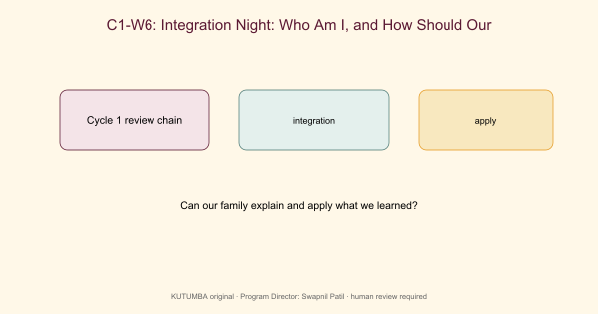
Original KUTUMBA visual: concept-diagram.png
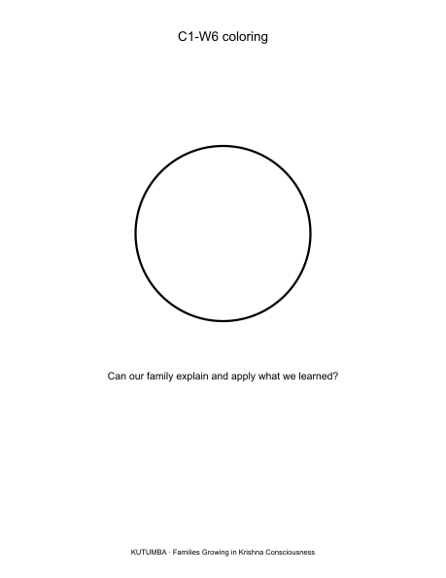
Original KUTUMBA visual: line-art-younger.png
RIGHTS NOTE | Original KUTUMBA program material. Scripture/BBT/ISKCON/third-party rights remain with their holders.

