KUTUMBA

C1-W6 YOUNGER TEACHER GUIDE
  - Families Growing in Krishna Consciousness
C1-W6
V12 • Families Growing in Krishna Consciousness
Program Director: Swapnil Patil
Internal founding-cohort teaching material — human/temple review EXTERNAL_OPEN
KUTUMBA | Families Growing in Krishna Consciousness

Week: Integration Night — Who Am I and How Should Our Family Live? Primary: Cycle 1 review chain — ŚB 1.2.18 · BG 2.13 · BG 2.20 · ŚB 11.9.29 · BG 8.15 Session length: 40 minutes (parallel track ~2:30–3:10) Parents: Remain onsite; reunite at 3:10 Status: Internal founding-cohort teaching material — human/temple review EXTERNAL_OPEN
◆ ◆ ◆

Objective
Children retrieve Cycle 1 as one necklace of beads — hearing, body/self, soul who serves, rare chance, lasting lamp — and take home a five-bead family card. Drawing-only shares count as success; no ranking.

Exact memory phrase
We remember who we are and how our family chooses to live.

Teacher background (2 minutes to review)
- KUTUMBA teaching meaning (adult wording): Identity, purpose, and practice must form one coherent family life — reviewing the Cycle 1 chain with W5 locked as BG 8.15.
- Child-facing paraphrase: Five beads on one string: Hear+Practice · Body changes/I continue · Spark who serves · Rare chance · Thanks + Kṛṣṇa’s lamp. Missing a week is okay — we refill kindly, not like a contest.
- Block misconceptions (child words):
- “Tonight is a contest / ranking.”
- “Only loud kids win.”
- “We must rush to Cycle 2 even if confused.”
- Do not: invent new ontology; score families; force verbal shares; cite Mṛgāri from wrong books if W4 bead appears (CC Madhya 24 only).

Materials
- Five large paper beads or circles labeled: Hear · Body/Self · Soul · Chance · Lamp
- Yarn or string for necklace demo
- Card stock for five-bead take-home cards
- Crayons; soft toss object; line-art if available
- “Drawing share” option cards (success without speaking)

Room setup
Five bead stations in a gentle path; circle for opening; aisles clear for Bead Walk.
◆ ◆ ◆

Minute-by-minute executable plan

0–5 min — Opening and recall
- Welcome; feet on floor. “Tonight we remember — not a contest.”
- Show empty string, then add beads one by one as you name weeks lightly.
- Echo memory phrase three times: We remember who we are / and how our family / chooses to live.
- Ask: “Is drawing your bead okay?” Yes — celebrate nods.

5–13 min — Story script (paraphrase only; ~8 minutes)
Say exactly this spine (do not invent deity dialogue):
For five weeks our families learned pieces that belong on one string. First bead: Regular hearing and a tiny home practice steady our devotion. Second bead: My body changes; I continue as the conscious self — kind words about bodies. Third bead: I am an eternal soul — a spark who serves Kṛṣṇa, not the whole sun — and I still care for my body. Fourth bead: Human life is a rare chance to ask who I am and serve — chance words, not scare words. Fifth bead: Temporary joys with gratitude; lasting fulfillment in Kṛṣṇa — the lamp. Tonight we put the beads together. If your family missed a bead, we smile and refill. Loud is not wiser. Drawing is success. We remember who we are and how our family chooses to live.
Story boundaries: Review only locked primaries above. No new metaphysics. No ranking. W5 bead = BG 8.15. Mṛgāri only if needed = Madhya 24.

13–16 min — Three wonder questions
- Are we having a contest tonight? (No)
- Name one bead you remember. (any week)
- What is one way our family can live this week? (hear / kind words / serve / Must / thanks)

16–24 min — Movement game: Bead Walk (steps)
- Place five bead stations in a path.
- Children walk slowly station to station.
- At each station, teacher gives a one-word cue; children echo the matching short line:
- Hear → “Hear + Practice”
- Body → “I continue”
- Soul → “Spark who serves”
- Chance → “Rare chance”
- Lamp → “Thanks + lamp”
- After station five, freeze and say full memory phrase.
- Two full walks max. Optional: children carry a paper bead and drop it in a “family bowl” (no scores).
- End seated.

24–32 min — Craft: Five-bead family card (steps)
- Give horizontal card stock with five circles pre-drawn (or children draw five).
- Color each bead a different color; helper labels 1–5 with week icons if literacy is limited.
- Inside or below, write memory phrase (helper may write).
- Child draws one family living choice in a sixth “live” box (dinner phrase, kind words, thanks).
- Practice pointing beads 1→5 while whispering cues.
- Offer drawing-only reunification option: show card instead of speaking.
Full steps in activities/YOUNGER-ACTIVITY-PACK.md.

32–35 min — Printable / coloring task
Line-art if time; else keep bead card. Drawing-only is complete success.

35–38 min — Behavior redirects and quiet reset
- Contest talk — “No ranking — beads for every family.”
- Dominating share — “Friend’s turn; drawing is success.”
- Running — “Bead walk feet.”
- Quiet reset — calm corner with one bead; rejoin on phrase.

38–40 min — Cleanup and parent handoff
Memory: “We remember who we are and how our family chooses to live.” Home cue: point to one bead nightly and do one living choice. Drawing-only share is success. Do not rush confused families publicly.
◆ ◆ ◆

Behavior redirects (quick reference)
Signal | Teacher line | Child action
Ranking talk | “No contest.” | Soft rewrite
Dominating | “Friend’s turn.” | Pass turn
Running | “Bead walk.” | Walk
Shutdown | “Drawing is success.” | Show card

Backup low-prep
Soft toss: catch → name one bead word (hear / continue / spark / chance / lamp). Three phrase echoes. Skip stations if energy crashes; use five cards on floor instead.

What success looks like
- Child can point to at least three beads with a cue word.
- Child can echo memory phrase.
- Child feels safe with drawing-only share.

Boundaries
- Snack/water at 3:30; no weekly meal.
- No family ranking; no “behind” labels.
- Review only — no new Cycle 2 ontology.

Instructional visuals
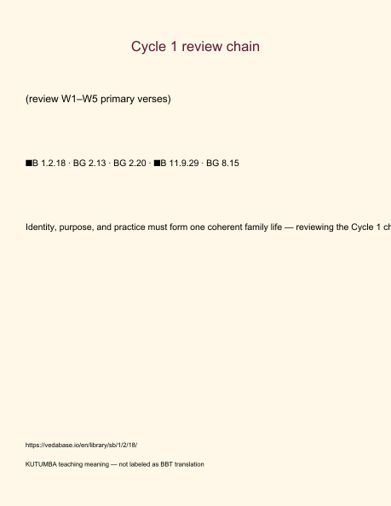
Original KUTUMBA visual: verse-card.png
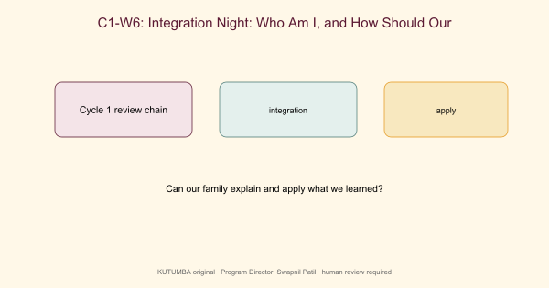
Original KUTUMBA visual: concept-diagram.png
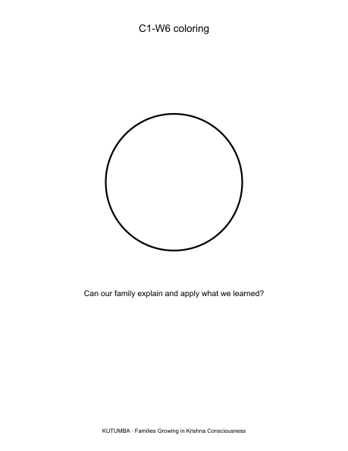
Original KUTUMBA visual: line-art-younger.png
RIGHTS NOTE | Original KUTUMBA program material. Scripture/BBT/ISKCON/third-party rights remain with their holders.

