KUTUMBA

C2-W1 OLDER TEACHER GUIDE
  - Families Growing in Krishna Consciousness
C2-W1
V12 • Families Growing in Krishna Consciousness
Program Director: Swapnil Patil
Internal founding-cohort teaching material — human/temple review EXTERNAL_OPEN
KUTUMBA | Families Growing in Krishna Consciousness

KUTUMBA • Families Growing in Krishna Consciousness Program Director: Swapnil Patil Status: INTERNAL founding-cohort — human/temple review EXTERNAL_OPEN

Objective
Students will observe BG 3.9, explain that work aimed only at separate material interest binds while work for Viṣṇu should be done without selfish attachment, and analyze one action using intention–method–consequence.

Primary text observation — BG 3.9
Open and keep visible: https://vedabase.io/en/library/bg/3/9/
- Devanāgarī: यज्ञार्थात्कर्मणोऽन्यत्र लोकोऽयं कर्मबन्धनः । तदर्थं कर्म कौन्तेय मुक्तसङ्गः समाचर ॥ ९ ॥
- IAST: yajñārthāt karmaṇo ’nyatra loko ’yaṁ karma-bandhanaḥ / tad-arthaṁ karma kaunteya mukta-saṅgaḥ samācara
- KUTUMBA teaching meaning: Work done for the satisfaction of the Lord frees us from bondage; otherwise action binds. Therefore act with detachment for His purpose.
Students write on observation sheet (5 minutes):
- Setting / speaker-listener (as known from class: Kṛṣṇa to Arjuna)
- Key Sanskrit phrase they notice (example: karma-bandhanaḥ)
- Teaching-meaning paraphrase in their own words (not a long dump)
- One thing this verse does not say (example: “it does not say we should stop all duties” / “it does not say we may blame victims”)

Misconception to block
Fatalism removes responsibility. Also block: diagnosing another person’s suffering as specific past karma.

40-minute sequence
Minutes | Block
0–5 | Essential question + memory line
5–12 | Primary text observation (above)
12–18 | Worksheet questions
18–25 | Scenario cards (triads)
25–32 | Puzzle/game: Action-Chain / Seed-Fruit Match
32–36 | Diagram task: Intention–Method–Consequence
36–38 | Project contribution line
38–40 | Reflection + reunification sentence

◆ ◆ ◆

Worksheet questions (write answers; check with activities/OLDER-ANSWER-KEY.md)
- According to BG 3.9’s teaching meaning, what kind of work causes bondage?
- What kind of work should we perform, and how (attachment posture)?
- Using BG 4.16–18 support (URLs on worksheet), why is “just stop working” too simple?
- Give one household example of offered work vs selfish work that look similar from outside.
- Why must we refuse the sentence: “That family’s hardship proves their past karma”?
Supporting URLs on student sheet:
- https://vedabase.io/en/library/bg/4/16/
- https://vedabase.io/en/library/bg/4/17/
- https://vedabase.io/en/library/bg/4/18/
◆ ◆ ◆

Scenario cards (real prompts — print from activity pack)
Students draw one card and answer: intention / method / likely consequence / one repair.
- Angry text: You send a sharp message in a group chat after a schedule mix-up.
- Gift for praise: You give a donation mainly hoping for public thanks.
- Quiet repair: You fix a sibling’s project and notice yourself waiting for praise.
Teacher circulates; stop victim-blame language immediately.
◆ ◆ ◆

Puzzle / game — Action-Chain / Seed-Fruit Match (WITH STEPS)
Materials: 8 seed cards + 8 fruit/result cards (see activities/OLDER-ACTIVITY-PACK.md)
- Shuffle seed cards and fruit cards into two piles.
- Students work in pairs.
- Match each seed (action) to a plausible fruit (result). Include at least two delayed results (practice → skill; harsh words → later distrust).
- For each match, pairs place an arrow card labeled direct, indirect, or delayed.
- Teacher checks two matches aloud using answer key guidance.
- Extension: build one action chain of three links from a single online post seed (post → screenshot → widened conflict) without shaming any real classmate.
◆ ◆ ◆

Diagram task — Intention–Method–Consequence
Students complete a three-box diagram for one scenario:
- Intention: Why am I acting?
- Method: How am I acting (careful / hasty / honest / showy)?
- Consequence: What may grow for me and for others?
Then add a fourth mini-box: Offered version — how would before–during–after change this?
Diagram may align with visuals/V12/concept-diagram.svg if projected.
◆ ◆ ◆

Project contribution
From project/CYCLE-CONTRIBUTION.md: write one sentence artifact line:
“Our family action that binds or frees: ______ / offered version: ______.”
Keep under two minutes. No ranking.
◆ ◆ ◆

Reflection (1–2 minutes)
“One sentence: What is the difference between an analogy (seed-fruit) and the verse (BG 3.9)?”
Target: analogy teaches; verse authorizes the doctrine.
◆ ◆ ◆

Extension (if early)
Read BG 3.13 URL https://vedabase.io/en/library/bg/3/13/ and write two columns: cooking for offering vs cooking only for myself — with one limit note (“no shaming newcomers”).
◆ ◆ ◆

Reunification sentence
“This week I will offer ______ by before ______, during ______, after ______.”

Answer key pointer
Use activities/OLDER-ANSWER-KEY.md for secure targets. Do not leave the key on student desks.

Materials
Observation sheets, pencils, scenario cards, seed/fruit match cards, arrow cards, diagram sheets, verse URL list.

Do not claim
INTERNAL only; EXTERNAL_OPEN review; teaching meaning ≠ BBT translation; no fabricated human approval.

Instructional visuals
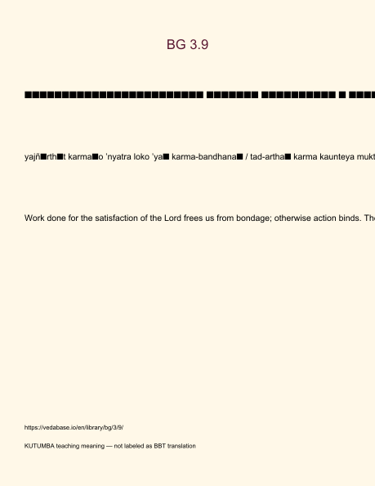
Original KUTUMBA visual: verse-card.png
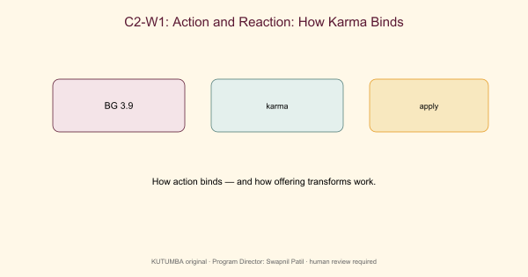
Original KUTUMBA visual: concept-diagram.png

Original KUTUMBA visual: line-art-younger.png
RIGHTS NOTE | Original KUTUMBA program material. Scripture/BBT/ISKCON/third-party rights remain with their holders.

