KUTUMBA

C2-W1 YOUNGER TEACHER GUIDE
  - Families Growing in Krishna Consciousness
C2-W1
V12 • Families Growing in Krishna Consciousness
Program Director: Swapnil Patil
Internal founding-cohort teaching material — human/temple review EXTERNAL_OPEN
KUTUMBA | Families Growing in Krishna Consciousness

KUTUMBA • Families Growing in Krishna Consciousness Program Director: Swapnil Patil Status: INTERNAL founding-cohort — human/temple review EXTERNAL_OPEN

Objective
Children will explain in child language that choices plant seeds, and they will practice planting “service seeds” (kind, careful helping) rather than “hurry-hurt seeds.”

Exact memory phrase
Choices are seeds. I want to plant service seeds.

Teacher background
- Primary verse for the week: BG 3.9 — https://vedabase.io/en/library/bg/3/9/
- Adult teaching meaning (for teacher clarity, not for children to memorize): Work done for the satisfaction of the Lord frees us from bondage; otherwise action binds. Therefore act with detachment for His purpose.
- Child-level bridge: Our choices are like seeds. Service seeds help. Selfish hurry-hurt seeds make trouble grow.
- Block: Fatalism removes responsibility. Also block victim-blaming (“you are sick because of bad karma”).
- Story source: seed/choices paraphrase plus a gentle King Nṛga care lesson from https://vedabase.io/en/library/sb/10/64/ — paraphrase only, no invented dialogue, no lizard/hell fright.

Materials (pack before 2:30)
- 8–12 picture seed cards (kind help / careful return / soft words / sharing) and 4 “hurry-hurt” cards (yank toy / shout / shove / hide mess)
- Soft toss object (scarf or foam ball)
- Crayons, US Letter print of visuals/V12/line-art-younger.svg
- Take-home phrase cards with memory phrase
- Tape or sticky tack; small basket labeled “Service Seeds”
- Optional allergy-safe paper “soil” tray (no real soil needed if allergies unknown)

40-minute run of show
Minutes | Block
0–5 | Welcome, calm bodies, echo memory phrase twice
5–13 | Story script (below)
13–16 | Three wonder questions
16–24 | Movement game: Seed Steps (full steps below)
24–33 | Craft: Service Seed Card (full steps below)
33–37 | Printable coloring + phrase paste
37–40 | Cleanup and parent handoff

◆ ◆ ◆

Story script (5–8 minutes) — read/speak as prose
“Friends, sit soft like little seeds in safe soil. Today we learn: choices are seeds.
When I plant a mango seed, I do not get a mango in one second. I wait. Later, something grows. Our choices are like that. If I help put shoes in a neat line, that is a service seed. If I grab and shout ‘mine!’, that is a hurry-hurt seed. Different seeds grow different gardens.
Long ago there was a king who loved to give gifts. One day a gift got mixed up because he did not check carefully enough. The mix-up caused trouble. We do not make up extra talking for the king. We learn one thing: careful checking is a service seed. Careless hurry can grow a hard problem.
Kṛṣṇa teaches grown-ups in Bhagavad-gītā that work done for the Lord can free us, and other work can bind. For us today, we say it this way: Choices are seeds. I want to plant service seeds.
We will move like seeds. We will make a service-seed card. We will color. And when we see our parents, we will say our phrase together.”
◆ ◆ ◆

Three wonder questions
- What is one service seed you can plant at home tonight?
- What happens inside a friendship when we plant hurry-hurt seeds?
- Whom can we help carefully this week without asking for a clap?
◆ ◆ ◆

Movement game — Seed Steps (WITH STEPS)
Name: Seed Steps Time: 7–8 minutes Space: Clear floor circle
- Teacher places two zones with tape: Service Garden (green card) and Hard Patch (gray card).
- Children stand in the middle as “sleeping seeds” (crouch).
- Teacher holds up one picture card and names it aloud (example: “soft words” or “yank toy”).
- If it is a service seed, children take three gentle heel-toe steps toward Service Garden, then freeze with hands on heart.
- If it is a hurry-hurt seed, children take three tiny steps toward Hard Patch, then freeze and show “reset hands” (palms open, quiet).
- Teacher says: “We can plant a new seed!” Children walk back to center and reset.
- Play 6–8 cards. End with all children in Service Garden echoing: “Choices are seeds. I want to plant service seeds.”
- If energy spikes: switch to seated hand-motions only (grow tall / curl small).
◆ ◆ ◆

Craft — Service Seed Card (WITH STEPS)
Time: 8–9 minutes
- Give each child a half-sheet card with a large empty seed outline.
- Child colors the seed warm colors (yellow/orange/green).
- Inside or under the seed, child draws one service action (helping set cups, returning a toy, gentle words).
- Teacher or helper writes the child’s words in one short sentence if the child dictates (“I help with shoes”).
- Glue or tape the memory phrase strip on the back: “Choices are seeds. I want to plant service seeds.”
- Place finished cards in the Service Seeds basket until parent handoff.
- Early finishers color the line-art printable (next section).
◆ ◆ ◆

Printable task
- Print visuals/V12/line-art-younger.svg on US Letter.
- Children color the scene calmly.
- At the bottom, child traces or stickers the memory phrase.
- Write child’s first name only on the back (no private family stories).
◆ ◆ ◆

Behavior redirects
- Feet on floor · hands kind · voices soft · toys rest on the shelf.
- If a child boasts or ranks (“I planted more seeds!”): “In KUTUMBA we cheer for everyone’s service seed.”
- If a child says someone “has bad karma”: “We don’t say that here. We plant our next service seed.”
- Quiet reset: sit, three breaths, soft palm tap on knees, rejoin.
◆ ◆ ◆

Backup (if craft fails or time collapses)
- Sit in a circle.
- Pass the soft object.
- Each child names one kind action or points to a service-seed card.
- Whole group echoes the memory phrase three times.
- Color only if minutes remain.
◆ ◆ ◆

Cleanup / parent handoff (3:05–3:10 toward reunification)
- Crayons in box; scraps in bin; cards in basket.
- Children stand with their Service Seed Card.
- Parent handoff line (say to parent, not as confession pressure):
“Memory phrase: Choices are seeds. I want to plant service seeds. Home cue: do one helpful action carefully before snack or bedtime.”
- Do not report private behavior incidents in the hallway; use teacher private note only if safeguarding requires.

Do not claim
Not human-approved for public distribution; not a substitute for local temple authority; teaching meaning ≠ BBT translation.

Instructional visuals
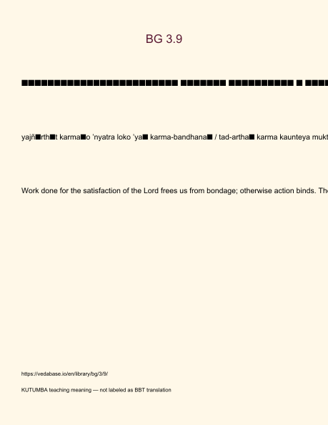
Original KUTUMBA visual: verse-card.png
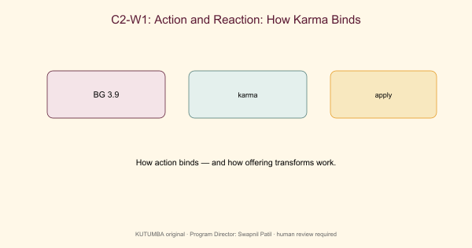
Original KUTUMBA visual: concept-diagram.png
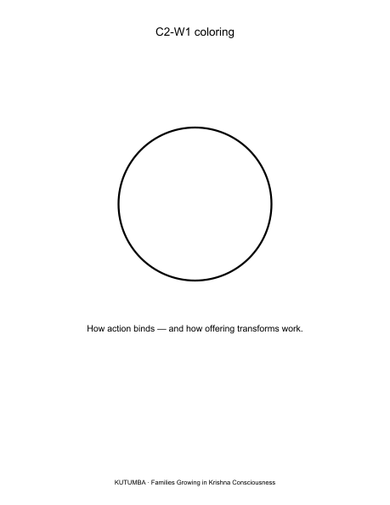
Original KUTUMBA visual: line-art-younger.png
RIGHTS NOTE | Original KUTUMBA program material. Scripture/BBT/ISKCON/third-party rights remain with their holders.

