KUTUMBA

C2-W2 OLDER TEACHER GUIDE
  - Families Growing in Krishna Consciousness
C2-W2
V12 • Families Growing in Krishna Consciousness
Program Director: Swapnil Patil
Internal founding-cohort teaching material — human/temple review EXTERNAL_OPEN
KUTUMBA | Families Growing in Krishna Consciousness

Week: Free Will and Responsibility: The Next Choice Matters Primary: BG 18.63 — https://vedabase.io/en/library/bg/18/63/ Session length: ~40 minutes (parallel track ~2:30–3:10) Parents: Remain onsite; reunite at 3:10 Status: Internal founding-cohort teaching material — human/temple review EXTERNAL_OPEN
◆ ◆ ◆

Objective
Students observe BG 18.63, explain that deliberation and choice go together with responsibility, map a trigger chain, and contribute one project sentence answering: What is my next responsible choice?

Exact memory phrase
After giving knowledge, Kṛṣṇa tells Arjuna to deliberate fully and then act as he chooses.
Short echo: The next choice matters.

Teacher background
- KUTUMBA teaching meaning: The Lord has explained confidential knowledge; now deliberate fully and then act as you choose — responsibility remains with the living being. (Label as KUTUMBA teaching meaning — not as BBT translation.)
- Supporting frames (one sentence each): BG 18.61 machine-of-nature limits; BG 3.34 sense attachment/aversion; BG 2.7 seeking guidance; BG 18.73 willing alignment after clarity.
- Block: “Choice = do whatever I feel” and “I have no agency.”
- Scope: Do not teach reincarnation ontology (C2-W3) tonight.

Materials
- Printed verse strip: Devanāgarī + IAST + KUTUMBA teaching meaning
- Worksheet copies from activities/OLDER-ACTIVITY-PACK.md
- Scenario cards (sibling anger; homework vs game; parent snap/repair — fictional)
- Choice-map diagram sheet (event → sensation → thought → urge → choice → consequence)
- Pencils; timer; answer key activities/OLDER-ANSWER-KEY.md for teacher only
- Project contribution half-sheets
◆ ◆ ◆

Minute-by-minute plan

0–5 min — Settle and hook
- Welcome; feet on floor.
- Hook: “Which sentence is more true — ‘I had no choice’ or ‘I can do whatever I feel’?” Let two volunteers answer; hold both as incomplete.
- State essential question: What is my next responsible choice?

5–14 min — Primary text observation (BG 18.63)
- Display verse; read IAST aloud together once; teacher reads Devanāgarī slowly or plays authorized audio if available.
- Students underline three idea-words in the teaching meaning: deliberate, choose, responsibility.
- Observation prompts (write short answers):
- What has already been given? (knowledge explained)
- What must Arjuna do before acting? (deliberate fully)
- Who remains responsible for action? (the living being / Arjuna as representative learner)
- Add one-sentence bridges:
- BG 2.7 — seeking guidance is a responsible move when confused.
- BG 18.73 — clarity can lead to acting according to the Lord’s instruction.
- Paraphrase only; no invented dialogue.

14–22 min — Worksheet questions
Students complete Section A of the older activity pack:
- Restate KUTUMBA teaching meaning in their own words (one sentence).
- Name two things a person might not control in a hard moment.
- Name one thing a person can still choose.
- Why is “do whatever you feel” not the meaning of this verse?
- Why is “I had no choice” incomplete?
Teacher circulates; use OLDER-ANSWER-KEY.md for expected directions (not for grading ranks).

22–28 min — Scenario cards (small groups)
Each group gets one fictional card:
Card A — Sibling anger: Urge to shout/snatch. Mistaken line: “Anger made me do it.” Card B — Homework vs game: Urge to skip work. Mistaken line: “Easy feeling = right choice.” Card C — Repair after a snap: Adult or older child spoke harshly; now what?
For each card, group writes:
- What is not fully controlled?
- What is the Pause–Remember–Choose path?
- What should we not say (shame, ranking, public exposure)?
Share one insight per group (60 seconds).

28–33 min — Puzzle / game: Responsible Fork
- Teacher reads a short fork aloud (two endings).
- Teams hold up R (responsible next step) or M (mistaken conclusion).
- Three rounds, then students explain one “R” choice using the words deliberate or responsibility.
- Keep energy respectful; no mocking wrong holds.

33–37 min — Diagram task
On the choice-map sheet, students fill one low-risk example (lost pencil, long line, noisy sibling — not forced trauma disclosure):
Event → Body sensation → Thought → Urge → Choice → Consequence
Circle the Choice box and write the memory short echo inside it.

37–40 min — Project contribution + reflection + handoff
- Complete project half-sheet: “This week my next responsible choice at _________ is _________.”
- Reflection (one sentence): How does BG 18.63 challenge both license and fatalism?
- Cleanup; bring sheets to reunification.
- Parent handoff line: Home practice is Pause–Remember–Choose once daily on the family trigger.

Extension (if group finishes early)
Compare BG 3.34 (sense attachment/aversion) with the traffic-light pause: feelings arise; we need not obey every urge. Still no reincarnation teaching.

Answer key pointer
Teacher-facing expected answers: activities/OLDER-ANSWER-KEY.md. Do not distribute the key to students during the first attempt.

Behavior and privacy
- Redirect side talk: “Return to your map — choice box only.”
- No forced confession of real family conflict details.
- No ranking scores aloud.
- Parents onsite; snack/water belongs to main schedule, not track rewards framed as a meal.

Instructional visuals
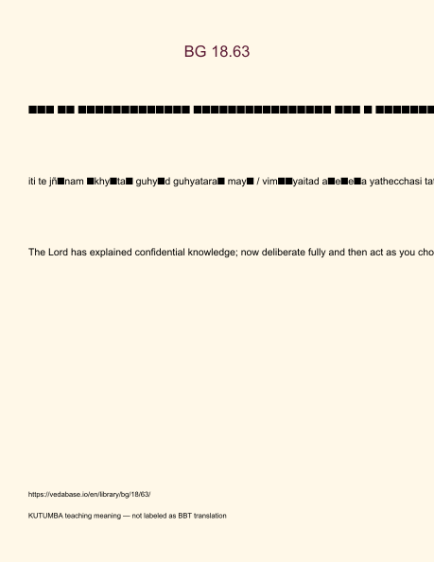
Original KUTUMBA visual: verse-card.png
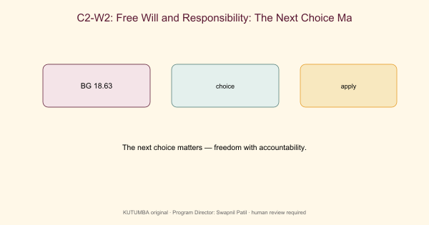
Original KUTUMBA visual: concept-diagram.png
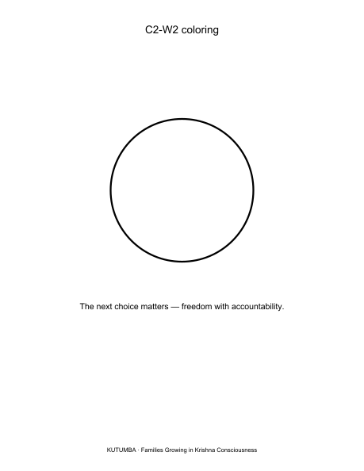
Original KUTUMBA visual: line-art-younger.png
RIGHTS NOTE | Original KUTUMBA program material. Scripture/BBT/ISKCON/third-party rights remain with their holders.

