KUTUMBA

C2-W2 YOUNGER TEACHER GUIDE
  - Families Growing in Krishna Consciousness
C2-W2
V12 • Families Growing in Krishna Consciousness
Program Director: Swapnil Patil
Internal founding-cohort teaching material — human/temple review EXTERNAL_OPEN
KUTUMBA | Families Growing in Krishna Consciousness

Week: Free Will and Responsibility: The Next Choice Matters Primary: BG 18.63 — https://vedabase.io/en/library/bg/18/63/ Session length: 40 minutes (parallel track ~2:30–3:10) Parents: Remain onsite; reunite at 3:10 Status: Internal founding-cohort teaching material — human/temple review EXTERNAL_OPEN
◆ ◆ ◆

Objective
Children experience that feelings can be strong while the next choice still matters. They practice a simple red–yellow–green pause and take home one cue card for Pause–Remember–Choose.

Exact memory phrase
The next choice matters.

Teacher background (2 minutes to review)
- KUTUMBA teaching meaning (adult wording): The Lord has explained confidential knowledge; now deliberate fully and then act as you choose — responsibility remains with the living being.
- Child-facing paraphrase: Kṛṣṇa teaches Arjuna: think carefully, then choose what is right. We do not control everything, but we can choose our next kind step.
- Block misconceptions (child words):
- “I can do whatever I feel.”
- “I had no choice.”
- Do not: invent Kṛṣṇa–Arjuna dialogue; use scary battle talk; force children to confess home fights; rank children.

Materials
- Red, yellow, and green cardstock circles (one set per small group)
- Soft puppet or two stuffed animals
- Toy or block for the “shared toy” demo
- Card stock for take-home cue cards
- Crayons / markers
- Printed visuals/V12/line-art-younger.svg if available (US Letter)
- Soft toss object for backup game
- Tape or mini-stands so traffic-light cards can stand

Room setup
Circle on the floor; materials table behind you; calm corner with one chair for quiet reset. Keep aisles clear for movement game.
◆ ◆ ◆

Minute-by-minute executable plan

0–5 min — Opening and recall
- Welcome by name; feet on floor; hands in lap.
- Echo memory phrase three times, clap rhythm: The next / choice / matters.
- Show red card: “Pause.” Yellow: “Remember Kṛṣṇa and kind rules.” Green: “Choose a good next step.”
- Ask: “Did anyone practice a pause at home?” Accept nods; no forced stories.

5–13 min — Story script (paraphrase only; ~8 minutes)
Say exactly this spine (do not invent deity dialogue):
Long ago, Arjuna felt confused about what he should do. He asked Kṛṣṇa to teach him what was best. That asking was already a good choice. Kṛṣṇa taught him many important things. Then Kṛṣṇa told him to think carefully about what he heard, and then to choose how to act. Later, Arjuna’s confusion was gone, and he was ready to follow Kṛṣṇa’s instruction. We also get confused. We do not control every feeling. But after we pause and remember, we can choose the next kind step. The next choice matters.
Story boundaries: Paraphrase from BG 2.7, 18.63, and 18.73 themes only. No invented quotes. No gore. No blaming a child as “the bad Arjuna.”

13–16 min — Three wonder questions
- When you feel mad or grabby, what is the red step?
- Whom can we remember on the yellow step? (Kṛṣṇa; also family kind rules)
- What is one green choice with a brother, sister, or friend?
Accept one- or two-word answers. Affirm effort.

16–24 min — Movement game: Traffic-Light Choice (steps)
- Spread children in a safe open space.
- Teacher calls Red — everyone freezes (pause).
- Teacher calls Yellow — everyone places hand on heart and whispers memory phrase.
- Teacher calls Green — everyone takes three gentle steps toward the kindness mat / circle center and sits.
- Play three rounds. On round three, add a choice: show two picture cards (kind share vs harsh snatch). On green, children point to the kind card.
- End seated; echo memory phrase once.

24–32 min — Craft: Pause–Remember–Choose cue card (steps)
- Give each child a folded card stock “traffic light.”
- Color top circle red, middle yellow, bottom green (model once).
- Inside the card, teacher or helper writes: The next choice matters.
- On the back, child draws one green choice (share, soft voice, ask for help).
- Practice once: hold card, touch red → yellow → green while saying Pause / Remember / Choose.
Full printable steps also live in activities/YOUNGER-ACTIVITY-PACK.md (use together; this guide remains executable if the pack is missing).

32–35 min — Printable / coloring task
If time remains, color the younger line-art sheet. If short on time, skip coloring and keep the cue card as the take-home.

35–38 min — Behavior redirects and quiet reset
Use calm, specific redirects:
- Feet on floor — “Feet visit the mat.”
- Kind words — “Try your green voice.”
- Toy rests — “Toy takes a nap on the shelf.”
- Quiet reset — one minute in calm corner with red card; rejoin on yellow whisper.

38–40 min — Cleanup and parent handoff
- Crayons in bin; cards stacked; soft toys away.
- Each child holds cue card.
- At reunification, tell parent in one sentence:
Memory phrase: “The next choice matters.” Home cue: once daily on your family trigger — Pause, Remember, Choose.
- Do not report private behavior struggles in front of other families.
◆ ◆ ◆

Behavior redirects (quick reference)
Signal | Teacher line | Child action
Running | “Red light bodies.” | Freeze, then walk
Snatching | “Yellow — remember kind hands.” | Hands to lap
Loud shout | “Green voice, please.” | Soft repeat
Shutdown | “Quiet reset is okay.” | Calm corner 60 sec

Backup low-prep (if craft fails or energy crashes)
- Sit in a circle with soft toss object.
- Child catches, says one kind next choice (“share,” “sorry,” “ask”), tosses to next.
- End with three echoes of the memory phrase.
- Optional: freeze-and-remember — freeze on clap, say phrase on second clap.

What success looks like
- Child can show red / yellow / green in order.
- Child can echo: The next choice matters.
- Child can name one green action.

Boundaries
- Snack/water only happens in main schedule (3:30), not as a track bribe.
- No weekly meal language.
- No fabricated approval stickers implying temple certification.
- Privacy: no forced confession of sibling fights.

Instructional visuals
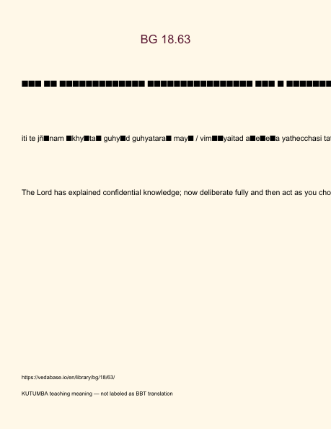
Original KUTUMBA visual: verse-card.png
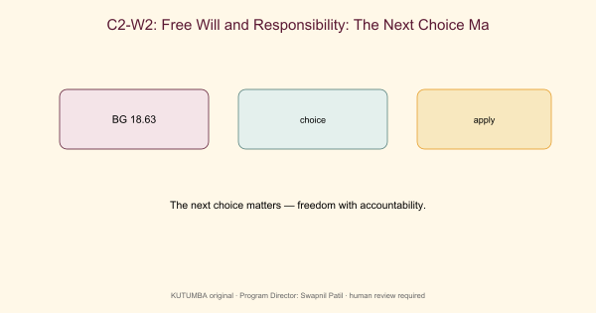
Original KUTUMBA visual: concept-diagram.png
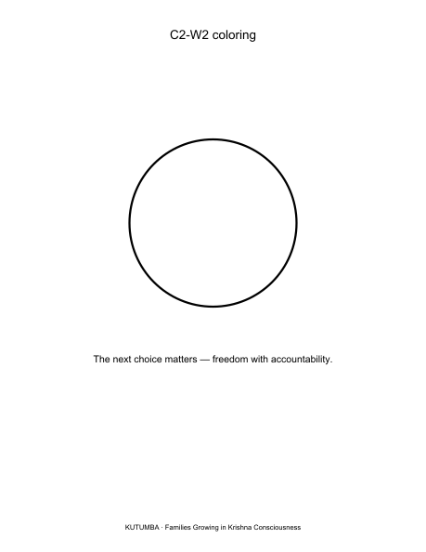
Original KUTUMBA visual: line-art-younger.png
RIGHTS NOTE | Original KUTUMBA program material. Scripture/BBT/ISKCON/third-party rights remain with their holders.

