KUTUMBA

C2-W3 MAIN FACILITATOR GUIDE
  - Families Growing in Krishna Consciousness
C2-W3
V12 • Families Growing in Krishna Consciousness
Program Director: Swapnil Patil
Internal founding-cohort teaching material — human/temple review EXTERNAL_OPEN
KUTUMBA | Families Growing in Krishna Consciousness

KUTUMBA • Families Growing in Krishna Consciousness Program Director: Swapnil Patil Status: Internal founding-cohort teaching material — human/temple review EXTERNAL_OPEN Controlling guide: This V12 file is authoritative for Saturday delivery. Core teaching is inlined below.

Two-minute summary
Birth and death are changes of dress for the eternal self — taught calmly, with hope, never with fear tactics. Primary: BG 2.22 (https://vedabase.io/en/library/bg/2/22/). Essential question: How do we speak calmly about birth and death?

Essential question
How do we speak calmly about birth and death?

15-minute night-before prep
- Open https://vedabase.io/en/library/bg/2/22/ and reread Devanāgarī, IAST, and KUTUMBA teaching meaning below.
- Rehearse the speaking script section aloud once (aim for clear 12–18 minute delivery with pauses). Soften your voice; this week triggers grief for some families.
- Pack younger materials (doll/clothes set or paper doll; no scary images) and older worksheets.
- Review blocks: scare pedagogy; diagnosing deceased destinations; ghost speculation; “choosing next body from a closet.”
- Confirm snack/water only (no weekly meal); parents onsite; privacy reminder visible.
- Pre-write home-practice card: one-minute bedtime remembrance on three nights.

60-minute deep prep
- Read the inlined analogies, examples, and three cases in this guide until you can teach them without notes.
- Mark which discovery / understanding / application questions you will actually ask.
- Choose one analogy (worn clothes) and one case (bedtime question or funeral language) as your “must teach” pair; keep the others ready for Q&A.
- Walk the room: parent circle, younger zone (calm visuals only), older zone, reunification seats.
- Rehearse the bhakti lab: Bedtime Remembrance Routine (one minute).
- Review deferral line: laboratory methods measure bodies/behavior; transmigration is a śāstra conclusion — no false science proof.
- Skim project/CYCLE-CONTRIBUTION.md for this week’s artifact layer.
- Optional enrichment only (not a substitute for this guide): research folder files.
- If a family is in acute grief, plan to offer private space and no forced participation — never call them out publicly.

Exact primary and supporting readings

Primary (locked)
- Reference: BG 2.22
- URL: https://vedabase.io/en/library/bg/2/22/
- Devanāgarī: वासांसि जीर्णानि यथा विहाय नवानि गृह्णाति नरोऽपराणि । तथा शरीराणि विहाय जीर्णान्यन्यानि संयाति नवानि देही ॥ २२ ॥
- IAST: vāsāṁsi jīrṇāni yathā vihāya navāni gṛhṇāti naro ’parāṇi / tathā śarīrāṇi vihāya jīrṇāny anyāni saṁyāti navāni dehī
- KUTUMBA teaching meaning: As a person puts on new garments, giving up old ones, the embodied self similarly accepts new bodies, giving up old ones — taught calmly, without fear tactics for children.
- Rights: Sanskrit verse text from VedaBase display; KUTUMBA teaching meaning original; no full purport; no BBT English translation copied.

Supporting readings
- BG 2.13 — https://vedabase.io/en/library/bg/2/13/ — Life stages in one body; the self continues (bridge from C1-W2).
- BG 2.20 — https://vedabase.io/en/library/bg/2/20/ — The self is not slain when the body is slain.
- BG 2.27 — https://vedabase.io/en/library/bg/2/27/ — For one who is born, death is certain; for one who dies, birth is certain — taught as sobriety, not scare.
- BG 8.5 — https://vedabase.io/en/library/bg/8/5/ — Remembering the Lord at the end points toward the Lord’s nature.
- BG 8.6 — https://vedabase.io/en/library/bg/8/6/ — The state of being remembered at the end shapes the next destination of consciousness.
- BG 14.14 — https://vedabase.io/en/library/bg/14/14/ — Recognition only this week: death in the mode of goodness leads toward higher destinations (full modes teaching is C2-W4).
- BG 14.15 — https://vedabase.io/en/library/bg/14/15/ — Recognition only this week: death under passion/ignorance shapes other destinations (do not lecture modes ontology tonight).

Teaching map with exact Saturday 2:00–4:00 time cues
Time | Block | Facilitator focus
1:50–2:00 | Arrival | Welcome; privacy; parents onsite; check younger visuals for calm only
2:00–2:10 | Opening mantras | Soft invitation; no volume contest
2:10–2:30 | Shared opening / Prem-kī-Kathā + verse | Deliver speaking script; state memory line; name blocks
2:30–3:10 | Parallel tracks | Parent circle / younger (gentle) / older — see track transition
3:10–3:30 | Reunification / bhakti lab | Bedtime Remembrance Routine demo; family synthesis sentence
3:30–3:40 | Snack + water only | No weekly meal service
3:40–3:55 | Saṅkalpa / project / Q&A | Three-night home cue + project + likely questions
3:55–4:00 | Closing | Next week: C2-W4 modes (BG 14.5) title only

10–20 minute speaking script (deliverable prose)
Facilitation note: Speak calmly. Pause for the 20-second pair share. Soften language around death. Do not replace this with a research-file deferral. No graphic imagery. No diagnosing anyone’s next destination.
Friends, welcome to Cycle 2, Week 3: Birth, Death, and Reincarnation.
Some of us come tonight with curiosity. Some come with grief. Some come with children’s bedtime questions that arrive at the wrong hour. We will teach with calm hope. We will not frighten anyone into devotion, and we will not turn this room into a ghost forum.
Our essential question is: How do we speak calmly about birth and death?
Please open with me the primary verse: Bhagavad-gītā 2.22. The stable link is https://vedabase.io/en/library/bg/2/22/. I will not read a full purport into the room. I will give our KUTUMBA teaching meaning — an original classroom paraphrase, not labeled as a BBT translation:
“As a person puts on new garments, giving up old ones, the embodied self similarly accepts new bodies, giving up old ones — taught calmly, without fear tactics for children.”
Say that back in your own words to the person beside you for twenty seconds — softly.
Here is the conclusion I want every facilitator and parent to be able to repeat: Birth and death are changes of dress for the eternal self — teach without fear.
Notice what the verse is doing. It does not say the person disappears. It does not say the body is the self. It says the embodied self (dehī) continues while garments — bodies — are given up and accepted. That is transmigration taught as continuity, not as a horror story.
From Cycle 1 we already practiced: the body changes through childhood, youth, and old age, yet the self continues (BG 2.13 — https://vedabase.io/en/library/bg/2/13/). Tonight we take the next step: the same continuity that holds across life stages also holds across births. BG 2.20 steadies us further: the self is not destroyed when the body ends (https://vedabase.io/en/library/bg/2/20/). BG 2.27 adds sobriety without scare: birth and death are certain for embodied life (https://vedabase.io/en/library/bg/2/27/). We name these calmly the way we name that night follows day — not to terrify children.
Let me make this concrete with worn clothes. When a shirt becomes too small or worn, a person sets it aside and accepts another. The wearer continues. That is pedagogy for continuity. The limit must be said out loud: you do not pick your next body from a closet like shopping. Desire, karma, and the Lord’s arrangement are not a costume rack. Analogies help; they are not the verse.
Second analogy: life-stage photos. A toddler photo, a school photo, a teen photo — faces change; the person is continuous. Limit: photographs do not prove the soul. They only illustrate continuity of identity through change. Śāstra teaches the metaphysics; photos teach calm speech.
Third analogy, especially for younger rooms: a doll changing clothes. The doll remains; outfits change. Limit: dolls are toys; living beings are not dolls. Never let children role-play dying or funerals with the doll.
Now a household picture. Imagine a child at bedtime asks, “Will I die?” The tempting response is either silence that feels like fear, or a frightening lecture about hell and ghosts. We reject both. The compassionate response is: “Your body will change someday, like clothes. You are the person Kṛṣṇa knows. Right now we are safe. Let’s remember Him for one minute and sleep.” That is hope, not scare pedagogy.
Supporting readings you may skim this week:
- BG 2.13 — https://vedabase.io/en/library/bg/2/13/ — life-stage continuity.
- BG 2.20 — https://vedabase.io/en/library/bg/2/20/ — the self is not slain.
- BG 2.27 — https://vedabase.io/en/library/bg/2/27/ — birth and death are certain; teach sobriety, not terror.
- BG 8.5–8.6 — https://vedabase.io/en/library/bg/8/5/ and https://vedabase.io/en/library/bg/8/6/ — remembrance at the end matters; therefore we practice remembrance now, gently, at bedtime.
- BG 14.14–14.15 — recognition only: modes affect destination — full teaching is next week (C2-W4).
Devotional pattern: In Bhagavad-gītā Chapter 2, Kṛṣṇa instructs Arjuna on the battlefield about the eternal self changing bodies (https://vedabase.io/en/library/bg/2/). We borrow the teaching intent — steadiness of the self — without inventing dialogue, without graphic war detail for children, and without pretending our living room equals Kurukṣetra.
A second sourced emphasis: BG 8.5–8.6 teach that the consciousness remembered at the end shapes direction. Classroom use: we practice short, calm remembrance now so remembrance is not foreign later. We do not claim we can diagnose where a deceased relative “went.”
In a moment we will split into tracks. Parents stay to practice calm funeral language and bedtime scripts. Younger friends meet a gentle doll-and-clothes story — no gore. Older students observe BG 2.22 and answer a fatalism challenge: “If we reincarnate, nothing matters.” We reunite at 3:10 for the Bedtime Remembrance Routine lab.
Memory line: Birth and death are changes of dress for the eternal self.
Let me teach one full case out loud so you can copy the pattern at home.
Situation: A six-year-old, lights out, asks, “Will Grandma come back as a baby? Will I die tonight?” Tempting mistaken conclusion: Either frighten them into “being good,” or invent a destination map for Grandma. Principle and source: BG 2.22 — the self continues through changing bodies; teach calmly (https://vedabase.io/en/library/bg/2/22/). BG 8.6 — practice remembrance; do not diagnose (https://vedabase.io/en/library/bg/8/6/). Compassionate response: Affirm the question is brave. Affirm safety tonight. Offer one-minute remembrance. Offer a hug. Offer to talk more in the morning with a trusted adult. Family action: Three nights this week — one-minute bedtime remembrance (mahā-mantra once or short approved hearing + one gratitude). What not to say: If you’re bad you’ll come back as… / Grandma is a ghost in the house / Let’s pick which body she got.
Second analogy again with its limit: Life-stage photos — same person across ages. Limit: Photos illustrate continuity of change; they do not prove ātman.
Third: Doll changing clothes — continuity of the doll through outfits. Limit: Not ontology; not a game about death; for K–2 only as a gentle object lesson.
Second sourced example: Remembrance practice from BG 8.5–8.6 — consciousness at the end matters, so families practice calm remembrance now. Paraphrase only; no invented purport lines. Links: https://vedabase.io/en/library/bg/8/5/ · https://vedabase.io/en/library/bg/8/6/
Before we split tracks, recite with me:
- Essential question: How do we speak calmly about birth and death?
- Conclusion: Birth and death are changes of dress for the eternal self — teach without fear.
- Misconceptions to block: scare pedagogy; diagnosing destinations; ghost speculation; closet-shopping for bodies.
- Primary: BG 2.22
Parents: your job in the parent circle is not to solve metaphysics tonight. It is to leave with a calm sentence for funerals, a bedtime script, and a one-minute cue for three nights.
We do not claim human, temple, or publication approval. We do not dump full purports. We do not invent quotations. We keep Saturday 2:00–4:00, snack and water only, parents onsite, and private grief private.
That is the heart of tonight’s teaching. Let us practice it gently.

Analogies with limits (inline — teach from here)

1. Worn clothes / new garments
- Teaches: As worn garments are set aside and new ones accepted, the embodied self continues while bodies change (BG 2.22).
- Limit (say out loud): You do not choose the next body from a closet. Analogy ≠ shopping. Desire, karma, and the Lord’s arrangement are not a costume rack.

2. Life-stage photos (continuity)
- Teaches: Faces and sizes change across photos; the person is continuous — pedagogy for calm speech about change.
- Limit (say out loud): Photos do not prove the soul. They illustrate continuity through change; metaphysics rests on śāstra.

3. Doll changing clothes (K–2 object lesson)
- Teaches: The doll remains while outfits change — gentle entry for young children.
- Limit (say out loud): Living beings are not dolls. No funeral role-play. No “dying game.” Stop at continuity and kindness.

Scriptural and devotional examples (inline paraphrase)

1. Kṛṣṇa’s Chapter 2 instruction to Arjuna (battlefield teaching context)
- Provenance: Bhagavad-gītā Chapter 2, centered on BG 2.22 and nearby verses
- URL: https://vedabase.io/en/library/bg/2/22/ (context: https://vedabase.io/en/library/bg/2/)
- Classroom paraphrase use: The Lord teaches that the embodied self continues while bodies change, so Arjuna should not be bewildered by bodily endings alone. Borrow steadiness and clarity — not graphic combat description for children; no invented dialogue.

2. Remembrance at the end (BG 8.5–8.6)
- Provenance: Bhagavad-gītā 8.5–8.6
- URLs: https://vedabase.io/en/library/bg/8/5/ · https://vedabase.io/en/library/bg/8/6/
- Classroom paraphrase use: Remembering the Lord at life’s end points toward the Lord’s nature; the state of consciousness remembered shapes direction. Therefore families practice short, calm remembrance now. Do not use these verses to diagnose a deceased person’s destination.

Three constructed household cases (inline)

Constructed case 1 — Child bedtime question
Field | Content
Situation | A child at bedtime asks, “Will I die? Where did Grandpa go? Will he come back as a baby?”
Mistaken conclusion | Either scare the child into obedience, or invent a confident map of Grandpa’s next body.
Principle | The self continues through changing bodies; speak calmly and practice remembrance — do not diagnose destinations.
Source | https://vedabase.io/en/library/bg/2/22/ · https://vedabase.io/en/library/bg/8/6/
Compassionate response | “That’s a brave question. Your body changes over time, like clothes. You are still you. Grandpa’s body finished this chapter; his self is in Kṛṣṇa’s care. Tonight we are safe. Let’s remember Kṛṣṇa for one minute.”
Family action | One-minute bedtime remembrance for three nights this week (cue: after teeth brushing).
What not to say | If you’re naughty you’ll die soon / Grandpa is a ghost / He came back as that stray cat / Let’s guess his next body.
Optional age adaptation | Ages 4–7: clothes/doll language only. Ages 8–10: add “we don’t know every detail; we trust the Lord.” Teens: invite their question without debate-as-dominance.

Constructed case 2 — Relative funeral language
Field | Content
Situation | At a relative’s funeral or memorial, a well-meaning aunt loudly announces the deceased’s precise next destination, or a cousin jokes about ghosts for the kids.
Mistaken conclusion | Public diagnosis of destination is devotion; ghost talk is harmless entertainment.
Principle | Speak with dignity and hope; leave destinations to the Lord and śāstra principles; protect children from scare and speculation.
Source | https://vedabase.io/en/library/bg/2/20/ · https://vedabase.io/en/library/bg/2/22/ · https://vedabase.io/en/library/bg/8/5/
Compassionate response | Privately redirect: “We honor them with remembrance and prayer. We don’t announce destinations. Kids hear calm hope, not ghost shows.”
Family action | Prepare two sentences before the next gathering: (1) honor line, (2) calm child line. Offer to step outside with a child who is overwhelmed.
What not to say | They definitely went to… / They’re haunting the house / Kids should see the body to “toughen up.”
Optional age adaptation | Younger: “We remember them kindly and pray.” Older: “We can grieve and still trust the self continues — without guessing chapters.”

Constructed case 3 — Teen fatalism (“nothing matters if we reincarnate”)
Field | Content
Situation | A teen says, “If we just get another body, nothing matters. Why try? Why be responsible?”
Mistaken conclusion | Reincarnation cancels responsibility and meaning.
Principle | Continuity of the self increases the weight of consciousness and choice; remembrance and responsibility still matter (link forward to modes without teaching them fully).
Source | https://vedabase.io/en/library/bg/2/22/ · https://vedabase.io/en/library/bg/8/6/ · https://vedabase.io/en/library/bg/18/63/ (C2-W2 continuity)
Compassionate response | “If the self continues, then what we cultivate in consciousness matters even more — not less. Reincarnation is not a get-out-of-responsibility card.”
Family action | Teen writes one sentence: “Because I continue, this week I will…” plus join one-minute remembrance three nights (or adult models if teen resists).
What not to say | You’re going to hell / Don’t think / Your doubt means you’re faithless / Nothing you do matters until initiation.
Optional age adaptation | Grades 4–5: simpler — “The self continues, so kind choices still matter.” Parents: connect to last week’s free will without shaming.

Discovery questions
- What word tonight (reincarnation / garments / remembrance / transmigration) is new or unclear?
- Where have you seen fear language or ghost talk enter family conversations about death?
- What would a one-minute bedtime minimum version look like in your home this week?

Understanding questions
- State this week’s conclusion in one sentence.
- Name the primary scripture and restate the KUTUMBA teaching meaning in your own words.
- What does this week not teach (scare pedagogy, destination diagnosis, ghost speculation, closet-shopping for bodies, full modes ontology)?

Application questions
- What is our family cue (exact time + place) for the one-minute bedtime remembrance?
- Who will start the practice if others are tired or grieving?
- What is the minimum version on a hard night (one mahā-mantra + one gratitude)?

Five likely Q&A
Question | Source-based direction
Can science prove reincarnation? | No empirical claim is required for this week’s doctrinal conclusion. Developmental psychology may inform *how* we speak calmly to children; it does not prove transmigration. Doctrine rests on śāstra (BG 2.22).
What do we tell a child who asks where Grandpa went? | Affirm care and continuity of the self; refuse destination diagnosis; offer remembrance and safety tonight (BG 2.22; BG 8.5–8.6).
Isn’t talking about death too heavy for kids? | Age-appropriate calm speech prevents fear filling the silence. Use clothes/doll language for K–2; no gore; no forced participation if a child is grieving.
If we reincarnate, why does this life matter? | Continuity raises the importance of consciousness and responsibility (BG 8.6; link to C2-W2 choice). Fatalism is a mistaken conclusion.
Should we discuss modes of nature and destinations tonight? | Recognition only for BG 14.14–14.15. Full modes teaching is C2-W4 (BG 14.5). Do not import next week’s ontology early.

Misconceptions to block
- Scare pedagogy (frightening children “into being good”)
- Diagnosing deceased persons’ destinations
- Ghost speculation as entertainment or doctrine
- Choosing the next body from a closet (analogy abuse)
- Confusing analogy with scripture quotation
- Claiming science proves or disproves transmigration
- Importing full C2-W4 modes ontology early
- Ranking families’ “advancement” by how they grieve
- False human, temple, CPO, or publication approval labels

What not to speculate about
- Invented quotations, purport dumps, or unverified lecture lines
- Private medical or spiritual diagnoses of families or the deceased
- Guarantees of a particular next birth
- Graphic death, funeral gore, or horror imagery — especially for Lāla–Lālī
- Ghost hauntings, possession entertainment, or “past-life identity” parties
- Guarantees of advancement, initiation, or certification

Track transition (say at ~2:28)
Parents remain in the parent circle. Younger friends go with [younger teacher] for a gentle clothes-and-doll lesson — no scary pictures. Older students go with [older teacher]. We reunite at 3:10 for the Bedtime Remembrance lab. We do not rank groups.

Family reunification synthesis (3:10–3:30)

Bhakti laboratory — Bedtime Remembrance Routine (demo ~5–7 min)
- Choose a fixed cue: device charging, teeth brushing, or entering the bedroom.
- Sit or stand safely before a sacred space or a clean image.
- Chant the mahā-mantra once slowly, or hear a short approved recording.
- Name one gratitude and one request for remembrance.
- End without lecture, without forced tears, without extending into debate.
Invite one sentence per family tied to the essential question:
“This week we will speak calmly about birth and death by…”
Accept drawings or whispered parent sentences for shy children. No scoreboard. Grieving families may pass.

Project contribution
Advance the Cycle 2 cumulative project using project/CYCLE-CONTRIBUTION.md. This week’s layer must connect to BG 2.22 and calm speech / remembrance practice. Store artifacts for Week 6 integration. Non-competitive.

Home practice (5–15 minutes; minimum is one minute × three nights)
- Say the memory line once: Birth and death are changes of dress for the eternal self.
- Paraphrase BG 2.22 in one family sentence (calm tone).
- Complete the one-minute bedtime remembrance on three nights this week.
- Minimum version if exhausted or grieving: one mahā-mantra + one gratitude only.

Next-week preview
Name only: C2-W4 — The Three Modes of Material Nature (primary BG 14.5). Do not teach modes ontology in depth tonight. BG 14.14–14.15 stay at recognition only.

Do not claim
Human/temple/CPO approval; publication readiness; BBT ownership of KUTUMBA teaching meanings; science proving transmigration; ranking results; guaranteed spiritual outcomes; knowledge of any specific person’s next destination.

Misconceptions and no-speculation boundaries
- Do not invent dialogue for scriptural persons.
- Do not diagnose private karma or modes as insults in the room.
- Do not claim temple/BBT/human approval that has not been given.
- Defer off-scope questions with the standard deferral line.

Instructional visuals
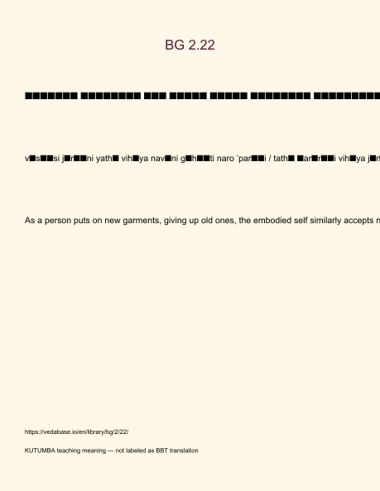
Original KUTUMBA visual: verse-card.png
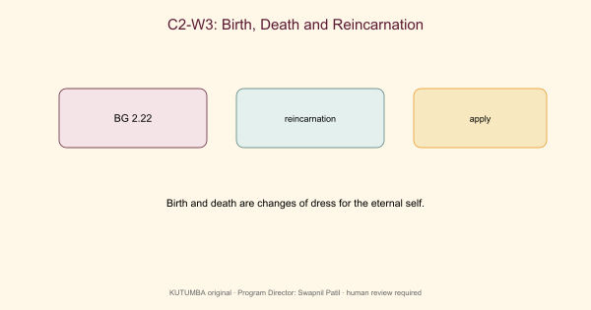
Original KUTUMBA visual: concept-diagram.png
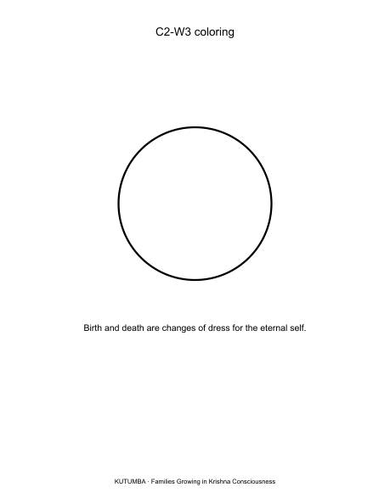
Original KUTUMBA visual: line-art-younger.png
RIGHTS NOTE | Original KUTUMBA program material. Scripture/BBT/ISKCON/third-party rights remain with their holders.

