KUTUMBA

C2-W3 OLDER TEACHER GUIDE
  - Families Growing in Krishna Consciousness
C2-W3
V12 • Families Growing in Krishna Consciousness
Program Director: Swapnil Patil
Internal founding-cohort teaching material — human/temple review EXTERNAL_OPEN
KUTUMBA | Families Growing in Krishna Consciousness

Track window: approx. 2:30–3:10 (40 minutes).

Objective
Students explain Birth and death are changes of dress for the eternal self — teach without fear using BG 2.22, and reject fatalism that “nothing matters if we reincarnate.”

Essential question
How do we speak calmly about birth and death?

Minute-by-minute
Minutes | Block | What you do
0–5 | Hook | Read essential question; students write a one-line first answer
5–15 | Text observation | Open https://vedabase.io/en/library/bg/2/22/; complete observation task below
15–22 | Diagram | Label garment → body continuity map; mark the “limit” box (not a closet)
22–30 | Scenario cards | Pairs work Cases 1–3 (bedtime / funeral / fatalism)
30–36 | Worksheet / matching | `activities/OLDER-ACTIVITY-PACK.md`
36–40 | Reflection + reunification sentence | Prepare one calm sentence for 3:10 share

Text-observation task (10 min)
Open https://vedabase.io/en/library/bg/2/22/. Students write:
- Who is speaking / what is the teaching setting (Kṛṣṇa to Arjuna in BG Chapter 2 — keep non-graphic)?
- One phrase that signals continuity of the self through changing bodies.
- One sentence paraphrase in their own words (not a long dump).
- One thing this verse does not say (e.g., does not say we shop for bodies; does not say scare children).
Target paraphrase: As a person puts on new garments, giving up old ones, the embodied self similarly accepts new bodies, giving up old ones — taught calmly, without fear tactics for children.

Diagram task
On board or visuals/V12/ materials, label:
- Worn garment → set aside
- New garment → accepted
- Embodied self (dehī) → continues
- Limit box: “Not choosing from a closet / not ghost speculation / not destination diagnosis”
Draw one arrow showing this week’s conclusion: the self continues; teach calmly.

Scenario cards
Use the three constructed cases inline in teacher/MAIN-FACILITATOR-GUIDE-V12.md:
- Child bedtime question
- Relative funeral language
- Teen fatalism (“nothing matters if we reincarnate”)
In pairs: name the mistaken conclusion + compassionate response + better family action. Prefer Case 3 if time is short — it matches this age band’s common doubt.

Worksheet + puzzle
See activities/OLDER-ACTIVITY-PACK.md; grade with activities/OLDER-ANSWER-KEY.md.

Project contribution
Advance project/CYCLE-CONTRIBUTION.md layer for C2-W3 (calm speech / remembrance artifact).

Reflection prompt
“Where might someone confuse the clothes analogy with ‘picking a next body’ — and how do we correct that kindly?”

Extension
Prepare reunification share sentence answering: How do we speak calmly about birth and death?

Boundaries
- Misconceptions to block: scare pedagogy; diagnosing destinations; ghost speculation; closet-shopping analogy abuse; reincarnation-as-fatalism.
- BG 14.14–14.15: recognition only — full modes next week (C2-W4).
- Science may inform calm speech pedagogy only — never prove transmigration.
- No ranking; no forced disclosure of private grief.

Instructional visuals
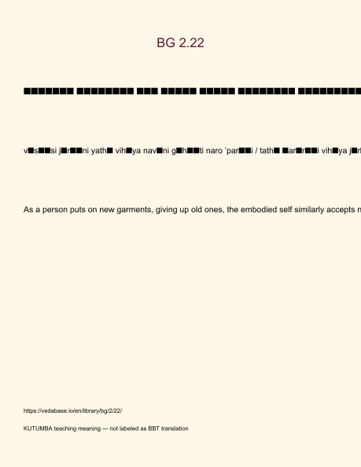
Original KUTUMBA visual: verse-card.png
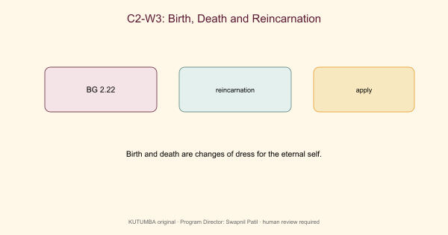
Original KUTUMBA visual: concept-diagram.png
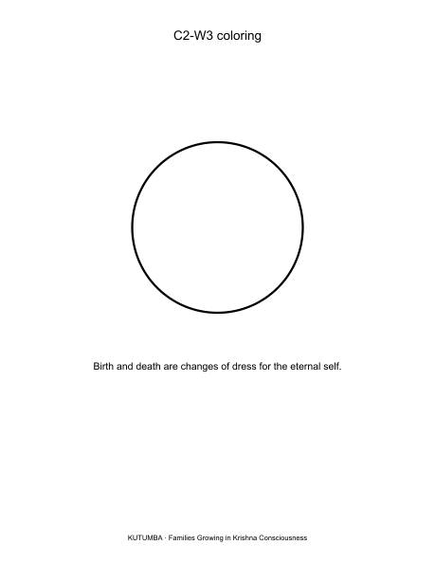
Original KUTUMBA visual: line-art-younger.png
RIGHTS NOTE | Original KUTUMBA program material. Scripture/BBT/ISKCON/third-party rights remain with their holders.

