KUTUMBA

C2-W3 YOUNGER TEACHER GUIDE
  - Families Growing in Krishna Consciousness
C2-W3
V12 • Families Growing in Krishna Consciousness
Program Director: Swapnil Patil
Internal founding-cohort teaching material — human/temple review EXTERNAL_OPEN
KUTUMBA | Families Growing in Krishna Consciousness

Track window: approx. 2:30–3:10 (40 minutes). Parents onsite elsewhere; reunite at 3:10.

Objective
Children can say and show: Birth and death are changes of dress for the eternal self — gently, without fear.

Exact memory phrase
Birth and death are changes of dress for the eternal self.

Teacher background (2 minutes, before children arrive)
- Primary: BG 2.22 — As a person puts on new garments, giving up old ones, the embodied self similarly accepts new bodies, giving up old ones — taught calmly, without fear tactics for children. (https://vedabase.io/en/library/bg/2/22/)
- Block: scare pedagogy; ghost talk; funeral role-play; scary pictures; “choosing bodies from a closet.”
- Do not teach adult debates, destinations of deceased relatives, or graphic death.
- If a child mentions a recent death, acknowledge kindly (“That is sad. We can remember them with love.”) and return to the gentle lesson. Do not diagnose.
- Snack later with whole group only; water okay if needed.

Minute-by-minute lesson
Minutes | Block | What you do
0–3 | Welcome + seated circle | Soft voice; “kind words only”; show calm clothes/doll visual — no scary images
3–8 | Memory phrase echo | You say half; they finish; two joyful rounds max
8–16 | Story script | Read/tell the gentle story below; ask one wonder question
16–23 | Movement game | Soft Clothes Walk (rules below)
23–33 | Hands-on + craft | Doll/clothes object lesson + take-home card
33–37 | Coloring | `visuals/V12/line-art-younger.svg` (calm scene only)
37–40 | Cleanup + door handoff | Tell parent the memory phrase + three-night bedtime cue

Age-appropriate story script (5–8 min) — gentle; no gore
Once there was a soft doll who wore a yellow shirt. The doll was still the same doll when the yellow shirt was folded away and a blue shirt was put on. The doll did not disappear. The clothes changed.
Kṛṣṇa teaches something kind: we are not only our clothes-of-the-body. When a body grows from little to bigger — like baby clothes to bigger clothes — we are still us. Someday bodies finish their work, the way worn clothes are set aside. The person Kṛṣṇa knows continues. We do not need to be afraid in this room. Tonight we practice kind words and remembering Kṛṣṇa with a calm heart.
Rules: no invented deity dialogue; no frightening detail; no funerals, hospitals, blood, ghosts, or “dying games.” Stop at the moral: bodies change like clothes; we speak calmly; we remember Kṛṣṇa gently.

Three wonder questions
- What stayed the same when the doll’s clothes changed?
- Whom can we remember with kindness this week?
- When could our family remember Kṛṣṇa for one minute before sleep?

Movement game (5–7 min) — Soft Clothes Walk — C2-W3
- Children walk gently in a circle holding (or pretending to hold) a soft scarf “shirt.”
- When you say “Change!”, they pause and fold the scarf to their heart (no throwing).
- You say the first half of the memory phrase; they finish it.
- Two rounds only; then sit. Redirect: “Feet on the floor. Kind words only. Soft bodies.”

Hands-on object lesson (8–10 min) — Doll / clothes
Object: One classroom doll (or paper doll) + two simple outfits or colored paper shirts. Steps:
- Teacher shows doll in outfit A: “This is the same friend.”
- Change to outfit B slowly: “Clothes changed. Friend is still here.”
- Children say: “The doll stays. The clothes change.”
- Secure ending: “Our bodies change too. We speak kindly. We remember Kṛṣṇa.”
Never: “Now the doll dies.” Never closet-shopping for “next life animals.”

Craft (8–10 min)
Clothes-card: Fold a card. Outside: draw a simple shirt. Inside: write or sticker the memory phrase. Optional: glue a tiny fabric scrap. Children take it home to look at before bedtime remembrance.

Coloring / line-art
Color ../visuals/V12/line-art-younger.svg. Title the page with C2-W3. If the art is unclear, children draw a calm shirt and a smiling child praying — no graves, no ghosts.

Sanskrit exposure (optional, 1 min)
Softly invite hearing one word from the verse: dehī (the embodied self) — or simply Kṛṣṇa / Hare. Never forced volume.

Behavior redirects
- “Feet on the floor.”
- “Kind words only.”
- “That toy rests for now.”
- “We use soft voices about bodies.”
- Quiet reset in visible space if needed (parents onsite).

Backup low-prep (if craft or doll fails)
Sit in a circle; pass a soft scarf; each child says one kind word; end with memory phrase echo twice.

Extension
Helper role: hand out crayons / collect papers / hold the “calm scarf.”

Materials
Printed line art; crayons; memory cards; soft scarf; doll or paper doll + two outfits/paper shirts; card stock; tape; fabric scrap optional.

Cleanup / handoff
3 minutes cleanup. At door: tell parent the memory phrase and: “Please try one-minute bedtime remembrance on three nights.”

Home-practice explanation to parents
“Please say the memory phrase once and do one calm minute of remembrance before bed on three nights. Soft language only — no scare stories.”

Instructional visuals
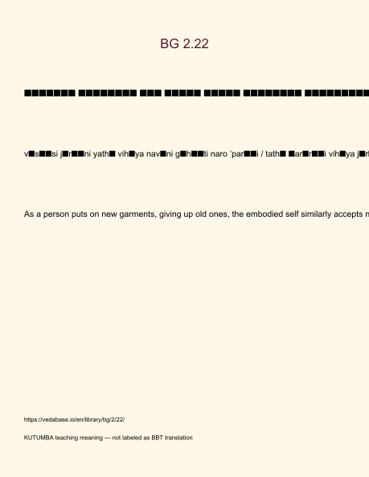
Original KUTUMBA visual: verse-card.png
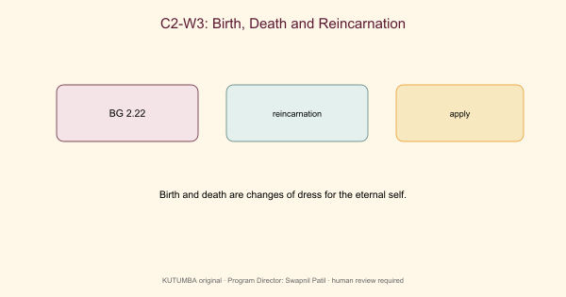
Original KUTUMBA visual: concept-diagram.png
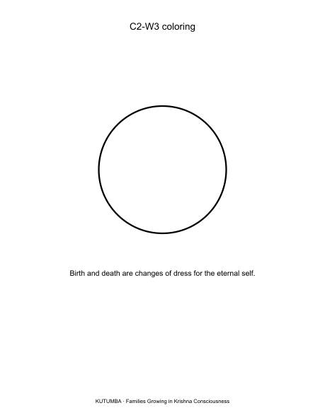
Original KUTUMBA visual: line-art-younger.png
RIGHTS NOTE | Original KUTUMBA program material. Scripture/BBT/ISKCON/third-party rights remain with their holders.

