KUTUMBA

C2-W4 MAIN FACILITATOR GUIDE
  - Families Growing in Krishna Consciousness
C2-W4
V12 • Families Growing in Krishna Consciousness
Program Director: Swapnil Patil
Internal founding-cohort teaching material — human/temple review EXTERNAL_OPEN
KUTUMBA | Families Growing in Krishna Consciousness

KUTUMBA • Families Growing in Krishna Consciousness Program Director: Swapnil Patil Week: The Three Modes of Material Nature Status: Internal founding-cohort teaching material — human/temple review EXTERNAL_OPEN Cycle: 2 — Karma, Rebirth and Material Nature Next week: C2-W5 — Māyā (BG 7.14)
◆ ◆ ◆

Two-minute summary
Material nature produces three modes—goodness (sattva), passion (rajas), and ignorance (tamas). These modes condition the eternal embodied self within the body. They mix and change; they are influences, not fixed personality labels. Families learn to notice which mode is shaping a moment, design small environmental supports for clarity, and keep bhakti—not pride—as the goal. Primary: BG 14.5 (https://vedabase.io/en/library/bg/14/5/). Lab: Clarity Before Chanting. Home: one five-minute environment reset before family chanting or reading.

Essential question
Which mode is shaping this moment?

Memory line
Material nature has three modes—goodness, passion and ignorance—that condition the eternal living being.

KUTUMBA teaching meaning (primary)
Goodness, passion, and ignorance — born of material nature — bind the eternal embodied self within the body.
(Labeled as KUTUMBA teaching meaning — not a BBT translation label.)
◆ ◆ ◆

15-minute night-before prep
- Open https://vedabase.io/en/library/bg/14/5/ and reread Devanāgarī, IAST, and the KUTUMBA teaching meaning from launch/C2-VERSE-PACK.md.
- Skim supporting URLs: BG 14.6–14.9, 14.17, 14.18, 17.8–10 (food tendencies only), and 14.26.
- Rehearse the opening script aloud once (about three minutes).
- Pack younger materials (weather-face cards, soft toss object, line-art printables) and older materials (mode-sort cards, worksheet, diagram).
- Review the hard blocks: never label a person as “a mode”; interrupt goodness-pride and food policing immediately.
- Confirm snack and water only (no weekly meal). Parents remain onsite.

60-minute deep prep
- Read this guide’s speaking script, three analogies with limits, three constructed cases, and the FAQ answers end-to-end.
- Read research/SCRIPTURAL-EXAMPLES.md for supporting verse teaching uses and limitations.
- Mark three discovery, three understanding, and three application questions you will actually ask (see lists below).
- Prepare one physical demo: three simple “evening” tableaus (calm/ordered, multi-screen rush, neglected dull) OR three weather-face cards—conditions, not people.
- Walk the room: parent circle, younger zone, older zone, reunification seating, snack table.
- Pre-write the home-practice minimum on a card: “Five-minute environment reset before chanting/reading.”
- Review deferral language: if a medical, mental-health, or budget food question arises, thank the speaker, refuse policing, and defer to personal conscience plus qualified counsel outside class.
- Confirm privacy: no public ranking of families’ “mode scores.”
◆ ◆ ◆

Exact primary and supporting readings

Primary
Field | Detail
Reference | Bhagavad-gītā 14.5
URL | https://vedabase.io/en/library/bg/14/5/
Devanāgarī | सत्त्वं रजस्तम इति गुणा: प्रकृतिसम्भवा: । निबध्नन्ति महाबाहो देहे देहिनमव्ययम् ॥ ५ ॥
IAST | sattvaṁ rajas tama iti guṇāḥ prakṛti-sambhavāḥ / nibadhnanti mahā-bāho dehe dehinam avyayam
KUTUMBA teaching meaning | Goodness, passion, and ignorance — born of material nature — bind the eternal embodied self within the body.
Rights | Sanskrit verse text from VedaBase display; KUTUMBA teaching meaning original; no full purport dump in session.

Supporting (paraphrase in session; open URL if challenged)
Reference | URL | Teaching use this week
BG 14.6 | https://vedabase.io/en/library/bg/14/6/ | Goodness illuminates and frees from sinful reactions, yet still binds by attachment to happiness and knowledge—hence the “goodness trap.”
BG 14.7 | https://vedabase.io/en/library/bg/14/7/ | Passion arises from unlimited desires and longings; binds by attachment to fruitive action—rush, craving, restless doing.
BG 14.8 | https://vedabase.io/en/library/bg/14/8/ | Ignorance covers knowledge; binds through madness, indolence, and sleep—dullness, neglect, confusion.
BG 14.9 | https://vedabase.io/en/library/bg/14/9/ | Summary binding map: goodness → happiness; passion → fruitive action; ignorance → covering knowledge / madness.
BG 14.17 | https://vedabase.io/en/library/bg/14/17/ | Results: from goodness, knowledge; from passion, greed; from ignorance, foolishness, madness, and illusion.
BG 14.18 | https://vedabase.io/en/library/bg/14/18/ | Destination tendency language (upward / middle / downward)—use for recognition, not scare tactics or ranking families.
BG 17.8–10 | https://vedabase.io/en/library/bg/17/8/ (through /17/10/) | Food *tendencies* only: freshness/clarity vs craving-heavy vs stale/impure leanings. Never police allergies, medical diets, or budgets.
BG 14.26 | https://vedabase.io/en/library/bg/14/26/ | Unfailing bhakti-yoga transcends the modes—environment supports practice; devotion, not polished sattva pride, is the crossing.

Scope boundary (verse pack): Does not teach mode-labeling as a tool to shame family members.
◆ ◆ ◆

One-page speaking map (Saturday 2:00–4:00)
Clock | Block | Facilitator focus
1:50 | Arrival | Greet; parents onsite; snack/water only; set three tableau cards
2:00 | Opening mantras | As program standard; keep calm pace
2:10 | Opening + verse | Essential question; BG 14.5 layers; memory line
2:18 | Teaching arc | Three modes; mix/change; analogies + limits
2:28 | Cases + questions | One full case aloud; two quick; discovery/understanding
2:35 | Track split | Younger K–2 / Older Grades 4–5 / Parent deepening
3:10 | Reunification | Children share one habit that helps hearing; parents one reset
3:20 | Lab bridge | Preview Clarity Before Chanting (or run abbreviated demo)
3:30 | Snack / water | No ranking talk; soft social time
3:40 | Saṅkalpa | Home minimum: five-minute reset before chanting/reading
3:50 | Project + next | Cycle contribution cue; preview C2-W5 māyā (BG 7.14)
3:55 | Close | Thank; privacy reminder; no approval claims
4:00 | End | On time

◆ ◆ ◆

Exact opening script (≈3 minutes)
Welcome. Today is C2-W4: The Three Modes of Material Nature. Our essential question is: Which mode is shaping this moment? From Bhagavad-gītā 14.5, our KUTUMBA teaching meaning is: Goodness, passion, and ignorance — born of material nature — bind the eternal embodied self within the body. We will hear together, practice in age bands, reunite, and take one small home step: a five-minute environment reset before family chanting or reading. Two promises: we describe influences and conditions, not fixed people. We do not rank families. We do not use this teaching to shame anyone’s food budget, allergy, or hard day.
◆ ◆ ◆

Core teaching script (10–20 minutes — speak, do not summarize only)

Beat 1 — Three evenings in one home (2–3 min)
Invite the room to picture the same household on three different evenings—not three different “types of people.”
- Calm/ordered evening: room reasonably clear, meal roughly on time, voices lower, a short reading feels possible.
- Rushed multi-screen evening: several devices active, plans changing, voices sharp, attention fragmented.
- Neglected dull evening: dishes linger, sleep is irregular, starting anything feels heavy, clarity feels far away.
Say clearly: “These are conditions. The people are still eternal souls. Modes shape the moment; they are not permanent name-tags.”

Beat 2 — Primary verse layers (3–4 min)
Read or display Devanāgarī and IAST briefly. State the KUTUMBA teaching meaning again. Emphasize three load-bearing words from the teaching:
- Born of material nature — the modes are prakṛti’s products, not the soul’s identity.
- Bind — they condition perception, desire, and action.
- Eternal embodied self — the living being remains avyaya (imperishable) even while conditioned in the body.
Then paraphrase BG 14.6–14.9 without purport dumps:
- Sattva (goodness): clarifying, illuminating; yet can bind through attachment to comfort and “I know / I am better.”
- Rajas (passion): restless wanting and doing; binds through attachment to results and endless projects.
- Tamas (ignorance): covering, dulling; binds through neglect, confusion, and inertia.
Use BG 14.17 in one sentence: knowledge tends to grow from goodness; greed from passion; foolishness and illusion from ignorance. Use BG 14.18 only as a recognition map of tendencies, not a threat chart for children.

Beat 3 — Mixing, change, and the essential question (2–3 min)
Modes rarely arrive as pure colors. Fatigue, media, company, time of day, and food tendencies can tilt a room within hours. Therefore the week’s practice question is always local and humble: Which mode is shaping this moment?—not “What mode are you?”
Name favorable habits for bhakti: order that serves attention, moderated stimulation, timely rest, gentle speech, and a short clear space before the holy name. Clarify: external clarity supports hearing; it is not itself pure devotion.

Beat 4 — Goodness trap and BG 14.26 (2–3 min)
Warn: a clean room plus a critical heart is still bondage. BG 14.6 already warns that goodness binds by happiness and knowledge-attachment. Connect immediately to BG 14.26: one who serves the Lord with unfailing devotion transcends the modes. Environment design is a servant of bhakti, not a scoreboard for superiority.

Beat 5 — Food note with hard boundary (1 min)
If food arises via BG 17.8–10, speak only in tendencies (fresh/clarifying vs craving-heavy vs stale/neglectful leanings). Explicitly refuse: allergy shaming, medical-diet commentary, budget judgment, and child food policing in circle.

Beat 6 — Bridge to lab and home (1–2 min)
Preview Clarity Before Chanting: five minutes—put away three items, wash hands, silence devices, sit, then chant briefly. Home minimum is the same reset once this week before family chanting or reading.
◆ ◆ ◆

Analogies with limits (≥3)

1) Three weather faces
- Value: Clear sky / windy storm / dark fog helps children and adults name calm, restless, and dull atmospheres without naming people.
- Limit: Weather is impersonal meteorology. Modes are ontological features of material nature per śāstra. Do not claim the analogy “proves” the guṇas.

2) Colored filters on a lamp
- Value: Same light (awareness) looks different through yellow, red, or dark filters—modes tint perception and response.
- Limit: Filters are chosen objects. Modes are not toys we fully control by willpower alone; bhakti (BG 14.26) is the crossing, not clever filter-swapping as a personality hack.

3) Three evenings in one home
- Value: Same family, different conditioning—supports anti-labeling.
- Limit: Do not romanticize the “calm evening” as spiritual arrival. Calm can host pride. Neglect can also hide depression or exhaustion—never diagnose; stay pastoral and practical.
◆ ◆ ◆

Scriptural / devotional examples (paraphrase only; ≥2)

Example A — Kṛṣṇa teaches Arjuna the guṇas (BG 14 context)
On the battlefield instruction setting of the Gītā, Kṛṣṇa systematically explains how the three modes born of material nature condition the embodied living being (opening at BG 14.5 and following). Teaching use: authority is śāstra dialogue, not a modern personality quiz. Limitation: do not invent dramatic dialogue beyond the verse sense; do not turn Kurukṣetra into entertainment gore for children.

Example B — Binding even in “better” conditions (BG 14.6 + 14.26 pair)
Śāstra itself warns that goodness still binds by happiness and knowledge-attachment, then points to unfailing devotion as the way that transcends the modes. Teaching use: block superiority. Limitation: do not claim any Kutumba family has “transcended”; claim only the principle and a small practice step.
◆ ◆ ◆

Three constructed family cases

Case 1 — Rushed multi-screen evening
- Concrete situation: After dinner, two screens play different videos, a parent answers work messages, a child starts homework then stops to watch, voices rise over “five more minutes,” and planned reading never begins.
- Mistaken conclusion: “We’re just a passionate family—that’s our personality.”
- Principle: Passion-like restlessness binds through attachment to stimulation and unfinished craving (BG 14.7; 14.9); modes shape the moment, not a fixed family identity (BG 14.5).
- Source: BG 14.5; BG 14.7; BG 14.9 — https://vedabase.io/en/library/bg/14/5/
- Compassionate response: “The room is loud and split. Let’s name the condition, not blame one person.”
- Action: Five-minute Clarity Before Chanting reset: devices silent, three items away, seats set, three minutes response chanting.
- What not to say: “You’re so rajasic.” “Real devotees never use phones.”
- Optional age adaptation: Younger—hold up the “windy” weather face and practice freeze-and-soft-voice. Older—write one remove / one add for the evening.

Case 2 — Neglected dull evening
- Concrete situation: Dishes from yesterday remain, laundry sits in the doorway, everyone overslept feelings, and the family says “we’re too tired for anything” while scrolling without choosing rest or practice.
- Mistaken conclusion: “Someone in this house is tamas—especially that teenager.”
- Principle: Ignorance-like covering shows as neglect, inertia, and unclear starts (BG 14.8; 14.17); still describe conditions, not persons (verse-pack scope boundary).
- Source: BG 14.5; BG 14.8; BG 14.17 — https://vedabase.io/en/library/bg/14/8/
- Compassionate response: “Dullness is heavy. We can change one square meter and one decision.”
- Action: Ten-minute micro-reset of one surface + lights on + water + sit for one verse memory line; sleep plan deferred to parents privately if needed.
- What not to say: “You’re lazy/tamasic.” Public diagnosis of depression or character attack.
- Optional age adaptation: Younger—tidy three toys into a basket as a game. Older—identify one “covering” cue (dark room, no start time) and one clarifying cue.

Case 3 — Clean calm evening used to judge others
- Concrete situation: The home is tidy, incense is lit, chanting happened on time. A parent then comments that another Kutumba family “must be in ignorance” because their house looked messy at pickup, or critiques a child’s school lunch as “tamasic.”
- Mistaken conclusion: “Our sattva means we are spiritually ahead.”
- Principle: Goodness still binds by happiness and knowledge-pride (BG 14.6); transcending the modes is linked to unfailing devotion, not interior-design victory (BG 14.26). Food talk stays at tendency level without policing (BG 17.8–10 carefully).
- Source: BG 14.6; BG 14.26; BG 17.8 — https://vedabase.io/en/library/bg/14/26/
- Compassionate response: “Clarity is a gift for hearing—gratitude, not ranking.”
- Action: Replace judgment sentence with one service sentence; keep home reset private; if food anxiety appears, stop circle commentary.
- What not to say: “They’re a tamasic family.” “That lunch is sinful.” Allergy or budget shame.
- Optional age adaptation: Younger—practice saying “calm helps me hear” without naming classmates. Older—write how BG 14.26 redirects pride to bhakti.
◆ ◆ ◆

Discovery questions (3)
- What three modes does BG 14.5 name, and what does it say they do to the embodied self?
- In your own words, what is one tendency of sattva, one of rajas, and one of tamas from BG 14.6–14.9 / 14.17?
- What is the difference between describing a room’s condition and labeling a person?

Understanding questions (3)
- Why can the mode of goodness still bind, according to the sense of BG 14.6?
- How do mixing and change prevent fixed family labels?
- How does BG 14.26 reframe “becoming more sattvic” as a bhakti goal rather than a pride project?

Application questions (3)
- Which input most agitates your evenings right now (screens, haste, unresolved conflict, other)—without naming a person as a mode?
- Which neglected condition most covers your family’s clarity?
- What will you remove, add, move earlier, or simplify for one five-minute Clarity Before Chanting reset this week?
◆ ◆ ◆

Five likely questions with source-based answers
Q1: Are the modes scientifically proven? A: The guṇas as ontological features of material nature are taught by śāstra (BG 14.5ff). Empirical studies may describe attention, stress, and interruption costs in modern environments, but they do not prove or disprove the metaphysical guṇas. Keep doctrine on scripture; keep science in the helper lane for habits only.
Q2: Can I tell my spouse/child “you’re in tamas”? A: No. The verse pack boundary forbids mode-labeling as shame. Describe a condition (“the room is chaotic; let’s reset”) and choose an elevating action. BG 14.5 addresses binding influences on the embodied self—not a license for domestic ranking.
Q3: If we clean up and eat “sattvic,” are we liberated? A: No. BG 14.6 warns goodness still binds; BG 14.26 points to unfailing devotion as transcending the modes. Clean order serves hearing; it is not the destination.
Q4: How should we use BG 17.8–10 on foods? A: Only as general tendency language. Never police allergies, medical needs, or budgets in class or at home under “mode” language. Compassion outranks commentary.
Q5: What do we do with BG 14.18’s upward/middle/downward language around children? A: Recognition only, calmly. Do not scare children with destiny charts. Keep child pedagogy on habits that help hearing and kindness.
◆ ◆ ◆

Common misconceptions
- Modes are fixed personality types or Enneagram-like identity labels.
- Calling someone a mode is “honest spiritual feedback.”
- Sattva equals pure devotion / liberation.
- Messy house = bad devotee; tidy house = advanced devotee.
- Food rules override medical, allergy, or economic reality.
- Noticing modes means gossiping about other families’ “levels.”
- Environmental tips replace surrender and chanting (imports C2-W5 poorly as technique-only).

No-speculation boundaries
- Do not invent psychological diagnoses from guṇa language.
- Do not claim science proves ātman, karma, or the guṇas.
- Do not dump full purports; paraphrase teaching sense.
- Do not import full māyā ontology from C2-W5 beyond a one-line preview.
- Do not fabricate human, temple, or publication approval for these materials.
- Do not attribute KUTUMBA teaching meanings as BBT translations.
◆ ◆ ◆

Track transitions
At 2:35: “Parents deepen cases and evening redesign here. Younger friends: weather faces and room-reset game with your teacher. Older students: verse observation, mode-sort, and scenario cards. We reunite at 3:10.”
Younger handoff cue: Memory phrase — “Calm helps me hear Kṛṣṇa.” Block labeling friends.
Older handoff cue: Essential question on the board; open BG 14.5 URL; worksheet + answer key with teacher.
Parent deepening (while tracks run): Walk Case 3 (goodness pride) carefully; design one remove/add/move earlier/simplify plan; rehearse anti-shame sentence.

Family synthesis (≈3:10)
Ask for three short shares only:
- Child: one habit that helps hearing.
- Parent: one five-minute reset they will try.
- Facilitator: restate BG 14.26 bridge—bhakti transcends; clarity serves.
Close synthesis: “Influences change. Souls are eternal. We practice clarity for chanting, not superiority.”
◆ ◆ ◆

Bhakti laboratory — Clarity Before Chanting
- Show contrast: cluttered noisy setup vs simple clear setup (30–60 seconds).
- Families (or demo family) do a five-minute reset: put away items, wash hands, silence devices, arrange seating.
- Lead about three minutes of attentive mahā-mantra response chanting.
- Reflect: which physical changes altered attention?
- Clarify: external goodness supports bhakti; it is not itself pure devotion (BG 14.6 + 14.26).
Competency check: Participant can name three modes + one tendency each, and can analyze a condition without labeling a person.
◆ ◆ ◆

Project contribution
Point to project/CYCLE-CONTRIBUTION.md and project/MODULE-PROJECT-BRIEF.md. This week’s artifact idea: a simple “evening redesign” card (remove / add / move earlier / simplify) suitable for Cycle 2 integration night—no family ranking metrics.

Home practice
Level | Practice
**Minimum** | Complete one five-minute environment reset before family chanting or reading.
**Standard** | Redesign one evening using remove, add, move earlier, and simplify.
**Stretch** | For three evenings, privately note clarity 1–5 before/after reset—no public scores.

Next week preview
C2-W5 — Māyā: Decorating the Prison Cell — primary BG 7.14 (https://vedabase.io/en/library/bg/7/14/). One-line bridge: after learning how modes bind, we meet māyā as the hard-to-cross covering—and surrender to the Lord as the way beyond. Do not teach full W5 content tonight.
◆ ◆ ◆

Saturday materials checklist
- Verse card: BG 14.5 Devanāgarī / IAST / KUTUMBA teaching meaning
- Three evening tableau cards or weather-face cards
- Optional colored cellophane/filters and a small lamp (safe, teacher-held)
- Younger: line-art printable, crayons, soft toss object, craft cards
- Older: mode-sort cards, worksheets, answer key, concept diagram
- Home-practice cards (minimum version)
- Snack/water supplies; allergy awareness without food-theology policing
- Timer for track split and on-time close

Do not claim
Human/temple/publication approval; BBT ownership of KUTUMBA teaching meanings; science proving guṇas/ātman; that any family has transcended the modes; that tidy homes equal advancement.
◆ ◆ ◆

Facilitator closing line
Modes change. The soul remains. Tonight we ask, “Which mode is shaping this moment?”—then we reset a little space so the holy name can be heard with less noise and less pride.

Instructional visuals
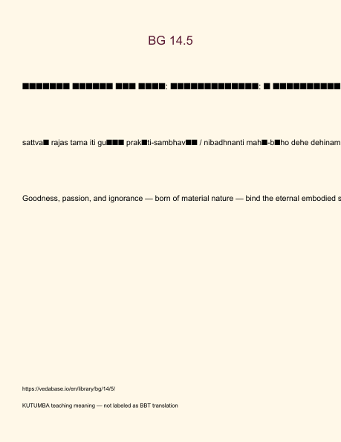
Original KUTUMBA visual: verse-card.png
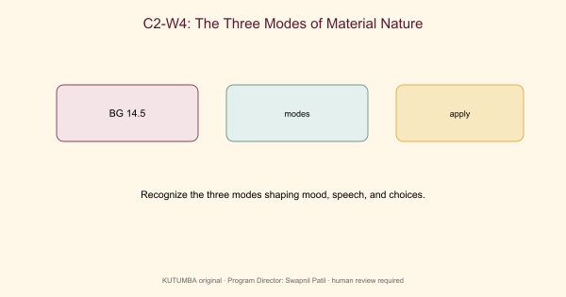
Original KUTUMBA visual: concept-diagram.png
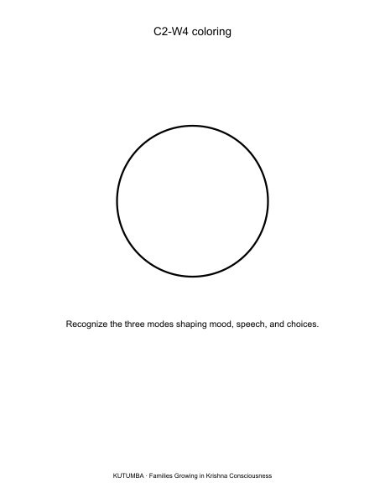
Original KUTUMBA visual: line-art-younger.png
RIGHTS NOTE | Original KUTUMBA program material. Scripture/BBT/ISKCON/third-party rights remain with their holders.

