KUTUMBA

C2-W4 OLDER TEACHER GUIDE
  - Families Growing in Krishna Consciousness
C2-W4
V12 • Families Growing in Krishna Consciousness
Program Director: Swapnil Patil
Internal founding-cohort teaching material — human/temple review EXTERNAL_OPEN
KUTUMBA | Families Growing in Krishna Consciousness

Track length: ~40 minutes (Saturday 2:35–3:10) Essential question: Which mode is shaping this moment? Primary: BG 14.5 — https://vedabase.io/en/library/bg/14/5/ Conclusion students should state: Modes are changing influences that bind the embodied self; we describe conditions, not people; clarity serves bhakti, not pride.
◆ ◆ ◆

Objective
Students will (1) observe BG 14.5 on VedaBase and paraphrase the KUTUMBA teaching meaning, (2) sort scenario cards into sattva/rajas/tamas tendencies without labeling persons, (3) complete a diagram and worksheet, and (4) write one reunification sentence plus a project contribution idea.

Teacher background
- Teaching meaning: Goodness, passion, and ignorance — born of material nature — bind the eternal embodied self within the body.
- Supports: BG 14.6–14.9 (tendencies + goodness trap), 14.17 (fruits), 14.26 (bhakti transcends), 17.8–10 only as non-policing food-tendency footnote if asked.
- Misconception to interrupt immediately: using modes to shame siblings/classmates/other families.

Materials
- Devices or printed screenshot of https://vedabase.io/en/library/bg/14/5/ (teacher-controlled)
- activities/OLDER-ACTIVITY-PACK.md printables / mode-sort cards
- activities/OLDER-ANSWER-KEY.md (teacher only)
- Concept diagram (visuals/V12/concept-diagram.svg or board copy)
- Pencils; timer; scenario card deck (6 cards minimum)
◆ ◆ ◆

Minute-by-minute

0–5 — Hook
Show three evening captions (calm ordered / multi-screen rush / neglected dull). Ask: “Same family—what changed?” Collect condition words only. Post essential question.

5–12 — Primary text observation
Students open or view BG 14.5 and complete four lines in notebooks:
- Setting: Kṛṣṇa teaching Arjuna in the Gītā (Chapter 14).
- Key Sanskrit/IAST phrase they notice (e.g., guṇāḥ prakṛti-sambhavāḥ or nibadhnanti).
- Paraphrase (KUTUMBA teaching meaning): Goodness, passion, and ignorance — born of material nature — bind the eternal embodied self within the body.
- **What it does not say:** That we should nickname people as modes.
Teacher checks paraphrases against answer key; corrects invented verse numbers.

12–18 — Worksheet questions (from activity pack)
Students answer:
- One tendency of each mode (from BG 14.6–9 / 14.17 sense).
- Why goodness can still bind (BG 14.6).
- How BG 14.26 redirects pride.

18–26 — Scenario cards + mode_sort puzzle
In pairs, sort six short scenarios into three columns: clarifying / restless-craving / dull-covering. Rule card on table: “Sort the situation, not the person.” Teacher circulates; flips any “Rahul is tamas” talk back to condition language. One group shares a sort aloud; class may challenge kindly with evidence from tendencies.

26–32 — Diagram task
On the concept diagram, label:
- Three modes
- “Bind the embodied self”
- Arrow to “bhakti transcends (BG 14.26)”
- Red “X” on “label people”

32–36 — Project contribution + reflection
- Write one evening redesign: remove / add / move earlier / simplify.
- Reflection sentence: “An analogy helps me picture modes, but scripture is the authority because…”
- Extension (fast finishers): How would food-tendency talk stay kind under BG 17.8–10 without policing allergies/budgets?

36–40 — Reunification sentence + cleanup
Each student drafts one sentence to share upstairs, e.g.: “Modes change; we reset the room so we can hear, without calling people names.” Stack materials; teacher keeps answer key private.

Answer key pointer
Use activities/OLDER-ANSWER-KEY.md for paraphrase targets and reject lists. Do not distribute the key to students.

Behavior / speech ethics
- Interrupt mode-labeling of peers in one calm sentence.
- No confession pressure about home mess.
- Privacy: no ranking families’ “scores.”

Backup if tech fails
Teacher reads IAST aloud from verse card; students write paraphrase from dictation; card sort continues offline.

Instructional visuals
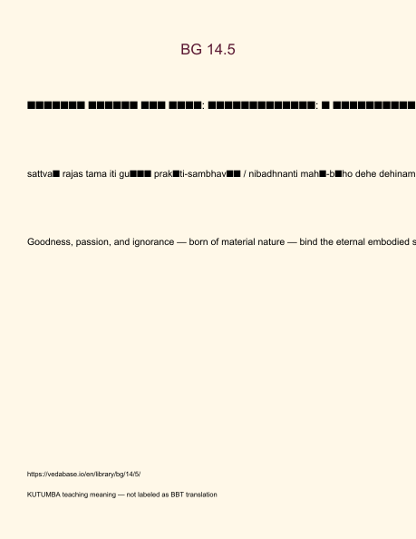
Original KUTUMBA visual: verse-card.png
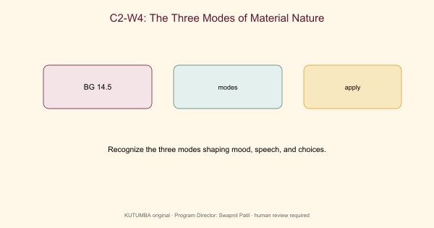
Original KUTUMBA visual: concept-diagram.png
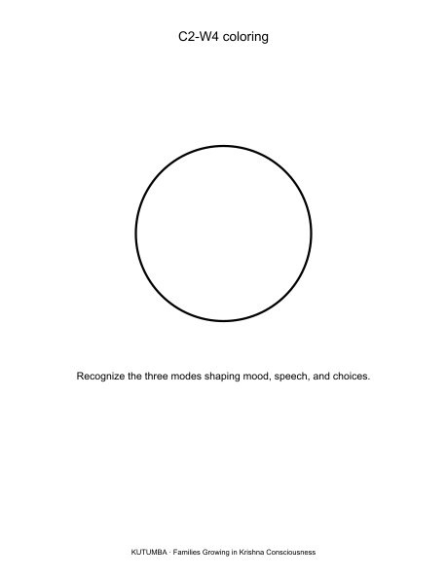
Original KUTUMBA visual: line-art-younger.png
RIGHTS NOTE | Original KUTUMBA program material. Scripture/BBT/ISKCON/third-party rights remain with their holders.

