KUTUMBA

C2-W4 YOUNGER TEACHER GUIDE
  - Families Growing in Krishna Consciousness
C2-W4
V12 • Families Growing in Krishna Consciousness
Program Director: Swapnil Patil
Internal founding-cohort teaching material — human/temple review EXTERNAL_OPEN
KUTUMBA | Families Growing in Krishna Consciousness

Track length: ~40 minutes (within Saturday 2:35–3:10 window) Theme: Modes are like weather in a room—changing influences that help or hinder hearing. Primary: BG 14.5 — https://vedabase.io/en/library/bg/14/5/ Hard block: Never call a child “sattva / rajas / tamas.” Describe the room or the choice.
◆ ◆ ◆

Objective
By the end of the track, each child can (1) name three simple “weather” feelings—clear, windy, foggy—as room helpers/hinderers, (2) join a five-step room-reset game, and (3) say the memory phrase without labeling friends.

Exact memory phrase
Calm helps me hear Kṛṣṇa.
(Adult memory line differs; children use this actionable phrase.)

Teacher background (2 minutes private prep)
- BG 14.5 teaches that goodness, passion, and ignorance—born of material nature—bind the eternal embodied self in the body.
- For K–2, translate to: rooms and habits can feel clear, rushed, or sleepy-confused; we practice habits that help us hear the holy name.
- Block: mode-shaming, food policing, and comparing families.
- Story must paraphrase only; no invented Kṛṣṇa–child dialogue; no scary destiny talk from BG 14.18.

Materials
- Three weather-face cards (clear sun, windy cloud, fog)
- Soft toss object (beanbag)
- Basket for “tidy three”
- Printed visuals/V12/line-art-younger.svg (US Letter) + crayons
- Take-home card stock (memory phrase inside)
- Optional: teacher-held colored cellophane scrap (no small choking pieces unsupervised)
- Timer; tissues; water
◆ ◆ ◆

Minute-by-minute run of show

0–5 — Opening / recall
- Circle sit; feet on floor.
- Ask: “Who remembers last week’s kind habit?” (one or two shares).
- Show three weather faces. Children echo: clear / windy / foggy.
- Say: “Today we learn that rooms can feel different—and we can help our room get ready to hear Kṛṣṇa.”

5–13 — Story script (paraphrase; ~5–8 minutes spoken)
Title: Three Weather Days in One House
Teacher narrates (no invented deity dialogue):
In one house lived a family who loved to chant Kṛṣṇa’s names. On a clear day, toys found their basket, voices were soft, and sitting for a short chant felt easy. On a windy day, screens talked loudly, everyone hurried, and ears felt too busy to listen. On a foggy day, the floor stayed messy, bodies felt heavy, and starting anything seemed hard. The same children lived in that house on all three days. The weather of the room changed. A helper adult said: “We don’t call people weather words. We change three things, wash hands, and try a short chant.” They put three toys away, lowered the noise, sat, and softly answered the holy name. Hearing felt clearer. Remember: calm helps us hear Kṛṣṇa—and we speak kindly about others.
Pause once mid-story for children to hold up which weather face they hear.

13–16 — Three wonder questions
- What was new in the story about clear, windy, and foggy days?
- Whom can we serve when the room feels windy or foggy?
- When can our family practice five quiet minutes before chanting?
Accept short answers; redirect labels (“My brother is fog”) to “The room feels foggy—what can we tidy?”

16–24 — Movement game: Room-Reset Relay (steps)
- Place three soft “mess” items in the center.
- On “Clear sky,” children freeze in a calm seated pose.
- On “Windy,” children do ten quiet tip-toe steps in place (no crashing).
- On “Foggy,” children move slowly to pick one item into the basket (teacher models gentle pace).
- Repeat two rounds; end with whole group seated, hands washed or wiped, soft echo of memory phrase.
- Teacher states: “We changed the room. We did not call anyone a weather name.”

24–32 — Craft / printable task (steps)
- Give each child the younger line-art page.
- Children color three zones lightly: sunny edge, wind lines, soft fog dots—or simply color the calm listening scene if the SVG is a single scene.
- Fold card stock; child (or teacher scribe) writes/copies: Calm helps me hear Kṛṣṇa.
- On the back, draw one tidy basket or one quiet device.
- If time: pass soft object; each child says one kind word, then the memory phrase.

32–35 — Verse / recall
- Teacher holds verse card and says slowly: “Śāstra teaches there are three modes—like helpers and hinderers in nature. We practice calm so we can hear.”
- Children repeat memory phrase twice.
- Optional echo of shortened adult idea: “Modes change. We can choose helpful habits.”

35–40 — Cleanup and parent handoff
- Crayons away; papers named; floor check.
- Behavior redirects if needed: feet on floor · kind words · toy rests · quiet reset corner (30 seconds), then rejoin.
- Parent handoff script:
Today’s phrase: “Calm helps me hear Kṛṣṇa.” Home cue: before chanting, tidy three things and silence devices for five minutes. Please don’t call children mode names.

Behavior redirects
Signal | Redirect
Rough bodies | “Feet on floor; hands soft.”
Name-calling with weather/mode words | “We name the room, not the friend.”
Food shaming at snack talk | “We don’t police food here.”
Overwhelm | Quiet reset: sit with teacher, three breaths, rejoin.

Backup (if craft fails / time collapses)
Pass soft object around the circle. Each child: (1) one kind word, (2) echo memory phrase. End with three-item tidy of the teaching rug.

What success looks like
- Children can point to clear/windy/foggy without labeling peers.
- Most children join tidy-three and seated chant echo.
- No child is publicly ranked.

Instructional visuals
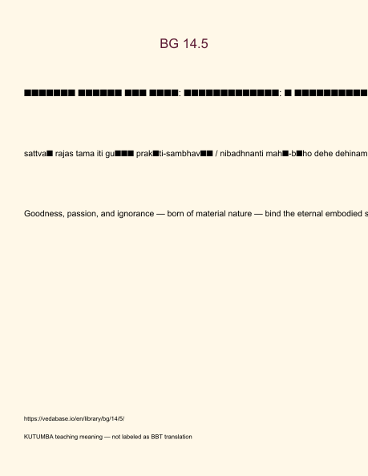
Original KUTUMBA visual: verse-card.png
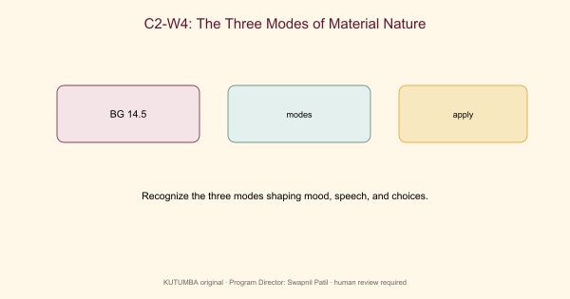
Original KUTUMBA visual: concept-diagram.png
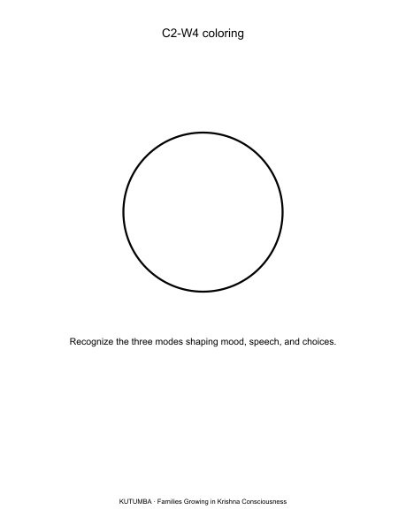
Original KUTUMBA visual: line-art-younger.png
RIGHTS NOTE | Original KUTUMBA program material. Scripture/BBT/ISKCON/third-party rights remain with their holders.

