KUTUMBA

C2-W5 MAIN FACILITATOR GUIDE
  - Families Growing in Krishna Consciousness
C2-W5
V12 • Families Growing in Krishna Consciousness
Program Director: Swapnil Patil
Internal founding-cohort teaching material — human/temple review EXTERNAL_OPEN
KUTUMBA | Families Growing in Krishna Consciousness

KUTUMBA · Families Growing in Krishna Consciousness Program Director: Swapnil Patil Week: Māyā: Decorating the Prison Cell Status: Internal founding-cohort teaching material — human/temple review EXTERNAL_OPEN Primary scripture: BG 7.14 — https://vedabase.io/en/library/bg/7/14/
◆ ◆ ◆

Two-minute summary
Māyā made of the modes is hard to overcome by private cleverness. BG 7.14 teaches that those who surrender to the Lord cross beyond it. This week names the habit of decorating bondage with nicer comforts while postponing seeking Kṛṣṇa. Block: comfort upgrades = spiritual progress.

Essential question
Where am I decorating the prison instead of seeking freedom?

Memory line
Do not decorate the prison — seek the Lord.

KUTUMBA teaching meaning (primary)
KUTUMBA teaching meaning: This divine illusory energy made of the modes is hard to overcome — but those who surrender to the Lord cross beyond it.
Label this as KUTUMBA teaching meaning. Do not label it as a BBT translation. No full purport dumps.
◆ ◆ ◆

15-minute night-before prep
- Open https://vedabase.io/en/library/bg/7/14/ and reread IAST + KUTUMBA teaching meaning.
- Rehearse opening script aloud once.
- Pack younger + older materials listed in age-band guides.
- Review misconception to block: Comfort upgrades equal spiritual progress.
- Confirm snack/water only (no weekly meal); parents onsite.
- Write home-practice minimum on a card: Once this week: before one comfort upgrade or treat, pause and offer a short remembrance of Kṛṣṇa.

60-minute deep prep
- Read this guide’s analogies, scriptural examples, and three cases so you can teach them inline.
- Open each supporting URL once; note teaching use and limitation.
- Mark one discovery, one understanding, and one application question you will ask.
- Walk parent / younger / older / reunification zones.
- Review privacy: no forced confession; no ranking; no public sādhana scoring.
- Confirm project contribution card and next-week title only: C2-W6 Integration Night: Choice, Consequence, and the Modes.
◆ ◆ ◆

Exact primary readings
- Primary: BG 7.14 — https://vedabase.io/en/library/bg/7/14/
- IAST: daivī hy eṣā guṇa-mayī mama māyā duratyayā / mām eva ye prapadyante māyām etāṁ taranti te
- KUTUMBA teaching meaning: This divine illusory energy made of the modes is hard to overcome — but those who surrender to the Lord cross beyond it.
- Rights: Sanskrit from VedaBase display; KUTUMBA teaching meaning original; teaching meaning ≠ BBT translation label.

Exact supporting readings (classroom paraphrase only)
Reference | URL | Teaching paraphrase (facilitator may say) | Limitation
BG 7.13 | https://vedabase.io/en/library/bg/7/13/ | Deluded by the three modes, the world does not know the Lord who is above them. | Do not mock people; keep compassion.
BG 7.15 | https://vedabase.io/en/library/bg/7/15/ | Those whose knowledge is stolen by māyā do not surrender. | Do not label children demoniac.
BG 15.7 | https://vedabase.io/en/library/bg/15/7/ | The living being is an eternal fragment of the Lord struggling with the senses. | Struggle language must stay kind.

◆ ◆ ◆

One-page speaking map (Saturday 2:00–4:00)
- 2:00 Welcome / mantras / purpose
- 2:10 Memory line + essential question
- Primary verse layer (IAST + KUTUMBA teaching meaning)
- Core explanation
- One analogy with limit spoken aloud
- One scriptural example paraphrase
- One constructed case
- 2:30 Track split
- 3:10 Reunification synthesis
- 3:30 Snack/water only — no weekly meal
- 3:40 Saṅkalpa / project / home practice
- 3:55 Next-week title only + close by 4:00
◆ ◆ ◆

Exact opening script (≈3 minutes)
Welcome. Today is C2-W5: Māyā: Decorating the Prison Cell. Our essential question is: Where am I decorating the prison instead of seeking freedom? From BG 7.14, our KUTUMBA teaching meaning is: This divine illusory energy made of the modes is hard to overcome — but those who surrender to the Lord cross beyond it. We will hear together, practice in age bands, reunite, and take one small home step. We do not rank families or children. Parents remain onsite. Snack and water only — no weekly meal.

Extended 10–20 minute speaking SCRIPT
[0–3 min — Hook] Many homes get better at making temporary life prettier: better screens, better snacks, better schedules. Those can be useful. The danger is believing polish equals freedom. A painted prison cell is still a cell.
[3–7 min — Verse layer] Read IAST briefly. State the full KUTUMBA teaching meaning. Pause.
[7–12 min — Core + support] State BG 7.14 fully. Add BG 7.13 in one sentence: mode-delusion hides the Lord who is above the modes. Keep compassion: we are not mocking comfort; we are refusing to confuse comfort with liberation.
[12–16 min — Analogy + limit] Teach one analogy below and state its limit out loud.
[16–18 min — Case] Read Constructed Case 1 once. Ask for the mistaken conclusion and one compassionate next step.
[18–20 min — Transition] Preview age-band labs. At ~2:28 give track transition. Reunite at 3:10.
◆ ◆ ◆

Core explanation (facilitator must say)
We can improve a cage without leaving it. Māyā is not merely ‘bad stuff’; it includes the bewildering energy that keeps the living being busy polishing temporary arrangements while forgetting the Lord. BG 7.14 is honest: crossing is hard — and possible for those who surrender to Kṛṣṇa. Tonight we look for one place we decorate the prison, then choose one seeking act.
Conclusion line: Seek the Lord; do not only decorate the cell.
Common error to block: Comfort upgrades equal spiritual progress.
◆ ◆ ◆

Analogies / examples with limits (teach inline)

1) Prison cell paint
- Say: Painting a cell prettier does not open the door.
- Limit: Do not shame ordinary comforts; pedagogy only.

2) Wallpaper vs battery
- Say: A beautiful phone wallpaper does not charge a dead battery.
- Limit: Tech analogy ≠ śāstra.

3) Costume crown
- Say: A costume crown can feel royal while dependence remains.
- Limit: Do not mock celebrations or dress.
◆ ◆ ◆

Scriptural / devotional examples (paraphrase only)

Example A — Modes hide the Lord (BG 7.13)
Paraphrase: bewildered by modes, people do not know the Lord above them. Teaching use: decorating can be mode-busy-ness. Limit: no mockery.

Example B — Crossing by surrender (BG 7.14)
Primary: hard to overcome; those who surrender cross. Teaching use: honest difficulty + hope. Limit: no invented surrender stories.
◆ ◆ ◆

Three constructed household cases (inline)

Constructed household case 1 — Upgrade spiral
- Situation: A family upgrades gadgets and treats whenever stress rises; spiritual practice waits until life feels nicer.
- Mistaken conclusion: Nicer life automatically means freer life.
- Principle / source: BG 7.14 — māyā is hard; surrender crosses (https://vedabase.io/en/library/bg/7/14/)
- Compassionate response: Name the comfort without shame; ask what seeking the Lord looks like in one small act.
- Action: One comfort pause + short remembrance before a treat.
- What not to say: Materialistic family / bad devotees.

Constructed household case 2 — Prestige first
- Situation: A teen treats school image as the real path; Kṛṣṇa talk can wait.
- Mistaken conclusion: Worldly polish equals crossing māyā.
- Principle / source: BG 7.14; BG 7.13 (https://vedabase.io/en/library/bg/7/14/)
- Compassionate response: Affirm education duty; separate duty from identity-as-image.
- Action: Replace one prestige scroll with memory line once.
- What not to say: School is māyā so quit trying.

Constructed household case 3 — Spiritualized neglect
- Situation: A parent uses māyā-talk to avoid needed repair and kindness at home.
- Mistaken conclusion: Talk about māyā excuses neglect of duty.
- Principle / source: Surrender includes responsible action (https://vedabase.io/en/library/bg/7/14/)
- Compassionate response: Separate prison-decorating from honest duty offered to Kṛṣṇa.
- Action: One duty act + one remembrance.
- What not to say: Using ‘you are in māyā’ as an insult.
◆ ◆ ◆

Discovery questions
- Where do we polish temporary arrangements?
- What does ‘hard to overcome’ protect us from?
- What does surrender look like in a small home act?

Understanding questions
- What does BG 7.14 say is hard?
- Who crosses māyā according to the verse?
- How is decorating different from duty?

Application questions
- Name one decorating habit to pause this week.
- Name one seeking act to add.
- How will we speak without shaming?
◆ ◆ ◆

Five likely questions and source-based answers
- Q: Is comfort sinful?
A: No. The issue is mistaking polish for liberation. Duty and kindness remain.
- Q: Does this condemn nice homes?
A: No. Hosts should keep spaces clean. We refuse the story that upgrades equal freedom.
- Q: What is surrender here?
A: Turning to Kṛṣṇa with humility and practice — not dramatic self-hate.
- Q: Can kids understand māyā?
A: Use prison/door language; avoid fear.
- Q: Is this anti-ambition?
A: No. Ambition without seeking can decorate bondage; duty can be offered to Kṛṣṇa.
◆ ◆ ◆

Misconceptions and no-speculation boundaries
- Block: Comfort upgrades equal spiritual progress.
- Do not invent dialogue for scriptural persons.
- Do not diagnose private karma in the room.
- Do not claim temple/BBT/human approval that has not been given.
- Defer off-scope ontology to the named next week: C2-W6 Integration Night: Choice, Consequence, and the Modes.
◆ ◆ ◆

Track transitions
2:30: “Younger friends with [teacher]; older learners with [teacher]; parents may observe or assist as assigned. We reunite at 3:10.” 3:10 synthesis prompt: “In one sentence, what did your track learn about: Where am I decorating the prison instead of seeking freedom?”

Family synthesis / project / home practice
- Project: one family artifact answering the essential question (see project/CYCLE-CONTRIBUTION.md).
- Home practice minimum: Once this week: before one comfort upgrade or treat, pause and offer a short remembrance of Kṛṣṇa.
- Success = minimum version completed once.

Next week
Title only: C2-W6 Integration Night: Choice, Consequence, and the Modes. Do not teach its full ontology tonight.

Close
Appreciate effort; leave host spaces cleaner; end by 4:00.
◆ ◆ ◆

Exact Saturday time cues (locked)
- 1:50 Arrival / calm setup / materials check
- 2:00 Opening mantras (invitation only) + welcome
- 2:10–2:28 Shared teaching from this guide (script above)
- 2:30–3:10 Age-band tracks
- 3:10–3:25 Reunification synthesis (one sentence per track/family)
- 3:25–3:35 Soft shared practice / bhakti lab as appropriate
- 3:35–3:45 Snack + water only (no weekly meal)
- 3:45–3:55 Saṅkalpa, project contribution, home-practice card
- 3:55–4:00 Next-week title only; appreciate; close on time

Materials / room / snack checklist
- Printed verse card / concept diagram PNG if available
- Younger craft + movement materials
- Older worksheets + scenario cards
- Blank saṅkalpa cards
- Water + simple snack only
- Teacher-only answer keys kept separate
- Leave host home cleaner than found

Privacy and public-repo boundaries
- No public scoring of private sādhana
- No forced confessions
- Blank covenant acknowledgement only in print packets
- Do not commit private family data to the repository

Source hierarchy reminder
- Primary verse URL for this week
- Supporting śāstra listed above
- This controlling facilitator guide
- Research files for prep enrichment — core teaching stays inline here
- Defer initiation / temple policy / legal approvals as EXTERNAL_OPEN

Facilitator self-check before opening
- [ ] I can state the KUTUMBA teaching meaning without notes
- [ ] I can name the misconception to block
- [ ] I have one analogy + limit ready
- [ ] I have one case ready
- [ ] Snack/water plan confirmed (no meal)
- [ ] Parents onsite plan confirmed

Instructional visuals
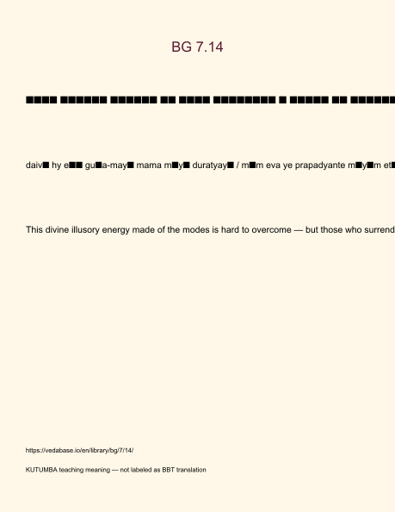
Original KUTUMBA visual: verse-card.png
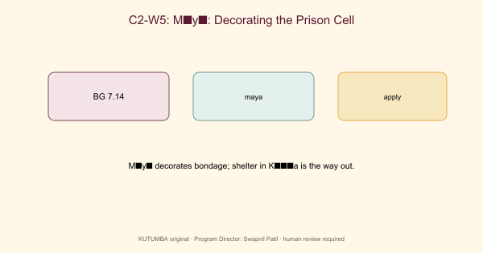
Original KUTUMBA visual: concept-diagram.png

Original KUTUMBA visual: line-art-younger.png
RIGHTS NOTE | Original KUTUMBA program material. Scripture/BBT/ISKCON/third-party rights remain with their holders.

