KUTUMBA

C2-W5 OLDER TEACHER GUIDE
  - Families Growing in Krishna Consciousness
C2-W5
V12 • Families Growing in Krishna Consciousness
Program Director: Swapnil Patil
Internal founding-cohort teaching material — human/temple review EXTERNAL_OPEN
KUTUMBA | Families Growing in Krishna Consciousness

Week: Māyā: Decorating the Prison Cell Primary: BG 7.14 — https://vedabase.io/en/library/bg/7/14/ Track window: ~2:30–3:10 then reunite Status: Internal founding-cohort teaching material — human/temple review EXTERNAL_OPEN

Objective
Students observe the primary text layer, complete a worksheet and scenario set, and contribute one project sentence answering: Where am I decorating the prison instead of seeking freedom?

Primary text observation
- Read IAST aloud once: daivī hy eṣā guṇa-mayī mama māyā duratyayā / mām eva ye prapadyante māyām etāṁ taranti te
- Students underline two words that seem important.
- State KUTUMBA teaching meaning in full: This divine illusory energy made of the modes is hard to overcome — but those who surrender to the Lord cross beyond it.
- Label clearly: KUTUMBA teaching meaning — not BBT translation.

Worksheet questions
- In your words, what does BG 7.14 teach this week?
- What mistaken idea does this week block? (Comfort upgrades equal spiritual progress.)
- Name one home situation where this teaching changes a next step.
- What is still confusing? (honest question OK)

Scenario cards (read–choose–explain)
- Stress → buy/upgrade treat immediately. 2) Image management online replaces evening remembrance. 3) Spiritual talk used to avoid chores. For each: name decorating vs seeking.

Puzzle / game — Cell vs Key match
Match cards: painted walls / new gadget / status post → ‘decorating’; prayer / verse / humble ask for help → ‘seeking’. Discuss one mismatch temptation.

Diagram task
Sketch a simple map of this week's idea using boxes/arrows. Label scripture vs analogy if both appear.

Project contribution
Add one sentence to the cycle project answering the essential question. Keep ≤5 minutes.

Reflection
Write: “This week I will practice ___ when ___.”

Extension (optional)
Compare one supporting reference from the facilitator guide with the primary — what does it add, and what limit remains?

Answer key pointer
Use activities/OLDER-ANSWER-KEY.md (teacher-only). Do not distribute keys to students during work time.

Instructional visuals
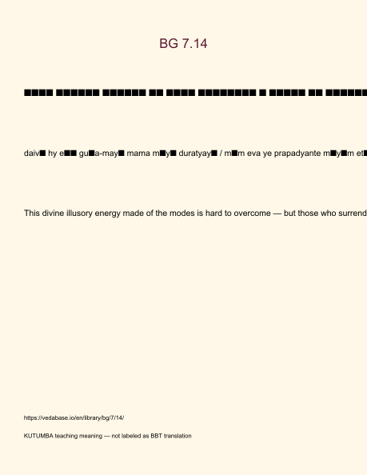
Original KUTUMBA visual: verse-card.png
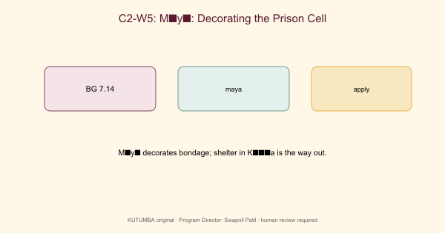
Original KUTUMBA visual: concept-diagram.png
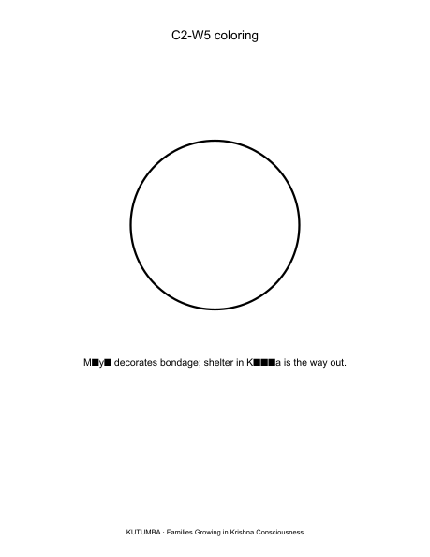
Original KUTUMBA visual: line-art-younger.png
RIGHTS NOTE | Original KUTUMBA program material. Scripture/BBT/ISKCON/third-party rights remain with their holders.

