KUTUMBA

C2-W5 YOUNGER TEACHER GUIDE
  - Families Growing in Krishna Consciousness
C2-W5
V12 • Families Growing in Krishna Consciousness
Program Director: Swapnil Patil
Internal founding-cohort teaching material — human/temple review EXTERNAL_OPEN
KUTUMBA | Families Growing in Krishna Consciousness

Week: Māyā: Decorating the Prison Cell Primary: BG 7.14 — https://vedabase.io/en/library/bg/7/14/ Session length: 40 minutes (parallel track ~2:30–3:10) Parents: Remain onsite; reunite at 3:10 Status: Internal founding-cohort teaching material — human/temple review EXTERNAL_OPEN

Objective
Children can say the memory phrase and complete one movement + one craft that reinforce this week's idea without fear or shame.

Exact memory phrase
Do not decorate the prison — seek the Lord.

Teacher background (2 minutes)
- KUTUMBA teaching meaning: This divine illusory energy made of the modes is hard to overcome — but those who surrender to the Lord cross beyond it.
- Child-facing paraphrase: Sometimes we try to make a stuck place prettier instead of asking Kṛṣṇa for help to become free. Seeking Kṛṣṇa matters more than fancy decorations.
- Block: Comfort upgrades equal spiritual progress.
- Do not: invent deity dialogue; force confessions; rank children; use scary imagery.

Materials
- Printed line art if available (visuals/V12/line-art-younger.png)
- Crayons, tape, scissors (teacher-only for youngers)
- Soft toss object; two baskets or mats for movement game
- Card stock for memory cards
- Snack/water only after reunification (no weekly meal)

Minute-by-minute plan

0–5 Opening
- Welcome by name; feet on floor.
- Echo memory phrase three times with clap rhythm.
- Show one picture cue for the week: A plain door drawing vs a decorated wall drawing — ask which one opens..

5–13 Story script (~8 minutes)
Say this spine (paraphrase only; do not invent dialogue):
Sometimes a person cleans and decorates a small locked room until it looks nice. Looking nice can feel good. But a pretty locked room is still locked. Kṛṣṇa teaches that His illusory energy is hard to cross by ourselves. Those who turn to Him can cross. So we practice one small way to seek Kṛṣṇa — not only to decorate what is temporary.

Wonder questions
- What is one pretty thing that is temporary?
- What does it mean to ask Kṛṣṇa for help?
- Who can we seek with at home?

13–20 Movement game — Decorate or Door
Steps:
- Two mats: Decorate mat and Door mat.
- Teacher calls a situation; children gently move to Door when the answer is seek Kṛṣṇa / ask help / remember.
- If they choose Decorate for a comfort-only answer, smile and invite a Door retry.
- Freeze cue: hands on heart; repeat memory phrase.

20–32 Craft — Open-door card
Steps:
- Fold cardstock as a door.
- Outside: draw one temporary pretty thing.
- Inside: write or sticker ‘Seek Kṛṣṇa’ / memory phrase.
- Write or sticker the memory phrase on the craft.

32–38 Printable / quiet task
Children color the week line art and circle one home place where they will remember the phrase.

38–40 Cleanup / parent handoff
Clean mats; show craft to parent; one sentence: “Our phrase is: Do not decorate the prison — seek the Lord..”

Behavior redirects
- Calm reminder → 2. Offer choice (sit spot / helper job) → 3. Quiet reset visible to parents → 4. Parent involvement. Never shame, yell, or force chanting.

Backup (if energy crashes)
Soft toss while answering: “One kind next step at home is ___.”

Materials checklist / cleanup
Bag crayons; wipe table; leave host space cleaner; return line-art masters to teacher folder.

Instructional visuals
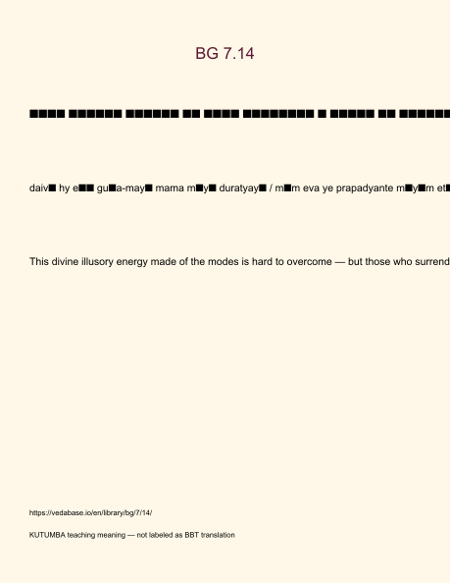
Original KUTUMBA visual: verse-card.png
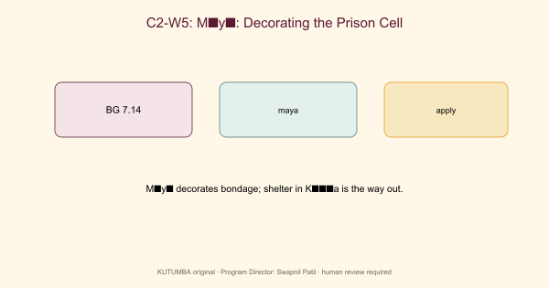
Original KUTUMBA visual: concept-diagram.png
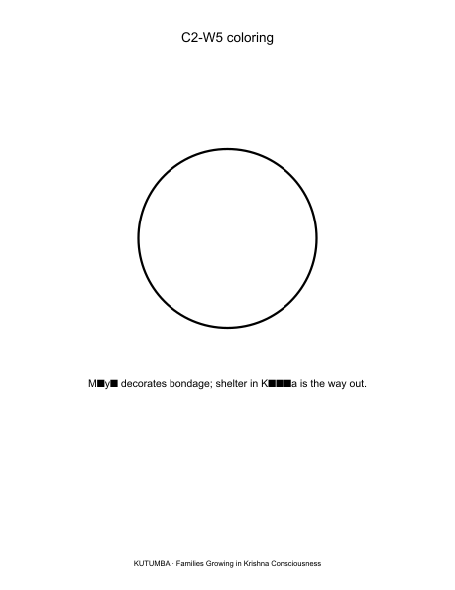
Original KUTUMBA visual: line-art-younger.png
RIGHTS NOTE | Original KUTUMBA program material. Scripture/BBT/ISKCON/third-party rights remain with their holders.

