KUTUMBA

C2-W6 MAIN FACILITATOR GUIDE
  - Families Growing in Krishna Consciousness
C2-W6
V12 • Families Growing in Krishna Consciousness
Program Director: Swapnil Patil
Internal founding-cohort teaching material — human/temple review EXTERNAL_OPEN
KUTUMBA | Families Growing in Krishna Consciousness

KUTUMBA · Families Growing in Krishna Consciousness Program Director: Swapnil Patil Week: Integration Night: Choice, Consequence, and the Modes Status: Internal founding-cohort teaching material — human/temple review EXTERNAL_OPEN Primary scripture: Cycle 2 review (BG 18.63 center) — https://vedabase.io/en/library/bg/18/63/
◆ ◆ ◆

Two-minute summary
Integration night retrieves Cycle 2: action can bind or free (BG 3.9), the next choice matters (BG 18.63), the body is temporary clothing (BG 2.22), modes color experience (BG 14.5), and māyā is hard without surrender (BG 7.14). No major new doctrine. Noncompetitive presentations.

Essential question
How do choice, consequence, and the modes form one coherent family practice?

Memory line
Retrieve, repair, and choose again — without ranking.

KUTUMBA teaching meaning (primary)
KUTUMBA teaching meaning: Choice, consequence, and the modes must form one coherent family practice — synthesis, not new doctrine.
Label this as KUTUMBA teaching meaning. Do not label it as a BBT translation. No full purport dumps.
◆ ◆ ◆

15-minute night-before prep
- Open https://vedabase.io/en/library/bg/18/63/ and reread IAST + KUTUMBA teaching meaning.
- Rehearse opening script aloud once.
- Pack younger + older materials listed in age-band guides.
- Review misconception to block: Integration night means competing to sound the most advanced.
- Confirm snack/water only (no weekly meal); parents onsite.
- Write home-practice minimum on a card: Once: family names one C2 learning and one repair/choice practice without scoring anyone.

60-minute deep prep
- Read this guide’s analogies, scriptural examples, and three cases so you can teach them inline.
- Open each supporting URL once; note teaching use and limitation.
- Mark one discovery, one understanding, and one application question you will ask.
- Walk parent / younger / older / reunification zones.
- Review privacy: no forced confession; no ranking; no public sādhana scoring.
- Confirm project contribution card and next-week title only: Protected off-week / calendar note — then Cycle 3 begins with BG 5.29 (title only tonight)..
◆ ◆ ◆

Exact primary readings
- Primary: Cycle 2 review (BG 18.63 center) — https://vedabase.io/en/library/bg/18/63/
- IAST: BG 3.9 · BG 18.63 · BG 2.22 · BG 14.5 · BG 7.14
- KUTUMBA teaching meaning: Choice, consequence, and the modes must form one coherent family practice — synthesis, not new doctrine.
- Rights: Sanskrit from VedaBase display; KUTUMBA teaching meaning original; teaching meaning ≠ BBT translation label.

Exact supporting readings (classroom paraphrase only)
Reference | URL | Teaching paraphrase (facilitator may say) | Limitation
BG 3.9 | https://vedabase.io/en/library/bg/3/9/ | Work done as sacrifice frees; other work binds. | Review only; no new karma casuistry.
BG 2.22 | https://vedabase.io/en/library/bg/2/22/ | As clothes are changed, the soul passes to another body. | No graphic death talk with young children.
BG 14.5 | https://vedabase.io/en/library/bg/14/5/ | The living being is conditioned by sattva, rajas, tamas. | Do not diagnose people’s modes as insults.
BG 7.14 | https://vedabase.io/en/library/bg/7/14/ | Māyā is hard; surrender crosses. | Keep hope; no despair speech.

◆ ◆ ◆

One-page speaking map (Saturday 2:00–4:00)
- 2:00 Welcome / mantras / purpose
- 2:10 Memory line + essential question
- Primary verse layer (IAST + KUTUMBA teaching meaning)
- Core explanation
- One analogy with limit spoken aloud
- One scriptural example paraphrase
- One constructed case
- 2:30 Track split
- 3:10 Reunification synthesis
- 3:30 Snack/water only — no weekly meal
- 3:40 Saṅkalpa / project / home practice
- 3:55 Next-week title only + close by 4:00
◆ ◆ ◆

Exact opening script (≈3 minutes)
Welcome. Today is C2-W6: Integration Night: Choice, Consequence, and the Modes. Our essential question is: How do choice, consequence, and the modes form one coherent family practice? From Cycle 2 review (BG 18.63 center), our KUTUMBA teaching meaning is: Choice, consequence, and the modes must form one coherent family practice — synthesis, not new doctrine. We will hear together, practice in age bands, reunite, and take one small home step. We do not rank families or children. Parents remain onsite. Snack and water only — no weekly meal.

Extended 10–20 minute speaking SCRIPT
[0–3 min — Hook] If Cycle 2 stayed as five separate posters, homes would leave with fragments. Integration asks: can these teachings speak as one family practice?
[3–7 min — Verse layer] Read IAST briefly. State the full KUTUMBA teaching meaning. Pause.
[7–12 min — Core + support] Walk the chain with one sentence each. Emphasize BG 18.63 as the center for tonight’s lab: deliberate, then act. Use retrieval stations, not lectures.
[12–16 min — Analogy + limit] Teach one analogy below and state its limit out loud.
[16–18 min — Case] Read Constructed Case 1 once. Ask for the mistaken conclusion and one compassionate next step.
[18–20 min — Transition] Preview age-band labs. At ~2:28 give track transition. Reunite at 3:10.
◆ ◆ ◆

Core explanation (facilitator must say)
Tonight we weave the chain. We do not add a new ontology. Families retrieve, correct misconceptions, present briefly, and choose one ongoing practice. Scoring devotion is forbidden.
Conclusion line: One coherent practice: hear, choose responsibly, remember temporariness, notice modes, seek Kṛṣṇa — without ranking.
Common error to block: Integration night means competing to sound the most advanced.
◆ ◆ ◆

Analogies / examples with limits (teach inline)

1) Five beads, one string
- Say: Separate beads fall; a stringed chain can be worn as practice.
- Limit: Do not claim the string replaces śāstra.

2) Orchestra rehearsal
- Say: Integration is rehearsal of known parts, not a new symphony.
- Limit: No ranking solos.

3) Map legend
- Say: Tonight redraws the legend for roads already traveled.
- Limit: No new continents of doctrine.
◆ ◆ ◆

Scriptural / devotional examples (paraphrase only)

Example A — Review chain
Walk BG 3.9 → 18.63 → 2.22 → 14.5 → 7.14 with one sentence each. Limit: no new casuistry.

Example B — Responsibility center (BG 18.63)
Deliberate then act. Limit: do not force dramatic life announcements.
◆ ◆ ◆

Three constructed household cases (inline)

Constructed household case 1 — Trophy night
- Situation: A child wants first-place sticker for ‘best spiritual answer.’
- Mistaken conclusion: Integration is a contest.
- Principle / source: Noncompetitive rubric (https://vedabase.io/en/library/bg/18/63/)
- Compassionate response: Thank effort; refuse ranking; invite helping a peer remember.
- Action: Use emerging/developing/secure language only if needed — never scores.
- What not to say: Winner family.

Constructed household case 2 — Fragmented dad
- Situation: A parent remembers only ‘modes’ and forgets responsibility/choice.
- Mistaken conclusion: One week replaces the chain.
- Principle / source: Coherent practice (https://vedabase.io/en/library/bg/18/63/)
- Compassionate response: Gently restore BG 18.63 beside modes.
- Action: Write two linked sentences on one card.
- What not to say: You failed Cycle 2.

Constructed household case 3 — New doctrine urge
- Situation: Someone wants a deep new topic tonight because energy is high.
- Mistaken conclusion: Integration = advanced new teaching.
- Principle / source: No major new doctrine (https://vedabase.io/en/library/bg/18/63/)
- Compassionate response: Park the topic for later; finish retrieval.
- Action: Parking-lot sticky note.
- What not to say: Shutting down curiosity with sarcasm.
◆ ◆ ◆

Discovery questions
- Which week was easiest to remember?
- Which misconception still tempts us?
- What does noncompetitive mean tonight?

Understanding questions
- What is the C2 chain?
- Why is BG 18.63 a useful center for practice?
- What must we not add tonight?

Application questions
- One sentence presentation plan
- One ongoing practice
- One way to avoid ranking at home
◆ ◆ ◆

Five likely questions and source-based answers
- Q: Can we teach something new?
A: No major new doctrine; retrieval and synthesis only.
- Q: What if a family missed weeks?
A: Welcome; give a one-sentence chain card; no shame.
- Q: How long are presentations?
A: About 10 minutes/family max; drawing-only OK.
- Q: Do we grade devotion?
A: Never.
- Q: What about Utsava dates?
A: Calendar candidates remain subject to local confirmation (EXTERNAL_OPEN).
◆ ◆ ◆

Misconceptions and no-speculation boundaries
- Block: Integration night means competing to sound the most advanced.
- Do not invent dialogue for scriptural persons.
- Do not diagnose private karma in the room.
- Do not claim temple/BBT/human approval that has not been given.
- Defer off-scope ontology to the named next week: Protected off-week / calendar note — then Cycle 3 begins with BG 5.29 (title only tonight)..
◆ ◆ ◆

Track transitions
2:30: “Younger friends with [teacher]; older learners with [teacher]; parents may observe or assist as assigned. We reunite at 3:10.” 3:10 synthesis prompt: “In one sentence, what did your track learn about: How do choice, consequence, and the modes form one coherent family practice?”

Family synthesis / project / home practice
- Project: one family artifact answering the essential question (see project/CYCLE-CONTRIBUTION.md).
- Home practice minimum: Once: family names one C2 learning and one repair/choice practice without scoring anyone.
- Success = minimum version completed once.

Next week
Title only: Protected off-week / calendar note — then Cycle 3 begins with BG 5.29 (title only tonight).. Do not teach its full ontology tonight.

Close
Appreciate effort; leave host spaces cleaner; end by 4:00.
◆ ◆ ◆

Exact Saturday time cues (locked)
- 1:50 Arrival / calm setup / materials check
- 2:00 Opening mantras (invitation only) + welcome
- 2:10–2:28 Shared teaching from this guide (script above)
- 2:30–3:10 Age-band tracks
- 3:10–3:25 Reunification synthesis (one sentence per track/family)
- 3:25–3:35 Soft shared practice / bhakti lab as appropriate
- 3:35–3:45 Snack + water only (no weekly meal)
- 3:45–3:55 Saṅkalpa, project contribution, home-practice card
- 3:55–4:00 Next-week title only; appreciate; close on time

Materials / room / snack checklist
- Printed verse card / concept diagram PNG if available
- Younger craft + movement materials
- Older worksheets + scenario cards
- Blank saṅkalpa cards
- Water + simple snack only
- Teacher-only answer keys kept separate
- Leave host home cleaner than found

Privacy and public-repo boundaries
- No public scoring of private sādhana
- No forced confessions
- Blank covenant acknowledgement only in print packets
- Do not commit private family data to the repository

Source hierarchy reminder
- Primary verse URL for this week
- Supporting śāstra listed above
- This controlling facilitator guide
- Research files for prep enrichment — core teaching stays inline here
- Defer initiation / temple policy / legal approvals as EXTERNAL_OPEN

Facilitator self-check before opening
- [ ] I can state the KUTUMBA teaching meaning without notes
- [ ] I can name the misconception to block
- [ ] I have one analogy + limit ready
- [ ] I have one case ready
- [ ] Snack/water plan confirmed (no meal)
- [ ] Parents onsite plan confirmed

Instructional visuals
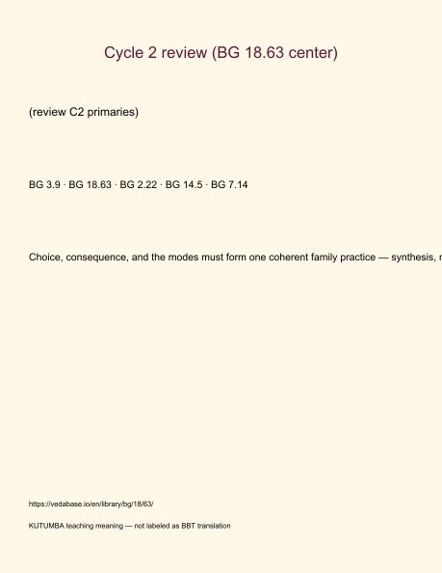
Original KUTUMBA visual: verse-card.png
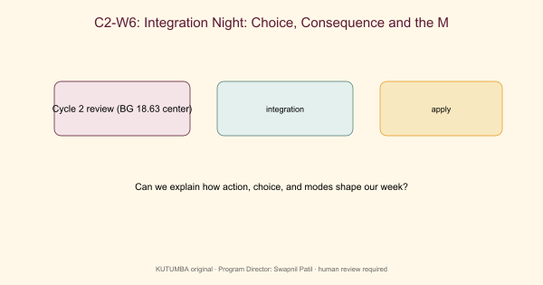
Original KUTUMBA visual: concept-diagram.png
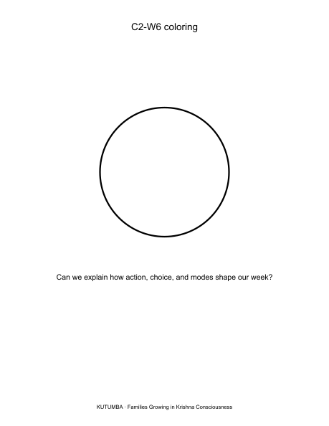
Original KUTUMBA visual: line-art-younger.png
RIGHTS NOTE | Original KUTUMBA program material. Scripture/BBT/ISKCON/third-party rights remain with their holders.

