KUTUMBA

C2-W6 OLDER TEACHER GUIDE
  - Families Growing in Krishna Consciousness
C2-W6
V12 • Families Growing in Krishna Consciousness
Program Director: Swapnil Patil
Internal founding-cohort teaching material — human/temple review EXTERNAL_OPEN
KUTUMBA | Families Growing in Krishna Consciousness

Week: Integration Night: Choice, Consequence, and the Modes Primary: Cycle 2 review (BG 18.63 center) — https://vedabase.io/en/library/bg/18/63/ Track window: ~2:30–3:10 then reunite Status: Internal founding-cohort teaching material — human/temple review EXTERNAL_OPEN

Objective
Students observe the primary text layer, complete a worksheet and scenario set, and contribute one project sentence answering: How do choice, consequence, and the modes form one coherent family practice?

Primary text observation
- Read IAST aloud once: BG 3.9 · BG 18.63 · BG 2.22 · BG 14.5 · BG 7.14
- Students underline two words that seem important.
- State KUTUMBA teaching meaning in full: Choice, consequence, and the modes must form one coherent family practice — synthesis, not new doctrine.
- Label clearly: KUTUMBA teaching meaning — not BBT translation.

Worksheet questions
- In your words, what does Cycle 2 review (BG 18.63 center) teach this week?
- What mistaken idea does this week block? (Integration night means competing to sound the most advanced.)
- Name one home situation where this teaching changes a next step.
- What is still confusing? (honest question OK)

Scenario cards (read–choose–explain)
Stations: (1) karma/action, (2) next choice, (3) reincarnation clothing, (4) modes, (5) māyā/decorating. At each: write one sentence + one misconception to reject.

Puzzle / game — Chain restore
Unscramble the five primary references into calendar order and state one teaching sentence each.

Diagram task
Sketch a simple map of this week's idea using boxes/arrows. Label scripture vs analogy if both appear.

Project contribution
Add one sentence to the cycle project answering the essential question. Keep ≤5 minutes.

Reflection
Write: “This week I will practice ___ when ___.”

Extension (optional)
Compare one supporting reference from the facilitator guide with the primary — what does it add, and what limit remains?

Answer key pointer
Use activities/OLDER-ANSWER-KEY.md (teacher-only). Do not distribute keys to students during work time.

Instructional visuals
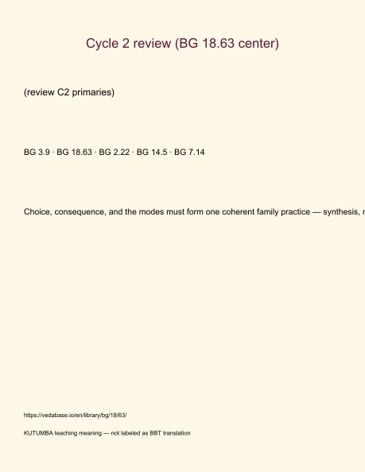
Original KUTUMBA visual: verse-card.png
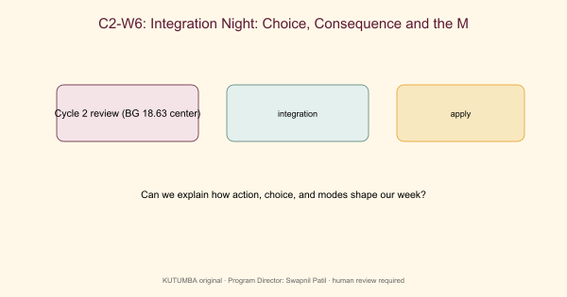
Original KUTUMBA visual: concept-diagram.png
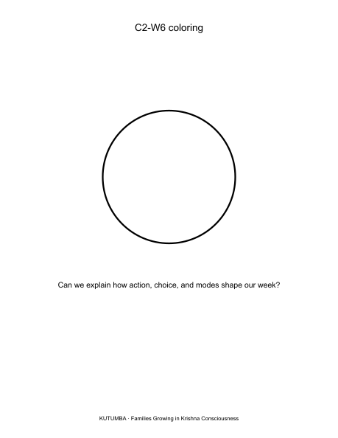
Original KUTUMBA visual: line-art-younger.png
RIGHTS NOTE | Original KUTUMBA program material. Scripture/BBT/ISKCON/third-party rights remain with their holders.

