KUTUMBA

C2-W6 YOUNGER TEACHER GUIDE
  - Families Growing in Krishna Consciousness
C2-W6
V12 • Families Growing in Krishna Consciousness
Program Director: Swapnil Patil
Internal founding-cohort teaching material — human/temple review EXTERNAL_OPEN
KUTUMBA | Families Growing in Krishna Consciousness

Week: Integration Night: Choice, Consequence, and the Modes Primary: Cycle 2 review (BG 18.63 center) — https://vedabase.io/en/library/bg/18/63/ Session length: 40 minutes (parallel track ~2:30–3:10) Parents: Remain onsite; reunite at 3:10 Status: Internal founding-cohort teaching material — human/temple review EXTERNAL_OPEN

Objective
Children can say the memory phrase and complete one movement + one craft that reinforce this week's idea without fear or shame.

Exact memory phrase
Retrieve, repair, and choose again — without ranking.

Teacher background (2 minutes)
- KUTUMBA teaching meaning: Choice, consequence, and the modes must form one coherent family practice — synthesis, not new doctrine.
- Child-facing paraphrase: We remember five friend-ideas from Cycle 2 and practice kindness without winning trophies.
- Block: Integration night means competing to sound the most advanced.
- Do not: invent deity dialogue; force confessions; rank children; use scary imagery.

Materials
- Printed line art if available (visuals/V12/line-art-younger.png)
- Crayons, tape, scissors (teacher-only for youngers)
- Soft toss object; two baskets or mats for movement game
- Card stock for memory cards
- Snack/water only after reunification (no weekly meal)

Minute-by-minute plan

0–5 Opening
- Welcome by name; feet on floor.
- Echo memory phrase three times with clap rhythm.
- Show one picture cue for the week: Five paper beads on a string labeled with simple C2 words..

5–13 Story script (~8 minutes)
Say this spine (paraphrase only; do not invent dialogue):
This cycle we learned: actions have fruits; the next choice matters; the body is like clothes; moods can color our day; and seeking Kṛṣṇa matters more than only decorating temporary things. Tonight we string those ideas like beads. No one is better than another. We help each other remember.

Wonder questions
- Which bead do you remember?
- How can we help a friend remember?
- What is one kind choice tonight?

13–20 Movement game — Bead walk
Steps:
- Five floor spots for C2 ideas.
- Children walk gently to a called bead and say a child-friendly word.
- Freeze and say memory phrase.
- Freeze cue: hands on heart; repeat memory phrase.

20–32 Craft — Retrieval bracelet
Steps:
- String five paper beads.
- Draw one symbol per bead.
- Add a tag: ‘No ranking — only remembering.’
- Write or sticker the memory phrase on the craft.

32–38 Printable / quiet task
Children color the week line art and circle one home place where they will remember the phrase.

38–40 Cleanup / parent handoff
Clean mats; show craft to parent; one sentence: “Our phrase is: Retrieve, repair, and choose again — without ranking..”

Behavior redirects
- Calm reminder → 2. Offer choice (sit spot / helper job) → 3. Quiet reset visible to parents → 4. Parent involvement. Never shame, yell, or force chanting.

Backup (if energy crashes)
Soft toss while answering: “One kind next step at home is ___.”

Materials checklist / cleanup
Bag crayons; wipe table; leave host space cleaner; return line-art masters to teacher folder.

Instructional visuals
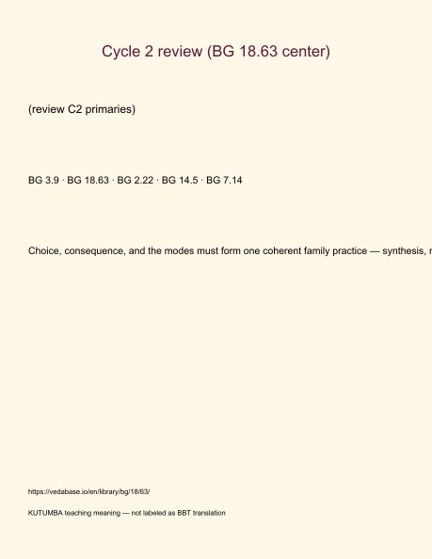
Original KUTUMBA visual: verse-card.png
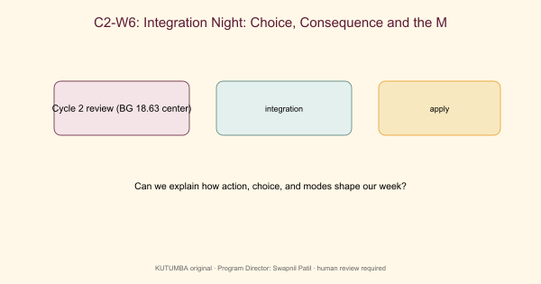
Original KUTUMBA visual: concept-diagram.png
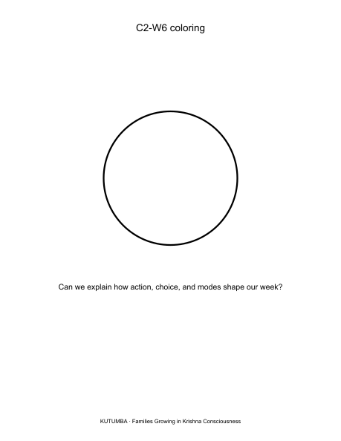
Original KUTUMBA visual: line-art-younger.png
RIGHTS NOTE | Original KUTUMBA program material. Scripture/BBT/ISKCON/third-party rights remain with their holders.

