KUTUMBA

C3-W1 OLDER TEACHER GUIDE
  - Families Growing in Krishna Consciousness
C3-W1
V12 • Families Growing in Krishna Consciousness
Program Director: Swapnil Patil
Internal founding-cohort teaching material — human/temple review EXTERNAL_OPEN
KUTUMBA | Families Growing in Krishna Consciousness

KUTUMBA • Families Growing in Krishna Consciousness Program Director: Swapnil Patil Status: Internal founding-cohort teaching material — human/temple review EXTERNAL_OPEN

Objective
Students explain BG 5.29’s three features and apply them to a family control conflict.

Exact memory / thesis line
Kṛṣṇa owns, Kṛṣṇa enjoys, Kṛṣṇa is friend — that brings peace.

Teacher background
Primary: BG 5.29 — https://vedabase.io/en/library/bg/5/29/
IAST: bhoktāraṁ yajña-tapasāṁ sarva-loka-maheśvaram / suhṛdaṁ sarva-bhūtānāṁ jñātvā māṁ śāntim ṛcchati
Teaching meaning: Knowing the Lord as the enjoyer of sacrifice and austerity, the proprietor of all worlds, and the friend of all beings — one attains peace.
Block: God is an impersonal force only (or ‘I am the real owner/enjoyer’).

Timed run-of-show (about 40 minutes)
Minutes | Move | Instructions
0–5 | Hook | Pose essential question: Who is God to our family? Collect 2–3 short answers without debate.
5–15 | Text | Display Devanāgarī + IAST. Students mark keywords. Read teaching meaning in full.
15–25 | Case lab | Run one case from the main guide; students write mistaken conclusion → repair.
25–33 | Activity pack | Complete OLDER-ACTIVITY-PACK primary task; use answer key privately.
33–38 | Share | Two volunteers; no ranking; source must be named.
38–40 | Handoff | Restate home practice: Before one daily duty, remember: Kṛṣṇa owns, Kṛṣṇa enjoys, Kṛṣṇa is friend.

Text protocol (do this every week)
- Student writes the reference.
- Student underlines 3–6 keywords in IAST or teaching meaning.
- Student restates the teaching meaning in one fresh sentence.
- Student names one limit (what this verse is not saying).

Discussion stems
- “What does the verse actually say — not what we wish it said?”
- “Where is the limit of our analogy?”
- “How would a family apply this without performing for others?”
- “What would ranking look like tonight, and how do we refuse it?”

Case lab facilitator moves
- Read the situation once.
- Ask for the mistaken conclusion before giving the key.
- Require a compassionate response sentence that a parent could actually say.
- Close with the family action timed at 5–15 minutes.

Assessment (formative, private)
- Can the student name BG 5.29?
- Can they restate the teaching meaning in their own words without truncation?
- Can they repair one misconception without sarcasm?
- For C3-W4 specifically: can they end the verse with paraṁ vijayate śrī-kṛṣṇa-saṅkīrtanam?
- For C3-W5 specifically: can they include iti puṁsārpitā / topmost learning?
- For C3-W6 specifically: can they recite BG 5.29 · BG 7.7 · BG 4.34 · CC Antya 20.12 · ŚB 7.5.23–24?

Safeguarding / tone
Respectful conviction, not aggressive debate. No public scoring of devotion. Parents onsite. If a safety disclosure appears, stop the lesson flow and follow safeguarding protocol.

Instructional visuals
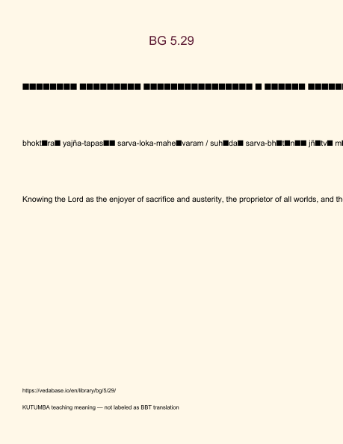
Original KUTUMBA visual: verse-card.png
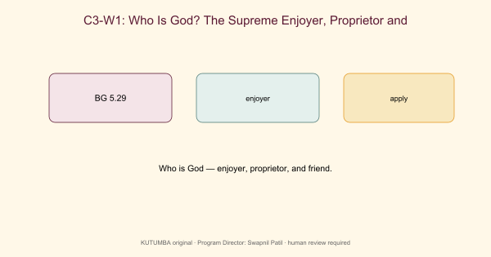
Original KUTUMBA visual: concept-diagram.png

Original KUTUMBA visual: line-art-younger.png
RIGHTS NOTE | Original KUTUMBA program material. Scripture/BBT/ISKCON/third-party rights remain with their holders.

