KUTUMBA

C3-W4 MAIN FACILITATOR GUIDE
  - Families Growing in Krishna Consciousness
C3-W4
V12 • Families Growing in Krishna Consciousness
Program Director: Swapnil Patil
Internal founding-cohort teaching material — human/temple review EXTERNAL_OPEN
KUTUMBA | Families Growing in Krishna Consciousness

KUTUMBA • Families Growing in Krishna Consciousness Program Director: Swapnil Patil Status: Internal founding-cohort teaching material — human/temple review EXTERNAL_OPEN

Two-minute summary
Śrī Caitanya Mahāprabhu gives the world congregational chanting. CC Antya 20.12 (Śikṣāṣṭaka 1) must be taught COMPLETE — through paraṁ vijayate śrī-kṛṣṇa-saṅkīrtanam. Families practice attentive, humble, joyful nāma without performance pressure or claims of advanced realization.
Primary: CC Antya 20.12 (Śikṣāṣṭaka 1) — https://vedabase.io/en/library/cc/antya/20/12/

Essential question
Why chant the holy name — and how do we chant without turning it into a show?

Learning outcomes (session)
- Identify Lord Caitanya’s saṅkīrtana gift and recite/recognize the full Śikṣāṣṭaka 1 teaching meaning.
- Participate in call-and-response kīrtana with attention and appropriate volume.
- Complete five-minute family kīrtana or attentive listening on three days.
- Children recognize Pañca-tattva respectfully and join mahā-mantra response.

15-minute night-before prep
- Open https://vedabase.io/en/library/cc/antya/20/12/ and read Devanāgarī, IAST, and the KUTUMBA teaching meaning aloud once.
- Rehearse the exact opening script below without improvising new doctrine.
- Pack younger materials and older materials listed under Materials.
- Mark the week's primary misconception to block: Force chanting as punishment / treat kīrtana as talent show..
- Confirm snack and water table (no weekly meal) and parent-onsite seating.
- Print or open the home-practice card wording for saṅkalpa.

60-minute deep prep
- Read the Core explanation section twice; highlight three sentences you will say slowly.
- Choose one analogy and one case you will actually use; mark time cues in the margin.
- Prepare three questions: one discovery, one understanding, one application.
- Walk the room: welcome zone, verse wall, younger track, older track, reunification circle, snack table.
- Confirm younger and older teachers have executable guides (not shells) and activity packs.
- Review deferral language: if a question exceeds week scope, thank the asker, note it, and schedule follow-up with a qualified source rather than inventing an answer.
- Review safeguarding: no private home struggles disclosed publicly; no ranking; child opt-out roles available.

Exact primary readings
- Reference: CC Antya 20.12 (Śikṣāṣṭaka 1)
- URL: https://vedabase.io/en/library/cc/antya/20/12/
- Devanāgarī: चेतोदर्पणमार्जनं भवमहादावाग्निनिर्वापणम् । श्रेयःकैरवचन्द्रिकावितरणं विद्यावधूजीवनम् ॥ आनन्दाम्बुधिवर्धनं प्रतिपदं पूर्णामृतास्वादनम् । सर्वात्मस्नपनं परं विजयते श्रीकृष्णसङ्कीर्तनम् ॥
- IAST: ceto-darpaṇa-mārjanaṁ bhava-mahā-dāvāgni-nirvāpaṇaṁ śreyaḥ-kairava-candrikā-vitaraṇaṁ vidyā-vadhū-jīvanam ānandāmbudhi-vardhanaṁ prati-padaṁ pūrṇāmṛtāsvādanaṁ sarvātma-snapanaṁ paraṁ vijayate śrī-kṛṣṇa-saṅkīrtanam
- KUTUMBA teaching meaning: Let there be all victory for śrī-kṛṣṇa-saṅkīrtana — which cleanses the mirror of the heart, extinguishes the blazing forest fire of material existence, spreads the moonlight of good fortune, is the life of all education, expands the ocean of bliss, gives a taste of full nectar at every step, and bathes the self of everyone.
- Rights: Sanskrit from VedaBase display; KUTUMBA teaching meaning is original program pedagogy — not labeled as a BBT English translation; do not paste full purports into slides or handouts.

Supporting sources (link-level; summarize, do not copy purports)
- CC Ādi 7.163 — https://vedabase.io/en/library/cc/adi/7/163/
- CC Ādi 17.21 — https://vedabase.io/en/library/cc/adi/17/21/
- ŚB 12.3.51 — https://vedabase.io/en/library/sb/12/3/51/
- Local authorized mahā-mantra chanting sheet

One-page speaking map
- Welcome and memory of prior week (2–3 min)
- Essential question (1 min)
- Verse layer — Devanāgarī / IAST / teaching meaning (6–8 min)
- Core explanation with board triangle or map (8–10 min)
- One analogy with spoken limit (3 min)
- One case study (5 min)
- Age-track handoff (tracks 40 min)
- Reunification share (8–10 min)
- Snack/water
- Home practice saṅkalpa and close

Exact opening script
Welcome to C3-W4: Śrī Caitanya Mahāprabhu and the Holy Name. Essential question: Why chant the holy name — and how do we chant without turning it into a show? From Caitanya-caritāmṛta Antya 20.12 — the complete Śikṣāṣṭaka 1 ending with paraṁ vijayate śrī-kṛṣṇa-saṅkīrtanam: Let there be all victory for śrī-kṛṣṇa-saṅkīrtana — which cleanses the mirror of the heart, extinguishes the blazing forest fire of material existence, spreads the moonlight of good fortune, is the life of all education, expands the ocean of bliss, gives a taste of full nectar at every step, and bathes the self of everyone. We will practice hearing and responding with humility. No ranking of voices.

Core explanation (teach this; do not outsource to research files)

Complete verse integrity (do not truncate)
Teachers must present the FULL IAST through paraṁ vijayate śrī-kṛṣṇa-saṅkīrtanam. Stopping at vidyā-vadhū-jīvanam is a content defect. Walk the images in order:
- ceto-darpaṇa-mārjanam — cleansing the mirror of the heart
- bhava-mahā-dāvāgni-nirvāpaṇam — extinguishing the forest fire of material existence
- śreyaḥ-kairava-candrikā-vitaraṇam — moonlight that opens the white lotus of good fortune
- vidyā-vadhū-jīvanam — the life of all education
- ānandāmbudhi-vardhanam — expanding the ocean of bliss
- prati-padaṁ pūrṇāmṛtāsvādanam — tasting full nectar at every step
- sarvātma-snapanam — bathing the self of everyone
- paraṁ vijayate śrī-kṛṣṇa-saṅkīrtanam — all victory to śrī-kṛṣṇa-saṅkīrtana

Who is Śrī Caitanya Mahāprabhu in this curriculum?
Teach according to Gauḍīya Vaiṣṇava understanding as presented by Śrīla Prabhupāda: Lord Caitanya taught and spread saṅkīrtana. Use authorized short accounts (mission of the holy name; gentle Jharikhaṇḍa animal-listening motif kept orderly). No invented dialogues. No sensationalism.

Performance problem
A family begins kīrtana: one child sings proudly, another is shy, an adult worries about melody, another checks whether people are impressed. The holy name is present, but the mind turns chanting into a show. Repair: attention to hearing, appropriate volume, inclusion, clear endings, no scoring.

Attention practice
Hear one mantra. Notice wandering. Return without self-attack. Older students write an attention-recovery plan (pause, breathe, restart at the next mantra).

Etiquette
Leader responsibility, response, tempo, instruments, and making space for shy participants. Never force chanting as punishment.

Boundaries
No claims of advanced bhāva. No ranking voices. No Mṛgāri. Verify local chanting sheet for mahā-mantra practice.

Minute-by-minute facilitator script (plenary portion)

2:00–2:10 — Welcome and settling
Greet each family by name if known. Point out restrooms, water, and the snack table timing (snack at 3:30, not a weekly meal). Remind parents they remain onsite. Open with the program’s authorized mantras using the local chanting sheet. Keep volume warm, not theatrical. If a child is dysregulated, offer a quiet helper role immediately rather than competing with the room.

2:10–2:18 — Opening script and essential question
Deliver the exact opening script without adding new doctrinal claims. Pause after the essential question. Collect two or three short responses. Do not debate. Write one phrase on the board that you will return to later. State the primary reference and URL verbally so older learners hear that scripture is locatable.

2:18–2:28 — Verse layer
Display Devanāgarī. Read slowly. Display IAST. Read slowly. Read the full KUTUMBA teaching meaning without truncation. Ask one child to repeat a memory phrase and one older learner to name the reference. If the primary is a multi-verse or long verse text, do not stop mid-verse. For C3-W4, end aloud on paraṁ vijayate śrī-kṛṣṇa-saṅkīrtanam. For C3-W5, include iti puṁsārpitā … ’dhītam uttamam. For C3-W6, recite the exact chain BG 5.29 · BG 7.7 · BG 4.34 · CC Antya 20.12 · ŚB 7.5.23–24.

2:28–2:40 — Core map, analogy, and one case
Teach the board map from the core explanation. Use exactly one analogy and speak its limit in the same breath. Run one case study with compassionate response language. Protect privacy: no family is asked to confess failures publicly. Transition: “Now we practice in age bands; parents stay onsite; we reunite at 3:10.”

2:40–3:10 — Tracks (facilitator float)
Float between younger and older rooms/zones. Ensure teachers are using executable guides, not improvising doctrine. Watch for punishment-chanting, ranking, or unsafe secrecy language and interrupt gently. Keep snack prep silent in the background.

3:10–3:30 — Reunification and snack
Use the reunification script. Limit shares to one sentence or one picture. Begin snack/water. No lesson competition during snack. Capture home-practice commitments on cards.

3:40–4:00 — Saṅkalpa and close
Read the minimum home practice. Invite one adult and one child to restate it. Preview next week in one sentence. Thank volunteers. Reset the room. End at 4:00.

Facilitator voice examples (say / don’t say)

Say
- “Śāstra first — let’s open the verse.”
- “That is a sincere question; we will note it and follow up with a qualified source.”
- “Helper roles are real service.”
- “We do not rank families.”

Don’t say
- “Your family is behind.”
- “Chant until you behave.”
- “Science has now proven this verse.”
- “This material is temple-approved / publication-ready.” (It is EXTERNAL_OPEN for human/temple review.)
- “Mṛgāri story time.” (Out of scope for Cycle 3.)

Differentiation and newcomers
Newcomer adults: give the two-minute summary and the home-practice card; do not flood with Sanskrit pressure. Newcomer children: pair with a buddy; allow listening-only kīrtana roles. Multilingual homes: English teaching meaning is enough for comprehension; Sanskrit is honored by hearing, not by forced accuracy on night one. If a family arrives late, skim to the verse layer and hand them the card; do not publicly recap someone else’s private share.

Room stewardship checklist (executable)
- Verse wall visible from both tracks’ return path.
- Younger materials bag packed before 1:50.
- Older worksheets and answer key (private) separated.
- Water labeled; allergen note if any shared snack.
- Timer visible for track teachers.
- Safeguarding adult identified on the run-sheet.
- Cleanup bags at doors by 3:50.
- Lost-and-found box for craft pieces.

Analogies (inline — with limits)

Analogy 1: Smudged mirror
- Say: When a mirror is wiped, the face appears; saṅkīrtana cleanses the heart’s mirror.
- Limit: Acrylic classroom mirrors are props, not mystical proof.
- Bridge back to verse: ceto-darpaṇa-mārjanam

Analogy 2: Cooling water on a hot day
- Say: Heat of anxiety cools when we stop and hear the name together.
- Limit: Does not claim all material problems vanish instantly.
- Bridge back to verse: bhava-mahā-dāvāgni-nirvāpaṇam and sarvātma-snapanam

Analogy 3: Team chorus vs solo spotlight
- Say: A chorus succeeds when voices blend; a spotlight contest fractures joy.
- Limit: Musical skill can serve devotion but is not the measure of devotion.
- Bridge back to verse: paraṁ vijayate śrī-kṛṣṇa-saṅkīrtanam — victory of the holy name, not of our image.

Case studies (three constructed pedagogical cases)

Case 1: Kīrtana talent show
- Situation: After kīrtana, adults praise only the ‘best singer,’ and a quieter child refuses to return.
- Mistaken conclusion: Devotion equals vocal performance.
- Principle from primary: Victory belongs to śrī-kṛṣṇa-saṅkīrtana; inclusion matters.
- Compassionate response (say): Thank all roles — leader, responder, listener, space helper.
- Family action (5–15 min): Next kīrtana assigns non-mic service roles first.
- What not to say: Sarcasm about ‘show-offs.’

Case 2: Chanting used as punishment
- Situation: A parent says, ‘Sit and chant because you misbehaved.’
- Mistaken conclusion: Holy name as penalty.
- Principle from primary: Nāma is mercy, not detention.
- Compassionate response (say): Separate discipline from spiritual practice; apologize and reset.
- Family action (5–15 min): Schedule joyful five-minute kīrtana unrelated to punishment.
- What not to say: Defending punishment-chanting as ‘strictness.’

Case 3: Melody anxiety
- Situation: An adult avoids leading because they fear wrong notes.
- Mistaken conclusion: Correct rāga is required before one can chant.
- Principle from primary: Attentive hearing and sincerity outweigh polish in family practice.
- Compassionate response (say): Offer a simple melody; let a trained leader help; keep volume moderate.
- Family action (5–15 min): Practice two call-and-response mantras with a clear ending.
- What not to say: Mocking accents or pitch.

Facilitator questions

Discovery
- What is the final phrase of CC Antya 20.12 / Śikṣāṣṭaka 1?
- Name three images from the verse (mirror, fire, ocean, etc.).
- What is the first action when attention wanders?

Understanding
- Why must we not stop the verse at vidyā-vadhū-jīvanam?
- How is skill different from devotion in kīrtana?
- Why is punishment-chanting a boundary violation?

Application
- When will your three five-minute practices happen?
- Who will lead, who will respond, who may listen quietly?
- What is your attention-recovery cue?

Adult FAQ (likely room questions)
Q: Must children dance? A: No. Offer opt-in movement; listening is valid participation.
Q: Which melody is official? A: Use locally authorized common melodies. Do not fight over style tonight.
Q: Can we claim cleansing already happened? A: No advanced realization claims. Teach hope and steady practice.

Common misconceptions to correct gently
- Truncating Śikṣāṣṭaka 1 is ‘close enough.’
- Best singer = best devotee.
- Force chanting to correct behavior.
- Shyness means lack of Kṛṣṇa’s mercy.

Doctrinal and delivery boundaries
- Complete verse through paraṁ vijayate śrī-kṛṣṇa-saṅkīrtanam.
- No invented Caitanya dialogue.
- No punishment-chanting.
- No ranking.
- No Mṛgāri.

Track facilitation notes

Younger track (K–2 / Lāla–Lālī)
- Objective: Children experience mirror-cleaning and call-and-response joy without performance pressure.
- Memory phrase: Paraṁ vijayate śrī-kṛṣṇa-saṅkīrtanam — all victory to the congregational chanting of Kṛṣṇa’s names.
- Keep movement short; prefer recognition over recitation pressure.
- Handoff to reunification with one picture or gesture share.

Older track (Kiśora–Kiśorī)
- Objective: Students unpack Śikṣāṣṭaka 1 images and design an attention-recovery plan for japa/kīrtana.
- Require source naming (CC Antya 20.12 (Śikṣāṣṭaka 1)) before opinions.
- Use text observation + one case repair; no competitive scoring.

Reunification script
Welcome back. We will hear a few short shares — a word, a picture, or one sentence — without ranking families. What did you notice about attentive chanting versus performance? Our home step is small and steady: Five-minute family kīrtana or attentive mantra listening on three days.. Next week we move to C3-W5 — The nine processes of bhakti without dropping this week's practice.

Home practice and saṅkalpa
- Minimum home practice: Five-minute family kīrtana or attentive mantra listening on three days.
- Bhakti laboratory cue: Attentive family kīrtana
- Write the card before closing; invite one adult and one child to restate it.

Transition to next week
Keep the three-day five-minute nāma practice. Next week maps nine processes (ŚB 7.5.23–24) so bhakti is wider than classroom only.

Materials checklist
- Full CC Antya 20.12 verse poster (complete IAST)
- Safe acrylic mirror + cloth
- Kartāls / simple rhythm instruments (optional)
- Pañca-tattva picture (rights-safe)
- Mahā-mantra listening sheet
- Snack/water

Do not claim
- Human, temple, legal, or publication approval
- That KUTUMBA teaching meanings are BBT translations
- That science proves ātman, karma, or bhakti siddhānta
- Ranking of families, children, or devotion
- Advanced realization from one night of practice

Saturday time cues (locked)
Clock | Block
1:50 | Facilitator arrival; room zones; snack/water table ready (no weekly meal)
2:00 | Opening mantras / welcome; parents remain onsite
2:10 | Opening script + verse layer (all ages together)
2:30 | Age tracks (younger + older) with parents nearby / onsite
3:10 | Reunification share (no ranking)
3:30 | Snack and water
3:40 | Saṅkalpa / home-practice card
3:55 | Close and cleanup
4:00 | End

Parents stay onsite for the full Saturday 2:00–4:00 window. Do not claim temple, human, or publication approval.

Misconceptions and no-speculation boundaries
- Do not invent dialogue for scriptural persons.
- Do not diagnose private karma or modes as insults in the room.
- Do not claim temple/BBT/human approval that has not been given.
- Defer off-scope questions with the standard deferral line.

Instructional visuals
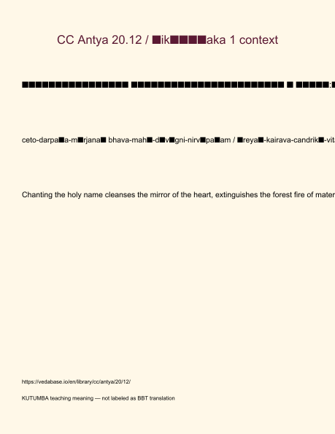
Original KUTUMBA visual: verse-card.png
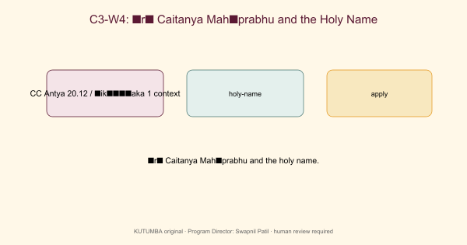
Original KUTUMBA visual: concept-diagram.png
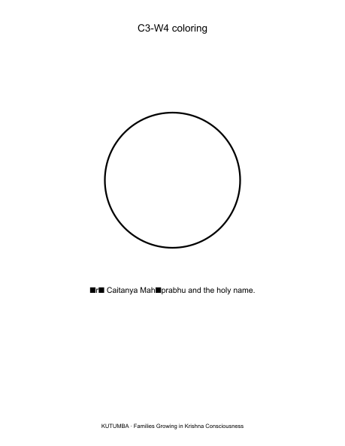
Original KUTUMBA visual: line-art-younger.png
RIGHTS NOTE | Original KUTUMBA program material. Scripture/BBT/ISKCON/third-party rights remain with their holders.

