KUTUMBA

C3-W4 OLDER TEACHER GUIDE
  - Families Growing in Krishna Consciousness
C3-W4
V12 • Families Growing in Krishna Consciousness
Program Director: Swapnil Patil
Internal founding-cohort teaching material — human/temple review EXTERNAL_OPEN
KUTUMBA | Families Growing in Krishna Consciousness

KUTUMBA • Families Growing in Krishna Consciousness Program Director: Swapnil Patil Status: Internal founding-cohort teaching material — human/temple review EXTERNAL_OPEN

Objective
Students unpack Śikṣāṣṭaka 1 images and design an attention-recovery plan for japa/kīrtana.

Exact memory / thesis line
Paraṁ vijayate śrī-kṛṣṇa-saṅkīrtanam — all victory to the congregational chanting of Kṛṣṇa’s names.

Teacher background
Primary: CC Antya 20.12 (Śikṣāṣṭaka 1) — https://vedabase.io/en/library/cc/antya/20/12/
IAST: ceto-darpaṇa-mārjanaṁ bhava-mahā-dāvāgni-nirvāpaṇaṁ śreyaḥ-kairava-candrikā-vitaraṇaṁ vidyā-vadhū-jīvanam ānandāmbudhi-vardhanaṁ prati-padaṁ pūrṇāmṛtāsvādanaṁ sarvātma-snapanaṁ paraṁ vijayate śrī-kṛṣṇa-saṅkīrtanam
Teaching meaning: Let there be all victory for śrī-kṛṣṇa-saṅkīrtana — which cleanses the mirror of the heart, extinguishes the blazing forest fire of material existence, spreads the moonlight of good fortune, is the life of all education, expands the ocean of bliss, gives a taste of full nectar at every step, and bathes the self of everyone.
Block: Force chanting as punishment / treat kīrtana as talent show.

Timed run-of-show (about 40 minutes)
Minutes | Move | Instructions
0–5 | Hook | Pose essential question: Why chant the holy name — and how do we chant without turning it into a show? Collect 2–3 short answers without debate.
5–15 | Text | Display Devanāgarī + IAST. Students mark keywords. Read teaching meaning in full.
15–25 | Case lab | Run one case from the main guide; students write mistaken conclusion → repair.
25–33 | Activity pack | Complete OLDER-ACTIVITY-PACK primary task; use answer key privately.
33–38 | Share | Two volunteers; no ranking; source must be named.
38–40 | Handoff | Restate home practice: Five-minute family kīrtana or attentive mantra listening on three days.

Text protocol (do this every week)
- Student writes the reference.
- Student underlines 3–6 keywords in IAST or teaching meaning.
- Student restates the teaching meaning in one fresh sentence.
- Student names one limit (what this verse is not saying).

Discussion stems
- “What does the verse actually say — not what we wish it said?”
- “Where is the limit of our analogy?”
- “How would a family apply this without performing for others?”
- “What would ranking look like tonight, and how do we refuse it?”

Case lab facilitator moves
- Read the situation once.
- Ask for the mistaken conclusion before giving the key.
- Require a compassionate response sentence that a parent could actually say.
- Close with the family action timed at 5–15 minutes.

Assessment (formative, private)
- Can the student name CC Antya 20.12 (Śikṣāṣṭaka 1)?
- Can they restate the teaching meaning in their own words without truncation?
- Can they repair one misconception without sarcasm?
- For C3-W4 specifically: can they end the verse with paraṁ vijayate śrī-kṛṣṇa-saṅkīrtanam?
- For C3-W5 specifically: can they include iti puṁsārpitā / topmost learning?
- For C3-W6 specifically: can they recite BG 5.29 · BG 7.7 · BG 4.34 · CC Antya 20.12 · ŚB 7.5.23–24?

Safeguarding / tone
Respectful conviction, not aggressive debate. No public scoring of devotion. Parents onsite. If a safety disclosure appears, stop the lesson flow and follow safeguarding protocol.

Instructional visuals
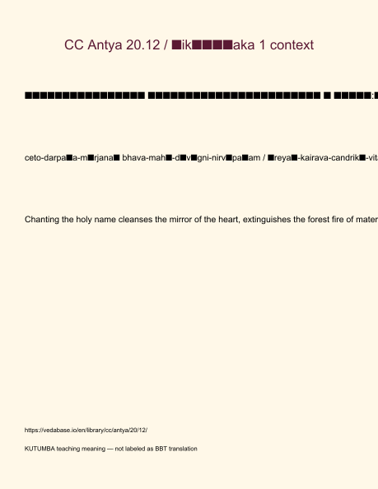
Original KUTUMBA visual: verse-card.png
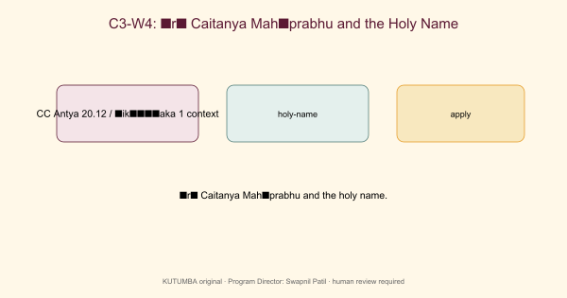
Original KUTUMBA visual: concept-diagram.png
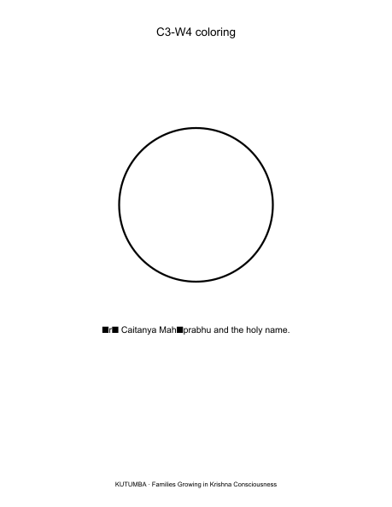
Original KUTUMBA visual: line-art-younger.png
RIGHTS NOTE | Original KUTUMBA program material. Scripture/BBT/ISKCON/third-party rights remain with their holders.

