KUTUMBA

C3-W4 YOUNGER TEACHER GUIDE
  - Families Growing in Krishna Consciousness
C3-W4
V12 • Families Growing in Krishna Consciousness
Program Director: Swapnil Patil
Internal founding-cohort teaching material — human/temple review EXTERNAL_OPEN
KUTUMBA | Families Growing in Krishna Consciousness

KUTUMBA • Families Growing in Krishna Consciousness Program Director: Swapnil Patil Status: Internal founding-cohort teaching material — human/temple review EXTERNAL_OPEN

Objective
Children experience mirror-cleaning and call-and-response joy without performance pressure.

Exact memory phrase
Paraṁ vijayate śrī-kṛṣṇa-saṅkīrtanam — all victory to the congregational chanting of Kṛṣṇa’s names.

Teacher background (enough to teach without improvising)
Primary: CC Antya 20.12 (Śikṣāṣṭaka 1) (https://vedabase.io/en/library/cc/antya/20/12/).
Teaching meaning to keep in mind: Let there be all victory for śrī-kṛṣṇa-saṅkīrtana — which cleanses the mirror of the heart, extinguishes the blazing forest fire of material existence, spreads the moonlight of good fortune, is the life of all education, expands the ocean of bliss, gives a taste of full nectar at every step, and bathes the self of everyone.
Block tonight: Force chanting as punishment / treat kīrtana as talent show..
Parents remain onsite. Session is Saturday 2:00–4:00 with snack/water only (no weekly meal).

Timed run-of-show (about 40 minutes inside the track window)
Minutes | Move | Exact teacher language / action
0–5 | Arrival + wonder | “Today we learn: Paraṁ vijayate śrī-kṛṣṇa-saṅkīrtanam — all victory to the congregational chanting of Kṛṣṇa’s names.. Can your hands show listening?”
5–15 | Story / picture | Use only authorized paraphrase from SCRIPTURAL-EXAMPLES and the week story boundary. No invented dialogue for the Lord.
15–28 | Movement / hands-on | Run YOUNGER-ACTIVITY-PACK stations in order. Offer opt-out quiet helper role.
28–35 | Recall | Choral memory phrase twice; one child restates with a picture card.
35–40 | Cleanup + handoff | “Tell your family one word: clean.”

Step-by-step story boundary
- Open with one concrete child-scale scene connected to this week’s essential question: Why chant the holy name — and how do we chant without turning it into a show?
- Introduce the Lord or teacher figure only with authorized names and actions.
- Pause for a wonder question before the craft.
- Close by tying the craft to the memory phrase — not to fear or competition.

Wonder questions (ask, then wait)
- What was new for your ears today?
- Whom can we serve with care?
- When can our family practice five quiet minutes?

Movement / hands-on / craft / coloring (executable)
- Mirror cleaning demo with a safely smudged acrylic mirror; say ‘clean heart.’
- Call-and-response names / mahā-mantra with hand-raise at the end of a full mantra.
- Role cards: leader, responder, listener, space helper — rotate without scores.
Use visuals/V12/line-art-younger.svg if available for coloring; otherwise plain paper + three labels. If a child refuses craft, they may be card-holder or line leader.

Inclusive participation menu
- Full participant
- Listener with gesture
- Materials helper
- Door/line helper beside an adult
Never require performance singing or public speaking.

Behavior redirects (short)
- Feet on floor · kind words · toy rests · quiet reset corner with a picture card.
- Never use chanting, verse, or seating as punishment.
- If a child is overwhelmed, offer helper role (card holder / line leader) with adult nearby.
- If two children conflict, separate gently, name the stewardship/friend rule for this week, and reset materials together.

Backup if energy crashes (5 minutes)
Circle: whisper memory phrase → stretch → place one sticker on “we tried” chart (no scores). If still flooded, quiet picture walk of three cards only.

Materials checklist
- mirror
- cloth
- role cards
- Pañca-tattva picture
- Tissues, wipes, spare pencils
- Parent handoff cards pre-written with memory phrase

Parent handoff line
Tonight’s phrase is: “Paraṁ vijayate śrī-kṛṣṇa-saṅkīrtanam — all victory to the congregational chanting of Kṛṣṇa’s names..” Home cue: Five-minute family kīrtana or attentive mantra listening on three days..

Instructional visuals
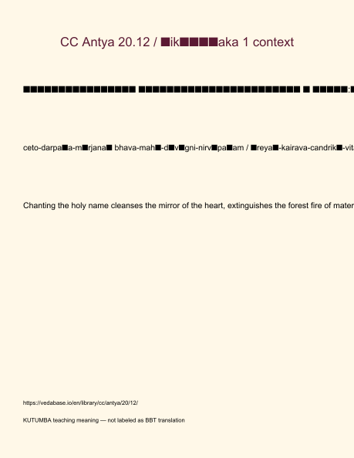
Original KUTUMBA visual: verse-card.png
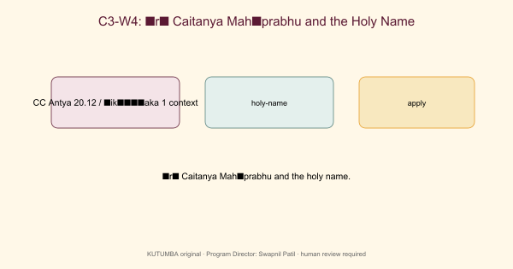
Original KUTUMBA visual: concept-diagram.png
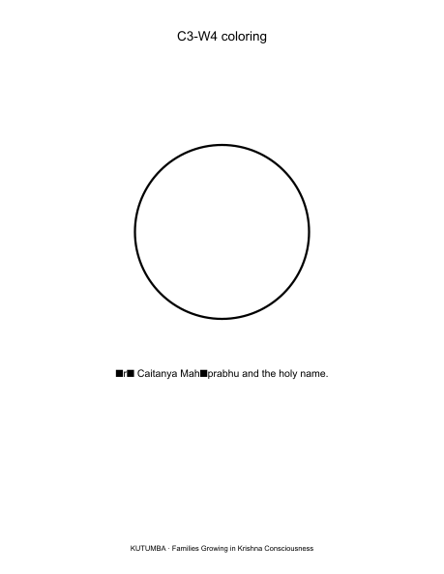
Original KUTUMBA visual: line-art-younger.png
RIGHTS NOTE | Original KUTUMBA program material. Scripture/BBT/ISKCON/third-party rights remain with their holders.

