KUTUMBA

C3-W5 MAIN FACILITATOR GUIDE
  - Families Growing in Krishna Consciousness
C3-W5
V12 • Families Growing in Krishna Consciousness
Program Director: Swapnil Patil
Internal founding-cohort teaching material — human/temple review EXTERNAL_OPEN
KUTUMBA | Families Growing in Krishna Consciousness

KUTUMBA • Families Growing in Krishna Consciousness Program Director: Swapnil Patil Status: Internal founding-cohort teaching material — human/temple review EXTERNAL_OPEN

Two-minute summary
Prahlāda teaches nine processes in ŚB 7.5.23 and then declares in 7.5.24 that such dedicated bhakti unto Viṣṇu is the topmost learning. Families map hearing, chanting, remembering, serving, worship, prayer, servitude, friendship, and surrender — without requiring mastery of all nine at once.
Primary: ŚB 7.5.23–24 — https://vedabase.io/en/library/sb/7/5/23-24/

Essential question
How does bhakti fill a whole family life — not only Friday class?

Learning outcomes (session)
- Name the nine processes at recognition level and state verse 24's topmost-learning claim.
- Audit which processes are strong, occasional, or absent at home (privately).
- Keep core hearing/chanting and add one underused process once.
- Children recognize nine picture icons and perform one safe action.

15-minute night-before prep
- Open https://vedabase.io/en/library/sb/7/5/23-24/ and read Devanāgarī, IAST, and the KUTUMBA teaching meaning aloud once.
- Rehearse the exact opening script below without improvising new doctrine.
- Pack younger materials and older materials listed under Materials.
- Mark the week's primary misconception to block: Bhakti = only attending class / pride in a single process while scorning others..
- Confirm snack and water table (no weekly meal) and parent-onsite seating.
- Print or open the home-practice card wording for saṅkalpa.

60-minute deep prep
- Read the Core explanation section twice; highlight three sentences you will say slowly.
- Choose one analogy and one case you will actually use; mark time cues in the margin.
- Prepare three questions: one discovery, one understanding, one application.
- Walk the room: welcome zone, verse wall, younger track, older track, reunification circle, snack table.
- Confirm younger and older teachers have executable guides (not shells) and activity packs.
- Review deferral language: if a question exceeds week scope, thank the asker, note it, and schedule follow-up with a qualified source rather than inventing an answer.
- Review safeguarding: no private home struggles disclosed publicly; no ranking; child opt-out roles available.

Exact primary readings
- Reference: ŚB 7.5.23–24
- URL: https://vedabase.io/en/library/sb/7/5/23-24/
- Devanāgarī: श्रवणं कीर्तनं विष्णो: स्मरणं पादसेवनम् । अर्चनं वन्दनं दास्यं सख्यमात्मनिवेदनम् ॥ २३ ॥ इति पुंसार्पिता विष्णौ भक्तिश्चेन्नवलक्षणा । क्रियेत भगवत्यद्धा तन्मन्येऽधीतमुत्तमम् ॥ २४ ॥
- IAST: śravaṇaṁ kīrtanaṁ viṣṇoḥ smaraṇaṁ pāda-sevanam / arcanaṁ vandanaṁ dāsyaṁ sakhyam ātma-nivedanam // iti puṁsārpitā viṣṇau bhaktiś cen nava-lakṣaṇā / kriyeta bhagavaty addhā tan manye ’dhītam uttamam
- KUTUMBA teaching meaning: Hearing, chanting, remembering, serving the Lord's feet, worship, offering prayers, becoming a servant, friendship, and full self-surrender — these nine processes of bhakti, when offered to Viṣṇu, are the topmost learning.
- Rights: Sanskrit from VedaBase display; KUTUMBA teaching meaning is original program pedagogy — not labeled as a BBT English translation; do not paste full purports into slides or handouts.

Supporting sources (link-level; summarize, do not copy purports)
- BG 9.14 — https://vedabase.io/en/library/bg/9/14/
- CC Madhya 22.128–129 — https://vedabase.io/en/library/cc/madhya/22/128/
- Purport examples to ŚB 7.5.23–24 (link-only summaries)

One-page speaking map
- Welcome and memory of prior week (2–3 min)
- Essential question (1 min)
- Verse layer — Devanāgarī / IAST / teaching meaning (6–8 min)
- Core explanation with board triangle or map (8–10 min)
- One analogy with spoken limit (3 min)
- One case study (5 min)
- Age-track handoff (tracks 40 min)
- Reunification share (8–10 min)
- Snack/water
- Home practice saṅkalpa and close

Exact opening script
Welcome to C3-W5: The Nine Processes of Bhakti. Essential question: How does bhakti fill a whole family life — not only Friday class? From Śrīmad-Bhāgavatam 7.5.23–24 — BOTH verses: Verse 23 names the nine processes unto Viṣṇu. Verse 24: iti puṁsārpitā viṣṇau bhaktiś cen nava-lakṣaṇā / kriyeta bhagavaty addhā tan manye ’dhītam uttamam — when such ninefold bhakti is offered to Viṣṇu, that is considered the topmost learning. We map widely, practice one underused process, and refuse ranking.

Core explanation (teach this; do not outsource to research files)

Both verses required
Verse 23 (IAST): śravaṇaṁ kīrtanaṁ viṣṇoḥ smaraṇaṁ pāda-sevanam / arcanaṁ vandanaṁ dāsyaṁ sakhyam ātma-nivedanam
Nine processes:
- Śravaṇam — hearing
- Kīrtanam — chanting
- Smaraṇam — remembering
- Pāda-sevanam — serving the Lord's feet
- Arcanam — worship
- Vandanam — offering prayers / obeisances
- Dāsyam — servitude
- Sakhyam — friendship
- Ātma-nivedanam — full self-surrender
Verse 24 (IAST): iti puṁsārpitā viṣṇau bhaktiś cen nava-lakṣaṇā / kriyeta bhagavaty addhā tan manye ’dhītam uttamam
Teaching meaning must cover: (a) the nine processes, and (b) that such dedicated Viṣṇu-bhakti is the topmost learning — not merely a hobby list.

Object of devotion
Processes are viṣṇoḥ / viṣṇau — centered on the Supreme Lord, not generic virtue projects. Kindness is good; bhakti is devotion offered to the Lord.

Narrowness problems
- “We do bhakti every Friday” but never hear, chant, remember, pray, or serve at home.
- Daily chanting without service and with criticism of others.
- Festival enjoyment without scripture.

One-process note (careful)
Authorized teaching allows that sincere practice of even one process can be powerful; this is not an excuse to scorn duties or mock others’ practices. Families keep hearing/chanting as core and add one underused process.

Prahlāda context (age-fit)
Prahlāda learned the best teaching from spiritual authority and valued it above material diplomacy lessons. Keep Nṛsiṁha details non-graphic for young children; focus on remembrance and courage to speak about Kṛṣṇa.

Boundaries
No public scoring of family audits. No requiring children to master all nine. No Mṛgāri.

Minute-by-minute facilitator script (plenary portion)

2:00–2:10 — Welcome and settling
Greet each family by name if known. Point out restrooms, water, and the snack table timing (snack at 3:30, not a weekly meal). Remind parents they remain onsite. Open with the program’s authorized mantras using the local chanting sheet. Keep volume warm, not theatrical. If a child is dysregulated, offer a quiet helper role immediately rather than competing with the room.

2:10–2:18 — Opening script and essential question
Deliver the exact opening script without adding new doctrinal claims. Pause after the essential question. Collect two or three short responses. Do not debate. Write one phrase on the board that you will return to later. State the primary reference and URL verbally so older learners hear that scripture is locatable.

2:18–2:28 — Verse layer
Display Devanāgarī. Read slowly. Display IAST. Read slowly. Read the full KUTUMBA teaching meaning without truncation. Ask one child to repeat a memory phrase and one older learner to name the reference. If the primary is a multi-verse or long verse text, do not stop mid-verse. For C3-W4, end aloud on paraṁ vijayate śrī-kṛṣṇa-saṅkīrtanam. For C3-W5, include iti puṁsārpitā … ’dhītam uttamam. For C3-W6, recite the exact chain BG 5.29 · BG 7.7 · BG 4.34 · CC Antya 20.12 · ŚB 7.5.23–24.

2:28–2:40 — Core map, analogy, and one case
Teach the board map from the core explanation. Use exactly one analogy and speak its limit in the same breath. Run one case study with compassionate response language. Protect privacy: no family is asked to confess failures publicly. Transition: “Now we practice in age bands; parents stay onsite; we reunite at 3:10.”

2:40–3:10 — Tracks (facilitator float)
Float between younger and older rooms/zones. Ensure teachers are using executable guides, not improvising doctrine. Watch for punishment-chanting, ranking, or unsafe secrecy language and interrupt gently. Keep snack prep silent in the background.

3:10–3:30 — Reunification and snack
Use the reunification script. Limit shares to one sentence or one picture. Begin snack/water. No lesson competition during snack. Capture home-practice commitments on cards.

3:40–4:00 — Saṅkalpa and close
Read the minimum home practice. Invite one adult and one child to restate it. Preview next week in one sentence. Thank volunteers. Reset the room. End at 4:00.

Facilitator voice examples (say / don’t say)

Say
- “Śāstra first — let’s open the verse.”
- “That is a sincere question; we will note it and follow up with a qualified source.”
- “Helper roles are real service.”
- “We do not rank families.”

Don’t say
- “Your family is behind.”
- “Chant until you behave.”
- “Science has now proven this verse.”
- “This material is temple-approved / publication-ready.” (It is EXTERNAL_OPEN for human/temple review.)
- “Mṛgāri story time.” (Out of scope for Cycle 3.)

Differentiation and newcomers
Newcomer adults: give the two-minute summary and the home-practice card; do not flood with Sanskrit pressure. Newcomer children: pair with a buddy; allow listening-only kīrtana roles. Multilingual homes: English teaching meaning is enough for comprehension; Sanskrit is honored by hearing, not by forced accuracy on night one. If a family arrives late, skim to the verse layer and hand them the card; do not publicly recap someone else’s private share.

Room stewardship checklist (executable)
- Verse wall visible from both tracks’ return path.
- Younger materials bag packed before 1:50.
- Older worksheets and answer key (private) separated.
- Water labeled; allergen note if any shared snack.
- Timer visible for track teachers.
- Safeguarding adult identified on the run-sheet.
- Cleanup bags at doors by 3:50.
- Lost-and-found box for craft pieces.

Analogies (inline — with limits)

Analogy 1: Nine-petal flower
- Say: One flower, many petals; each petal is a process around the same center — Viṣṇu/Kṛṣṇa.
- Limit: Craft petals are not the processes themselves.
- Bridge back to verse: nava-lakṣaṇā in verse 24

Analogy 2: Family menu
- Say: A healthy menu has staples and variety; families keep core hearing/chanting and add one underused dish.
- Limit: Food menus are not theology.
- Bridge back to verse: Practice design after naming all nine

Analogy 3: Top of the class redefined
- Say: Prahlāda redefines ‘highest learning’ as dedicated bhakti, not only material curriculum prestige.
- Limit: Does not insult ordinary schooling; it orders values.
- Bridge back to verse: tan manye ’dhītam uttamam

Case studies (three constructed pedagogical cases)

Case 1: Friday-only bhakti
- Situation: A family loves class but has no home hearing/chanting/remembrance.
- Mistaken conclusion: Attendance equals complete bhakti.
- Principle from primary: Nine processes map a life; class is one support.
- Compassionate response (say): Appreciate attendance; add one home process.
- Family action (5–15 min): Choose hearing OR chanting for ten minutes on two weeknights.
- What not to say: Shaming ‘Sunday Hindus’ stereotypes.

Case 2: One-process pride
- Situation: A teen says only kīrtana matters and mocks someone who likes deity greeting.
- Mistaken conclusion: My preferred process is the only real bhakti.
- Principle from primary: Nine processes; respect variety within Viṣṇu-centered devotion.
- Compassionate response (say): Affirm kīrtana; open the list; practice appreciation.
- Family action (5–15 min): Teen tries one respectful vandana or seva act this week.
- What not to say: Forcing arcana details beyond local guidance.

Case 3: Study without service
- Situation: Adults quote verses but refuse shared cleanup and hospitality seva.
- Mistaken conclusion: Knowing words replaces dāsya.
- Principle from primary: Verse 24’s learning includes dedicated offered bhakti, not quotation alone.
- Compassionate response (say): Invite one concrete service alongside study.
- Family action (5–15 min): Pair five minutes of reading with five minutes of family seva.
- What not to say: Accusing hypocrisy in public.

Facilitator questions

Discovery
- What are the nine processes in verse 23?
- What does verse 24 say about learning?
- Which processes already appear in your Friday program?

Understanding
- Why must both verses be taught together?
- How is Viṣṇu-centered bhakti different from generic virtue?
- How can ‘one process is powerful’ be misused as an excuse?

Application
- Which process is underused at home?
- What is your core practice to continue?
- What demonstration could you bring to Bhakti Mela?

Adult FAQ (likely room questions)
Q: Must we do all nine this week? A: No. Recognize all nine; keep core practice; add one underused process once.
Q: Is school learning useless then? A: No. Prahlāda’s point orders values: dedicated bhakti is topmost, not that literacy is worthless.
Q: Can we practice friendship with God casually? A: Sakhyam is reverence-filled friendship, not flippancy. Keep age-fit language.

Common misconceptions to correct gently
- Only verse 23 matters; verse 24 is optional.
- Bhakti is Friday attendance only.
- My process legitimizes mocking others.
- Children must memorize all Sanskrit tonight.

Doctrinal and delivery boundaries
- Include iti puṁsārpitā ... ’dhītam uttamam.
- No public family scoring.
- No graphic violence in Prahlāda storytelling for young children.
- No Mṛgāri.

Track facilitation notes

Younger track (K–2 / Lāla–Lālī)
- Objective: Children meet nine process icons with gestures and Prahlāda as a rememberer/speaker about Kṛṣṇa.
- Memory phrase: Nine ways to love Viṣṇu — and that dedicated bhakti is the highest learning.
- Keep movement short; prefer recognition over recitation pressure.
- Handoff to reunification with one picture or gesture share.

Older track (Kiśora–Kiśorī)
- Objective: Students categorize processes and explain why verse 24 calls dedicated bhakti the topmost education.
- Require source naming (ŚB 7.5.23–24) before opinions.
- Use text observation + one case repair; no competitive scoring.

Reunification script
Welcome back. We will hear a few short shares — a word, a picture, or one sentence — without ranking families. What did you notice about wide bhakti map without ranking? Our home step is small and steady: Continue the family's core practice and add one underused process once.. Next week we move to C3-W6 — Bhakti Mela without dropping this week's practice.

Home practice and saṅkalpa
- Minimum home practice: Continue the family's core practice and add one underused process once.
- Bhakti laboratory cue: Nine-process bhakti stations
- Write the card before closing; invite one adult and one child to restate it.

Transition to next week
Bring one process demonstration idea to Bhakti Mela. Review chain will include ŚB 7.5.23–24 with both verses.

Materials checklist
- Nine-process wall map
- ŚB 7.5.23–24 complete verse card
- Picture icons / nine-petal craft
- Family audit sheets (private)
- Snack/water

Do not claim
- Human, temple, legal, or publication approval
- That KUTUMBA teaching meanings are BBT translations
- That science proves ātman, karma, or bhakti siddhānta
- Ranking of families, children, or devotion
- Advanced realization from one night of practice

Saturday time cues (locked)
Clock | Block
1:50 | Facilitator arrival; room zones; snack/water table ready (no weekly meal)
2:00 | Opening mantras / welcome; parents remain onsite
2:10 | Opening script + verse layer (all ages together)
2:30 | Age tracks (younger + older) with parents nearby / onsite
3:10 | Reunification share (no ranking)
3:30 | Snack and water
3:40 | Saṅkalpa / home-practice card
3:55 | Close and cleanup
4:00 | End

Parents stay onsite for the full Saturday 2:00–4:00 window. Do not claim temple, human, or publication approval.

Misconceptions and no-speculation boundaries
- Do not invent dialogue for scriptural persons.
- Do not diagnose private karma or modes as insults in the room.
- Do not claim temple/BBT/human approval that has not been given.
- Defer off-scope questions with the standard deferral line.

Instructional visuals
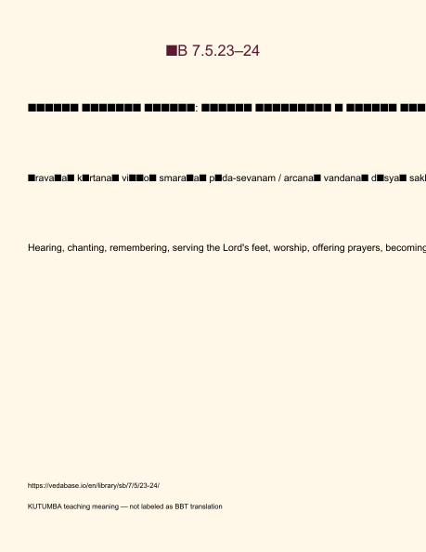
Original KUTUMBA visual: verse-card.png
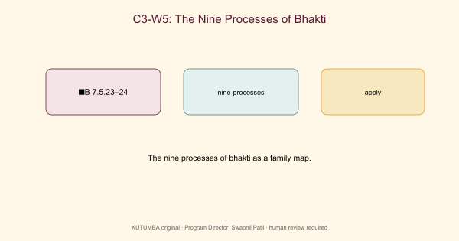
Original KUTUMBA visual: concept-diagram.png
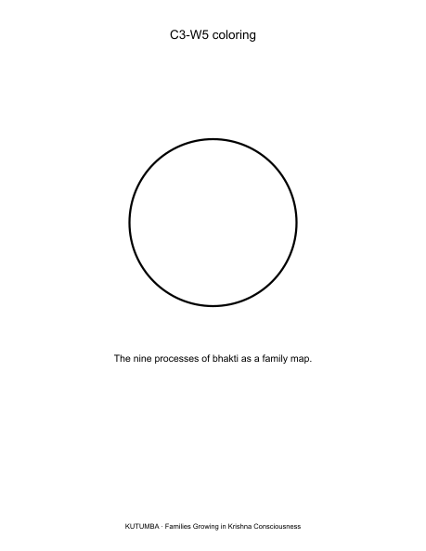
Original KUTUMBA visual: line-art-younger.png
RIGHTS NOTE | Original KUTUMBA program material. Scripture/BBT/ISKCON/third-party rights remain with their holders.

