KUTUMBA

C3-W5 YOUNGER TEACHER GUIDE
  - Families Growing in Krishna Consciousness
C3-W5
V12 • Families Growing in Krishna Consciousness
Program Director: Swapnil Patil
Internal founding-cohort teaching material — human/temple review EXTERNAL_OPEN
KUTUMBA | Families Growing in Krishna Consciousness

KUTUMBA • Families Growing in Krishna Consciousness Program Director: Swapnil Patil Status: Internal founding-cohort teaching material — human/temple review EXTERNAL_OPEN

Objective
Children meet nine process icons with gestures and Prahlāda as a rememberer/speaker about Kṛṣṇa.

Exact memory phrase
Nine ways to love Viṣṇu — and that dedicated bhakti is the highest learning.

Teacher background (enough to teach without improvising)
Primary: ŚB 7.5.23–24 (https://vedabase.io/en/library/sb/7/5/23-24/).
Teaching meaning to keep in mind: Hearing, chanting, remembering, serving the Lord's feet, worship, offering prayers, becoming a servant, friendship, and full self-surrender — these nine processes of bhakti, when offered to Viṣṇu, are the topmost learning.
Block tonight: Bhakti = only attending class / pride in a single process while scorning others..
Parents remain onsite. Session is Saturday 2:00–4:00 with snack/water only (no weekly meal).

Timed run-of-show (about 40 minutes inside the track window)
Minutes | Move | Exact teacher language / action
0–5 | Arrival + wonder | “Today we learn: Nine ways to love Viṣṇu — and that dedicated bhakti is the highest learning.. Can your hands show listening?”
5–15 | Story / picture | Use only authorized paraphrase from SCRIPTURAL-EXAMPLES and the week story boundary. No invented dialogue for the Lord.
15–28 | Movement / hands-on | Run YOUNGER-ACTIVITY-PACK stations in order. Offer opt-out quiet helper role.
28–35 | Recall | Choral memory phrase twice; one child restates with a picture card.
35–40 | Cleanup + handoff | “Tell your family one word: nine.”

Step-by-step story boundary
- Open with one concrete child-scale scene connected to this week’s essential question: How does bhakti fill a whole family life — not only Friday class?
- Introduce the Lord or teacher figure only with authorized names and actions.
- Pause for a wonder question before the craft.
- Close by tying the craft to the memory phrase — not to fear or competition.

Wonder questions (ask, then wait)
- What was new for your ears today?
- Whom can we serve with care?
- When can our family practice five quiet minutes?

Movement / hands-on / craft / coloring (executable)
- Nine-process action circle with picture icons and simple gestures.
- Prahlāda focus: he remembers and speaks about Kṛṣṇa (gentle).
- Nine-petal flower craft; child chooses one petal to ‘try at home.’
Use visuals/V12/line-art-younger.svg if available for coloring; otherwise plain paper + three labels. If a child refuses craft, they may be card-holder or line leader.

Inclusive participation menu
- Full participant
- Listener with gesture
- Materials helper
- Door/line helper beside an adult
Never require performance singing or public speaking.

Behavior redirects (short)
- Feet on floor · kind words · toy rests · quiet reset corner with a picture card.
- Never use chanting, verse, or seating as punishment.
- If a child is overwhelmed, offer helper role (card holder / line leader) with adult nearby.
- If two children conflict, separate gently, name the stewardship/friend rule for this week, and reset materials together.

Backup if energy crashes (5 minutes)
Circle: whisper memory phrase → stretch → place one sticker on “we tried” chart (no scores). If still flooded, quiet picture walk of three cards only.

Materials checklist
- icons
- petal craft
- glue sticks
- crayons
- Tissues, wipes, spare pencils
- Parent handoff cards pre-written with memory phrase

Parent handoff line
Tonight’s phrase is: “Nine ways to love Viṣṇu — and that dedicated bhakti is the highest learning..” Home cue: Continue the family's core practice and add one underused process once..

Instructional visuals
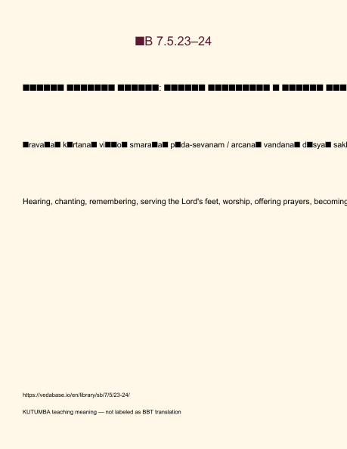
Original KUTUMBA visual: verse-card.png
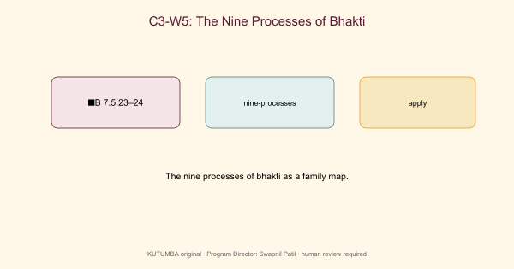
Original KUTUMBA visual: concept-diagram.png
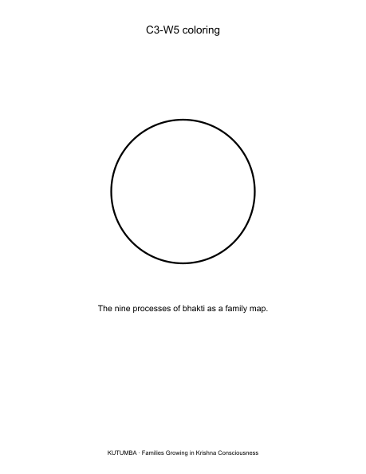
Original KUTUMBA visual: line-art-younger.png
RIGHTS NOTE | Original KUTUMBA program material. Scripture/BBT/ISKCON/third-party rights remain with their holders.

