KUTUMBA

C3-W6 MAIN FACILITATOR GUIDE
  - Families Growing in Krishna Consciousness
C3-W6
V12 • Families Growing in Krishna Consciousness
Program Director: Swapnil Patil
Internal founding-cohort teaching material — human/temple review EXTERNAL_OPEN
KUTUMBA | Families Growing in Krishna Consciousness

KUTUMBA • Families Growing in Krishna Consciousness Program Director: Swapnil Patil Status: Internal founding-cohort teaching material — human/temple review EXTERNAL_OPEN

Two-minute summary
Integration night. Exact review chain MUST be: BG 5.29 · BG 7.7 · BG 4.34 · CC Antya 20.12 · ŚB 7.5.23–24. Never substitute a generic ‘holy name’ label for CC Antya 20.12. Families present, serve, chant, and draft a thirty-day baseline.
Primary: Cycle 3 review chain: BG 5.29 · BG 7.7 · BG 4.34 · CC Antya 20.12 · ŚB 7.5.23–24 — https://vedabase.io/en/library/sb/7/5/23-24/

Essential question
How do we celebrate what we learned — with joy, accuracy, and no ranking?

Learning outcomes (session)
- Connect the five C3 primaries in order without generic placeholders.
- Present one source-based principle through kīrtana, drama, poster, or explanation.
- Draft a thirty-day baseline: daily, weekly, monthly elements.
- Children contribute through safe, opt-out-capable roles.

15-minute night-before prep
- Open https://vedabase.io/en/library/sb/7/5/23-24/ and read Devanāgarī, IAST, and the KUTUMBA teaching meaning aloud once.
- Rehearse the exact opening script below without improvising new doctrine.
- Pack younger materials and older materials listed under Materials.
- Mark the week's primary misconception to block: Competitive scoring of devotion / replacing CC Antya 20.12 with vague ‘holy name’ in the review chain..
- Confirm snack and water table (no weekly meal) and parent-onsite seating.
- Print or open the home-practice card wording for saṅkalpa.

60-minute deep prep
- Read the Core explanation section twice; highlight three sentences you will say slowly.
- Choose one analogy and one case you will actually use; mark time cues in the margin.
- Prepare three questions: one discovery, one understanding, one application.
- Walk the room: welcome zone, verse wall, younger track, older track, reunification circle, snack table.
- Confirm younger and older teachers have executable guides (not shells) and activity packs.
- Review deferral language: if a question exceeds week scope, thank the asker, note it, and schedule follow-up with a qualified source rather than inventing an answer.
- Review safeguarding: no private home struggles disclosed publicly; no ranking; child opt-out roles available.

Exact primary readings
- Reference: Cycle 3 review chain: BG 5.29 · BG 7.7 · BG 4.34 · CC Antya 20.12 · ŚB 7.5.23–24
- URL: https://vedabase.io/en/library/sb/7/5/23-24/
- Devanāgarī: BG 5.29 · BG 7.7 · BG 4.34 · CC Antya 20.12 · ŚB 7.5.23–24 (full texts in prior week packs)
- IAST: BG 5.29 · BG 7.7 · BG 4.34 · CC Antya 20.12 · ŚB 7.5.23–24
- KUTUMBA teaching meaning: Bhakti Mela — review the Cycle 3 chain (peace formula, Kṛṣṇa’s supremacy, guru–sādhu–śāstra, saṅkīrtana victory, nine processes) and celebrate family presentation without ranking.
- Rights: Sanskrit from VedaBase display; KUTUMBA teaching meaning is original program pedagogy — not labeled as a BBT English translation; do not paste full purports into slides or handouts.

Supporting sources (link-level; summarize, do not copy purports)
- BG 5.29 — https://vedabase.io/en/library/bg/5/29/
- BG 7.7 — https://vedabase.io/en/library/bg/7/7/
- BG 4.34 — https://vedabase.io/en/library/bg/4/34/
- CC Antya 20.12 — https://vedabase.io/en/library/cc/antya/20/12/
- ŚB 7.5.23–24 — https://vedabase.io/en/library/sb/7/5/23-24/

One-page speaking map
- Welcome and memory of prior week (2–3 min)
- Essential question (1 min)
- Verse layer — Devanāgarī / IAST / teaching meaning (6–8 min)
- Core explanation with board triangle or map (8–10 min)
- One analogy with spoken limit (3 min)
- One case study (5 min)
- Age-track handoff (tracks 40 min)
- Reunification share (8–10 min)
- Snack/water
- Home practice saṅkalpa and close

Exact opening script
Welcome to C3-W6: Bhakti Mela — Kīrtana, Drama and Family Presentation. Essential question: How do we celebrate what we learned — with joy, accuracy, and no ranking? Exact Cycle 3 review chain: BG 5.29 · BG 7.7 · BG 4.34 · CC Antya 20.12 · ŚB 7.5.23–24 We will rotate through presentations, chant together, and choose a small thirty-day baseline. Mela rules: service, source accuracy, time limits, no ranking, child opt-out roles.

Core explanation (teach this; do not outsource to research files)

Exact review chain (memorize the labels)
- BG 5.29 — God as enjoyer, proprietor, friend → peace
- BG 7.7 — Nothing superior to Kṛṣṇa; pearls on a thread
- BG 4.34 — Humility, inquiry, service to knowers of truth
- CC Antya 20.12 — Complete Śikṣāṣṭaka 1 through paraṁ vijayate śrī-kṛṣṇa-saṅkīrtanam
- ŚB 7.5.23–24 — Nine processes AND topmost learning (iti puṁsārpitā…)
Facilitators must say CC Antya 20.12 in the chain — never a generic “holy name” placeholder. The holy name is the content of that verse; the citation must remain precise for integrity audits.

Mela rules (state at minute 0)
- Service first
- Source accuracy
- Time limits
- No ranking / no scoreboard devotion
- Child opt-out roles always available
- Parents onsite; snack/water only

Zone ideas
- Source poster zone (one verse from the chain)
- Short drama zone (misconception repair: performance kīrtana, charismatic rumor, false proprietorship)
- Kīrtana role zone
- Nine-process demonstration zone
- Stewardship exhibit (from W1)

Thirty-day baseline
Daily: smallest sustainable practice (often hearing/chanting minutes) Weekly: one family kīrtana or verse review Monthly: one service or temple connection act

Closing gratitude
Six months of KUTUMBA aimed at hearing, chanting, remembering, serving, and reorganizing home life around Kṛṣṇa — not creating another empty event.

Minute-by-minute facilitator script (plenary portion)

2:00–2:10 — Welcome and settling
Greet each family by name if known. Point out restrooms, water, and the snack table timing (snack at 3:30, not a weekly meal). Remind parents they remain onsite. Open with the program’s authorized mantras using the local chanting sheet. Keep volume warm, not theatrical. If a child is dysregulated, offer a quiet helper role immediately rather than competing with the room.

2:10–2:18 — Opening script and essential question
Deliver the exact opening script without adding new doctrinal claims. Pause after the essential question. Collect two or three short responses. Do not debate. Write one phrase on the board that you will return to later. State the primary reference and URL verbally so older learners hear that scripture is locatable.

2:18–2:28 — Verse layer
Display Devanāgarī. Read slowly. Display IAST. Read slowly. Read the full KUTUMBA teaching meaning without truncation. Ask one child to repeat a memory phrase and one older learner to name the reference. If the primary is a multi-verse or long verse text, do not stop mid-verse. For C3-W4, end aloud on paraṁ vijayate śrī-kṛṣṇa-saṅkīrtanam. For C3-W5, include iti puṁsārpitā … ’dhītam uttamam. For C3-W6, recite the exact chain BG 5.29 · BG 7.7 · BG 4.34 · CC Antya 20.12 · ŚB 7.5.23–24.

2:28–2:40 — Core map, analogy, and one case
Teach the board map from the core explanation. Use exactly one analogy and speak its limit in the same breath. Run one case study with compassionate response language. Protect privacy: no family is asked to confess failures publicly. Transition: “Now we practice in age bands; parents stay onsite; we reunite at 3:10.”

2:40–3:10 — Tracks (facilitator float)
Float between younger and older rooms/zones. Ensure teachers are using executable guides, not improvising doctrine. Watch for punishment-chanting, ranking, or unsafe secrecy language and interrupt gently. Keep snack prep silent in the background.

3:10–3:30 — Reunification and snack
Use the reunification script. Limit shares to one sentence or one picture. Begin snack/water. No lesson competition during snack. Capture home-practice commitments on cards.

3:40–4:00 — Saṅkalpa and close
Read the minimum home practice. Invite one adult and one child to restate it. Preview next week in one sentence. Thank volunteers. Reset the room. End at 4:00.

Facilitator voice examples (say / don’t say)

Say
- “Śāstra first — let’s open the verse.”
- “That is a sincere question; we will note it and follow up with a qualified source.”
- “Helper roles are real service.”
- “We do not rank families.”

Don’t say
- “Your family is behind.”
- “Chant until you behave.”
- “Science has now proven this verse.”
- “This material is temple-approved / publication-ready.” (It is EXTERNAL_OPEN for human/temple review.)
- “Mṛgāri story time.” (Out of scope for Cycle 3.)

Differentiation and newcomers
Newcomer adults: give the two-minute summary and the home-practice card; do not flood with Sanskrit pressure. Newcomer children: pair with a buddy; allow listening-only kīrtana roles. Multilingual homes: English teaching meaning is enough for comprehension; Sanskrit is honored by hearing, not by forced accuracy on night one. If a family arrives late, skim to the verse layer and hand them the card; do not publicly recap someone else’s private share.

Room stewardship checklist (executable)
- Verse wall visible from both tracks’ return path.
- Younger materials bag packed before 1:50.
- Older worksheets and answer key (private) separated.
- Water labeled; allergen note if any shared snack.
- Timer visible for track teachers.
- Safeguarding adult identified on the run-sheet.
- Cleanup bags at doors by 3:50.
- Lost-and-found box for craft pieces.

Analogies (inline — with limits)

Analogy 1: Relay baton
- Say: Each week passes a baton; dropping the citation label drops integrity.
- Limit: Spiritual life is not a race.
- Bridge back to verse: Keep the five citations in order

Analogy 2: Potluck without prizes
- Say: Everyone brings a dish; we do not crown a winner.
- Limit: Food is analogy for sharing only.
- Bridge back to verse: No ranking rule

Analogy 3: Garden baseline
- Say: Water a little daily rather than flood once a year.
- Limit: Agriculture ≠ siddhānta.
- Bridge back to verse: Thirty-day baseline design

Case studies (three constructed pedagogical cases)

Case 1: Scoreboard mela
- Situation: A helper starts awarding points for ‘best drama.’
- Mistaken conclusion: Celebration requires winners.
- Principle from primary: No ranking of devotion.
- Compassionate response (say): Stop the scoreboard; thank service roles instead.
- Family action (5–15 min): Replace points with gratitude cards.
- What not to say: Embarrassing the helper; coach privately.

Case 2: Generic chain language
- Situation: A poster says: BG 5.29 · BG 7.7 · BG 4.34 · holy name · ŚB 7.5.23–24.
- Mistaken conclusion: Vague label is fine for review.
- Principle from primary: Chain must name CC Antya 20.12.
- Compassionate response (say): Correct the poster before presentations.
- Family action (5–15 min): Rewrite the chain line exactly.
- What not to say: Public shaming of the poster maker.

Case 3: Overbuilt baseline
- Situation: A family plans two hours daily and burns out by day four.
- Mistaken conclusion: Intensity equals sincerity.
- Principle from primary: Smallest daily practice that survives busy weeks.
- Compassionate response (say): Shrink the plan kindly.
- Family action (5–15 min): Rewrite daily element to five attentive minutes.
- What not to say: Calling burnout ‘lack of faith.’

Facilitator questions

Discovery
- Say the exact five-link review chain.
- Which week’s verse will your family present?
- What opt-out role can a shy child take?

Understanding
- Why must CC Antya 20.12 appear by name?
- How do mela rules protect children and humility?
- Why is a small baseline better than a heroic plan?

Application
- What is your daily / weekly / monthly baseline trio?
- Who supports you if you miss a day?
- What gratitude will you speak without comparing families?

Adult FAQ (likely room questions)
Q: Do we need costumes? A: Optional and modest. Content accuracy beats costume complexity.
Q: Can we skip presenting? A: Yes. Service roles count. No coercion.
Q: Is Cycle 3 ‘approved complete’? A: Do not claim human/temple/publication approval. Mark internal readiness only as EXTERNAL_OPEN items require.

Common misconceptions to correct gently
- Generic ‘holy name’ is an acceptable chain label.
- Mela needs winners.
- Everyone must perform on stage.
- Baseline must be impressive to be real.

Doctrinal and delivery boundaries
- Exact chain: BG 5.29 · BG 7.7 · BG 4.34 · CC Antya 20.12 · ŚB 7.5.23–24
- No ranking
- No false approvals
- No Mṛgāri
- Parents onsite; Saturday 2–4; snack/water only

Track facilitation notes

Younger track (K–2 / Lāla–Lālī)
- Objective: Children join procession, simple kīrtana, and a safe drama role without pressure.
- Memory phrase: BG 5.29 · BG 7.7 · BG 4.34 · CC Antya 20.12 · ŚB 7.5.23–24 — learned, shared, continued.
- Keep movement short; prefer recognition over recitation pressure.
- Handoff to reunification with one picture or gesture share.

Older track (Kiśora–Kiśorī)
- Objective: Students run a station or two-minute source explanation and help draft the baseline.
- Require source naming (Cycle 3 review chain: BG 5.29 · BG 7.7 · BG 4.34 · CC Antya 20.12 · ŚB 7.5.23–24) before opinions.
- Use text observation + one case repair; no competitive scoring.

Reunification script
Welcome back. We will hear a few short shares — a word, a picture, or one sentence — without ranking families. What did you notice about gratitude for the whole chain without ranking? Our home step is small and steady: Begin the thirty-day baseline with the smallest daily practice.. Next week we move to Protected off-week / cycle celebration planning as scheduled by program calendar — then next curriculum phase when ready. without dropping this week's practice.

Home practice and saṅkalpa
- Minimum home practice: Begin the thirty-day baseline with the smallest daily practice.
- Bhakti laboratory cue: Bhakti Mela rotation and thirty-day baseline
- Write the card before closing; invite one adult and one child to restate it.

Transition to next week
Close Cycle 3 with gratitude. Keep the baseline small enough to survive busy weeks. Do not announce false completion approvals.

Materials checklist
- Review-chain banner with exact citations
- Station signs
- Timer
- Baseline worksheets
- Gratitude cards
- Snack/water
- Cleanup kits

Do not claim
- Human, temple, legal, or publication approval
- That KUTUMBA teaching meanings are BBT translations
- That science proves ātman, karma, or bhakti siddhānta
- Ranking of families, children, or devotion
- Advanced realization from one night of practice

Saturday time cues (locked)
Clock | Block
1:50 | Facilitator arrival; room zones; snack/water table ready (no weekly meal)
2:00 | Opening mantras / welcome; parents remain onsite
2:10 | Opening script + verse layer (all ages together)
2:30 | Age tracks (younger + older) with parents nearby / onsite
3:10 | Reunification share (no ranking)
3:30 | Snack and water
3:40 | Saṅkalpa / home-practice card
3:55 | Close and cleanup
4:00 | End

Parents stay onsite for the full Saturday 2:00–4:00 window. Do not claim temple, human, or publication approval.

Misconceptions and no-speculation boundaries
- Do not invent dialogue for scriptural persons.
- Do not diagnose private karma or modes as insults in the room.
- Do not claim temple/BBT/human approval that has not been given.
- Defer off-scope questions with the standard deferral line.

Instructional visuals
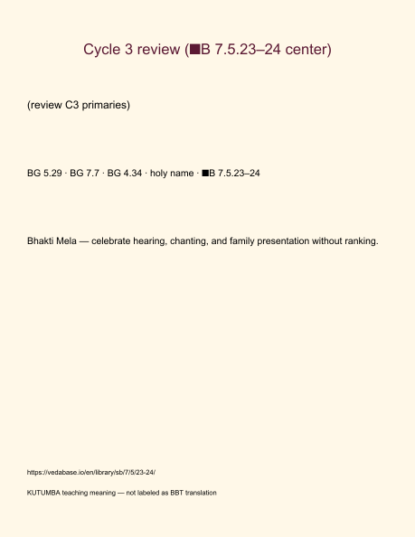
Original KUTUMBA visual: verse-card.png
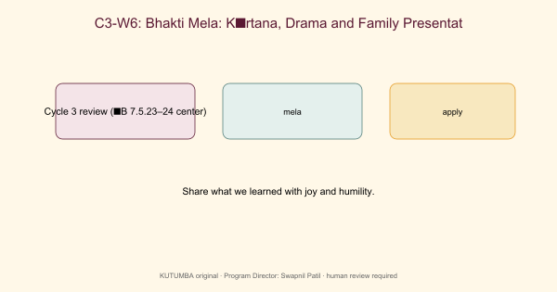
Original KUTUMBA visual: concept-diagram.png
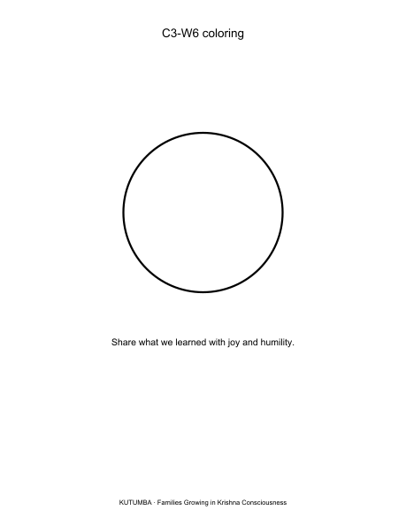
Original KUTUMBA visual: line-art-younger.png
RIGHTS NOTE | Original KUTUMBA program material. Scripture/BBT/ISKCON/third-party rights remain with their holders.

