KUTUMBA

C2-W5 Weekly Print Packet
  - Families Growing in Krishna Consciousness
C2-W5
V12 • Families Growing in Krishna Consciousness
Program Director: Swapnil Patil
Internal founding-cohort teaching material — human/temple review EXTERNAL_OPEN
KUTUMBA | Families Growing in Krishna Consciousness

TIME CUE | Saturday 2:00–4:00 · parents onsite · snack + water only

Week cover + objective
◆ ◆ ◆
week_code: C2-W5 week_title: Māyā: Decorating the Prison Cell derived_from: canonical_file: 03-first-six-months/FIRST-SIX-MONTH-DETAILED-CURRICULUM.md source_id: KUT-SRC-0004 source_hash: 7123781051c732bc82baee084284d0bcac6c6b5011baf12d07216c2e503a7f58 extraction_heading: "C2-W5 — Māyā: Decorating the Prison Cell" extraction_date: 2026-06-30 component: overview ---
Cycle 2 — Karma, Rebirth and Material Nature
**Field** | **Detail**
**Week code** | C2-W5
**Cycle function** | Case study and practical application
**Purpose** | Teach māyā as Kṛṣṇa’s difficult-to-overcome material energy that covers and misdirects the conditioned soul, while showing surrender, association and devotional practice as the way through—not hatred of the world or of women.
**Key verse** | Bhagavad-gītā 7.14 — daivī hy eṣā guṇa-mayī mama māyā duratyayā
**Memory line** | Kṛṣṇa’s material energy is difficult to overcome, but those who surrender to Him can cross beyond it.
**Bhakti laboratory** | Attention Boundary and Japa Shelter
**Minimum home practice** | Use one media or consumption boundary for three days.

Verse / concept visual
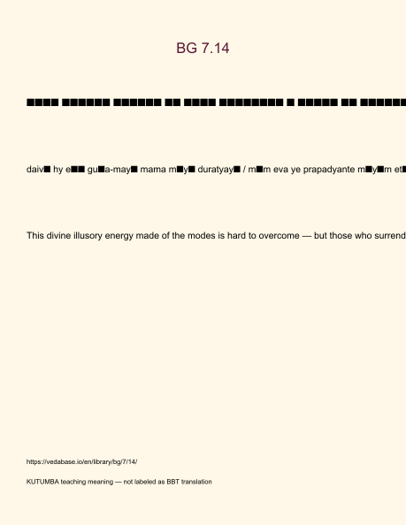
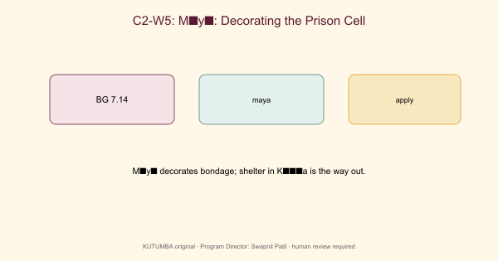

Family handout / home practice
5–15 minutes
- Say the memory/teaching line once.
- Read the KUTUMBA teaching meaning for the primary verse (not a long purport).
- One gratitude or service act.
- Minimum version if tired: one sentence of thanks.
Saturday 2:00–4:00 remains the protected gathering; home practice is the daily/weekly cue.

Younger printable(s)

Memory card
Write: Do not decorate the prison — seek the Lord.

Color page
Color visuals/V12/line-art-younger and draw one place at home to practice.

Craft reminder
Open-door card: Fold cardstock as a door. Then add the memory phrase.

Home mini-task
With a parent, say the memory phrase once before bed.

Older printable(s)

Verse observation
IAST: daivī hy eṣā guṇa-mayī mama māyā duratyayā / mām eva ye prapadyante māyām etāṁ taranti te KUTUMBA teaching meaning: This divine illusory energy made of the modes is hard to overcome — but those who surrender to the Lord cross beyond it. Source: https://vedabase.io/en/library/bg/7/14/

Worksheet
Answer the four worksheet questions from the older teacher guide.

Scenarios
- Stress → buy/upgrade treat immediately. 2) Image management online replaces evening remembrance. 3) Spiritual talk used to avoid chores. For each: name decorating vs seeking.

Puzzle
Cell vs Key match: Match cards: painted walls / new gadget / status post → ‘decorating’; prayer / verse / humble ask for help → ‘seeking’. Discuss one mismatch temptation.

Project line
Essential question: Where am I decorating the prison instead of seeking freedom? Write one sentence contribution.

Project contribution

Cumulative project
Cycle project for this band — week layer for C2-W5.

Essential question
Where are we decorating bondage?

Artifact
One family artifact answering the question; ≤20 minutes optional burden.

Primary
BG 7.14 — https://vedabase.io/en/library/bg/7/14/

Boundaries
No ranking; no forced disclosure; distinguish paraphrase from analogy.

TEACHER-ONLY: Answer key

Teaching meaning check
Accept paraphrases that preserve: This divine illusory energy made of the modes is hard to overcome — but those who surrender to the Lord cross beyond it.

Misconception to reject
Comfort upgrades equal spiritual progress.

Scenario guidance
Prefer answers that are compassionate, source-bound, and specific about a next responsible action. Reject shaming, ranking, and speculation.

Puzzle
Accept any ordering/matching that keeps BG 7.14 as the doctrinal center and analogies labeled as pedagogy.
TEACHER NOTE | Teacher-only section — do not distribute to families.

TEACHER-ONLY: Younger run sheet
Week: Māyā: Decorating the Prison Cell Primary: BG 7.14 — https://vedabase.io/en/library/bg/7/14/ Session length: 40 minutes (parallel track ~2:30–3:10) Parents: Remain onsite; reunite at 3:10 Status: Internal founding-cohort teaching material — human/temple review EXTERNAL_OPEN

Objective
Children can say the memory phrase and complete one movement + one craft that reinforce this week's idea without fear or shame.

Exact memory phrase
Do not decorate the prison — seek the Lord.

Teacher background (2 minutes)
- KUTUMBA teaching meaning: This divine illusory energy made of the modes is hard to overcome — but those who surrender to the Lord cross beyond it.
- Child-facing paraphrase: Sometimes we try to make a stuck place prettier instead of asking Kṛṣṇa for help to become free. Seeking Kṛṣṇa matters more than fancy decorations.
- Block: Comfort upgrades equal spiritual progress.
- Do not: invent deity dialogue; force confessions; rank children; use scary imagery.

Materials
- Printed line art if available (visuals/V12/line-art-younger.png)
- Crayons, tape, scissors (teacher-only for youngers)
- Soft toss object; two baskets or mats for movement game
- Card stock for memory cards
- Snack/water only after reunification (no weekly meal)

Minute-by-minute plan

0–5 Opening
- Welcome by name; feet on floor.
- Echo memory phrase three times with clap rhythm.
- Show one picture cue for the week: A plain door drawing vs a decorated wall drawing — ask which one opens..

5–13 Story script (~8 minutes)
Say this spine (paraphrase only; do not invent dialogue):
Sometimes a person cleans and decorates a small locked room until it looks nice. Looking nice can feel good. But a pretty locked room is still locked. Kṛṣṇa teaches that His illusory energy is hard to cross by ourselves. Those who turn to Him can cross. So we practice one small way to seek Kṛṣṇa — not only to decorate what is temporary.

Wonder questions
- What is one pretty thing that is temporary?
- What does it mean to ask Kṛṣṇa for help?
- Who can we seek with at home?

13–20 Movement game — Decorate or Door
Steps:
- Two mats: Decorate mat and Door mat.
- Teacher calls a situation; children gently move to Door when the answer is seek Kṛṣṇa / ask help / remember.
- If they choose Decorate for a comfort-only answer, smile and invite a Door retry.
- Freeze cue: hands on heart; repeat memory phrase.

20–32 Craft — Open-door card
Steps:
- Fold cardstock as a door.
- Outside: draw one temporary pretty thing.
- Inside: write or sticker ‘Seek Kṛṣṇa’ / memory phrase.
- Write or sticker the memory phrase on the craft.

32–38 Printable / quiet task
Children color the week line art and circle one home place where they will remember the phrase.

38–40 Cleanup / parent handoff
Clean mats; show craft to parent; one sentence: “Our phrase is: Do not decorate the prison — seek the Lord..”

Behavior redirects
- Calm reminder → 2. Offer choice (sit spot / helper job) → 3. Quiet reset visible to parents → 4. Parent involvement. Never shame, yell, or force chanting.

Backup (if energy crashes)
Soft toss while answering: “One kind next step at home is ___.”

Materials checklist / cleanup
Bag crayons; wipe table; leave host space cleaner; return line-art masters to teacher folder.

TEACHER-ONLY: Older run sheet
Week: Māyā: Decorating the Prison Cell Primary: BG 7.14 — https://vedabase.io/en/library/bg/7/14/ Track window: ~2:30–3:10 then reunite Status: Internal founding-cohort teaching material — human/temple review EXTERNAL_OPEN

Objective
Students observe the primary text layer, complete a worksheet and scenario set, and contribute one project sentence answering: Where am I decorating the prison instead of seeking freedom?

Primary text observation
- Read IAST aloud once: daivī hy eṣā guṇa-mayī mama māyā duratyayā / mām eva ye prapadyante māyām etāṁ taranti te
- Students underline two words that seem important.
- State KUTUMBA teaching meaning in full: This divine illusory energy made of the modes is hard to overcome — but those who surrender to the Lord cross beyond it.
- Label clearly: KUTUMBA teaching meaning — not BBT translation.

Worksheet questions
- In your words, what does BG 7.14 teach this week?
- What mistaken idea does this week block? (Comfort upgrades equal spiritual progress.)
- Name one home situation where this teaching changes a next step.
- What is still confusing? (honest question OK)

Scenario cards (read–choose–explain)
- Stress → buy/upgrade treat immediately. 2) Image management online replaces evening remembrance. 3) Spiritual talk used to avoid chores. For each: name decorating vs seeking.

Puzzle / game — Cell vs Key match
Match cards: painted walls / new gadget / status post → ‘decorating’; prayer / verse / humble ask for help → ‘seeking’. Discuss one mismatch temptation.

Diagram task
Sketch a simple map of this week's idea using boxes/arrows. Label scripture vs analogy if both appear.

Project contribution
Add one sentence to the cycle project answering the essential question. Keep ≤5 minutes.

Reflection
Write: “This week I will practice ___ when ___.”

Extension (optional)
Compare one supporting reference from the facilitator guide with the primary — what does it add, and what limit remains?

Answer key pointer
Use activities/OLDER-ANSWER-KEY.md (teacher-only). Do not distribute keys to students during work time.

