KUTUMBA

C2-W6 Weekly Print Packet
  - Families Growing in Krishna Consciousness
C2-W6
V12 • Families Growing in Krishna Consciousness
Program Director: Swapnil Patil
Internal founding-cohort teaching material — human/temple review EXTERNAL_OPEN
KUTUMBA | Families Growing in Krishna Consciousness

TIME CUE | Saturday 2:00–4:00 · parents onsite · snack + water only

Week cover + objective
◆ ◆ ◆
week_code: C2-W6 week_title: Integration Night: Choice, Consequence and the Modes derived_from: canonical_file: 03-first-six-months/FIRST-SIX-MONTH-DETAILED-CURRICULUM.md source_id: KUT-SRC-0004 source_hash: 7123781051c732bc82baee084284d0bcac6c6b5011baf12d07216c2e503a7f58 extraction_heading: "C2-W6 — Integration Night: Choice, Consequence and the Modes" extraction_date: 2026-06-30 component: overview ---
Cycle 2 — Karma, Rebirth and Material Nature
**Field** | **Detail**
**Week code** | C2-W6
**Cycle function** | Family case-study night and assessed application
**Purpose** | Consolidate karma, responsibility, reincarnation, modes and māyā through family decisions, scenario analysis and one practical redesign plan.
**Key verse** | Bhagavad-gītā 18.63 — vimṛśyaitad ... yathecchasi tathā kuru
**Memory line** | Knowledge should lead to thoughtful, responsible choice under Kṛṣṇa’s guidance.
**Bhakti laboratory** | Five-Lens Family Case Lab
**Minimum home practice** | Continue one selected Cycle 2 method during the off week.

Verse / concept visual
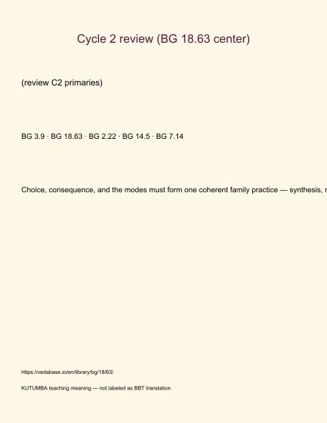
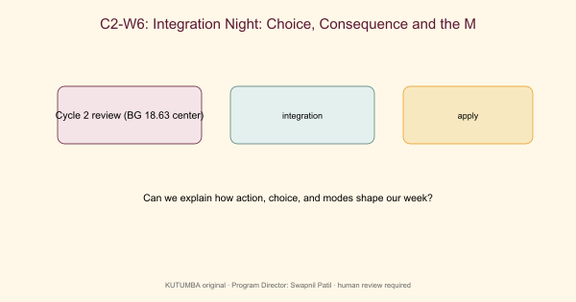

Family handout / home practice
5–15 minutes · Off-week continuity
- Say the memory line once: Knowledge should lead to thoughtful, responsible choice under Kṛṣṇa’s guidance.
- Continue one selected Cycle 2 method (choose one): before–during–after review · choice pause · bedtime remembrance · clarity reset · boundary-plus-shelter.
- Keep one environmental change that supports the method (example: Friday device basket / earlier prep cue).
- One gratitude or service act.
- Minimum version if tired: memory line + one choice pause or one kind boundary only.
Standard (if energy allows): use the method three times during the off week and keep the environmental change. Evidence: private continuity card with method, trigger, and support person — never a public scoreboard.
Saturday 2:00–4:00 remains the protected gathering; home practice is the daily/weekly cue. Next week title only: Cycle 3 begins (Who is God / BG 5.29) — no early ontology homework.

Younger printable(s)

Memory card
Write: Retrieve, repair, and choose again — without ranking.

Color page
Color visuals/V12/line-art-younger and draw one place at home to practice.

Craft reminder
Retrieval bracelet: String five paper beads. Then add the memory phrase.

Home mini-task
With a parent, say the memory phrase once before bed.

Older printable(s)

Verse observation
IAST: BG 3.9 · BG 18.63 · BG 2.22 · BG 14.5 · BG 7.14 KUTUMBA teaching meaning: Choice, consequence, and the modes must form one coherent family practice — synthesis, not new doctrine. Source: https://vedabase.io/en/library/bg/18/63/

Worksheet
Answer the four worksheet questions from the older teacher guide.

Scenarios
Stations: (1) karma/action, (2) next choice, (3) reincarnation clothing, (4) modes, (5) māyā/decorating. At each: write one sentence + one misconception to reject.

Puzzle
Chain restore: Unscramble the five primary references into calendar order and state one teaching sentence each.

Project line
Essential question: How do choice, consequence, and the modes form one coherent family practice? Write one sentence contribution.

Project contribution

Cumulative project
Cycle project for this band — week layer for C2-W6.

Essential question
Can we synthesize choice and modes?

Artifact
One family artifact answering the question; ≤20 minutes optional burden.

Primary
Cycle 2 review (BG 18.63 center) — https://vedabase.io/en/library/bg/18/63/

Boundaries
No ranking; no forced disclosure; distinguish paraphrase from analogy.

TEACHER-ONLY: Answer key

Teaching meaning check
Accept paraphrases that preserve: Choice, consequence, and the modes must form one coherent family practice — synthesis, not new doctrine.

Misconception to reject
Integration night means competing to sound the most advanced.

Scenario guidance
Prefer answers that are compassionate, source-bound, and specific about a next responsible action. Reject shaming, ranking, and speculation.

Puzzle
Accept any ordering/matching that keeps Cycle 2 review (BG 18.63 center) as the doctrinal center and analogies labeled as pedagogy.
TEACHER NOTE | Teacher-only section — do not distribute to families.

TEACHER-ONLY: Younger run sheet
Week: Integration Night: Choice, Consequence, and the Modes Primary: Cycle 2 review (BG 18.63 center) — https://vedabase.io/en/library/bg/18/63/ Session length: 40 minutes (parallel track ~2:30–3:10) Parents: Remain onsite; reunite at 3:10 Status: Internal founding-cohort teaching material — human/temple review EXTERNAL_OPEN

Objective
Children can say the memory phrase and complete one movement + one craft that reinforce this week's idea without fear or shame.

Exact memory phrase
Retrieve, repair, and choose again — without ranking.

Teacher background (2 minutes)
- KUTUMBA teaching meaning: Choice, consequence, and the modes must form one coherent family practice — synthesis, not new doctrine.
- Child-facing paraphrase: We remember five friend-ideas from Cycle 2 and practice kindness without winning trophies.
- Block: Integration night means competing to sound the most advanced.
- Do not: invent deity dialogue; force confessions; rank children; use scary imagery.

Materials
- Printed line art if available (visuals/V12/line-art-younger.png)
- Crayons, tape, scissors (teacher-only for youngers)
- Soft toss object; two baskets or mats for movement game
- Card stock for memory cards
- Snack/water only after reunification (no weekly meal)

Minute-by-minute plan

0–5 Opening
- Welcome by name; feet on floor.
- Echo memory phrase three times with clap rhythm.
- Show one picture cue for the week: Five paper beads on a string labeled with simple C2 words..

5–13 Story script (~8 minutes)
Say this spine (paraphrase only; do not invent dialogue):
This cycle we learned: actions have fruits; the next choice matters; the body is like clothes; moods can color our day; and seeking Kṛṣṇa matters more than only decorating temporary things. Tonight we string those ideas like beads. No one is better than another. We help each other remember.

Wonder questions
- Which bead do you remember?
- How can we help a friend remember?
- What is one kind choice tonight?

13–20 Movement game — Bead walk
Steps:
- Five floor spots for C2 ideas.
- Children walk gently to a called bead and say a child-friendly word.
- Freeze and say memory phrase.
- Freeze cue: hands on heart; repeat memory phrase.

20–32 Craft — Retrieval bracelet
Steps:
- String five paper beads.
- Draw one symbol per bead.
- Add a tag: ‘No ranking — only remembering.’
- Write or sticker the memory phrase on the craft.

32–38 Printable / quiet task
Children color the week line art and circle one home place where they will remember the phrase.

38–40 Cleanup / parent handoff
Clean mats; show craft to parent; one sentence: “Our phrase is: Retrieve, repair, and choose again — without ranking..”

Behavior redirects
- Calm reminder → 2. Offer choice (sit spot / helper job) → 3. Quiet reset visible to parents → 4. Parent involvement. Never shame, yell, or force chanting.

Backup (if energy crashes)
Soft toss while answering: “One kind next step at home is ___.”

Materials checklist / cleanup
Bag crayons; wipe table; leave host space cleaner; return line-art masters to teacher folder.

TEACHER-ONLY: Older run sheet
Week: Integration Night: Choice, Consequence, and the Modes Primary: Cycle 2 review (BG 18.63 center) — https://vedabase.io/en/library/bg/18/63/ Track window: ~2:30–3:10 then reunite Status: Internal founding-cohort teaching material — human/temple review EXTERNAL_OPEN

Objective
Students observe the primary text layer, complete a worksheet and scenario set, and contribute one project sentence answering: How do choice, consequence, and the modes form one coherent family practice?

Primary text observation
- Read IAST aloud once: BG 3.9 · BG 18.63 · BG 2.22 · BG 14.5 · BG 7.14
- Students underline two words that seem important.
- State KUTUMBA teaching meaning in full: Choice, consequence, and the modes must form one coherent family practice — synthesis, not new doctrine.
- Label clearly: KUTUMBA teaching meaning — not BBT translation.

Worksheet questions
- In your words, what does Cycle 2 review (BG 18.63 center) teach this week?
- What mistaken idea does this week block? (Integration night means competing to sound the most advanced.)
- Name one home situation where this teaching changes a next step.
- What is still confusing? (honest question OK)

Scenario cards (read–choose–explain)
Stations: (1) karma/action, (2) next choice, (3) reincarnation clothing, (4) modes, (5) māyā/decorating. At each: write one sentence + one misconception to reject.

Puzzle / game — Chain restore
Unscramble the five primary references into calendar order and state one teaching sentence each.

Diagram task
Sketch a simple map of this week's idea using boxes/arrows. Label scripture vs analogy if both appear.

Project contribution
Add one sentence to the cycle project answering the essential question. Keep ≤5 minutes.

Reflection
Write: “This week I will practice ___ when ___.”

Extension (optional)
Compare one supporting reference from the facilitator guide with the primary — what does it add, and what limit remains?

Answer key pointer
Use activities/OLDER-ANSWER-KEY.md (teacher-only). Do not distribute keys to students during work time.

