KUTUMBA

C3-W1 Weekly Print Packet
  - Families Growing in Krishna Consciousness
C3-W1
V12 • Families Growing in Krishna Consciousness
Program Director: Swapnil Patil
Internal founding-cohort teaching material — human/temple review EXTERNAL_OPEN
KUTUMBA | Families Growing in Krishna Consciousness

TIME CUE | Saturday 2:00–4:00 · parents onsite · snack + water only

Week cover + objective
◆ ◆ ◆
week_code: C3-W1 week_title: Who Is God? The Supreme Enjoyer, Proprietor and Friend derived_from: canonical_file: 03-first-six-months/FIRST-SIX-MONTH-DETAILED-CURRICULUM.md source_id: KUT-SRC-0004 source_hash: 7123781051c732bc82baee084284d0bcac6c6b5011baf12d07216c2e503a7f58 extraction_heading: "C3-W1 — Who Is God? The Supreme Enjoyer, Proprietor and Friend" extraction_date: 2026-06-30 component: overview ---
Cycle 3 — Kṛṣṇa, Guru and the Process of Bhakti
**Field** | **Detail**
**Week code** | C3-W1
**Cycle function** | Foundational principle
**Purpose** | Give families a clear personal conception of God as the supreme conscious controller, proprietor, enjoyer, witness and well-wishing friend, and show how this knowledge brings practical peace.
**Key verse** | Bhagavad-gītā 5.29 — bhoktāraṁ yajña-tapasāṁ ... suhṛdaṁ sarva-bhūtānām
**Memory line** | Peace comes from knowing Kṛṣṇa as the supreme enjoyer, proprietor of everything and friend of all living beings.
**Bhakti laboratory** | Stewardship Seva and Simple Offering Mood
**Minimum home practice** | Before one daily duty, remember: Kṛṣṇa owns, Kṛṣṇa enjoys, Kṛṣṇa is friend.

Verse / concept visual
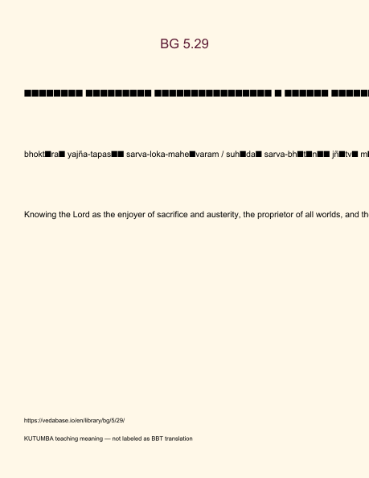
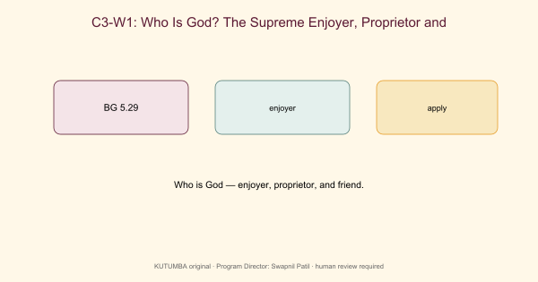

Family handout / home practice
5–15 minutes
- Say the memory/teaching line once.
- Read the KUTUMBA teaching meaning for the primary verse (not a long purport).
- One gratitude or service act.
- Minimum version if tired: one sentence of thanks.
Saturday 2:00–4:00 remains the protected gathering; home practice is the daily/weekly cue.

Younger printable(s)
KUTUMBA • Families Growing in Krishna Consciousness Program Director: Swapnil Patil Status: Internal founding-cohort teaching material — human/temple review EXTERNAL_OPEN

Setup (before children arrive)
- Lay stations left-to-right: Picture walk → Hands-on → Recall.
- Place memory phrase card at each station.
- Prepare helper badges (sticker + “helper” word).
- Keep one calm-corner mat with a single picture card.

Station A — Picture walk (8–10 min)
Shared basket: children place toys/books in ‘Kṛṣṇa’s care basket,’ then practice returning one item clean.
Teacher script: “Walk slowly. Point to one picture. Tell me one word you notice.” Look-fors: pointing, one-word share, gentle hands. Adaptation: child may carry the card without speaking.

Station B — Hands-on (8–10 min)
Three-picture chant with gestures: receive (hands up), own (hands open over room), friend (hand on heart).
Teacher script: “We practice with care. If it feels too much, you may be the materials helper.” Look-fors: attempt + cleanup. Adaptation: hand-over-hand help from parent onsite.

Station C — Recall game (5–7 min)
Offer a flower or drawing with love; thank the friend.
Teacher script: “Whisper our phrase with me: Kṛṣṇa owns, Kṛṣṇa enjoys, Kṛṣṇa is friend — that brings peace.” Look-fors: choral attempt; smile; no forced solos.

Materials
- basket
- picture cards
- flowers/paper
- stickers for effort (not scores)

Success look-fors (not scores)
- Child can gesture or say the memory phrase with help.
- Child participates or takes a helper role without pressure.
- Materials returned; room reset before reunification.

If station fails
Skip to whisper recall + one sticker for effort. Still hand off the memory phrase to parents.

Older printable(s)
KUTUMBA • Families Growing in Krishna Consciousness Program Director: Swapnil Patil Status: Internal founding-cohort teaching material — human/temple review EXTERNAL_OPEN

Materials
- Printed primary verse card (Devanāgarī + IAST + full teaching meaning)
- Case slip from MAIN facilitator guide
- Pencil, timer, private folder for answer sheets

Task 1 — Text observation (10 min)
Underline enjoyer, proprietor, friend, and peace in the teaching meaning; list one family ‘mine’ phrase to retire.
Deliverable: underlined keywords + one-sentence restatement of the teaching meaning (complete, not truncated).

Task 2 — Case repair (10 min)
Repair the credit-war case: write mistaken conclusion and a BG 5.29-aligned response.
Deliverable: mistaken conclusion / principle / compassionate response / 5–15 min family action.

Task 3 — Application card (8–10 min)
Draft a three-line remembrance card for one real duty (wake-up, homework help, or commute).
Deliverable: home card with day/time cue.

Extension (optional)
Compare BG 5.29 with Īśopaniṣad Mantra 1 at link-level; write three contrast notes (no purport paste).

Collaboration rules
- Pairs okay; no public scoring.
- Source must be named on every share.
- If debate heats up, return to the verse card and timer.

Project contribution

Cumulative project
Cycle project for this band — week layer for C3-W1.

Essential question
Who is God to our family?

Artifact
One family artifact answering the question; ≤20 minutes optional burden.

Primary
BG 5.29 — https://vedabase.io/en/library/bg/5/29/

Boundaries
No ranking; no forced disclosure; distinguish paraphrase from analogy.

TEACHER-ONLY: Answer key
KUTUMBA • Families Growing in Krishna Consciousness Program Director: Swapnil Patil Status: Internal founding-cohort teaching material — human/temple review EXTERNAL_OPEN

Task 1 — Expected observations
Keywords present; ‘mine’ phrase is concrete and non-shaming.

Task 2 — Case repair key
Repair centers Lord as enjoyer/proprietor/friend; avoids public humiliation.

Task 3 — Application quality
Card is specific, short, and schedulable this week.

Facilitator note
Use privately. Do not announce scores. Affirm effort and source accuracy.
TEACHER NOTE | Teacher-only section — do not distribute to families.

TEACHER-ONLY: Younger run sheet
KUTUMBA • Families Growing in Krishna Consciousness Program Director: Swapnil Patil Status: Internal founding-cohort teaching material — human/temple review EXTERNAL_OPEN

Objective
Children recognize God as owner, enjoyer of offerings, and friend — with stewardship care.

Exact memory phrase
Kṛṣṇa owns, Kṛṣṇa enjoys, Kṛṣṇa is friend — that brings peace.

Teacher background (enough to teach without improvising)
Primary: BG 5.29 (https://vedabase.io/en/library/bg/5/29/).
Teaching meaning to keep in mind: Knowing the Lord as the enjoyer of sacrifice and austerity, the proprietor of all worlds, and the friend of all beings — one attains peace.
Block tonight: God is an impersonal force only (or ‘I am the real owner/enjoyer’)..
Parents remain onsite. Session is Saturday 2:00–4:00 with snack/water only (no weekly meal).

Timed run-of-show (about 40 minutes inside the track window)
Minutes | Move | Exact teacher language / action
0–5 | Arrival + wonder | “Today we learn: Kṛṣṇa owns, Kṛṣṇa enjoys, Kṛṣṇa is friend — that brings peace.. Can your hands show listening?”
5–15 | Story / picture | Use only authorized paraphrase from SCRIPTURAL-EXAMPLES and the week story boundary. No invented dialogue for the Lord.
15–28 | Movement / hands-on | Run YOUNGER-ACTIVITY-PACK stations in order. Offer opt-out quiet helper role.
28–35 | Recall | Choral memory phrase twice; one child restates with a picture card.
35–40 | Cleanup + handoff | “Tell your family one word: friend.”

Step-by-step story boundary
- Open with one concrete child-scale scene connected to this week’s essential question: Who is God to our family?
- Introduce the Lord or teacher figure only with authorized names and actions.
- Pause for a wonder question before the craft.
- Close by tying the craft to the memory phrase — not to fear or competition.

Wonder questions (ask, then wait)
- What was new for your ears today?
- Whom can we serve with care?
- When can our family practice five quiet minutes?

Movement / hands-on / craft / coloring (executable)
- Shared basket: children place toys/books in ‘Kṛṣṇa’s care basket,’ then practice returning one item clean.
- Three-picture chant with gestures: receive (hands up), own (hands open over room), friend (hand on heart).
- Offer a flower or drawing with love; thank the friend.
Use visuals/V12/line-art-younger.svg if available for coloring; otherwise plain paper + three labels. If a child refuses craft, they may be card-holder or line leader.

Inclusive participation menu
- Full participant
- Listener with gesture
- Materials helper
- Door/line helper beside an adult
Never require performance singing or public speaking.

Behavior redirects (short)
- Feet on floor · kind words · toy rests · quiet reset corner with a picture card.
- Never use chanting, verse, or seating as punishment.
- If a child is overwhelmed, offer helper role (card holder / line leader) with adult nearby.
- If two children conflict, separate gently, name the stewardship/friend rule for this week, and reset materials together.

Backup if energy crashes (5 minutes)
Circle: whisper memory phrase → stretch → place one sticker on “we tried” chart (no scores). If still flooded, quiet picture walk of three cards only.

Materials checklist
- basket
- picture cards
- flowers/paper
- stickers for effort (not scores)
- Tissues, wipes, spare pencils
- Parent handoff cards pre-written with memory phrase

Parent handoff line
Tonight’s phrase is: “Kṛṣṇa owns, Kṛṣṇa enjoys, Kṛṣṇa is friend — that brings peace..” Home cue: Before one daily duty, remember: Kṛṣṇa owns, Kṛṣṇa enjoys, Kṛṣṇa is friend..

TEACHER-ONLY: Older run sheet
KUTUMBA • Families Growing in Krishna Consciousness Program Director: Swapnil Patil Status: Internal founding-cohort teaching material — human/temple review EXTERNAL_OPEN

Objective
Students explain BG 5.29’s three features and apply them to a family control conflict.

Exact memory / thesis line
Kṛṣṇa owns, Kṛṣṇa enjoys, Kṛṣṇa is friend — that brings peace.

Teacher background
Primary: BG 5.29 — https://vedabase.io/en/library/bg/5/29/
IAST: bhoktāraṁ yajña-tapasāṁ sarva-loka-maheśvaram / suhṛdaṁ sarva-bhūtānāṁ jñātvā māṁ śāntim ṛcchati
Teaching meaning: Knowing the Lord as the enjoyer of sacrifice and austerity, the proprietor of all worlds, and the friend of all beings — one attains peace.
Block: God is an impersonal force only (or ‘I am the real owner/enjoyer’).

Timed run-of-show (about 40 minutes)
Minutes | Move | Instructions
0–5 | Hook | Pose essential question: Who is God to our family? Collect 2–3 short answers without debate.
5–15 | Text | Display Devanāgarī + IAST. Students mark keywords. Read teaching meaning in full.
15–25 | Case lab | Run one case from the main guide; students write mistaken conclusion → repair.
25–33 | Activity pack | Complete OLDER-ACTIVITY-PACK primary task; use answer key privately.
33–38 | Share | Two volunteers; no ranking; source must be named.
38–40 | Handoff | Restate home practice: Before one daily duty, remember: Kṛṣṇa owns, Kṛṣṇa enjoys, Kṛṣṇa is friend.

Text protocol (do this every week)
- Student writes the reference.
- Student underlines 3–6 keywords in IAST or teaching meaning.
- Student restates the teaching meaning in one fresh sentence.
- Student names one limit (what this verse is not saying).

Discussion stems
- “What does the verse actually say — not what we wish it said?”
- “Where is the limit of our analogy?”
- “How would a family apply this without performing for others?”
- “What would ranking look like tonight, and how do we refuse it?”

Case lab facilitator moves
- Read the situation once.
- Ask for the mistaken conclusion before giving the key.
- Require a compassionate response sentence that a parent could actually say.
- Close with the family action timed at 5–15 minutes.

Assessment (formative, private)
- Can the student name BG 5.29?
- Can they restate the teaching meaning in their own words without truncation?
- Can they repair one misconception without sarcasm?
- For C3-W4 specifically: can they end the verse with paraṁ vijayate śrī-kṛṣṇa-saṅkīrtanam?
- For C3-W5 specifically: can they include iti puṁsārpitā / topmost learning?
- For C3-W6 specifically: can they recite BG 5.29 · BG 7.7 · BG 4.34 · CC Antya 20.12 · ŚB 7.5.23–24?

Safeguarding / tone
Respectful conviction, not aggressive debate. No public scoring of devotion. Parents onsite. If a safety disclosure appears, stop the lesson flow and follow safeguarding protocol.

