KUTUMBA

C3-W4 Weekly Print Packet
  - Families Growing in Krishna Consciousness
C3-W4
V12 • Families Growing in Krishna Consciousness
Program Director: Swapnil Patil
Internal founding-cohort teaching material — human/temple review EXTERNAL_OPEN
KUTUMBA | Families Growing in Krishna Consciousness

TIME CUE | Saturday 2:00–4:00 · parents onsite · snack + water only

Week cover + objective
◆ ◆ ◆
week_code: C3-W4 week_title: Śrī Caitanya Mahāprabhu and the Holy Name derived_from: canonical_file: 03-first-six-months/FIRST-SIX-MONTH-DETAILED-CURRICULUM.md source_id: KUT-SRC-0004 source_hash: 7123781051c732bc82baee084284d0bcac6c6b5011baf12d07216c2e503a7f58 extraction_heading: "C3-W4 — Śrī Caitanya Mahāprabhu and the Holy Name" extraction_date: 2026-06-30 component: overview ---
Cycle 3 — Kṛṣṇa, Guru and the Process of Bhakti
**Field** | **Detail**
**Week code** | C3-W4
**Cycle function** | Parent and child formation
**Purpose** | Introduce Śrī Caitanya Mahāprabhu’s gift of congregational chanting and help families experience attentive, humble and joyful nāma practice without performance pressure or claims of advanced realization.
**Key verse** | Caitanya-caritāmṛta Antya 20.12 — Śikṣāṣṭakam 1 — ceto-darpaṇa-mārjanaṁ ... paraṁ vijayate śrī-kṛṣṇa-saṅkīrtanam
**Memory line** | The congregational chanting of Kṛṣṇa’s holy name cleanses the heart and expands spiritual life.
**Bhakti laboratory** | Attentive Family Kīrtana
**Minimum home practice** | Five-minute family kīrtana or attentive mantra listening on three days.

Verse / concept visual
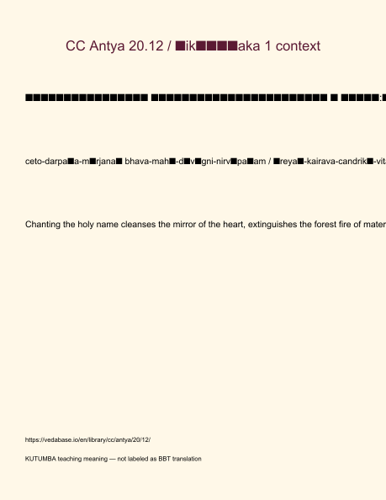
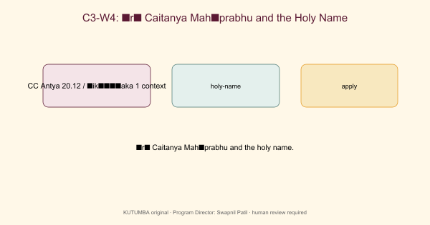

Family handout / home practice
5–15 minutes
- Say the memory/teaching line once.
- Read the KUTUMBA teaching meaning for the primary verse (not a long purport).
- One gratitude or service act.
- Minimum version if tired: one sentence of thanks.
Saturday 2:00–4:00 remains the protected gathering; home practice is the daily/weekly cue.

Younger printable(s)
KUTUMBA • Families Growing in Krishna Consciousness Program Director: Swapnil Patil Status: Internal founding-cohort teaching material — human/temple review EXTERNAL_OPEN

Setup (before children arrive)
- Lay stations left-to-right: Picture walk → Hands-on → Recall.
- Place memory phrase card at each station.
- Prepare helper badges (sticker + “helper” word).
- Keep one calm-corner mat with a single picture card.

Station A — Picture walk (8–10 min)
Mirror cleaning demo with a safely smudged acrylic mirror; say ‘clean heart.’
Teacher script: “Walk slowly. Point to one picture. Tell me one word you notice.” Look-fors: pointing, one-word share, gentle hands. Adaptation: child may carry the card without speaking.

Station B — Hands-on (8–10 min)
Call-and-response names / mahā-mantra with hand-raise at the end of a full mantra.
Teacher script: “We practice with care. If it feels too much, you may be the materials helper.” Look-fors: attempt + cleanup. Adaptation: hand-over-hand help from parent onsite.

Station C — Recall game (5–7 min)
Role cards: leader, responder, listener, space helper — rotate without scores.
Teacher script: “Whisper our phrase with me: Paraṁ vijayate śrī-kṛṣṇa-saṅkīrtanam — all victory to the congregational chanting of Kṛṣṇa’s names.” Look-fors: choral attempt; smile; no forced solos.

Materials
- mirror
- cloth
- role cards
- Pañca-tattva picture

Success look-fors (not scores)
- Child can gesture or say the memory phrase with help.
- Child participates or takes a helper role without pressure.
- Materials returned; room reset before reunification.

If station fails
Skip to whisper recall + one sticker for effort. Still hand off the memory phrase to parents.

Older printable(s)
KUTUMBA • Families Growing in Krishna Consciousness Program Director: Swapnil Patil Status: Internal founding-cohort teaching material — human/temple review EXTERNAL_OPEN

Materials
- Printed primary verse card (Devanāgarī + IAST + full teaching meaning)
- Case slip from MAIN facilitator guide
- Pencil, timer, private folder for answer sheets

Task 1 — Text observation (10 min)
Number the eight phrase-images of Śikṣāṣṭaka 1 and write a four-word gloss for each; final line must include paraṁ vijayate śrī-kṛṣṇa-saṅkīrtanam.
Deliverable: underlined keywords + one-sentence restatement of the teaching meaning (complete, not truncated).

Task 2 — Case repair (10 min)
Repair the talent-show case with inclusion roles.
Deliverable: mistaken conclusion / principle / compassionate response / 5–15 min family action.

Task 3 — Application card (8–10 min)
Write a personal attention-recovery plan for japa or kīrtana (3 steps).
Deliverable: home card with day/time cue.

Extension (optional)
Lead two moderate call-and-response mantras with a clear ending.

Collaboration rules
- Pairs okay; no public scoring.
- Source must be named on every share.
- If debate heats up, return to the verse card and timer.

Project contribution

Cumulative project
Cycle project for this band — week layer for C3-W4.

Essential question
Why chant the holy name?

Artifact
One family artifact answering the question; ≤20 minutes optional burden.

Primary
CC Antya 20.12 / Śikṣāṣṭaka 1 context — https://vedabase.io/en/library/cc/antya/20/12/

Boundaries
No ranking; no forced disclosure; distinguish paraphrase from analogy.

TEACHER-ONLY: Answer key
KUTUMBA • Families Growing in Krishna Consciousness Program Director: Swapnil Patil Status: Internal founding-cohort teaching material — human/temple review EXTERNAL_OPEN

Task 1 — Expected observations
All images present; ending phrase exact; no truncation.

Task 2 — Case repair key
Response removes ranking and adds listener/helper dignity.

Task 3 — Application quality
Plan is concrete (pause/breathe/restart) without self-hatred language.

Facilitator note
Use privately. Do not announce scores. Affirm effort and source accuracy.
TEACHER NOTE | Teacher-only section — do not distribute to families.

TEACHER-ONLY: Younger run sheet
KUTUMBA • Families Growing in Krishna Consciousness Program Director: Swapnil Patil Status: Internal founding-cohort teaching material — human/temple review EXTERNAL_OPEN

Objective
Children experience mirror-cleaning and call-and-response joy without performance pressure.

Exact memory phrase
Paraṁ vijayate śrī-kṛṣṇa-saṅkīrtanam — all victory to the congregational chanting of Kṛṣṇa’s names.

Teacher background (enough to teach without improvising)
Primary: CC Antya 20.12 (Śikṣāṣṭaka 1) (https://vedabase.io/en/library/cc/antya/20/12/).
Teaching meaning to keep in mind: Let there be all victory for śrī-kṛṣṇa-saṅkīrtana — which cleanses the mirror of the heart, extinguishes the blazing forest fire of material existence, spreads the moonlight of good fortune, is the life of all education, expands the ocean of bliss, gives a taste of full nectar at every step, and bathes the self of everyone.
Block tonight: Force chanting as punishment / treat kīrtana as talent show..
Parents remain onsite. Session is Saturday 2:00–4:00 with snack/water only (no weekly meal).

Timed run-of-show (about 40 minutes inside the track window)
Minutes | Move | Exact teacher language / action
0–5 | Arrival + wonder | “Today we learn: Paraṁ vijayate śrī-kṛṣṇa-saṅkīrtanam — all victory to the congregational chanting of Kṛṣṇa’s names.. Can your hands show listening?”
5–15 | Story / picture | Use only authorized paraphrase from SCRIPTURAL-EXAMPLES and the week story boundary. No invented dialogue for the Lord.
15–28 | Movement / hands-on | Run YOUNGER-ACTIVITY-PACK stations in order. Offer opt-out quiet helper role.
28–35 | Recall | Choral memory phrase twice; one child restates with a picture card.
35–40 | Cleanup + handoff | “Tell your family one word: clean.”

Step-by-step story boundary
- Open with one concrete child-scale scene connected to this week’s essential question: Why chant the holy name — and how do we chant without turning it into a show?
- Introduce the Lord or teacher figure only with authorized names and actions.
- Pause for a wonder question before the craft.
- Close by tying the craft to the memory phrase — not to fear or competition.

Wonder questions (ask, then wait)
- What was new for your ears today?
- Whom can we serve with care?
- When can our family practice five quiet minutes?

Movement / hands-on / craft / coloring (executable)
- Mirror cleaning demo with a safely smudged acrylic mirror; say ‘clean heart.’
- Call-and-response names / mahā-mantra with hand-raise at the end of a full mantra.
- Role cards: leader, responder, listener, space helper — rotate without scores.
Use visuals/V12/line-art-younger.svg if available for coloring; otherwise plain paper + three labels. If a child refuses craft, they may be card-holder or line leader.

Inclusive participation menu
- Full participant
- Listener with gesture
- Materials helper
- Door/line helper beside an adult
Never require performance singing or public speaking.

Behavior redirects (short)
- Feet on floor · kind words · toy rests · quiet reset corner with a picture card.
- Never use chanting, verse, or seating as punishment.
- If a child is overwhelmed, offer helper role (card holder / line leader) with adult nearby.
- If two children conflict, separate gently, name the stewardship/friend rule for this week, and reset materials together.

Backup if energy crashes (5 minutes)
Circle: whisper memory phrase → stretch → place one sticker on “we tried” chart (no scores). If still flooded, quiet picture walk of three cards only.

Materials checklist
- mirror
- cloth
- role cards
- Pañca-tattva picture
- Tissues, wipes, spare pencils
- Parent handoff cards pre-written with memory phrase

Parent handoff line
Tonight’s phrase is: “Paraṁ vijayate śrī-kṛṣṇa-saṅkīrtanam — all victory to the congregational chanting of Kṛṣṇa’s names..” Home cue: Five-minute family kīrtana or attentive mantra listening on three days..

TEACHER-ONLY: Older run sheet
KUTUMBA • Families Growing in Krishna Consciousness Program Director: Swapnil Patil Status: Internal founding-cohort teaching material — human/temple review EXTERNAL_OPEN

Objective
Students unpack Śikṣāṣṭaka 1 images and design an attention-recovery plan for japa/kīrtana.

Exact memory / thesis line
Paraṁ vijayate śrī-kṛṣṇa-saṅkīrtanam — all victory to the congregational chanting of Kṛṣṇa’s names.

Teacher background
Primary: CC Antya 20.12 (Śikṣāṣṭaka 1) — https://vedabase.io/en/library/cc/antya/20/12/
IAST: ceto-darpaṇa-mārjanaṁ bhava-mahā-dāvāgni-nirvāpaṇaṁ śreyaḥ-kairava-candrikā-vitaraṇaṁ vidyā-vadhū-jīvanam ānandāmbudhi-vardhanaṁ prati-padaṁ pūrṇāmṛtāsvādanaṁ sarvātma-snapanaṁ paraṁ vijayate śrī-kṛṣṇa-saṅkīrtanam
Teaching meaning: Let there be all victory for śrī-kṛṣṇa-saṅkīrtana — which cleanses the mirror of the heart, extinguishes the blazing forest fire of material existence, spreads the moonlight of good fortune, is the life of all education, expands the ocean of bliss, gives a taste of full nectar at every step, and bathes the self of everyone.
Block: Force chanting as punishment / treat kīrtana as talent show.

Timed run-of-show (about 40 minutes)
Minutes | Move | Instructions
0–5 | Hook | Pose essential question: Why chant the holy name — and how do we chant without turning it into a show? Collect 2–3 short answers without debate.
5–15 | Text | Display Devanāgarī + IAST. Students mark keywords. Read teaching meaning in full.
15–25 | Case lab | Run one case from the main guide; students write mistaken conclusion → repair.
25–33 | Activity pack | Complete OLDER-ACTIVITY-PACK primary task; use answer key privately.
33–38 | Share | Two volunteers; no ranking; source must be named.
38–40 | Handoff | Restate home practice: Five-minute family kīrtana or attentive mantra listening on three days.

Text protocol (do this every week)
- Student writes the reference.
- Student underlines 3–6 keywords in IAST or teaching meaning.
- Student restates the teaching meaning in one fresh sentence.
- Student names one limit (what this verse is not saying).

Discussion stems
- “What does the verse actually say — not what we wish it said?”
- “Where is the limit of our analogy?”
- “How would a family apply this without performing for others?”
- “What would ranking look like tonight, and how do we refuse it?”

Case lab facilitator moves
- Read the situation once.
- Ask for the mistaken conclusion before giving the key.
- Require a compassionate response sentence that a parent could actually say.
- Close with the family action timed at 5–15 minutes.

Assessment (formative, private)
- Can the student name CC Antya 20.12 (Śikṣāṣṭaka 1)?
- Can they restate the teaching meaning in their own words without truncation?
- Can they repair one misconception without sarcasm?
- For C3-W4 specifically: can they end the verse with paraṁ vijayate śrī-kṛṣṇa-saṅkīrtanam?
- For C3-W5 specifically: can they include iti puṁsārpitā / topmost learning?
- For C3-W6 specifically: can they recite BG 5.29 · BG 7.7 · BG 4.34 · CC Antya 20.12 · ŚB 7.5.23–24?

Safeguarding / tone
Respectful conviction, not aggressive debate. No public scoring of devotion. Parents onsite. If a safety disclosure appears, stop the lesson flow and follow safeguarding protocol.

