Assignment 2

Part 1

Program | No. of Machine Accesses
Prog1 | 128991501
Prog2 | 2510676
Prog3 | 9461123
Prog4 | 1064975

Part 2
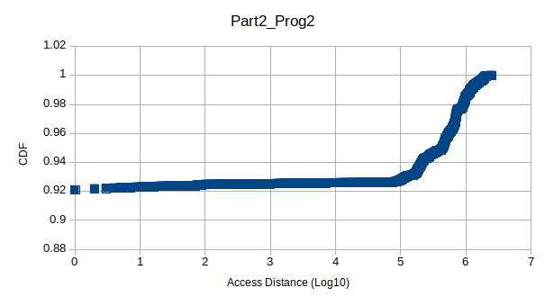
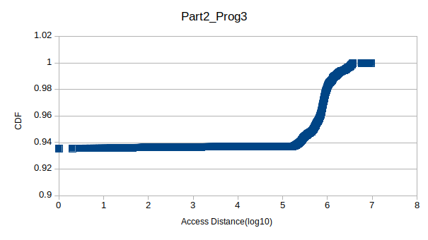

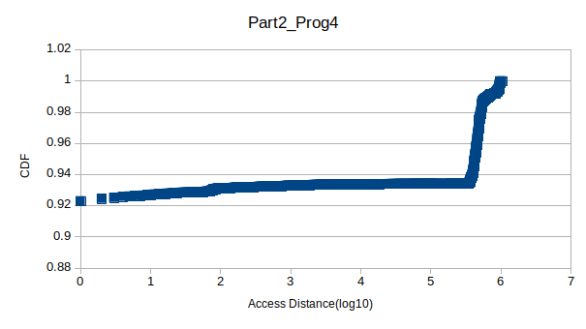

Part 3
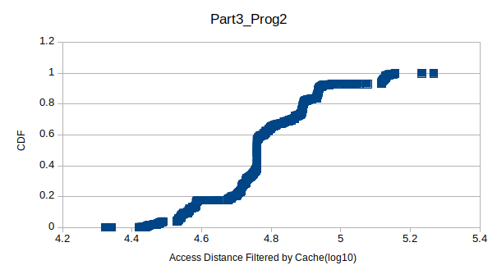
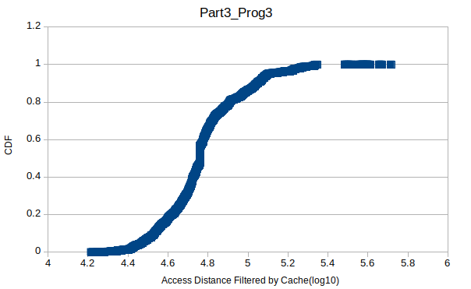

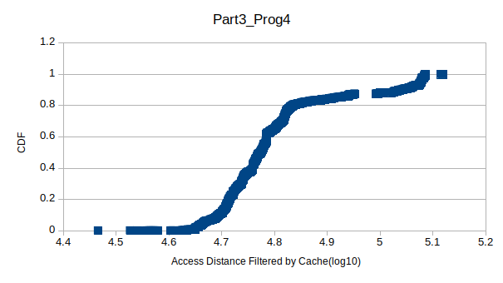

Program | Hit | Miss

Part 4

Program | Private | 2 shared | 3 shared | 4 shared | 5 shared | 6 shared | 7shared | 8 shared
Prog1 | 412 | 63 | 1872 | 32456 | 143251 | 244970 | 173831 | 124527
Prog2 | 407 | 8255 | 16384 | 40958 | 5 | 0 | 0 | 9
Prog3 | 412 | 56 | 0 | 1 | 1 | 0 | 0 | 65545
Prog4 | 8599 | 57403 | 6 | 0 | 0 | 0 | 1 | 10

