# BRAIN TUMOR DETECTION



**UNIVERSITY OF ENGINEERING**

# & MANAGEMENT, JAIPUR

## BRAIN TUMOR DETECTION

Submitted in the partial fulfillment of the degree of

## BACHELOR OF TECHNOLOGY

in

## COMPUTER SCIENCE & ENGINEERING

under

## UNIVERSITY OF ENGINEERING & MANAGEMENT, JAIPUR

BY

## Swapan Kumar Shee University Enrollment No.12021002001009

**Registration No. 204202100200014**

**Shivam Kumar Mishra University Enrollment. No.12021002001042**

## Registration No. 204202100200046

UNDER THE GUIDANCE OF

## Prof. Jyoti Khandelwal

COMPUTER SCIENCE & ENGINEERING



UNIVERSITY OF ENGINEERING & MANAGEMENT, JAIPUR

**Approval Certificate**

This is to certify that the project report entitled “**BRAIN TUMOR DETECTION”** submitted by **Swapan Kumar Shee (Roll:12021002001009) & Shivam Kumar Mishra (Roll:12021002001042)** in partial fulfillment of the requirements of the degree of **Bachelor of Technology** in **Computer Science & Engineering** from University **of Engineering and Management, Jaipur** was carried out in a systematic and procedural manner to the best of our knowledge. It is a bona fide work of the candidate and was carried out under our supervision and guidance during the academic session of 2021- 2025.

### Prof. Jyoti Khandelwal

Project Guide, Assistant Professor (CSE) UEM, JAIPUR

### Prof. Mrinal Kanti Sarkar Prof. A Mukherjee

HOD (CSE) Dean

UEM, JAIPUR UEM, JAIPUR

# ACKNOWLEDGEMENT

The endless thanks go to Lord Almighty for all the blessings he has showered on us, which has enabled us to write this last note in my research work. During the period of our research, as in the rest of my life, we have been blessed by Almighty with some extraordinary people who have spun a web of support around us. Words can never be enough to express how grateful we are to those incredible people in my life who made this thesis possible. We would like to thank them for making my time during my research in the Institute a period We will treasure. We deeply indebted to my research supervisor, Professor Jyoti Khandelwal for such an interesting thesis topic. Each meeting with her added invaluable aspects to the implementation and broadened my perspective. She has guided us with his invaluable suggestions, lightened up the way in my darkest times, and encouraged me a lot in academic life.

Swapan Kumar Shee

Shivam Kumar Mishra

# ABSTRACT

Now a day’s tumor is second leading cause of cancer. Due to cancer large no of patients are in danger. The medical field needs fast, automated, efficient and reliable technique to detect tumor like brain tumor. Detection plays very important role in treatment. If proper detection of tumor is possible then doctors keep a patient out of danger. we have used various image processing techniques to detect tumors in this GUI. Using this GUI doctors provide proper treatment and save a number of tumor patients. A tumor is nothing but excess cells growing in an uncontrolled manner. Brain tumor cells grow in a way that they eventually take up all the nutrients meant for the healthy cells and tissues, which results in brain failure. Currently, doctors locate the position and the area of brain tumor by looking at the MR Images of the brain of the patient manually. This results in inaccurate detection of the tumor and is considered very time consuming. Tumor is a mass of tissue it grows out of control. We can use a Deep Learning architectures CNN (Convolution Neural Network) generally known as NN (Neural Network) for detecting the brain tumor. The performance of model is predicting image tumor is present or not in image. If the tumor is present, it will show the predicted tumor type otherwise it will show No tumor.

**Keyword:** CNN, brain tumors, automation, MRI images.

# TABLE OF CONTENTS

**CONTENTS**  **PAGE NO**.

TABLE OF CONTENTS…………………………………………………………………... 1

LIST OF FIGURES…………………………………………………………………............ 2

1. INTRODUCTION………………………………………………………………………...3
2. LITERATURE REVIEW………………………………………………………………… 4
3. OBJECTIVE & SCOPE OF THE PROJECT……………………………………………. 5
   1. OBJECTIVE
   2. SCOPE OF THE PROJECT
4. EXPERIMENTAL SETUP AND PROPOSED MODEL………………………………... 6
   1. REQUIREMENTS
   2. PROPOSED MODEL
5. RESULTS………………………………………………………………………………... 7
6. CONCLUSION AND FUTURE SCOPE………………………………………………... 12
7. REFERENCES…………………………………………………………………………... 13

**List of Figures**

Figure 1 - Proposed model 6

Figure 2 - Some sample MRI Images from Training Datasets 7

Figure 3 - Data set partitions (a) Train Data; (b) Test Data 7

Figure 4 - Logistic Regression results (a) Confusion matrix; (b) Classification report 8

Figure 5 - Random Forest results (a) Confusion matrix; (b) Classification report 8

Figure 6 - Support vector machine results (a) Confusion matrix; (b) Classification report 9

Figure 7 - KNN Classifier results (a) Confusion matrix; (b) Classification report 9

Figure 8 - Naive bayes results (a) Confusion matrix; (b) Classification report 10

Figure 9 - Training and Validation Model results (a) Accuracy of CNN; (b) Loss of CNN 10

Figure 10 - CNN results (a) Confusion matrix; (b) Classification report. 11

Figure 11 - (a)Test1; (b)Test2. 11

**CHAPTER 1.**

**INTRODUCTION**

This study of brain MRI Images is helpful in brain tumor diagnosis process. Tumor and cancer are a harmful and death-defying disease for human life. This study is another effort to reveal the importance of the image classification in the world of the Bio-computing field. Image classification technique is efficiently improving the process of disease diagnosis. It is a process in which images are labeled into numerous predefined classes. Several techniques have been introduced for image classification like Logistic Regression, Random Forest, SVM, KNN and many others. This study proposed a model in which deep neural network technique is used with Gray scaled segmentation technique. Combination of these two techniques is giving better result in minimum computational time.

There are different techniques we use for checking noise in brain tumors are standard deviation, quality matrix, variance and filter. The standard deviation measures how spread out the values are around the mean. A higher standard deviation indicates a noisier image. Quality matrix contains information about the relationships between the pixels in an image. A higher quality matrix indicates a less noisy image. And lastly higher variance indicates a noisier image and Once you have calculated the standard deviation, quality matrix, or variance of an image, you can use this information to filter out noise.

**CHAPTER 2.**

**LITERATURE REVIEW**

1. Several research studies explored the potential benefits of early brain tumor detection. One such study conducted by Hemanth G, Janardhan M, Sujihelen L (2019) [1], for Designing and implementing brain tumor detection using machine learning approach. The study found that the techniques of ML (machine learning) and Data mining are being effectively employed for brain tumor detection and prevention at an early stage.
2. Another study by Somasundaram S, Gobinath R (2019) [2], survey the current trends on deep learning models for brain tumor segmentation and detection—a review. The study found that the 3D NN (Neural Network) and Computational Machine learning that assists in processing the input images at multiple scales simultaneously.
3. One more study conducted by Çınarer G, Emiroğlu BG (2019) [3], for Classification of brain tumors by machine learning algorithms. The study found that SVM (support vector machines) algorithm with 90% accuracy rate was better than other algorithms.
4. Other study conducted by Wu W et al (2020) [4] have focused on the intelligent diagnosis method of brain MRI tumor segmentation using deep convolutional neural network and SVM algorithm. The study found that the performance of the proposed model is significantly better than the deep convolutional neural network and the integrated SVM classifier.

**CHAPTER 3.**

**OBJECTIVE & SCOPE OF THE PROJECT**

### 3.1 Objective

* To accurately identify the presence and type of a tumour in the brain. This information is essential for developing an effective treatment plan.
* To Early detection of brain tumors is crucial, as malignant tumors can quickly grow and spread. By detecting tumour early, doctors can intervene with treatment before they cause significant damage to the brain.
* To detect brain tumors, including MRI scans, CT scans, and PET scans. These imaging techniques can provide detailed images of the brain, which can be used to identify tumors and other abnormalities.
* To Save patient’s time and get timely consultation.

### 3.2 Scope of the project

* Build an app-based user interface in hospitals which allows doctors to easily determine the impact of tumor and suggest treatment accordingly.
* Adapting the model for real-time applications could enable on-the-fly tumor classification, significantly benefiting medical practitioners during critical decision-making processes.
* Incorporating additional imaging modalities, such as functional MRI or diffusion tensor imaging, could provide complementary information, improving the model's accuracy and expanding its diagnostic capabilities.
* Collaborating with healthcare institutions for extensive clinical validation will validate the model's efficacy in real-world scenarios, ensuring its practical utility and compliance with medical standards.

**CHAPTER 4.**

**EXPERIMENTAL SETUP & PROPOSED MODEL**

### 4.1 REQUIREMENTS:

### Table 1: Requirements of the projects

|  |  |
| --- | --- |
| **Software Requirements** | **Hardware**  **Requirements** |
| Operating system: Windows (10) or Linux or MAC | Processor: Intel core i5 |
| Programming language:  python | Hard disk:10 GB minimum |
| Editor and compiler (IDE):  Jupyter Notebook (6.5.3) | RAM:256 MB or more |

According to the Table 1, following requirements are needed to complete the project work.

### 4.2 PROPOSED MODEL:

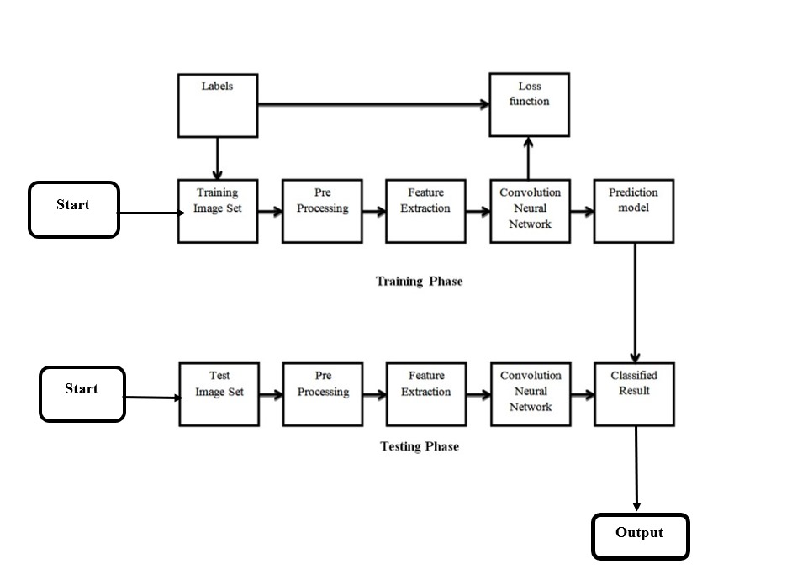

**Fig.1** Proposed model

The above flowchart depicts the two-phase process of image classification using a Convolutional Neural Network (CNN): training involves preprocessing, feature extraction, and CNN training, while testing employs similar preprocessing and feature extraction to classify new images.

## CHAPTER 5. RESULTS

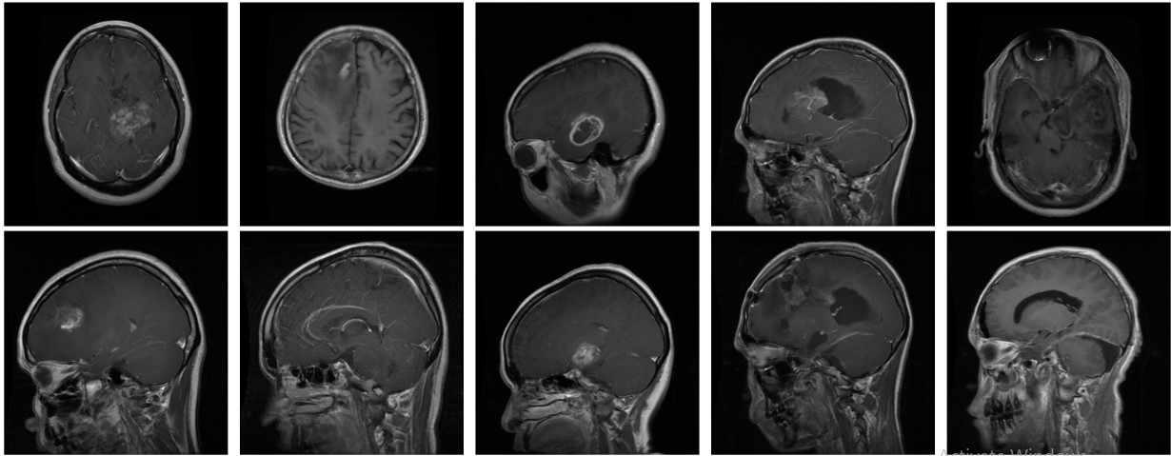

**Fig.2.** Some sample MRI Images from Training Datasets.

Above Fig. shows Grid of 9 black and white MRI brain scans, arranged in 3x3 format, depicting various angles and cross-sections of the same brain at different stages or time points. Gray shades represent brain tissue against a black background.

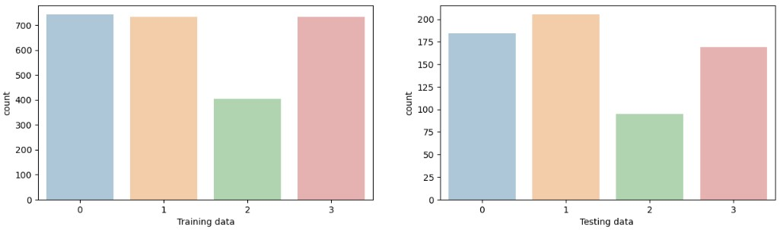

1. **(b)**

**Fig.3** Data set partitions (a) Train Data; (b) Test Data.

Above Fig. 3(a), shows the count plot of training datasets from which it is analyzed maximum MRI images present in pituitary_tumor (827) and minimum MRI images present in no_tumor (395). Above Fig. 3(b) shows the count plot of test datasets from which it is analyzed maximum MRI images present in meningioma_tumor (115) and minimum MRI images present in pituitary_tumor (74).

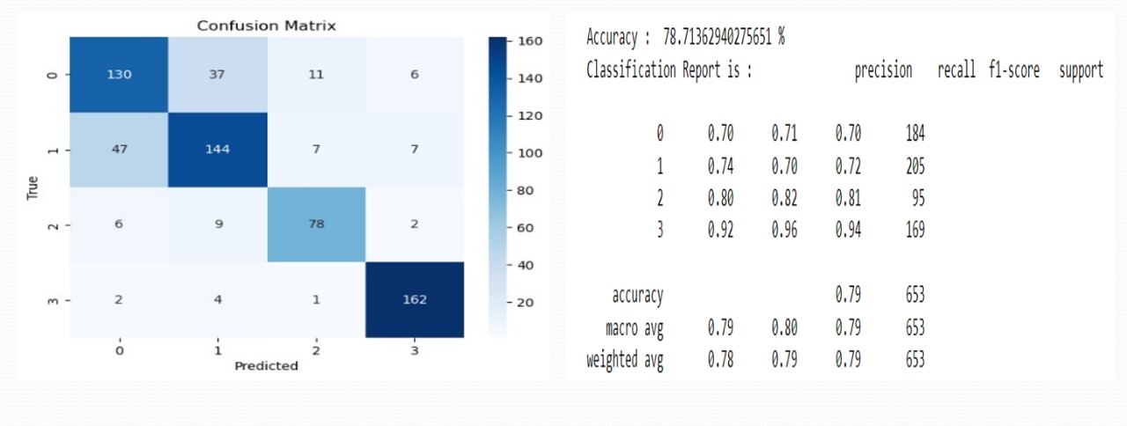

**(a)** **(b)**

**Fig. 4** Logistic Regression results (a) Confusion matrix; (b) Classification report.

Above Fig. 4(a), shows the model's performance on a test set, with rows representing the actual labels and columns representing the predicted labels. Above Fig. 4(b) is the classification report of the logistic regression model in the image shows that the model has an overall accuracy of 78.71%.

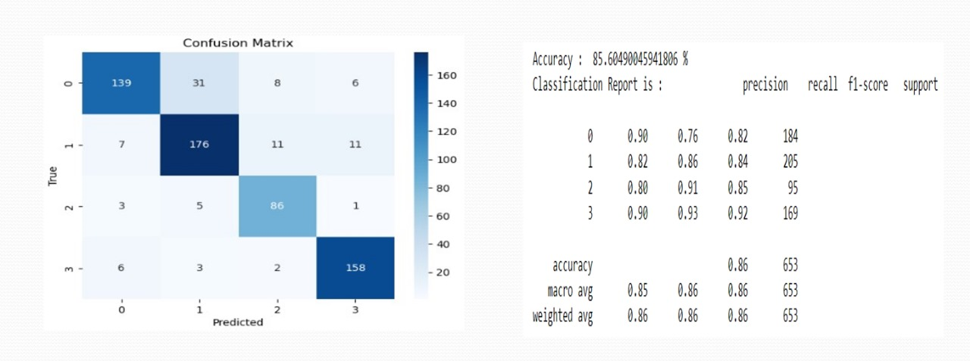

**(a)**   **(b)**

**Fig. 5** Random Forest results (a) Confusion matrix; (b) Classification report.

Above Fig. 5(a), shows the model's performance on a test set, with rows representing the actual labels and columns representing the predicted labels. Above Fig. 5(b) is the classification report of the Random Forest model in the image shows that the model has an overall accuracy of 85.6%.

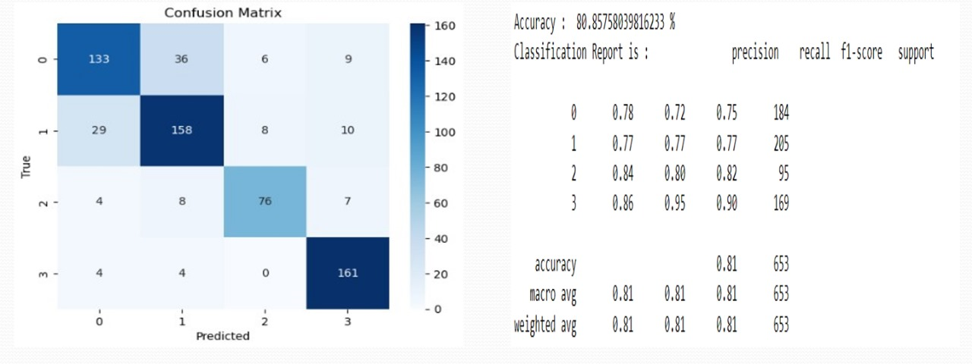

1. **(b)**

**Fig. 6** Support vector machine results (a) Confusion matrix; (b) Classification report.

Above Fig. 6(a), shows the model's performance on a test set, with rows representing the actual labels and columns representing the predicted labels. Above Fig. 6(b) is the classification report of the Support Vector Machine model in the image shows that the model has an overall accuracy of 80.85%.

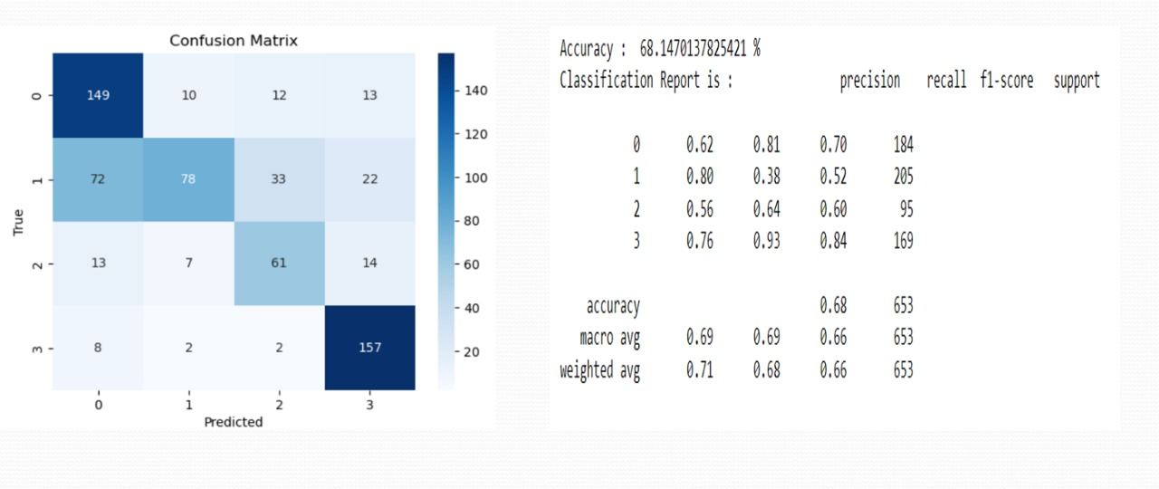

1. **(b)**

**Fig. 7** KNN Classifier results (a) Confusion matrix; (b) Classification report.

Above Fig. 7(a), shows the model's performance on a test set, with rows representing the actual labels and columns representing the predicted labels. Above Fig. 7(b) is the classification report of the KNN Classifier model in the image shows that the model has an overall accuracy of 68.14%.

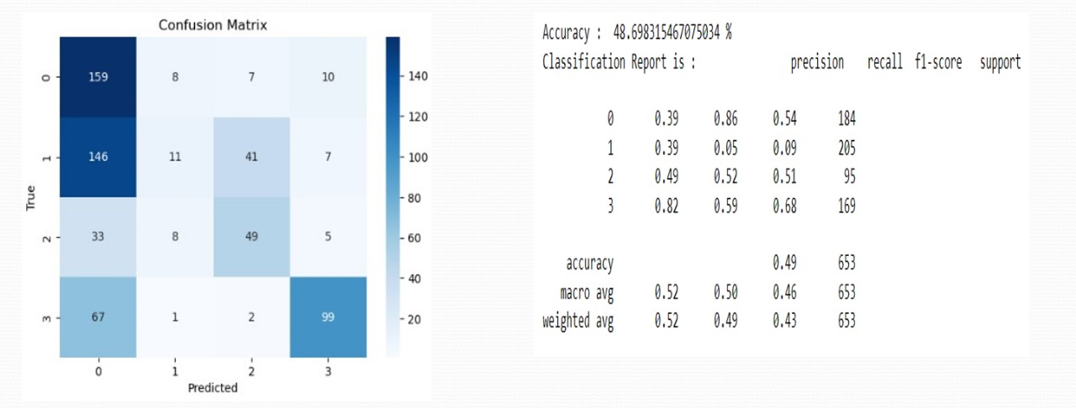

1. **(b)**

**Fig. 8** Naive Bayes results (a) Confusion matrix; (b) Classification report.

Above Fig. 8(a), shows the model's performance on a test set, with rows representing the actual labels and columns representing the predicted labels. Above Fig. 8(b) is the classification report of the Naive Bayes Classifier model in the image shows that the model has an overall accuracy of 48.69%.

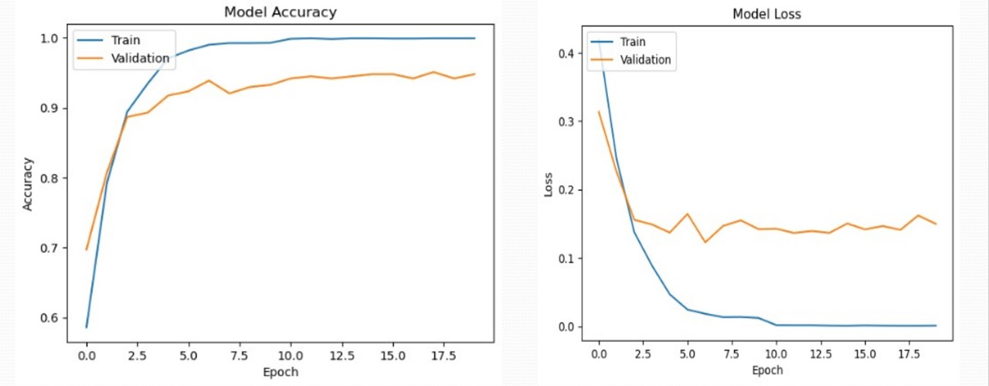

1. **(b)**

**Fig.9** Training and Validation Model results (a) Accuracy of CNN; (b) Loss of CNN.

Above Fig. 9(a), shows the training accuracy increases from 0.6 to 1.0 over the course of 20 epochs, and the validation accuracy increases from 0.7 to 0.9 over the same period. Above Fig. 9(b) shows that the model loss on the training set is around 0.3 at the end of the graph. The model loss on the validation set is around 0.4 at the end of the graph.

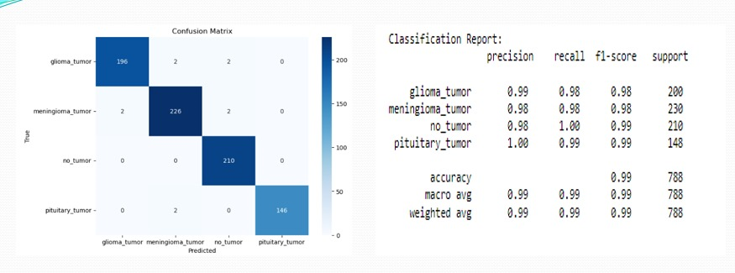

1. (b)

**Fig. 10** CNN results (a) Confusion matrix; (b) Classification report.

Above Fig. 10(a), shows the model's performance on a test set, with rows representing the actual labels and columns representing the predicted labels. Above Fig. 10(b) is the classification report of the CNN Classifier model in the image shows that the model has an overall accuracy of 99%.

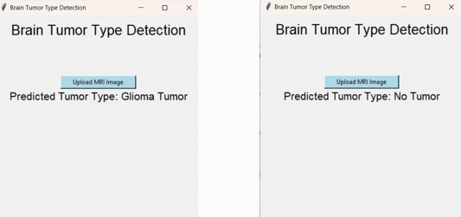

**(a) (b)**

**Fig.11** (a)Test1; (b)Test2.

Above Fig. 11(a), shows a GUI by which we are uploading the MRI images from the test datasets and predicting it as a Glioma Tumor using our model. Above Fig. 11(b) shows a GUI by which we are uploading the MRI images from the test datasets and predicting it as a No Tumor present using our model.

**CHAPTER 6.**

**CONCLUSION AND FUTURE SCOPE**

* Our project achieved success in implementing a robust CNN for brain tumor classification in MRI scans, demonstrating promising performance.
* Acknowledging limitations like datasets size and interpret ability issues, the project sets the stage for future enhancements in this critical medical field.
* Several techniques we have used for image classification like Logistic Regression, Random Forest, SVM, KNN and many others.
* Build an app-based user interface in hospitals which allows doctors to easily determine the impact of tumor and suggest treatment accordingly.
* Collaborating with healthcare institutions for extensive clinical validation will validate the model's efficacy in real-world scenarios, ensuring its practical utility and compliance with medical standards.
* Adapting the model for real-time applications could enable on-the-fly tumor classification, significantly benefiting medical practitioners during critical decision-making processes.

# REFERENCES

1. Hemanth G, Janardhan M, Sujihelen L (2019) Design and implementing brain tumor detection using machine learning approach. In: 3rd international conference on trends in electronics and informatics (ICOEI). <https://doi.org/10.1109/ICOEI.2019.8862553>
2. Somasundaram S, Gobinath R (2019) Current trends on deep learning models for brain tumor segmentation and detection—a review. In: International conference on machine learning, big data, cloud and parallel computing (COMITCon).

<https://doi.org/10.1109/COMITCon.2019.8862209>

1. Çınarer G, Emiroğlu BG (2019) Classification of brain tumors by machine learning algorithms. In: 3rd international symposium on multidisciplinary studies and innovative technologies (ISMSIT). <https://doi.org/10.1109/ISMSIT.2019.8932878>
2. Wu, W., Li, D., Du, J., Gao, X., Gu, W., Zhao, F., Feng, X., &amp; Yan, H. (2020, July 14). An intelligent diagnosis method of brain MRI tumor segmentation using deep convolutional neural network and SVM algorithm. Computational and Mathematical Methods in Medicine. https://www.hindawi.com/journals/cmmm/2020/6789306/