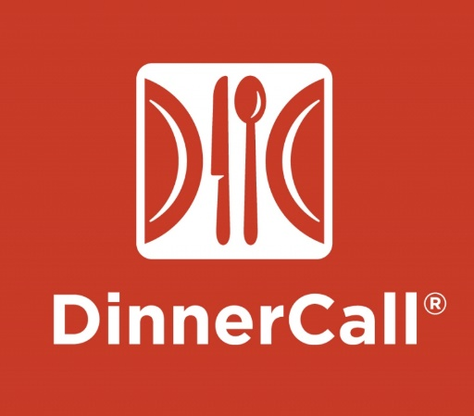

The main aim of this project is to conduct a Design Evaluation for this application by following the methodologies of

* **Cognitive walkthrough**
* **Contextual Inquiries and Interviews**
* **Heuristic evaluation,**

And provide the client with a set of Design Recommendations for the app.

App Selected for our project: DinnerCall ((<https://www.dinnercall.com/index.html>). DinnerCall is a mobile application aiding the users to find a healthy ready-to-eat meal from a near-by Deli. In words of our client, Chief Technical Officer, Mr. Akram Mnif,

“Our main mission through this app is to convert fast food consumers to grocery shoppers and bring families together.”

Methods:

* Evaluating the design of the app
* Cognitive walkthrough
* Contextual Inquiries and Interviews
* Heuristic evaluation
* Documentation
* Carefully thinking of recommended steps for the app

My Roles

* UX Research
* UI Research
* Contact the DinnerCall team

Process 1: Interviews

Cognitive Walkthrough:

We, as a team, conducted a task by task walkthrough in the app and evaluated the design flaws. This gave us the overall idea of the application. We chose the four main tasks of the application:

* View and schedule a pick-up
* Pay for an order
* Track a dinner
* Preload money into DinnerCall

Contextual inquiries and Interviews

We observed 2 people while they used the app and deeply analyzed their movements throughout the app understanding the way the design interacts with the user.

Along with these observations we asked 3 participants to use the app and provide their thoughts on the processes they had to go through in the app.

Even though most of their insights matched our evaluations resulted from the cognitive walkthrough, we received many inputs that were helpful such as an input regarding the color scheme of the application being unpleasing for a user.

Heuristic Evaluation:

Keeping the Jacob Neilson’s 10 Heuristic Principles as our guidelines, we evaluated the design again and understood the design flaws in a more organized manner. Using an affinity diagram we categorized our findings according to the Jacob Neilson’s 10 Heuristic Principles. In this way we realized the severity of the issues that we have found and hence prioritized them to provide us a more focused approach for the future steps.

Experience and Take Away:

This project was my first project in which I contacted a client. I was the primary contact for him and communicating our findings to him along with understanding his requirements and then communicating his requirements to my team was something I enjoyed during the project. Working with a great team, we were able to come up with great constructive recommendations. We are in the middle of this project and will have the final report ready by the mid of December.

A major take away from this project is the enormous hands on experience I gathered while conducting the above procedures. The practical knowledge I gained will form a strong basics for me to build upon as I grow as a UX designer.