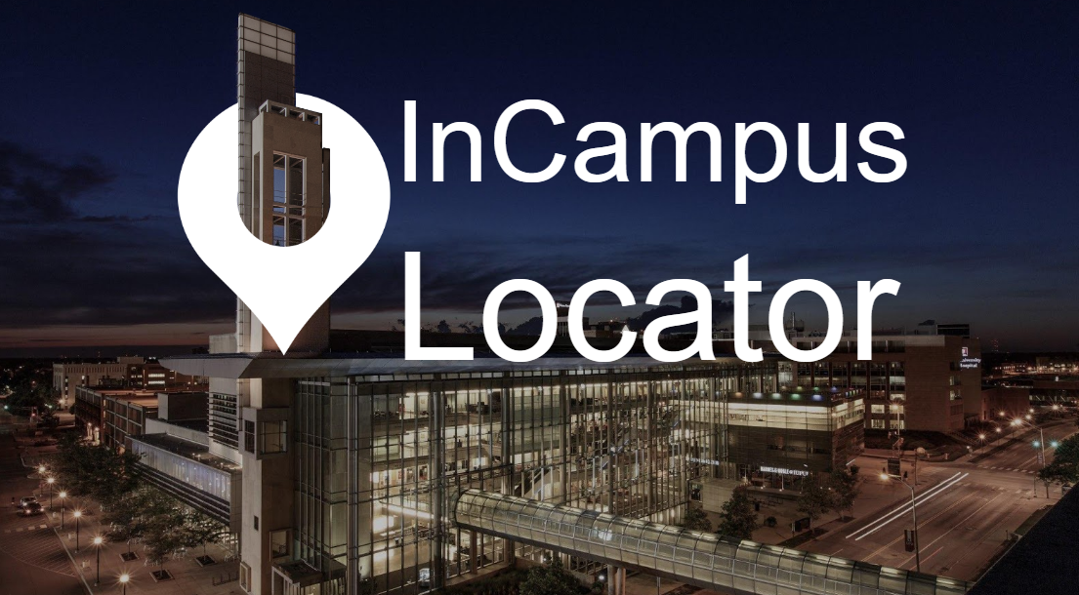

Design Process:

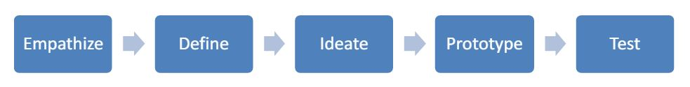

About this project:

Remembering routes to each and every place is not possible, hence we have Google Maps. However, what when you need to look for a building or a classroom in campus, which has a specific name given to them by the students and faculty. That’s where InCampus Locator becomes the go-to solution rather than Google Maps or “ask people”. The aim of InCampus Locator is to guide the user to a specific location, be it a building or a room inside the building. Secondary aim is to share your location and find your friend through GPS instead of inaccurate directions.

Team: Chaolan Lin, Mikaylah Gross, Pushkar Joshi and Swapnil Chandra

Methods:

* User Interviews and study
* Affinity Diagram
* Concept Mapping
* Empathy Mapping
* Brainstorming
* Scenarios
* Storyboarding
* Prototyping – High fidelity and Low fidelity
* Cognitive Walkthrough
* Heuristic Analysis
* User Testing

My Role:

* UX Researcher
* Designer

Process 1: Empathize

In the first stage of the project, we decided the project domain - an app to ease the life on campus. However, we still needed to research on what the actual problem is and why the students around campus face this problem.

We interviewed 9 people and observed at 8 different locations to get a feel of the problems students face while navigating around campus. Through relevant questions we were able to understand what how they dealt with the problem and what they would desire from the technology to combat this problem.

Process 2: Define

Having all the inputs we needed from the user research, we analyzed the inputs in an organized way. We chose:

* Affinity Mapping
* Concept Mapping
* Empathy Mapping

for this step.

Finally, we categorized the problems and the requirements. A better understanding of the problem helped us narrow our target users. Then, after a discussion, we came up with our two personas for this design project:

* A freshman, Emma, who finds it hard to navigate
* A senior, Alex, who finds is tough to find his friends on campus through their directions

Process 3: Ideate

Next, keeping the requirements and the personas in mind we brainstormed 80 ideas to target the problem. Out of them, we chose 3 solutions:

* A mobile application
* A virtual reality application
* A kiosk

Once we studied each in depth, we **storyboarded 2 scenarios** for each solution, one for Emma and one for Alex.

In the end, on the basis of the below 3 questions, we chose **a mobile application** as our main solution with a kiosk as a future scope add-on.

* Will it be accessible for the user?
* Will it be fun to use?
* Will it give accurate and precise information?

Process 4: Prototype

We then began working on the design. Once we had a good design, we produced it using:

* Balsmiq
* Invision
* Photoshop

Our final design has a map of the specific campus. Using the search or a tap on the map, a user can select a point to travel to. The map will guide them throughout the way. It will also guide the user inside the building to specific room, if needed.

Second feature of our design helps users connect. A user can request or share their location with another user and hence be navigated to their friend’s location using the application. If the user doesn’t wish to share their location, they can simply decline the request.

We ran a cognitive walkthrough and a heuristic evaluation of the design.

Process 5: Test

Finally, the prototypes were tested on the users and their responses were recorded.

Key Learnings:

* The interview process was challenging because we needed to find the right question to ask the users.
* Picking out the 3 solutions out of 80 was confusing due to the different choices. However, listing down our requirements in form of questions was insightful.
* Working in a team is always a learning experience, since without the inputs of each of the teammates, the project would be lacking.