# SPLASH SCREEN:

NEW PROJECT

1. CREATE NEW ACTIVITY: JAVA -> NEW -> ACTIVITY -> EMPTY ACTIVITY -> RENAME IT TO SPLASHSCREEN

2. LAYOURS -> activity_main.xml

<?*xml version*="1.0" *encoding*="utf-8"?>  
<LinearLayout *xmlns:android*="http://schemas.android.com/apk/res/android"  
 *xmlns:app*="http://schemas.android.com/apk/res-auto"  
 *xmlns:tools*="http://schemas.android.com/tools"  
 *android:layout_width*="match_parent"  
 *android:layout_height*="match_parent"  
 *tools:context*=".MainActivity"  
 *android:orientation*="vertical"  
 *android:layout_gravity*="center"  
 *android:gravity*="center"  
 *android:background*="@color/white">  
   
 <ImageView  
 *android:id*="@+id/oneEye"  
 *android:layout_width*="300dp"  
 *android:layout_height*="250dp"  
 *android:src*="@drawable/oneeye"/>  
  
 <TextView  
 *android:id*="@+id/logoText"  
 *android:layout_width*="wrap_content"  
 *android:layout_height*="wrap_content"  
 *android:text*="@string/clothing_accessories_bags_footwear"  
 *android:textColor*="@color/black"  
 *android:textSize*="15sp"  
 *android:textStyle*="italic" />  
  
</LinearLayout>

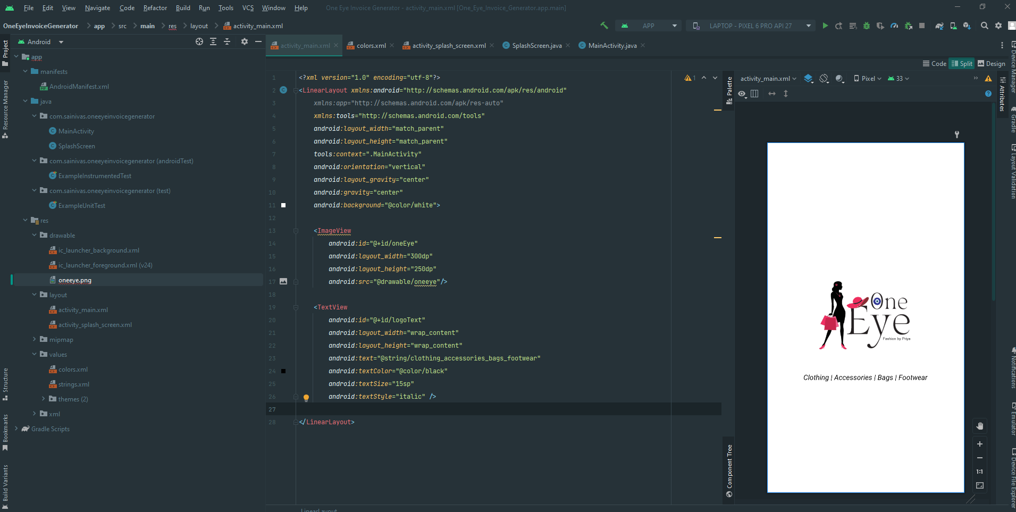

3. CREATE ANIM DIRECTORY UNDER RES AND ADD 2 XML FILES NAME – top & bottom by clicking on anim folder -> new -> Animation Resource File

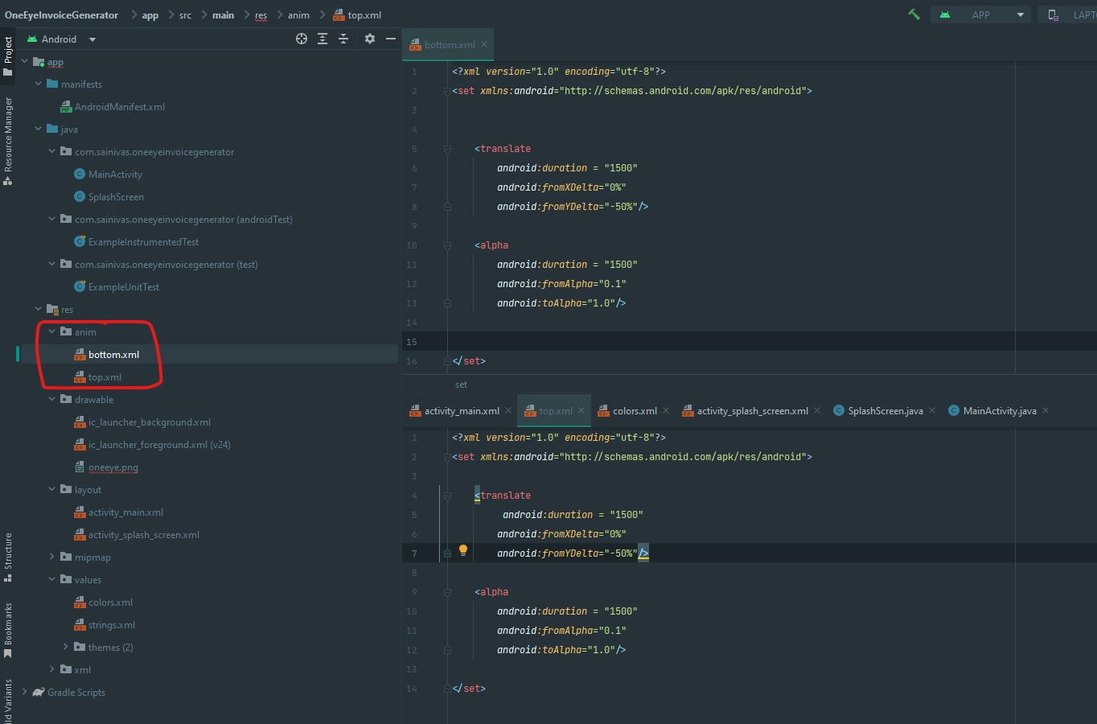

Bottom.xml

<?*xml version*="1.0" *encoding*="utf-8"?>  
<set *xmlns:android*="http://schemas.android.com/apk/res/android">  
  
  
 <translate  
 *android:duration* = "1500"  
 *android:fromXDelta*="0%"  
 *android:fromYDelta*="-50%"/>  
  
 <alpha  
 *android:duration* = "1500"  
 *android:fromAlpha*="0.1"  
 *android:toAlpha*="1.0"/>  
  
  
</set>

Top.xml

<?*xml version*="1.0" *encoding*="utf-8"?>  
<set *xmlns:android*="http://schemas.android.com/apk/res/android">  
  
 <translate  
 *android:duration* = "1500"  
 *android:fromXDelta*="0%"  
 *android:fromYDelta*="-50%"/>  
  
 <alpha  
 *android:duration* = "1500"  
 *android:fromAlpha*="0.1"  
 *android:toAlpha*="1.0"/>  
  
</set>

COME TO ACTIVITY MAIN.JAVA FILE

*package* com.sainivas.oneeyeinvoicegenerator;  
  
*import* androidx.appcompat.app.AppCompatActivity;  
  
*import* android.content.Intent;  
*import* android.os.Bundle;  
*import* android.os.Handler;  
*import* android.view.*WindowManager*;  
*import* android.view.animation.Animation;  
*import* android.view.animation.AnimationUtils;  
*import* android.widget.ImageView;  
*import* android.widget.TextView;  
  
*public class* MainActivity *extends* AppCompatActivity {  
  
 ImageView logoImage;  
 TextView logoText;  
 Animation top,bottom;  
 *private static int SPLASH_SCREEN* = 2500;  
  
 @Override  
 *protected void* onCreate(Bundle savedInstanceState) {  
 *super*.onCreate(savedInstanceState);  
 getWindow().setFlags(*WindowManager*.LayoutParams.***FLAG_FULLSCREEN***,*WindowManager*.LayoutParams.***FLAG_FULLSCREEN***);  
 setContentView(R.layout.***activity_main***);  
 logoImage = findViewById(R.id.***oneEye***);  
 logoText = findViewById(R.id.***logoText***);  
  
 top = AnimationUtils.*loadAnimation*(*this*,R.anim.***top***);  
 bottom = AnimationUtils.*loadAnimation*(*this*,R.anim.***bottom***);  
  
 logoImage.setAnimation(top);  
 logoText.setAnimation(bottom);  
  
 *new* Handler().postDelayed(*new* Runnable() {  
 @Override  
 *public void* run() {  
 Intent intent = *new* Intent(MainActivity.*this*, SplashScreen.*class*);  
 startActivity(intent);  
 finish();  
 }  
 },*SPLASH_SCREEN*);  
  
  
 }  
}

# DROP DOWN

Add list of items in string.xml

<string *name*="selectItem">Select Item</string>  
  
 <string-array *name*="products">  
 <item>Co-erd set</item>  
 <item>One piece</item>  
 <item>Off shoulder</item>  
 <item>Jumpsuit</item>  
 <item>Tops</item>  
 <item>Tang top</item>  
 <item>Shirts</item>  
 <item>Shorts</item>  
 <item>Skirt</item>  
 <item>Stright fit jeans</item>  
 <item>Pant</item>  
 <item>Mom fit jeans</item>  
 <item>Highwaist jeans</item>  
 <item>Footwear</item>  
 </string-array>

For eg:

<resources>  
 <string *name*="app_name">1eye Invoice</string>  
 <string *name*="clothing_accessories_bags_footwear">Clothing | Accessories | Bags | Footwear</string>  
 <string *name*="generate_invoice">Share Invoice</string>  
 <string *name*="buyer_details">Buyer Details</string>  
 <string *name*="mr">Mr.</string>  
 <string *name*="ms">Ms</string>  
 <string *name*="full_name">Full Name</string>  
 <string *name*="name">Name</string>  
 <string *name*="mobile_number">Mobile Number</string>  
 <string *name*="product_details">Product Details</string>  
  
 <string *name*="selectItem">Select Item</string>  
  
 <string-array *name*="products">  
 <item>Co-erd set</item>  
 <item>One piece</item>  
 <item>Off shoulder</item>  
 <item>Jumpsuit</item>  
 <item>Tops</item>  
 <item>Tang top</item>  
 <item>Shirts</item>  
 <item>Shorts</item>  
 <item>Skirt</item>  
 <item>Stright fit jeans</item>  
 <item>Pant</item>  
 <item>Mom fit jeans</item>  
 <item>Highwaist jeans</item>  
 <item>Footwear</item>  
 </string-array>  
  
</resources>

2. ADD NEW LAYOUR

List_items.xml

<?*xml version*="1.0" *encoding*="utf-8"?>  
<TextView *xmlns:android*="http://schemas.android.com/apk/res/android"  
 *android:layout_width*="match_parent"  
 *android:layout_height*="wrap_content"  
 *android:padding*="16dp"  
 *android:ellipsize*="end"  
 *android:maxLines*="1"  
 *android:textAppearance*="?attr/textAppearanceSubtitle1">  
  
</TextView>

*package* com.sainivas.oneeyeinvoicegenerator;  
  
*import* androidx.appcompat.app.AppCompatActivity;  
*import* android.os.Bundle;  
*import* android.view.View;  
*import* android.widget.AdapterView;  
*import* android.widget.ArrayAdapter;  
*import* android.widget.AutoCompleteTextView;  
*import* android.widget.Toast;  
  
*public class* Home *extends* AppCompatActivity {  
  
 **String[] items = {"Co-erd set","One piece","Off shoulder","Jumpsuit","Tops","Tang top","Shirts","Shorts","Skrit","Stright fit jeans","Pant","Mom fit jeans","Highwaist jeans","Footwear"};  
  
 AutoCompleteTextView autoCompleteTextView1,autoCompleteTextView2,autoCompleteTextView3,autoCompleteTextView4,autoCompleteTextView5;  
 ArrayAdapter<String> adapterItems;**  
  
 @Override  
 *protected void* onCreate(Bundle savedInstanceState) {  
 *super*.onCreate(savedInstanceState);  
 setContentView(R.layout.activity_home);  
  
 **autoCompleteTextView1 = findViewById(R.id.auto_complete_text1);  
 adapterItems = *new* ArrayAdapter<String>(*this*,R.layout.list_items,items);  
 autoCompleteTextView1.setAdapter(adapterItems);  
 autoCompleteTextView1.setOnItemClickListener(*new* AdapterView.OnItemClickListener() {  
 @Override  
 *public void* onItemClick(AdapterView<?> parent, View view, *int* position, *long* id) {  
 String item = parent.getItemAtPosition(position).toString();  
 Toast.makeText(getApplicationContext(),"Items: "+item, Toast.LENGTH_SHORT).show();  
 }  
 });**

# HOW TO UPDATE APP ICON:

1. Choose an image and keep it in drawable
2. Open -> res > mipmp directory
3. Right click on it > New > Image Asset
4. Select image from path – then click OK

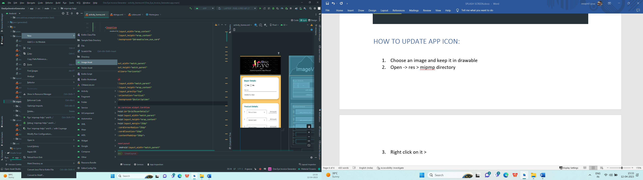

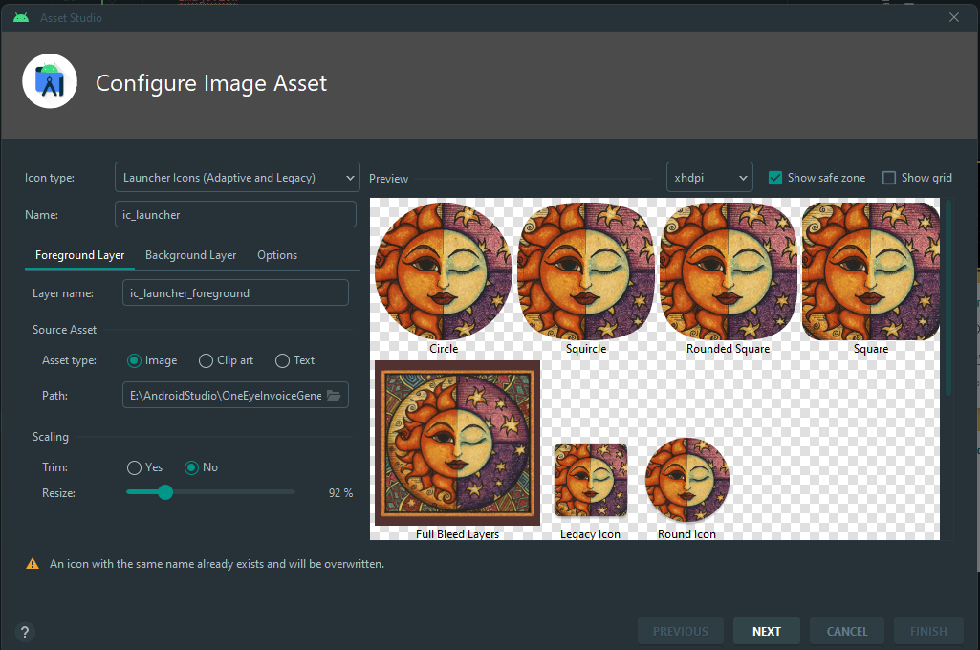

RADIO BUTTON GROUP:

Add this in XML

<RadioGroup  
 *android:layout_width*="wrap_content"  
 *android:layout_height*="wrap_content"  
 *android:id*="@+id/radioGroup"  
 *android:orientation*="horizontal">  
  
 <RadioButton  
 *android:id*="@+id/mr"  
 *android:layout_width*="wrap_content"  
 *android:layout_height*="wrap_content"  
 *android:layout_marginTop*="10dp"  
 *android:text*="@string/mr"  
 *android:textStyle*="bold"  
 *android:visibility*="visible"  
 *android:onClick*="checkRadioButton"/>  
  
 <RadioButton  
 *android:id*="@+id/ms"  
 *android:layout_width*="115dp"  
 *android:layout_height*="wrap_content"  
 *android:layout_marginTop*="10dp"  
 *android:text*="@string/ms"  
 *android:textStyle*="bold"  
 *android:visibility*="visible"  
 *android:onClick*="checkRadioButton"/>  
  
</RadioGroup>

Declare these 2 in Java file

*import* android.widget.RadioButton;  
*import* android.widget.RadioGroup;

RadioButton mr,ms, radioButton;  
RadioGroup radioGroup;

mr = findViewById(R.id.mr);  
ms = findViewById(R.id.ms);  
radioGroup = findViewById(R.id.radioGroup);

*public void* checkRadioButton(View view)  
{  
  
 *int* radioID = radioGroup.getCheckedRadioButtonId();  
 radioButton = findViewById(radioID);  
  
 Toast.makeText(Home.*this*,"Title : "+radioButton.getText(),Toast.LENGTH_LONG).show();  
}