Product Dissection for Spotify

Company Overview
Spotify is one of the world's most popular digital music streaming platforms. It was founded in 2006 by Daniel Ek and Martin Lorentzon in Sweden with the aim of making music easily accessible to everyone. Before Spotify, people usually had to purchase songs or albums individually or download music from different sources. Spotify changed this by allowing users to stream millions of songs instantly over the internet.
Today, Spotify offers a huge collection of music, podcasts, and audiobooks from artists around the world. Users can listen for free with advertisements or subscribe to Spotify Premium for an ad-free experience, offline downloads, and better audio quality. The platform is available on smartphones, laptops, tablets, smart TVs, gaming consoles, and smart speakers, allowing users to enjoy their favourite content anytime and anywhere.
One of Spotify's biggest strengths is its personalized experience. By analyzing users' listening history, favourite artists, playlists, and genres, Spotify recommends songs that match each user's interests. Features such as Discover Weekly, Daily Mix, Release Radar, and personalized playlists help users discover new music without spending time searching for it manually.
Spotify has transformed the music industry by providing a legal, convenient, and affordable way to access digital music. It benefits both listeners and artists by creating a platform where users can enjoy unlimited entertainment while artists can share their work with a global audience and earn revenue through streaming. Today, Spotify serves hundreds of millions of active users worldwide and continues to be one of the leading platforms in the digital entertainment industry.

Product Dissection and Real-World Problems Solved by Spotify
Spotify is designed to make listening to music simple, fast, and enjoyable for people around the world. Before music streaming services became popular, users had to buy individual songs or albums, download music from different websites, or store large music files on their devices. This process was time-consuming and often inconvenient. Spotify solved this problem by giving users instant access to millions of songs, podcasts, and audiobooks through an internet connection.
Another important challenge Spotify addresses is helping users discover new music. With such a large collection of songs available, finding music that matches personal interests can be difficult. Spotify uses listening history, favorite artists, playlists, and genres to recommend songs that suit each user's taste. Features like personalized playlists and recommendations help users explore new artists and tracks without spending time searching manually.

Case Study: Real-World Problems and Spotify's Innovative Solutions

Spotify is one of the world's most successful music streaming platforms because it focuses on solving real problems faced by music listeners. Instead of only providing access to songs, Spotify improves the overall listening experience through personalized recommendations, playlist management, and seamless synchronization across devices. The following case studies explain some of the major challenges users faced before Spotify and how the platform successfully solved them.

Problem 1: Limited Access to Music
Real-World Challenge
Before music streaming services became popular, people had to buy CDs, purchase digital albums, or download individual songs to listen to their favorite music. This process was expensive and time-consuming. Users also had limited storage on their devices, making it difficult to keep large music collections. Many people wanted a simple way to access millions of songs without downloading or purchasing each one separately.
Spotify's Solution
Spotify introduced a cloud-based music streaming platform that allows users to listen to millions of songs instantly through an internet connection. Instead of buying music, users can search for any artist, album, or song and start listening within seconds. Spotify also offers a free version supported by advertisements and a Premium subscription that provides ad-free listening, offline downloads, and better audio quality. This approach has made music more affordable, accessible, and convenient for people around the world.

Problem 2: Difficulty in Discovering New Music
Real-World Challenge
With millions of songs available today, finding music that matches personal interests can be difficult. Many users only listened to familiar artists because discovering new songs required a lot of searching. This limited users' music experience and made it difficult for new artists to reach potential listeners.
Spotify's Solution
Spotify uses intelligent recommendation algorithms to understand each user's listening behavior. It analyzes recently played songs, favorite artists, liked tracks, playlists, and preferred genres to recommend music that matches the user's taste. Features such as Discover Weekly, Daily Mix, Release Radar, and personalized playlists help users discover new songs and artists automatically. This creates a more enjoyable listening experience while also helping emerging artists reach a larger audience.

Problem 3: Organizing Personal Music Collections
Real-World Challenge
People often listen to different types of music depending on their mood, activity, or occasion. Managing hundreds or thousands of songs manually was difficult, especially when users wanted separate collections for studying, exercising, travelling, or relaxing. Sharing music collections with friends was also not easy.
Spotify's Solution
Spotify allows users to create unlimited playlists and organize their favorite songs according to their preferences. Users can rename playlists, add or remove songs, change the order of tracks, and even collaborate with friends on shared playlists. Public playlists also allow users to share their music with others around the world. This feature makes music organization simple, flexible, and highly personalized.

Problem 4: Seamless Listening Across Multiple Devices
Real-World Challenge
Modern users switch between smartphones, laptops, tablets, smart TVs, gaming consoles, and smart speakers throughout the day. Without proper synchronization, users would have to search for their songs again or lose their listening progress whenever they changed devices.
Spotify's Solution
Spotify stores user accounts, playlists, liked songs, and listening history securely in the cloud. This allows users to continue listening from exactly where they stopped, regardless of which device they are using. Features like Spotify Connect also let users control playback across different devices without interrupting the music. This seamless synchronization provides a smooth and consistent listening experience everywhere.

Conclusion
Spotify has transformed the way people listen to music by making it simple, affordable, and accessible through online streaming. Instead of purchasing individual songs or albums, users can instantly access millions of tracks, podcasts, and audiobooks from anywhere in the world. Its intelligent recommendation system, personalized playlists, and seamless synchronization across multiple devices have significantly improved the overall listening experience.
This case study demonstrates how Spotify successfully solves real-world problems by combining technology, personalization, and cloud-based services into a single platform. Its user-focused approach has helped it become one of the world's leading music streaming services. The study also provides a strong foundation for designing a scalable PostgreSQL database schema that efficiently manages users, artists, albums, tracks, playlists, subscriptions, and other platform features.

Top Features
1. User Accounts and Profiles
Spotify allows users to create personal accounts where they can manage their listening preferences, playlists, subscriptions, and saved songs. Every user has a personalized profile that stores account information, listening history, and favorite content. This enables Spotify to provide a customized music experience for every user.
2. Music Streaming
The core feature of Spotify is online music streaming. Users can search for songs, artists, albums, podcasts, and audiobooks and instantly play them without downloading the files permanently. Spotify supports high-quality audio streaming across multiple devices and offers offline listening for Premium subscribers.
3. Playlist Management
Spotify allows users to create, edit, organize, and share playlists. Users can build playlists based on their mood, activities, or favorite artists. Collaborative playlists also allow multiple users to contribute songs, making playlist management interactive and user-friendly.
4. Personalized Music Recommendations
Spotify uses user listening history, favorite artists, genres, and playlists to recommend new music. Features such as Discover Weekly, Daily Mix, and Release Radar automatically generate personalized playlists, helping users discover songs that match their interests without manually searching.
5. Premium Subscription
Spotify offers both Free and Premium subscription plans. Premium users receive additional benefits such as ad-free listening, offline downloads, unlimited skips, and improved audio quality. The subscription system allows Spotify to generate revenue while providing users with enhanced features.
6. Cross-Device Synchronization
Spotify synchronizes playlists, liked songs, recently played tracks, and playback history across smartphones, laptops, tablets, smart TVs, gaming consoles, and smart speakers. Users can continue listening from exactly where they stopped regardless of the device they are using.

Schema Description
The Spotify database schema is designed to efficiently manage millions of users, songs, artists, playlists, subscriptions, and listening activities. Since Spotify operates as a large-scale music streaming platform, its database must support high volumes of user interactions while maintaining fast query performance and data consistency.
The schema consists of several related entities that work together to support Spotify's core features such as music streaming, playlist management, personalized recommendations, and subscription services. Each entity stores a specific type of information, while relationships between entities ensure that data is organized efficiently and duplication is minimized through database normalization.
The primary entities in the Spotify database include Users, Artists, Albums, Tracks, Genres, Playlists, Playlist Tracks, Listening History, Subscription Plans, Subscriptions, Recommendations, and Devices. These entities collectively represent the core operations performed by users while interacting with the platform.
Schema Entities
User Entity
The User entity stores information about every registered Spotify user.
- UserID (Primary Key): A unique identifier for every user.
- Username: Unique username selected by the user.
- Email: User's registered email address.
- Password_Hash: Encrypted password used for authentication.
- Full_Name: User's full name.
- Country: Country where the user is registered.
- Date_of_Birth: User's birth date.
- Created_At: Account creation date and time.

Artist Entity
The Artist entity stores information about musicians, singers, bands, and podcast creators available on Spotify.
- ArtistID (Primary Key)
- Artist_Name
- Country
- Genres
- Monthly_Listeners
- Created_At

Album Entity
Albums group multiple tracks released by an artist.
- AlbumID (Primary Key)
- ArtistID (Foreign Key referencing Artist)
- Album_Name
- Release_Date
- Album_Type
- Total_Tracks
Track Entity
The Track entity stores information about every song available on Spotify.
- TrackID (Primary Key)
- AlbumID (Foreign Key referencing Album)
- ArtistID (Foreign Key referencing Artist)
- Track_Name
- Duration_MS
- Popularity
- Explicit
- Audio_Features
- Release_Date

Genre Entity
The Genre entity categorizes music into different genres.
- GenreID (Primary Key)
- Genre_Name
Playlist Entity
The Playlist entity stores playlists created by users.
- PlaylistID (Primary Key)
- UserID (Foreign Key referencing User)
- Playlist_Name
- Description
- Is_Public
- Created_At
Playlist_Track Entity
This entity creates a many-to-many relationship between playlists and tracks.
- PlaylistTrackID (Primary Key)
- PlaylistID (Foreign Key referencing Playlist)
- TrackID (Foreign Key referencing Track)
- Added_At

Listening_History Entity
Stores every song played by a user.
- HistoryID (Primary Key)
- UserID (Foreign Key referencing User)
- TrackID (Foreign Key referencing Track)
- Played_At
- DeviceID (Foreign Key referencing Device)

Subscription Entity
Stores Premium subscription details.
- SubscriptionID (Primary Key)
- UserID (Foreign Key referencing User)
- PlanID (Foreign Key referencing Subscription Plan)
- Start_Date
- End_Date
- Status
Device Entity
Stores devices used by Spotify users.
- DeviceID (Primary Key)
- UserID (Foreign Key referencing User)
- Device_Name
- Device_Type
- Operating_System

Relationships
- One User can create multiple Playlists.
- One User can have multiple Listening History records.
- One User can own multiple Devices.
- One Artist can release multiple Albums.
- One Album can contain multiple Tracks.
- One Genre can classify multiple Tracks.
- One Playlist can contain multiple Tracks through the Playlist_Track table.
- One Track can belong to multiple Playlists.
- One User can have one active Subscription at a time.
- One Subscription Plan can be used by many Users.

PostgreSQL Database Design
While designing the Spotify database, my main goal was to create a structure that is simple, organized, and capable of handling a large amount of data efficiently. Spotify is used by millions of people every day, so the database must be able to manage users, songs, artists, playlists, subscriptions, and listening activities without creating duplicate data or slowing down the system.
I started by identifying the main features of Spotify such as user accounts, music streaming, playlist management, and personalized recommendations. Based on these features, I created separate tables for each major entity. Instead of storing all the information in a single table, I divided the data into multiple related tables. This makes the database easier to maintain and improves overall performance.
The Users table acts as the central table because almost every activity on Spotify is connected to a user account. Whether a user creates a playlist, listens to a song, purchases a Premium subscription, or receives recommendations, all these actions are linked to the User table.
The Artists, Albums, and Tracks tables were created separately because they represent different types of information. One artist can release many albums, and each album can contain multiple tracks. Keeping these entities separate avoids repeating the same artist or album information for every song and makes the database more organized.
The Genres table was created to classify songs into different music categories. This helps Spotify organize its music library and makes it easier to recommend songs based on a user's preferred genres.
For playlist management, I created two separate tables: Playlists and Playlist_Tracks. A playlist can contain many songs, and the same song can appear in multiple playlists created by different users. Because of this many-to-many relationship, a separate junction table is required to connect playlists and tracks without storing duplicate information.
The Listening_History table records every song played by a user. This information is very useful because Spotify uses it to generate personalized recommendations, display recently played songs, and understand the user's listening habits.
Spotify is available on many devices such as mobile phones, laptops, tablets, smart TVs, and speakers. To support this feature, I included a Devices table that stores information about the devices used by each user. This makes it possible to synchronize music playback and playlists across different devices.
Since Spotify offers both Free and Premium services, I created separate tables for Subscription_Plans and Subscriptions. This design makes it easy to add new subscription plans in the future without changing the database structure. I also included a Payments table to maintain payment history for Premium users.
The Recommendations table stores songs recommended to users based on their listening history, favourite artists, and preferred genres. Keeping recommendations in a separate table makes the recommendation system more flexible and easier to manage.
To maintain data accuracy, every table has a Primary Key that uniquely identifies each record. Foreign Keys are used to connect related tables and ensure that only valid data is stored. For example, a playlist cannot exist without a valid user, and a track cannot belong to an album that does not exist.
The database has also been designed using Third Normal Form (3NF). This reduces duplicate data, improves consistency, and makes updates much easier. If an artist changes their information, the update only needs to be made in one place instead of multiple records.
Overall, this schema provides a well-structured and scalable database that supports Spotify's major features while maintaining good performance, data integrity, and flexibility for future growth.

PostgreSQL Database Design

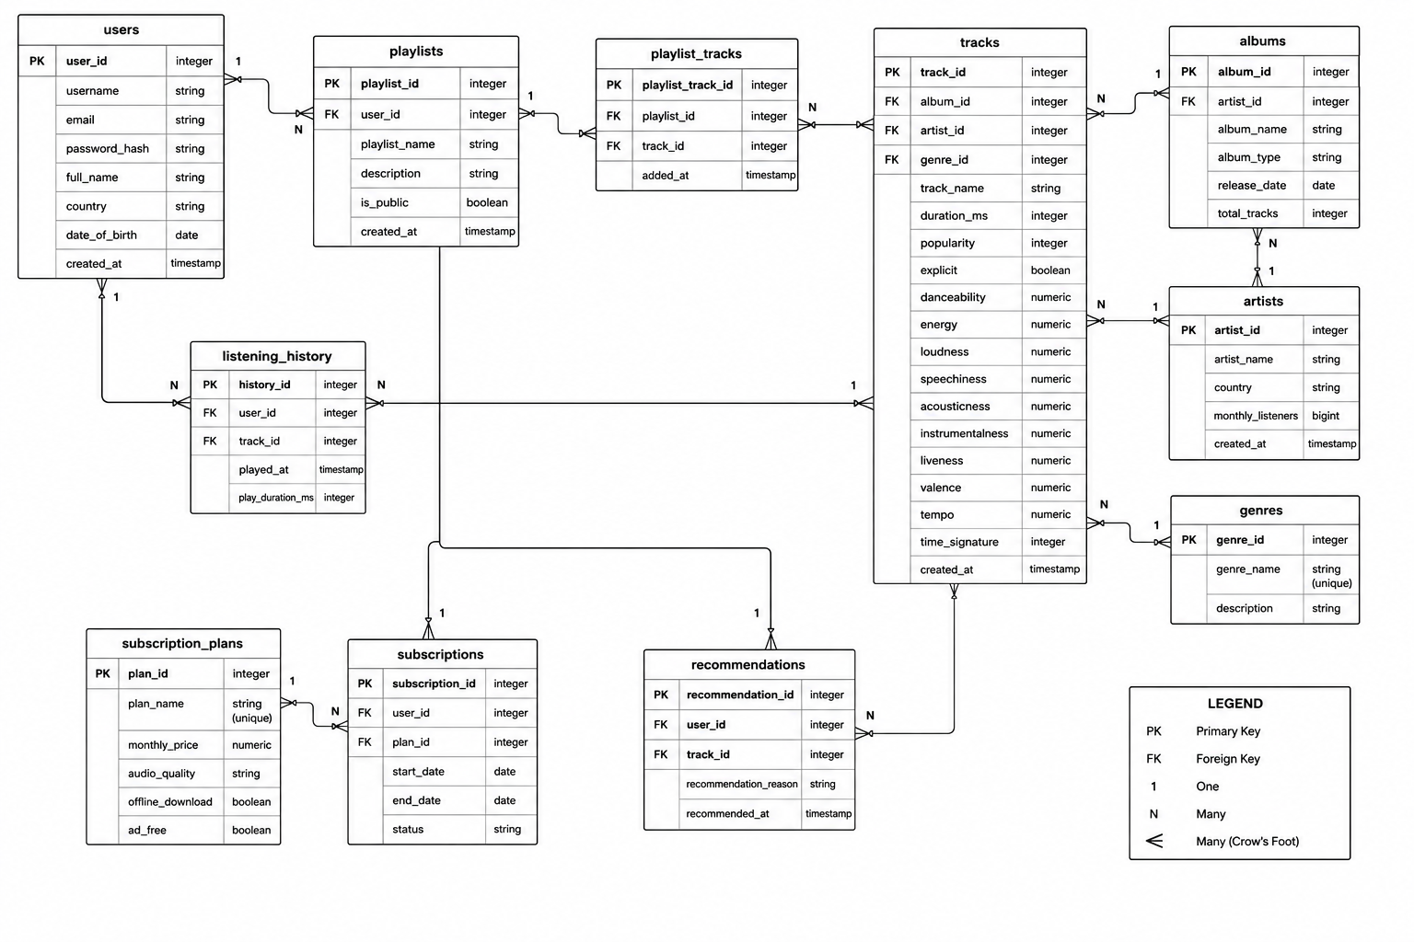

Relationship Table
No. | Parent Table | Child Table | Relationship | Cardinality | Description
1 | Users | Playlists | User creates Playlist | 1 : N | One user can create multiple playlists, but each playlist belongs to only one user.
2 | Playlists | Playlist_Tracks | Playlist contains Tracks | 1 : N | One playlist can contain many songs through the Playlist_Tracks table.
3 | Tracks | Playlist_Tracks | Track belongs to Playlist | 1 : N | One track can appear in multiple playlists.
4 | Users | Listening_History | User listens to Tracks | 1 : N | One user can have many listening history records.
5 | Tracks | Listening_History | Track playback | 1 : N | One track can be played many times by different users.
6 | Artists | Albums | Artist releases Albums | 1 : N | One artist can release multiple albums.
7 | Albums | Tracks | Album contains Tracks | 1 : N | One album contains multiple tracks, while each track belongs to one album.
8 | Artists | Tracks | Artist performs Tracks | 1 : N | One artist can perform many tracks.
9 | Genres | Tracks | Genre classifies Tracks | 1 : N | One genre can be assigned to multiple tracks.
10 | Users | Subscriptions | User purchases Subscription | 1 : N | A user may have multiple subscription records over time, but only one active subscription at a given time.
11 | Subscription_Plans | Subscriptions | Plan assigned to Users | 1 : N | One subscription plan can be subscribed to by many users.
12 | Users | Recommendations | User receives Recommendations | 1 : N | One user can receive multiple personalized track recommendations.
13 | Tracks | Recommendations | Recommended Tracks | 1 : N | One track can be recommended to many different users.

Many-to-Many Relationship
Relationship | Bridge Table | Explanation
Playlists <-> Tracks | Playlist_Tracks | A playlist can contain many tracks, and a track can appear in many playlists. This relationship is resolved using the Playlist_Tracks table.

Conclusion
Spotify has transformed the music streaming industry by providing users with instant access to millions of songs through a reliable and personalized platform. This project explored Spotify's core features, analyzed the real-world problems it solves, and designed a normalized PostgreSQL database schema to support its functionality. The ER diagram, SQL schema, and analytical queries demonstrate how relational databases can efficiently manage large volumes of interconnected data. Overall, this project strengthened the understanding of database design, normalization, PostgreSQL, and data analysis while applying these concepts to a real-world application.

