**Task:**

Create a file max-temp.txt in local FS.

Put some 10-15 records of date and temperature example:

dd-mm-yyyy,temperature

Example:

10-01-1990,10

10-02-1991,20

Move this file to HDFS at /user/acadgild/hadoop.

I performed following steps

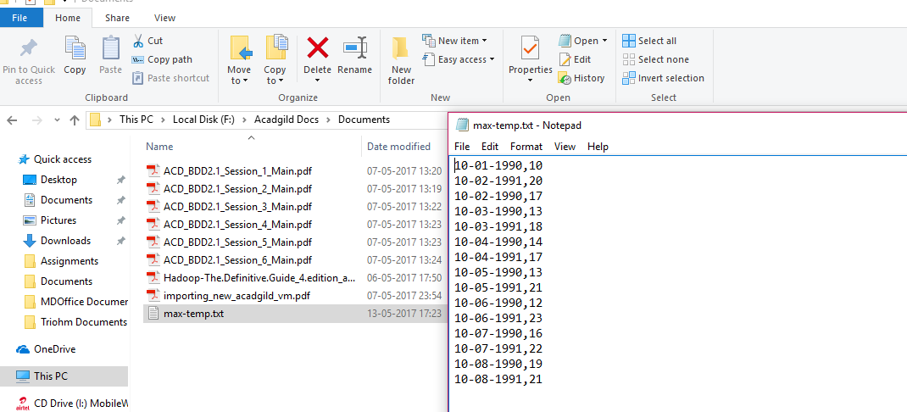

Moving file to /user/acadgild/hadoop by winscp

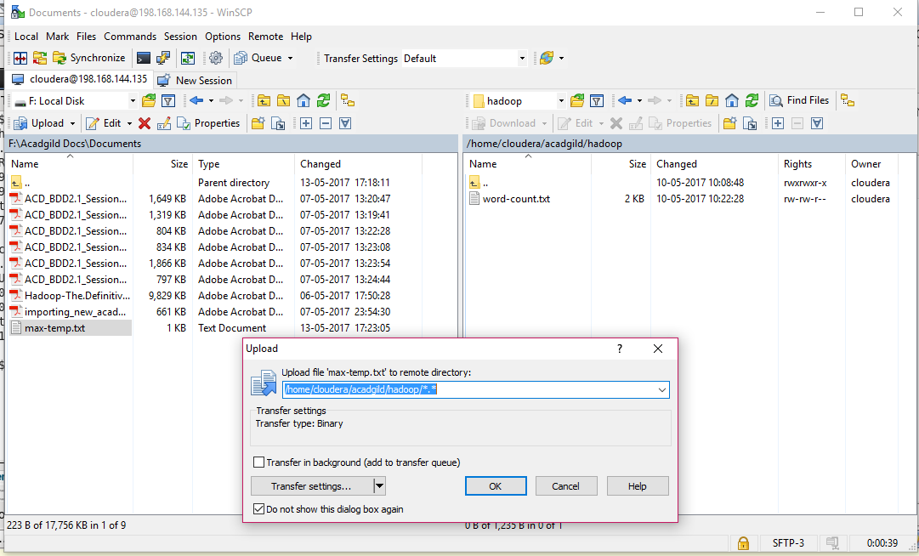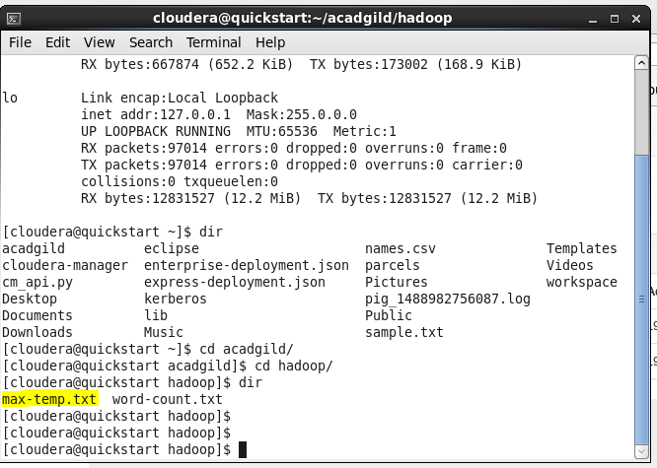

**Tasks :**

Change the permission of the file /user/acadgild/hadoop/max-temp.txt, such that

Only the owner and the group members have full control over the file.

Others do not have any control over it.

