Evolution of Software

In Software Engineering: A Practitioner's Approach, Roger Pressman details software evolution not merely as a maintenance phase, but as a continuous and inherent characteristic of software systems that exist in real-world environments. Unlike hardware that wears out, software deteriorates due to change, and must constantly adapt to remain useful and relevant.

The Nature and Drivers of Software Evolution

Pressman emphasizes several core reasons software evolves:

Changing Requirements: As users interact with a system, their needs and expectations change, prompting requests for new features or modifications to existing ones.

Environmental Shifts: Software must adapt to new operating systems, hardware platforms, network configurations, or cloud environments to remain operational and efficient.

Error Correction and Quality Improvement: The process of evolution includes the ongoing identification and fixing of bugs and the necessity to improve performance, reliability, and security over time.

Business Needs and Regulations: New business rules, market demands, or government regulations often necessitate changes in software functionality.

Pressman and Lehman's Laws of Software Evolution

Pressman includes Meir M. Lehman's "Laws of Software Evolution" which describe the dynamics of E-type systems (those embedded in the real world). Key laws include:

Continuing Change: E-type programs must adapt or become less useful.

Increasing Complexity: Program complexity grows unless actively managed.

Continuing Growth: Functional content must increase to satisfy users.

Declining Quality: Quality appears to decline without rigorous maintenance and adaptation.

Evolutionary Process Models

Pressman advocates for iterative process models over rigid linear ones like Waterfall.

1. Prototyping Model
Concept: The prototyping model is ideal when requirements are unclear or the customer has difficulty visualizing the final product. The goal is to quickly build a simplified, working version (a prototype) of the software to gather feedback and refine requirements, not to build the final production system. The prototype can be a "throwaway" or an "evolutionary" one that is refined into the final product.

Methodologies/Techniques: The core methodology involves rapid development and user feedback loops.
- Rapid Throwaway Prototyping: Building a quick, rough version (e.g., a paper mockup or basic HTML wireframe) to visualize requirements and gather feedback, then discarding it and building the final system from scratch.
- Evolutionary Prototyping: Continuously refining an initial, robust prototype until it becomes the final production system, saving initial time and effort.
- User Interface (UI) Design Focus: Often uses screen generators or design tools to focus on the human-computer interaction.

Example: A New Language Learning Mobile App
Imagine a team is building a novel language-learning app. The customer has a general idea but is unsure about the user interface (UI) and interaction flow.
- Process:
  - The team quickly creates a clickable mockup or wireframe (the prototype) focusing solely on the core functionality, such as conversation simulations and vocabulary quizzes.
  - The customer and potential users interact with this basic, non-functional (or minimally functional) prototype.
  - Based on user feedback ("I'd like the vocabulary quizzes to be more visual," "The conversation flow is confusing"), the team refines the requirements and builds a more detailed, functional version.
- Discussion Point: This allows the team to validate the user experience early on, ensuring the final app aligns with user expectations before significant development costs are incurred.
2. Spiral Model
Concept: The spiral model, developed by Barry Boehm, is a risk-driven approach suitable for large, complex, and high-risk projects. It combines the iterative nature of prototyping with the systematic steps of the waterfall model, emphasizing risk analysis at each stage. Each loop (spiral) of the process involves planning, risk analysis, engineering, and evaluation.

Methodologies/Techniques: This model is risk-driven and incorporates elements of other models.
- Risk Analysis and Mitigation: This is central to the model, using techniques like simulation, analytical modeling, and benchmark testing to assess and resolve risks in each loop.
- Iterative Waterfall or Prototyping within Cycles: Each spiral iteration can use a mini-waterfall approach for specific features or build a prototype as a risk-handling technique.
- Objective Setting: Each cycle begins with clearly defining objectives, alternatives, and constraints for that specific phase.

Example: Developing an Avionics System for a New Aircraft
Building software for an aircraft's navigation or control system involves exceptionally high risks. A failure could be catastrophic.
- Process:
  - Planning & Risk Analysis (Spiral 1): The team defines basic requirements. A major risk identified might be the integration of new sensor technology. They create a simple prototype to simulate sensor input and test the feasibility of the technology.
  - Engineering & Evaluation (Spiral 1): The prototype is built and tested. If the risk is manageable, they proceed.
  - Planning & Risk Analysis (Spiral 2): The team plans the next set of features and re-evaluates all known risks, perhaps focusing on data processing speeds.
  - Iteration: This process repeats, with each spiral addressing higher-level functionality and mitigating new risks until the complete, highly reliable system is developed.
- Discussion Point: The continuous focus on identifying and managing risk at every stage makes this model essential for life-critical or mission-critical systems.
3. Concurrent Model (Concurrent Engineering)
Concept: The concurrent model, or concurrent engineering, represents software development activities as a network of parallel tasks. Different teams work on different components or phases simultaneously, and events trigger transitions between states. It is a highly flexible and efficient approach that shortens overall development time.

Methodologies/Techniques: The key is parallel development across multiple disciplines.
- Cross-functional Teams: Involves multidisciplinary teams (e.g., design, coding, testing, manufacturing, support) working in parallel to ensure all aspects of the product lifecycle are considered early on.
- State-based Activities: Software activities are defined as a network where events trigger state transitions (e.g., an "analysis complete" event triggers the "design" team to move from "waiting" to "in progress" state).
- Product Data Management (PDM) / Product Lifecycle Management (PLM): Utilizes robust software tools like PDM or PLM systems as a central repository to facilitate real-time information sharing and communication among parallel teams.

Example: A New Video Game Development
In game development, various components like graphics, audio, user input, and game logic need to be developed and integrated.
- Process:
  - The graphics team works on rendering engines and visual assets.
  - The sound design team works on audio effects and music.
  - The logic team works on the game's rules and artificial intelligence.
  - These teams work in parallel (concurrently). When the graphics team finishes a set of character models, it triggers a transition for the integration team to merge those assets with the game logic code.
- Discussion Point: This parallel workflow allows for rapid iteration and integration. If one task is delayed (e.g., character animations need redesign), other related tasks (e.g., sound effects for existing animations) can continue, reducing bottlenecks.
4. Incremental Model
Concept: The incremental model delivers a series of releases (increments) where each subsequent release provides more functionality until the complete system is delivered. The first increment is often a "core product" or minimum viable product (MVP) with basic features, which users can start using immediately.

Methodologies/Techniques: This approach focuses on delivering functional modules in stages.
- Staged Delivery Model: The product is delivered in a series of functional releases, with each release adding new features to the previously delivered version.
- Iterative Waterfall (within increments): Each individual increment often follows a mini-waterfall lifecycle (requirements, design, code, test, deploy).
- Prioritization of Requirements: High-priority or core functionalities are identified and developed in earlier increments.

Example: Building an E-commerce Website
An e-commerce startup needs to launch quickly but has many features in its roadmap.
- Process:
  - Increment 1: Deliver a basic website with a product catalog and simple search functionality. Users can browse products but not buy them yet.
  - Increment 2: Add a shopping cart and a secure user registration system based on initial user feedback and testing.
  - Increment 3: Integrate a payment gateway and order tracking features.
  - Increment 4+: Add customer reviews, personalized recommendations, and advanced search filters.
- Discussion Point: This strategy allows the business to generate revenue or gather real-world user data from the first increment while continuing development, reducing time-to-market and managing development costs effectively.

Incremental Model: Delivers software in small, working pieces for continuous feedback.

Spiral Model: Manages risk through iteration, supporting continuous adaptation.

Agile Methodologies: Approaches like Scrum and Kanban align with evolution by emphasizing flexibility and frequent delivery.

Pressman views software evolution as a core principle requiring proactive management and iterative methods for long-term success.

Software Life Cycle Phases (SDLC)

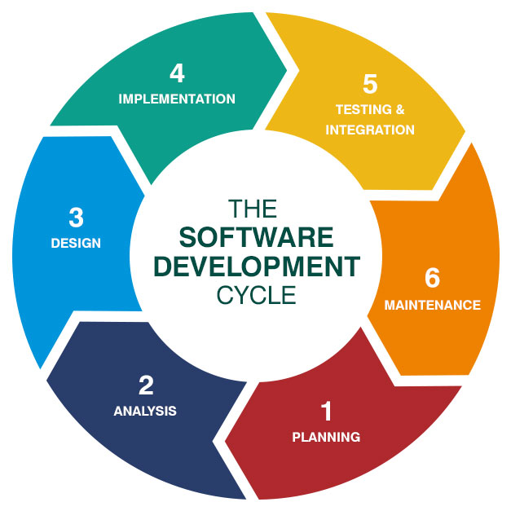

1. Planning & Feasibility Analysis
Goal: Understand what to build and whether it is practical.

Activities:
- Identify problem/opportunity
- Define project scope
- Cost estimation
- Feasibility study (Technical, Operational, Financial)
- Prepare initial project plan

Output:
- Feasibility Report
- Project Proposal

2. Requirements Analysis
Goal: Understand user needs clearly.

Activities:
- Meeting with clients/users
- Use cases identification
- Functional + non-functional requirements gathering

Output:
- SRS Document (Software Requirements Specification)

Functional Requirements:
- What the system should do
Example: “System should allow users to register.”

Non-functional Requirements:
- Performance, reliability, usability.
Example: “System should load within 2 seconds.”

Design and Prototyping
Goal: Create the blueprint of the system.

Activities:
- System architecture design
- UI/UX design
- Database design
- Low-level design (detailed modules, classes)
- High-level design (overall structure)
- Build prototype screens for client approval

Output:
- HLD (High-Level Design)
- LLD (Low-Level Design)
- Wireframes / Prototypes

4. Development (Coding)
Goal: Actual software is built here.

Activities:
- Assign modules to developers
- Write code according to design
- Follow coding standards
- Integrate modules

Output:
- Working Software / Build

5. Testing
Goal: Find bugs and ensure quality.

Testing Types:
- Unit testing
- Integration testing
- System testing
- User acceptance testing (UAT)

Outputs:
- Test cases
- Bug reports
- Tested software

6. Deployment
Goal: Release software to users.

Deployment Types:
- Production deployment
- Staging deployment
- Rollout or phased deployment

Outputs:
- Live Software
- User documentation

7. Maintenance (Post-Deployment)
Goal: Support and improve the system.

Types of Maintenance:
- Corrective (Fixing bugs)
- Adaptive (Changing environment)
- Perfective (Improving performance/features)
- Preventive (Avoiding future issues)

Project Management in SDLC
Project Management ensures SDLC runs smoothly.

Key Areas:
- Scope Management – Define what is included/excluded
- Time Management – Scheduling tasks, milestones
- Cost Management – Budgeting and monitoring expenses
- Risk Management – Identify and reduce risks
- Quality Management – Ensure standards are followed
- Resource Management – Manage people, tools, skills
- Communication – Meetings, documentation, reporting

Tools Used:
- Jira
- Trello
- MS Project
- Asana
- Slack

