**Objects:**

If we want to create anything in the kubernetes is called as objects. Creating a pod, network policy, deleting... etc. all those actions called as objects.

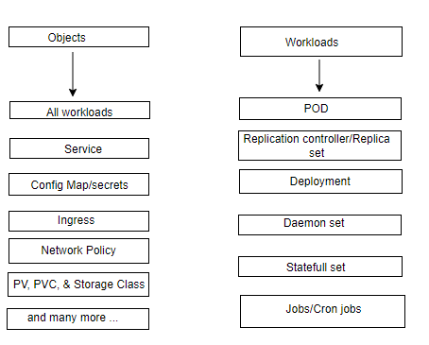

**POD:**

What is Pod?

A pod is the smallest execution unit in Kubernetes. A pod encapsulates (express the essential feature of something) one or more applications. Pods are ephemeral (something that lasts for a very short time) by nature, if a pod fails kubernetes can automatically create a new replica of that pod to continue operation.

* Pod creates a logical layer to group one or more containers to have a common network & shared storage, configuration information.

**Common network:**

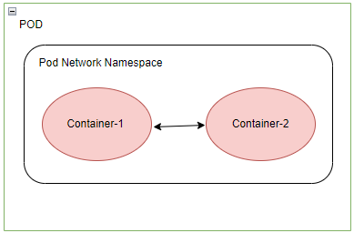

**Shared Network:**

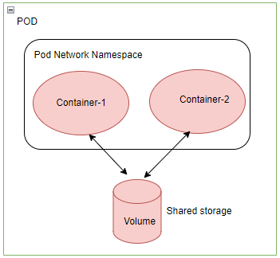

* Pod IP address is ephemeral means if we delete a pod then its IP address also gets removed. Then after if we create another pod it will be assigned with new IP. If we want to read our application outside, then we need to use pod IP not container IP.
* Containers inside POD talk each other on localhost/127.0.0.1, since containers share same network stack.
* Containers share data inside POD.
* In general, we need to create containers inside POD which are dependent, not different application. (we can create different applications but it is not recommended.)

**Note:** pods are not directly exposed to external network traffic. To enable external access, Kubernetes provides other abstractions like services and ingress resources, which act as proxies or load balancers to route traffic to the pods based on certain rules or policies.

**Architecture Diagram of POD:**

Cluster contains Node – Node contains Pod – Pod contains containers – Inside of the containers we run application.

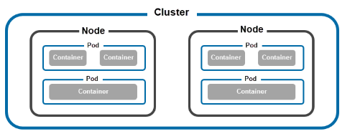

**Types of Pods:**

Based on the number of containers they hold, pods can be **single-container** and **multi-container** pods.

**Single-Container Pods:** Pods in kubernetes most often host a single container that provides all the necessary dependencies for an application to run. Single container pods are simple to create and offer a way for kubernetes to control individual containers indirectly.

**Multi Container Pods:**

Multi-container pods host containers that depend on each other and share the same resources. Inside such pods, containers can establish simple network connections and access the same storage volumes. Since they are all in the same pod, kubernetes treats them as a single unit and simplifies their management.

**References:**

1. Video: <https://visualpath.teachable.com/courses/docker-kubernetes-2022-recorded-videos-by-mr-sudheer/lectures/45143613>
2. Pod: <https://phoenixnap.com/kb/kubernetes-pod>
3. <https://kubernetes.io/docs/contribute/style/diagram-guide/>