In the Navigation bar- select vpc- click on create vpc 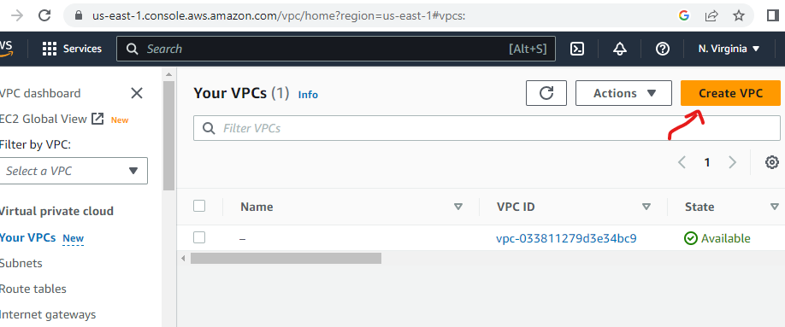

After clicking on create VPC the below page will appear. For creating VPC select VPC only

Name tag: vpc IPV4 CIDR: 10.30.0.0/16

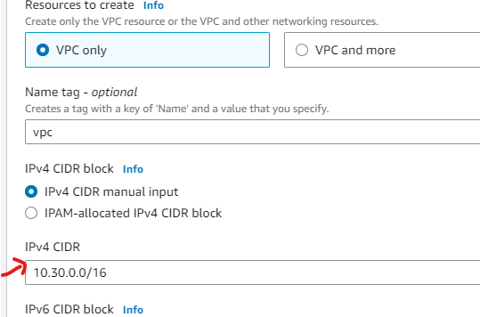

Then click on create VPC

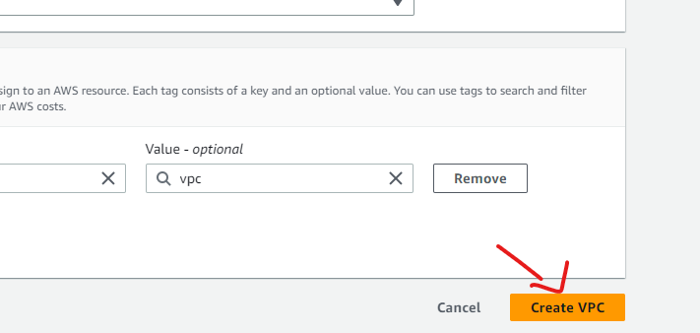

In the Navigation bar- go to subnets- click on create subnets- select the vpc

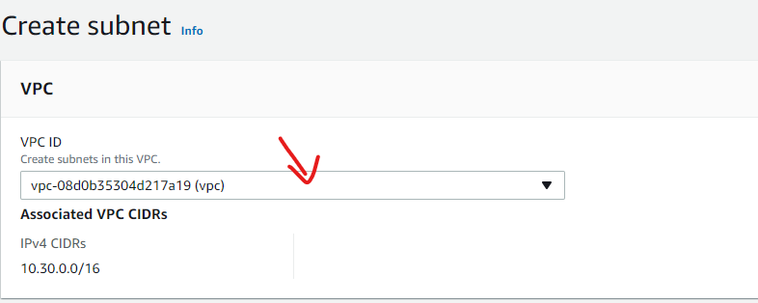

Subnet Name: provide the name of the subnet(public-1a)

AZ: provide the region (US East (N. Virginia)/us-east-1a) Ipv4 CIDR: provide the subnet as per the vpc CIDR (ex: 10.30.0.0/24) click on Add subnet

create another subnet, Subnet Name: public-1b, AZ: US East(N. Virginia)/us-east-1b

Ipv4 CIDR: 10.30.1.0/24

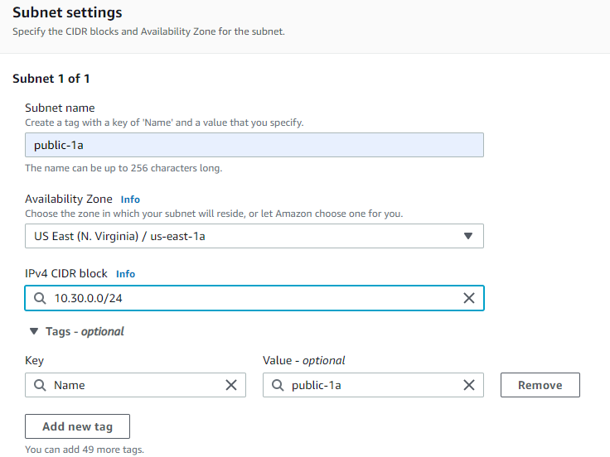

Click on Add new subnet with help of that at a time multiple subnets can create. Create 2 private subnets. Subnet name: private-1a Availability Zone: US East (N. Virginia) / us-east-1c IPv4 CIDR: 10.30.2.0/24

Click on Add subnet create another private subnet

Subnet name: private-1b Availability Zone: US East (N. Virginia) / us-east-1d IPv4 CIDR: 10.30.3.0/24

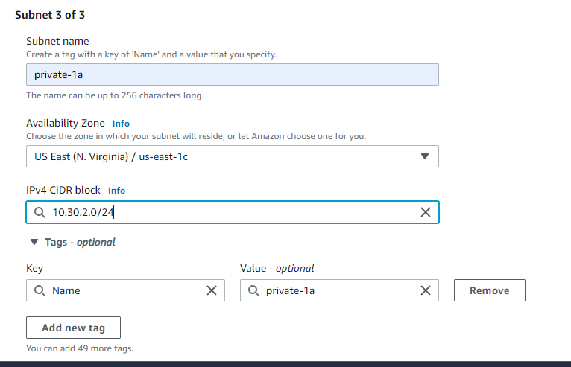

In the Navigation Bar- select Route Table- Name: Name of the route table (private route) vpc: select the vpc – Create route table 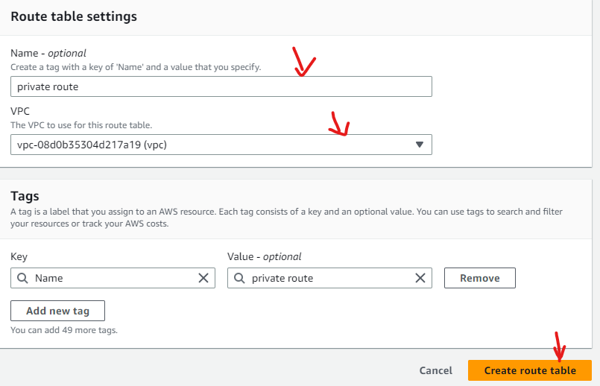

Create Route table- Name: 