**Swapnadeep Mohapatra 22053820 Lab-05**

1. Create a program to add a new paragraph to the page whenever a button is clicked.

<!*DOCTYPE* *html*>

<html *lang*="en">

<head>

<meta *charset*="UTF-8">

<meta *http-equiv*="X-UA-Compatible" *content*="IE=edge">

<meta *name*="viewport" *content*="width=device-width, initial-scale=1.0">

<title>Add Paragraph</title>

</head>

<body>

<h1>Click the button to add a new paragraph:</h1>

<button *onclick*="addParagraph()">Add Paragraph</button>

<div *id*="paragraph-container"></div>

<script>

*function* addParagraph() {

*const* paragraphContainer = document.getElementById('paragraph-container');

*const* newParagraph = document.createElement('p');

newParagraph.textContent = 'This is a new paragraph.';

paragraphContainer.appendChild(newParagraph);

}

</script>

</body>

</html>

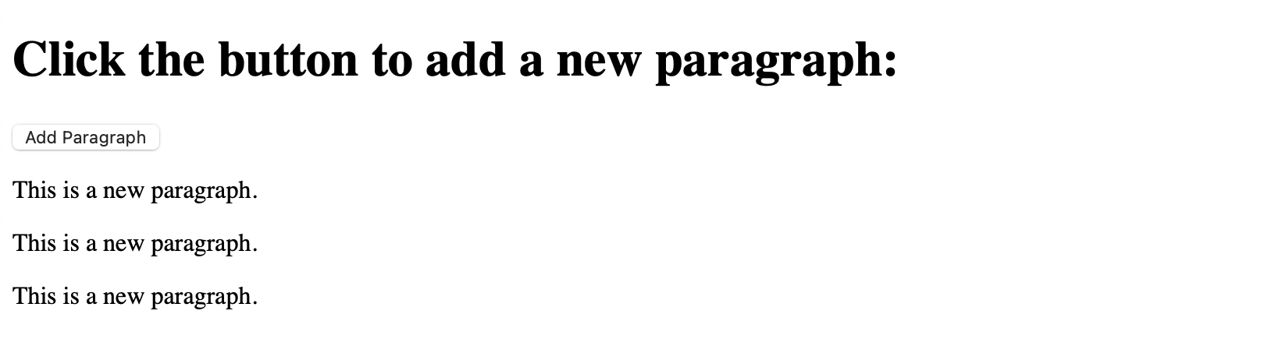

1. Write a script to dynamically change the content of an HTML table based on user input.

<!*DOCTYPE* *html*>

<html>

<head>

<title>Dynamic Table</title>

</head>

<body>

<h2>Enter number of rows and columns for the table:</h2>

Rows: <input *type*="text" *id*="rowsInput" /> Columns:

<input *type*="text" *id*="columnsInput" />

<button *onclick*="generateTable()">Generate Table</button>

<table *id*="myTable" border="1"></table>

<script>

*function* generateTable() {

*var* rows = document.getElementById("rowsInput").value;

*var* columns = document.getElementById("columnsInput").value;

*var* table = document.getElementById("myTable");

table.innerHTML = "";

*for* (*var* i = 0; i < rows; i++) {

*var* row = table.insertRow();

*for* (*var* j = 0; j < columns; j++) {

*var* cell = row.insertCell();

cell.innerHTML = "Row " + (i + 1) + ", Column " + (j + 1);

}

}

}

</script>

</body>

</html>

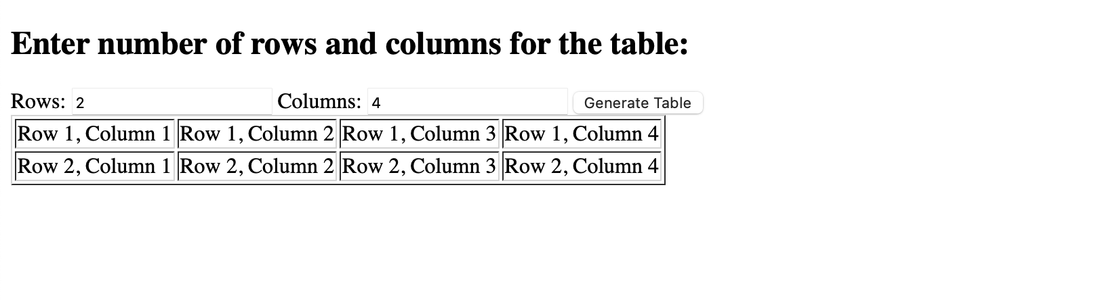

1. Develop a program where hovering over a button changes its color and text dynamically.

<!*DOCTYPE* *html*>

<html>

<head>

<title>Dynamic Button Color and Text Change</title>

</head>

<body>

<button *id*="btn" *onmouseover*="changeButton()">Hover over me!</button>

<script>

*function* changeButton() {

*var* button = document.getElementById('btn');

button.style.backgroundColor = 'red';

button.textContent = 'Thanks for hovering!';

}

</script>

</body>

</html>



1. Write a program to display a live clock on a web page using JavaScript.