# Docker Getting Started

## Docker commands

To run with administration access start all commands with **sudo**.

### Regular commands

**To find Ubuntu current release version:**



**Docker version:**



**Docker build (To build custom image):**

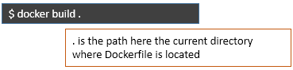

**Docker build with a name:**



**Docker run:**



**Docker remove container:**



**Docker stop container:**



**Docker list all the images present in local:**



**Docker container(s) execution status:**



**Docker run container from image with host port to container port mapping:**



App2 – container name

mynginximage – image name (From which container(runtime of an image) is started)

### Most commonly used commands

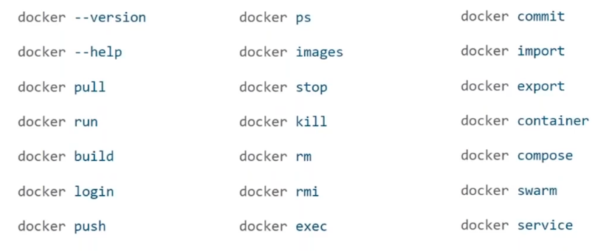

$ docker pull ubuntu

This command will pull the docker image (here ubuntu) from local if present if not found will get it from docker hub.

$ docker run hello-world

hello-world – Image name

run also automatically pulls the image from docker hub if it’s not found in local repo.

**docker container** command is used to perform various operations on the container. Refer to [www.docs.docker.com](http://www.docs.docker.com)

