# Git configure with eclipse

## Configure with Eclipse

**Create the git repository and clone it with eclipse**

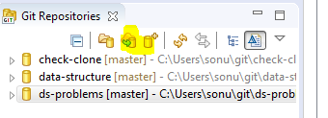

**Share the project**

Right click on project -> Team -> share project

Now, select the cloned repository and Next then finish. Now your eclipse project is ready to be operated with git

**Add gitignore file to avoid unnecessary file**

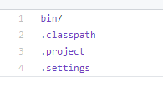

## Eclipse to remember your password of git

Right click on the repository -> properties -> configurations

Change the **URL** including **username: password** as below

