# Web Socket

### Http Connection

When we make 5 different HTTP requests, 5 different connections are going to open and close when response returned and received. This is how a typical HTTP or HTTPS connection works.

### Web Socket

**Web Socket** is a bi-directional connection where sender and receiver sends the data continuously without opening new connections.

It starts with **WS://**

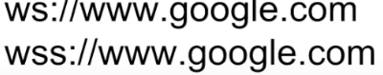

The connection open till either Client or Server dies (decides to terminate the connection).

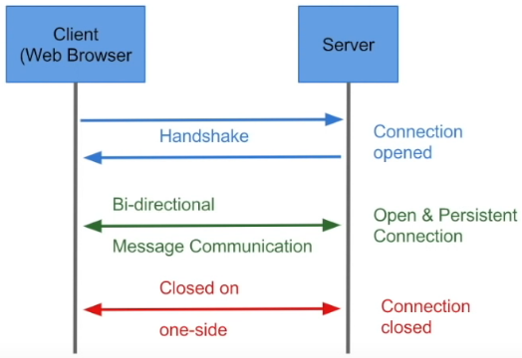

### Where and when Web Sockets can be used

* In Real time application where we want to load the UI without refreshing (Bit coin trading)
* Gaming applications
* Chat applications



**Frames** will be coming continuously to UI and updated.

**Chat Application:**

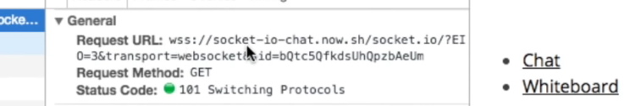

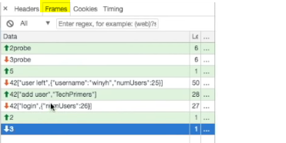

Once we **refresh** connection will be lost and recreated.