We will be creating  a sample RAML for demo purpose

1. Open design center: [Design Center Link](https://anypoint.mulesoft.com/designcenter)

2. Click on create → API specification

3. Add API name and choose code editor  and start designing

We will be using below RAML for employee_details purpose

RAML Snippet : Empdata.

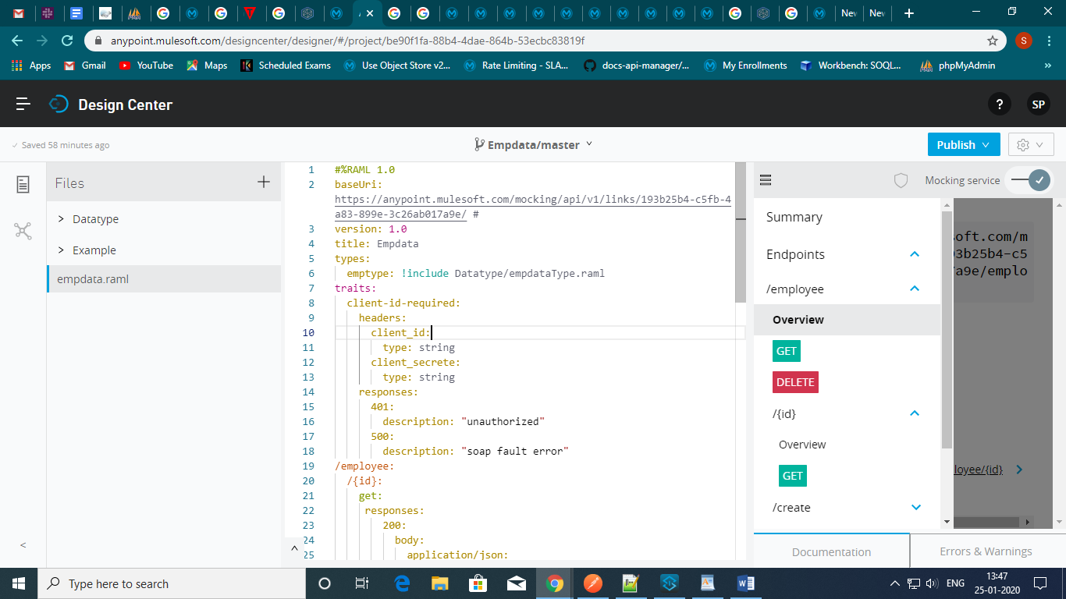

Once the API design is final, test your API with mocking service and publish it to exchange.

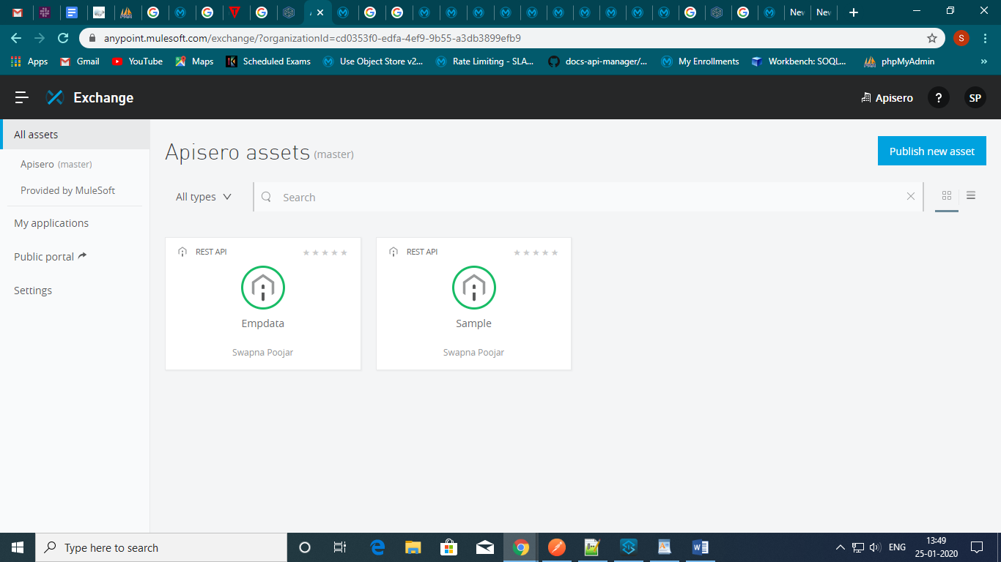

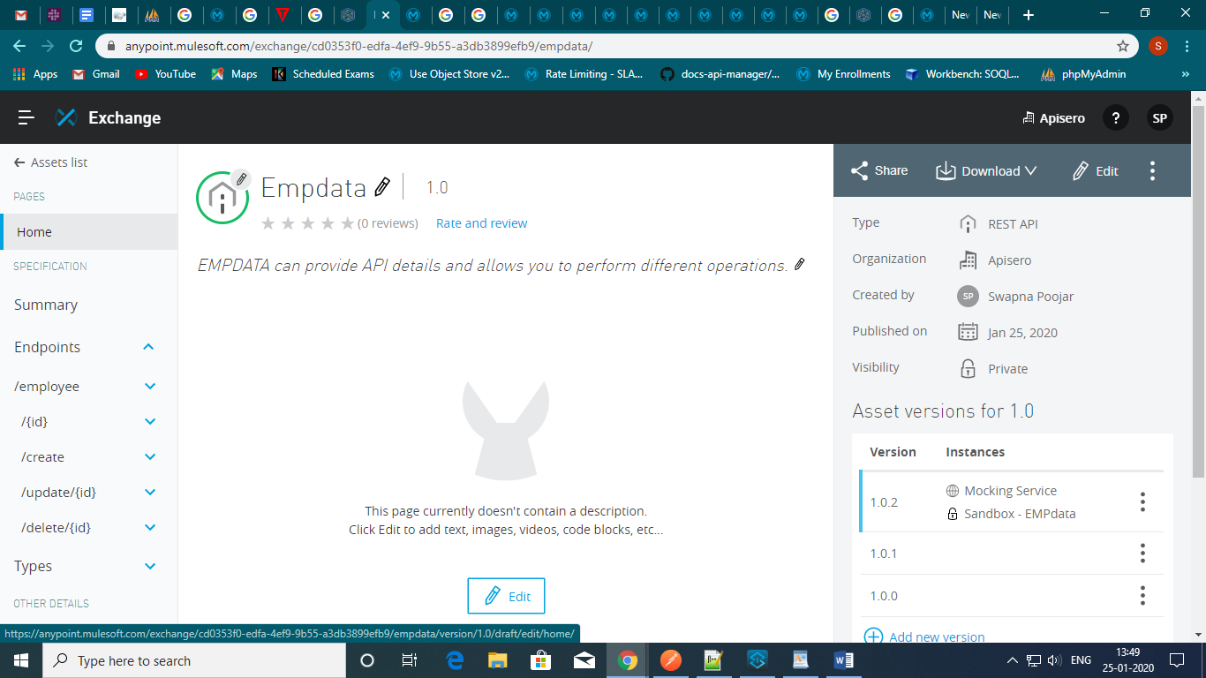

**How to use API Manager and API Autodiscovery feature**

API Manager allows us to apply different types of policies and also helps us in API analytics. Follow below steps to register our API in API manager.

1.  Click on **Manage API**and select  **Manage API from exchange**.

2.  Make sure to select the checkbox for mule version

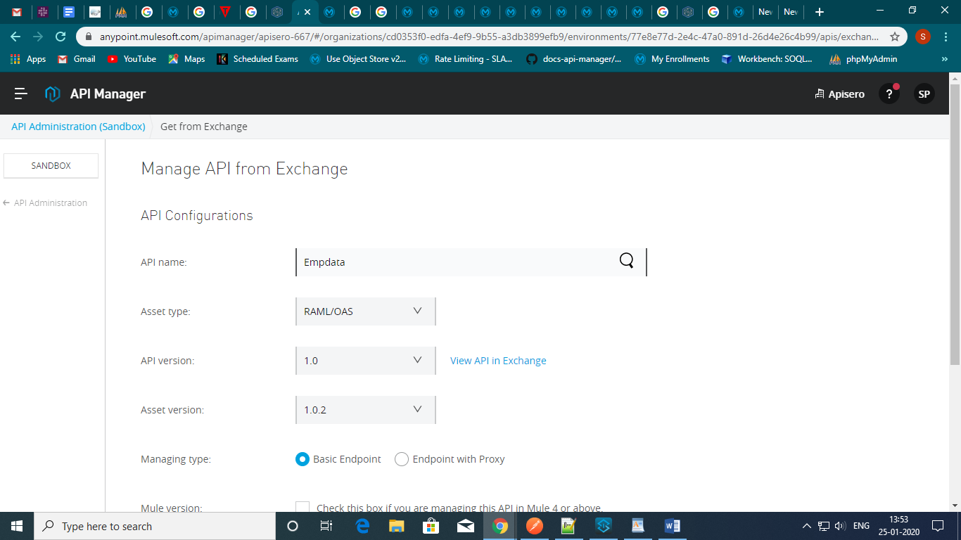

After clicking on save, the API will be registered to the API manager in the  unregistered status.

To make the API active, we need to enable the AutoDiscovery feature.

**AutoDiscovery Feature :**

 Open Anypoint Studio and follow the below steps :

1.  Create new mule project  → provide projectname  → select runtime  → provide RAML URL  → finish.

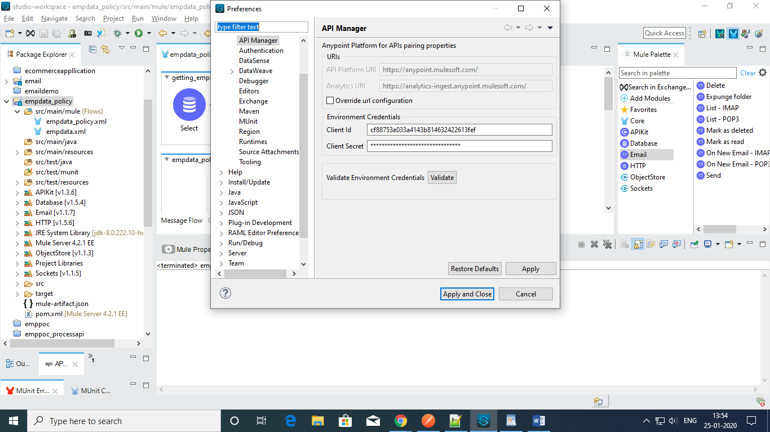

2.  Create new application, provide name and select API instance

3.  Click on request API access

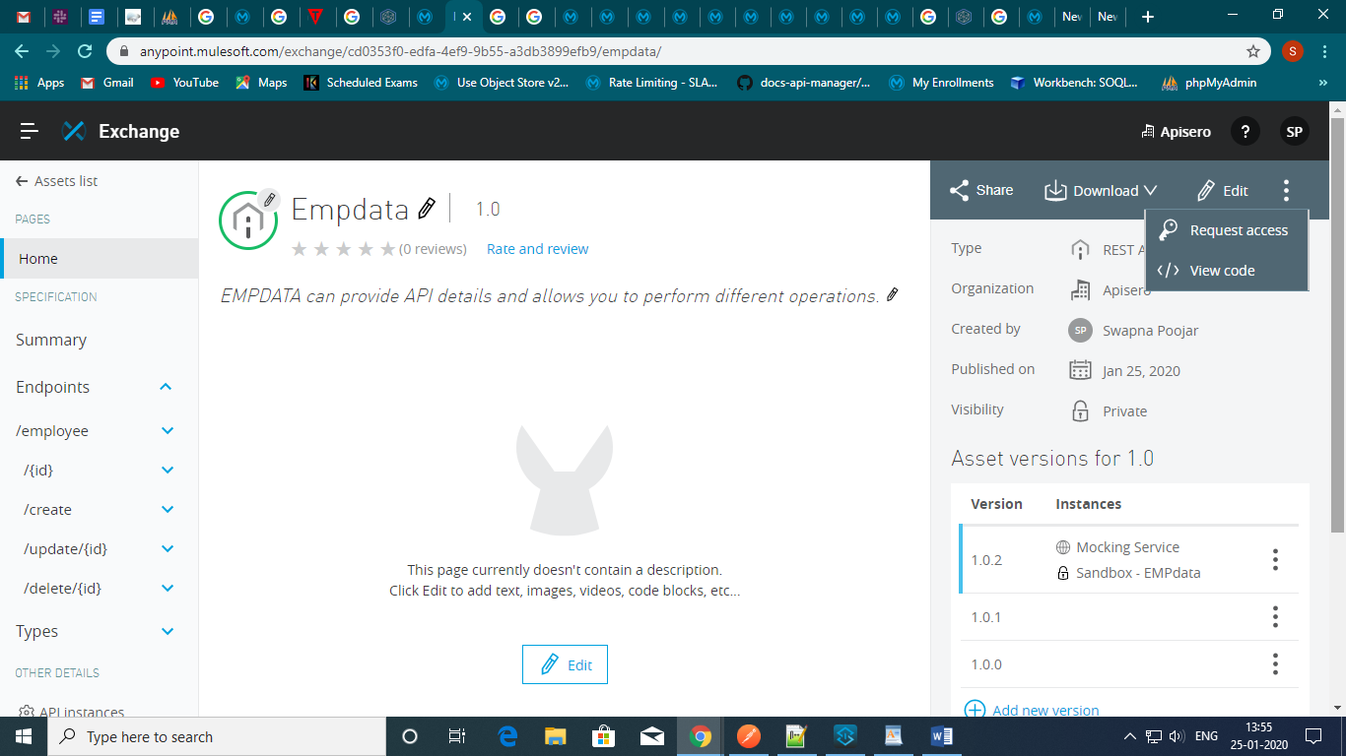

This application in Anypoint Platform will provide client id and client secret to access the API. It also validates client credentials (client id and client secret) passed by a consumer in request.

Go to API manager → select policies → select client id enforcement policy.

Click on configure policy, after providing below details

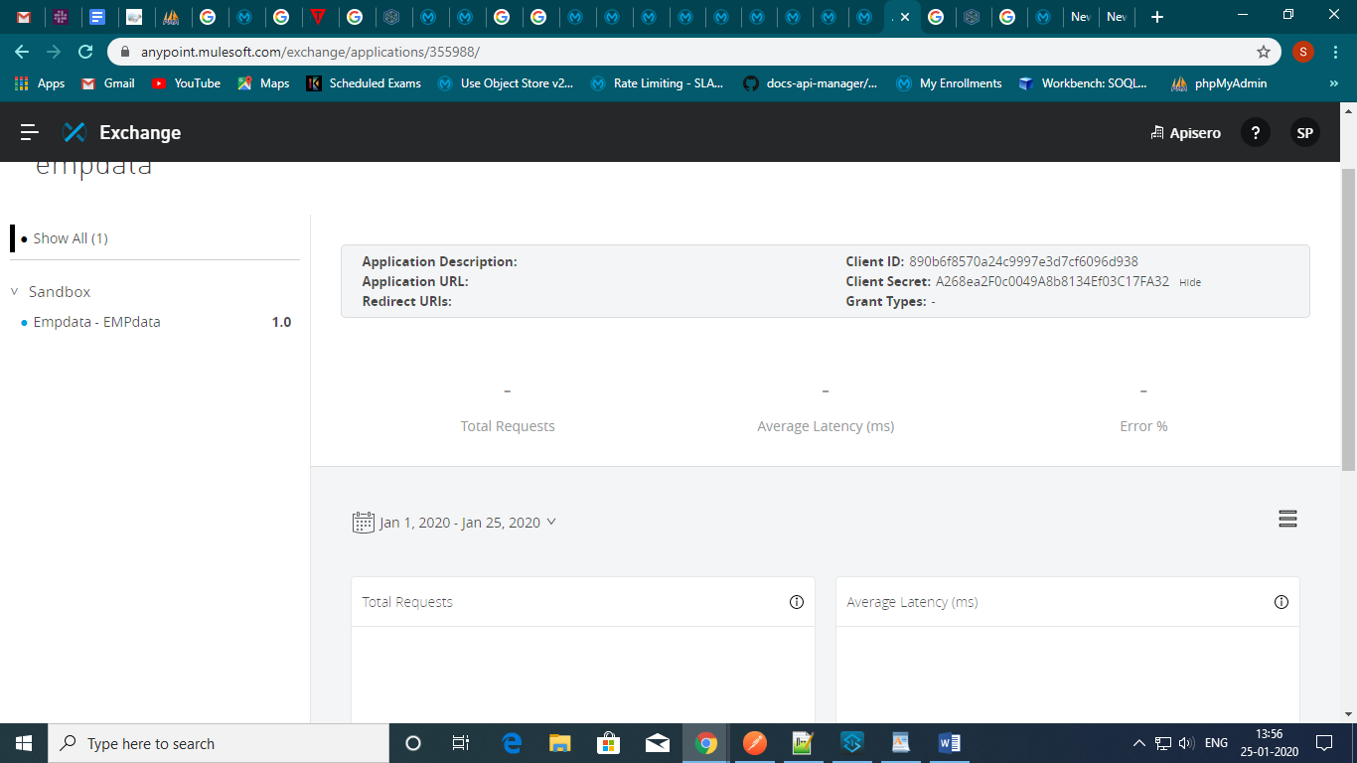

After clicking on the configure policy we will see two options:

1.  HTTP basic authentication

2.  Custom expression

In this post, I will be using custom expression

Now, this policy is enabled for all methods and resources.

Use postman to test demo application.

Add the client Id and client secret pass the values in header tab.

