Screenshots of Request and response of Interview Tracker System:

1. Allows to add a user:

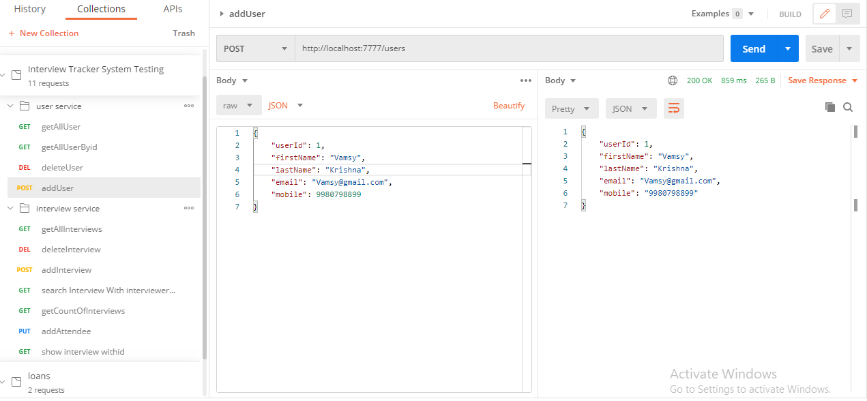

Validations:

* Validations for user details:

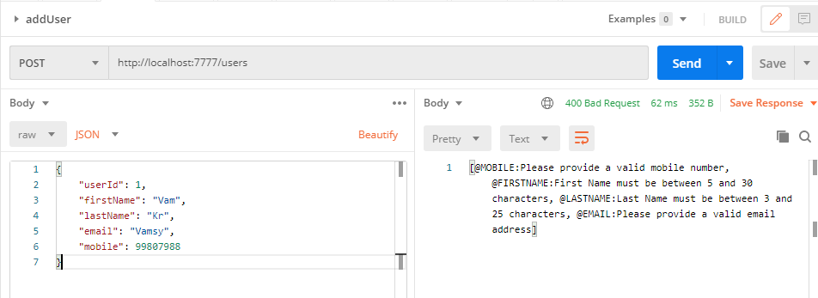

* Creating user with same userid:

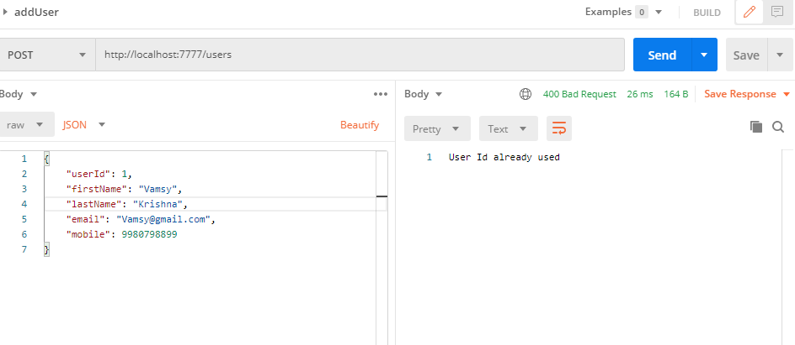

1. Allows to delete an existing user

* Get All the users before delete:

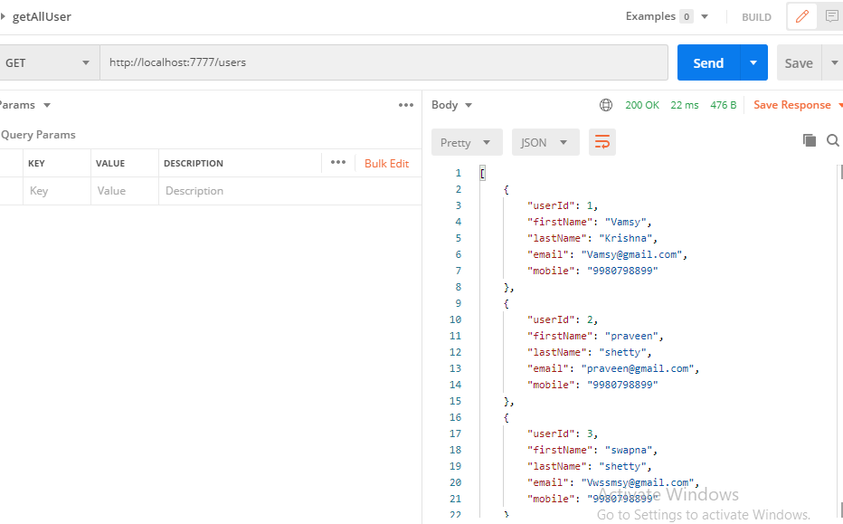

* Delete user:

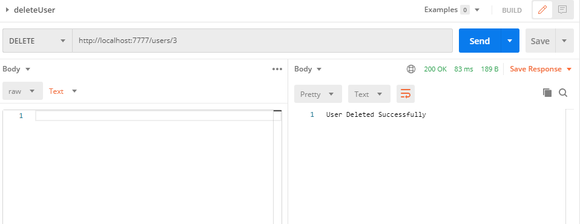

* Get All the users after delete:

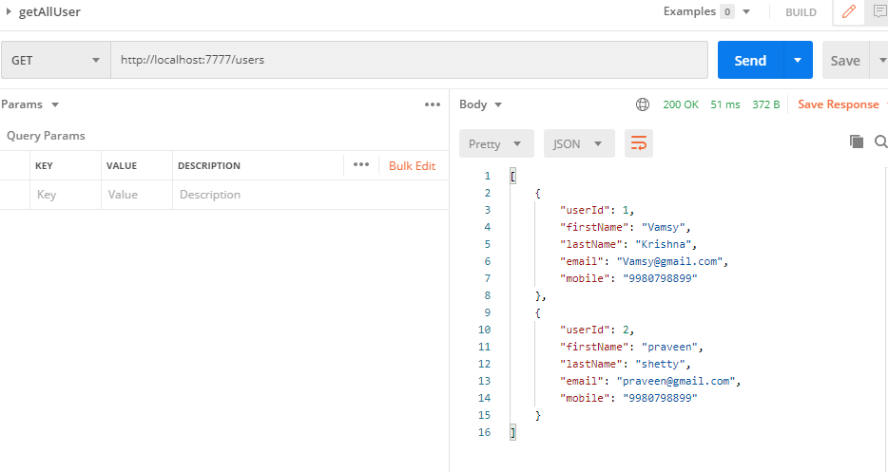

* Validation for delete when triggered with invalid userid:

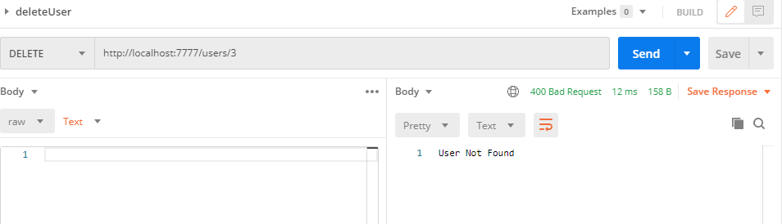

1. Allows to display all the users



1. Allow to add interview

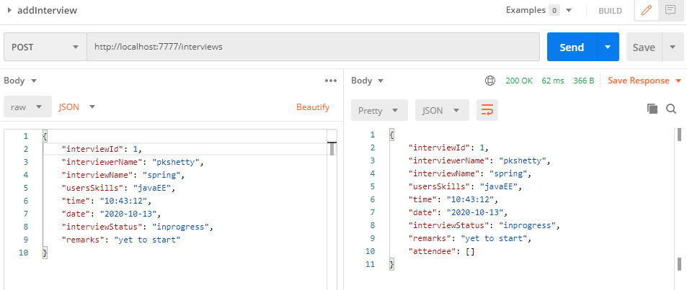

* validation for interview:
* same id used while creating

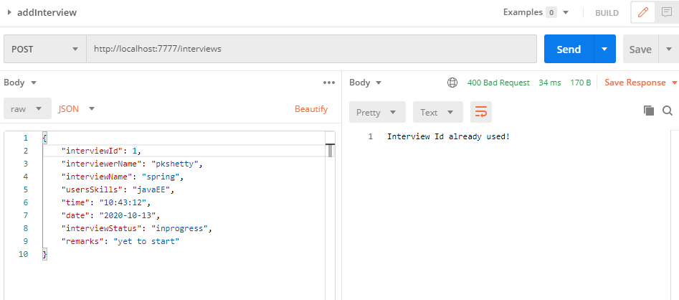

* invalid values validation:

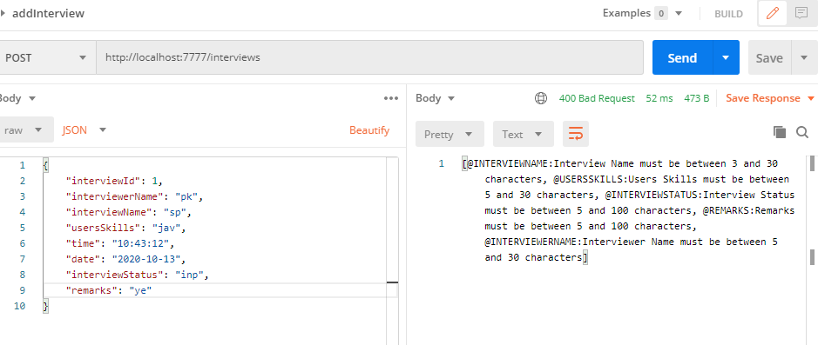

1. Allow to delete an existing interview:

-Get All the interviews before delete:

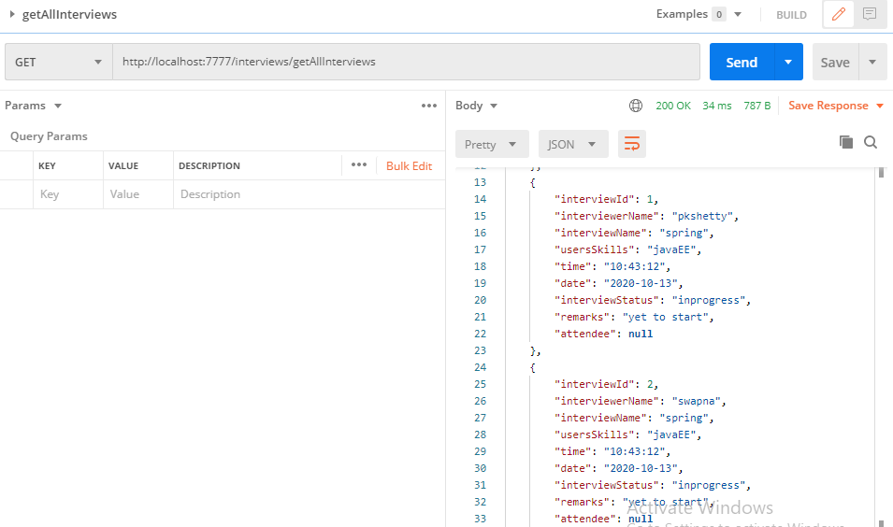

* Delete interview:

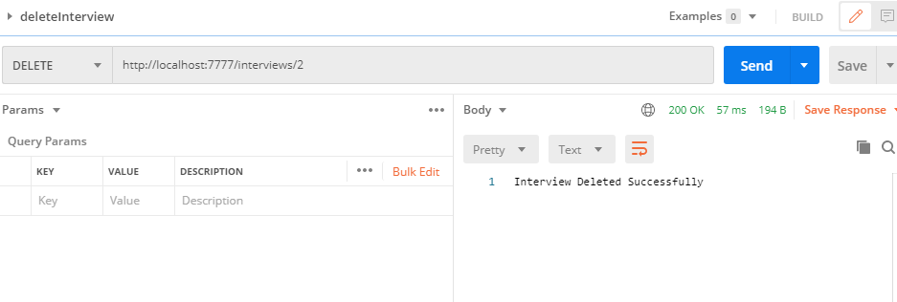

-Get all the interviews after delete:

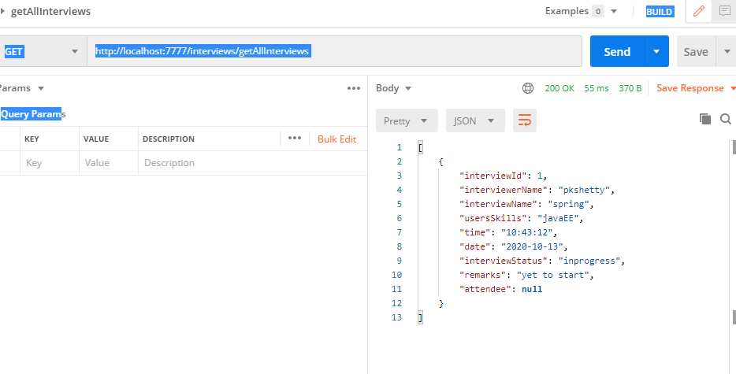

* invalid interview ID:

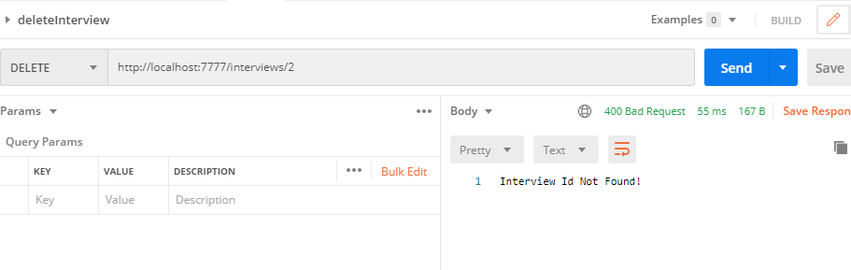

1. Allow to update interview status on go

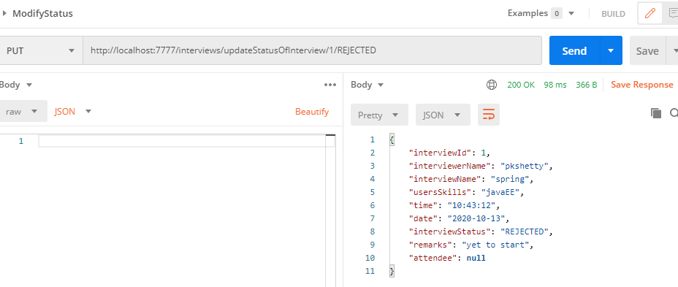

1. Allows to search the interview on the basis of Interview Name and Interviewer Name

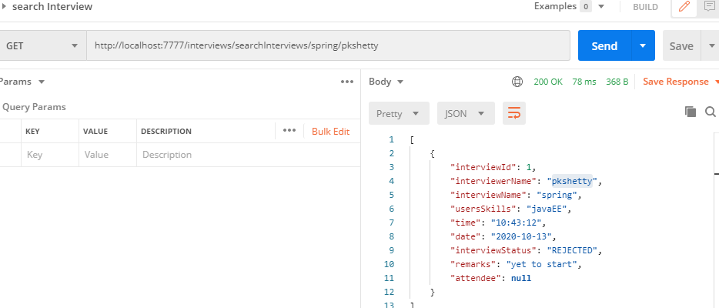

1. Allows searching total no of count of interview.

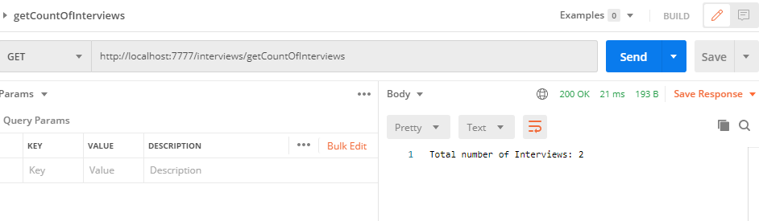

1. Allows to display all the interviews

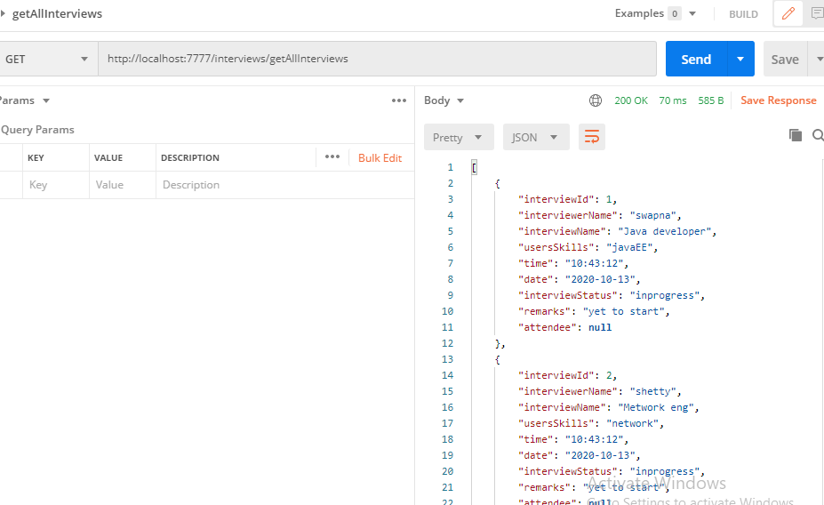

1. Allow to add attendee to an interview

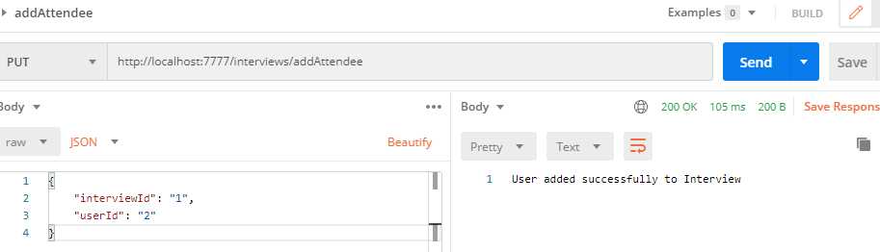

Validation –

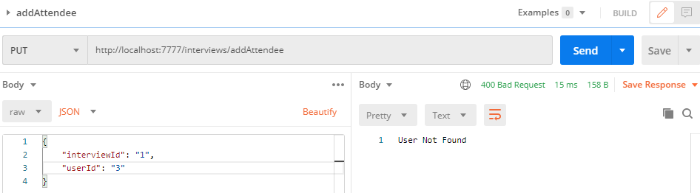

1. Allow to show all attendee of an interview

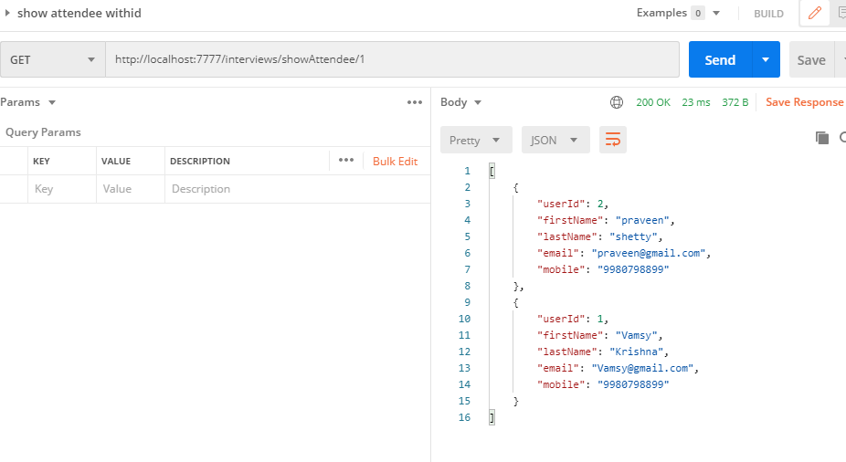

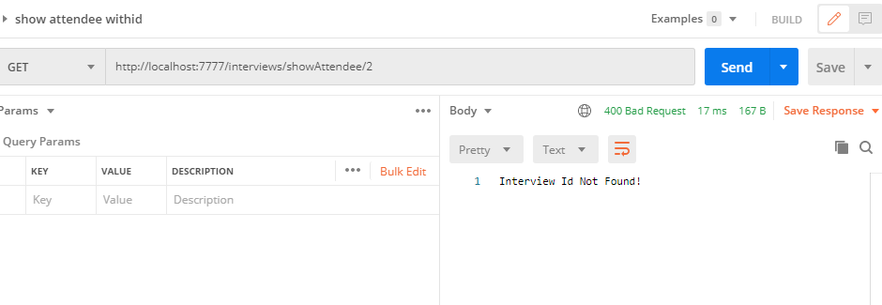

1. While adding a user to interview as attendee, if user id already exists, it should throw a custom exception:

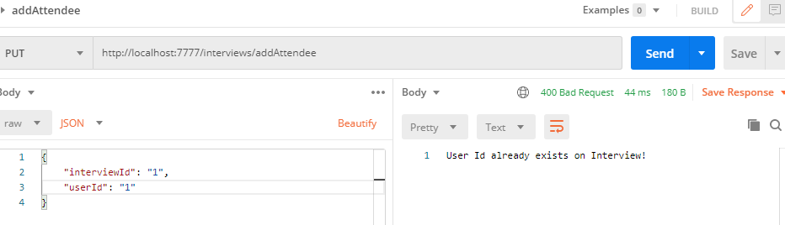

1. While deleting the user and interview also, assumed that id already exists, else throw an custom exception



