**Week_1: Write a python program to compute Central Tendency Measures: Mean, Median, Mode Measure of Dispersion: Variance, Standard Deviation**

Python program that computes the central tendency measures (Mean, Median, Mode) and measures of dispersion (Variance, Standard Deviation) for a given dataset.

**Ex**:Dataset: [12, 15, 12, 18, 16, 20, 15, 14, 15, 18]

* **Mean (Average)**: The sum of all the numbers in the dataset divided by the number of values.

In this case:

Mean=(12+15+12+18+16+20+15+14+15+18)/10=15.3

* **Median**: The middle value when the data is ordered. If there is an even number of values, the median is the average of the two middle numbers. After sorting the dataset:

Sorted dataset=[12,12,14,15,15,15,16,18,18,20]

The median is 15, as it is the average of the 5th and 6th values.

* **Mode**: The number that appears most frequently in the dataset.

In this case, the number 15 appears 3 times, more than any other value, so the mode is 15.

* **Variance**: A measure of how far each number in the dataset is from the mean.

The higher the variance, the more spread out the numbers are.

The formula for variance is:

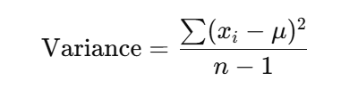

Where:

* xi​ = individual data points
* μ = mean of the data points
* n = number of data points in the dataset

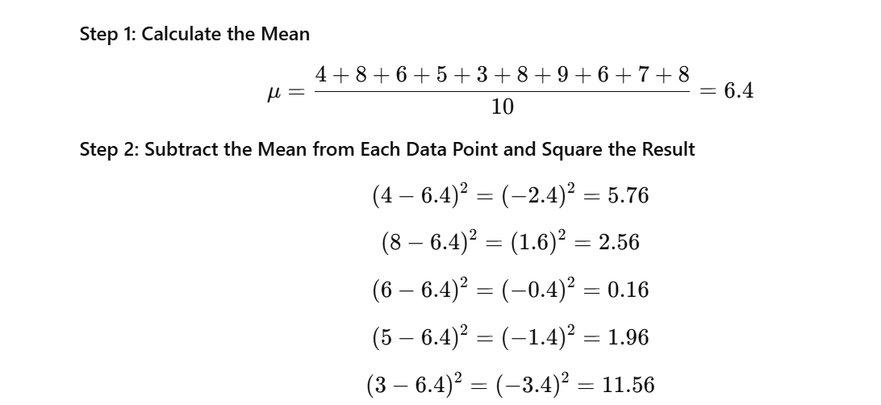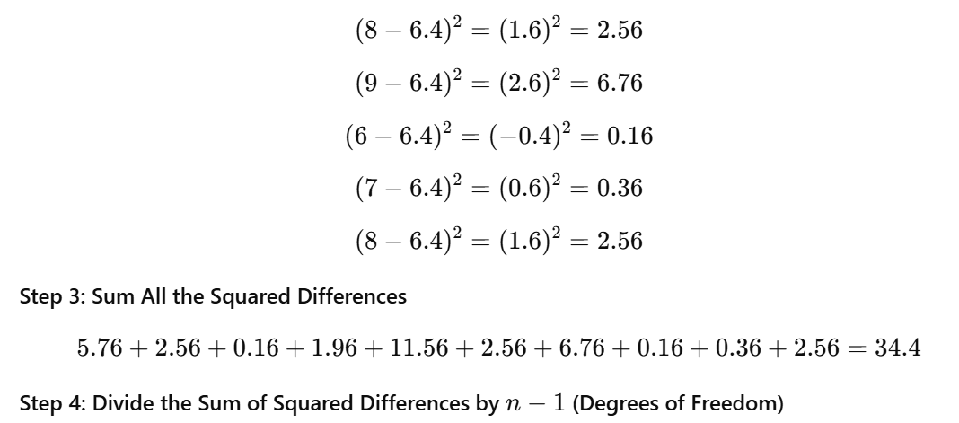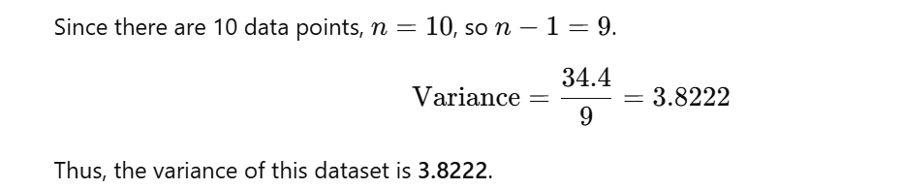

* **Standard Deviation**: which is a measure of the amount of variation or dispersion of a set of values. Standard deviation is the square root of the variance.

The standard deviation is the square root of the variance:



import statistics

defcompute_central_tendency_and_dispersion(data):

# Central Tendency Measures

mean = statistics.mean(data)

median = statistics.median(data)

mode = statistics.mode(data)

# Measure of Dispersion

variance = statistics.variance(data)

std_deviation = statistics.stdev(data)

# Print the results

print("Central Tendency Measures:")

print(f"Mean: {mean}")

print(f"Median: {median}")

print(f"Mode: {mode}")

print("\nMeasure of Dispersion:")

print(f"Variance: {variance}")

print(f"Standard Deviation: {std_deviation}")

# Example data

data = [4, 8, 6, 5, 3, 8, 9, 6, 7, 8]

compute_central_tendency_and_dispersion(data)

**Explanation:**

* **Mean** is calculated using statistics.mean(data).
* **Median** is calculated using statistics.median(data).
* **Mode** is calculated using statistics.mode(data).
* **Variance** is calculated using statistics.variance(data).
* **Standard Deviation** is calculated using statistics.stdev(data).

**Example Output:**

Central Tendency Measures:

Mean: 6.4

Median: 6.5

Mode: 8

Measure of Dispersion:

Variance: 4.511111111111111

Standard Deviation: 2.123674415557643