# **SQL**

## **Database:**

It is an organized structure collection of data, which is used to store in an electronic device.

Types:

1. SQL
2. No SQL

### **SQL:**

It is used to manipulate and retrieve the data of the relationship database management system (RDMS) or Database Programming Language.

Eg: MySQL, Oracle.

### **No SQL:**

There are no tables, they can be stored in any kind of system. (no images or videos can be recorded, only the pathway is mentioned)

## **Database:**

1. Click on Schema.
2. Type in the command, “ Create database databasename eg: create database sqlclass
3. Click on Thunder I (above the text command area)

How to delete ?

1. Drop database databasename;

Manual Procedure

1. Under the schemas, right click the database
2. Select drop schema from the dialogue box that has appeared.

How to create a table?

Before creating a table you select the respective database you want to insert the table in.

Eq: command- use sqlclass

**Procedure:**

1. **Creating**

* Write the command,”create table tablename” eg: create table sys
* Write down the table column name you wish to flow.

Eg: 1. (

2. Id int,

3. Name varchar (60),

4. Age int

5. )

Here, the number must have the “int” command and letters like name must have Varchar command along with (60) /(120) - stating the letter number capacity of the table.

**B. Flowing**

* To check if the table is flowing or not one must write the command “ describe tablename” eq: describe sys

**C. Inserting values**

Eg: 1. Insert into sys

2.Values

3. (

4. 1,

5. “Naina”,

6. 25

7. )

Note: If once wants the id number to flow according the normal chronological numbers order, they need to type auto increment in the command

Eg: create table sys (id int auto_increment………)

**D. Data flowing in the table**

- Write the command, “select * from sys”

Eg: select * from sys

* How to add extra column?

alter table tablename add column name varchar(60)/int

* Drop the table

alter table table name drop column name

* Rename

Alter table tablename change cloumnname(that you want to change) name of the chaging column varchar(60)

* How to update?

Update tablename setname(that you want to change) where id= (where you want to change)

* Delete single lines

Delete from table name where id=

**Aggregative functions**

* How does one know the number of entries?

Select count(*( as numberofrecords from tablename

* How to know the average of all the data?

Select avg(marks) as numberofmarks from tablename

* How to find maximum number?

Select max(marks) as numberofmaxmarks from tablename

* How to arrange order where same numbers will not be appeared?

Select distincto(marks) as numberofdistinctmarks from table name

* How to know specific data?

Select * from tablename where age=(give age you need to find)

* How to search a particular name of names starting with particular alphabet

Select * from tablename where name like “%A”

Here, if we type “a%” it shows the results with “a”as an ending alphabet

**Join tables**

* How to interjoin tables (interjunction)

select*from table1name as t1 inner join table2name as t2 on t1.id=t2.id

(t1 and t2 are refer indications)

* How to join right table ( according to the 2nd table)

Select * from table1name as t1 right join table2name as t2 on t1.id=t2.id

* How to join left table (according to 1st table)

Select * from table1name as t1 left join table2name as t2 t1.id=t2.id

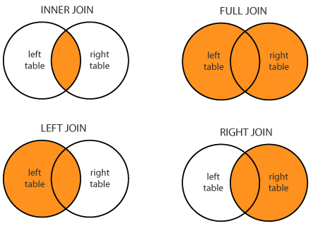

* How to enable data to flow in ascending or descending order

Select * from tablename order by id asc

(or)

Select * from tablename order by id desc

* How to know the number of people in each category?

Select stream, count(name) numberofs from tablename group by stream

**Ranking**

* How to give marks in descending order according to the age?

1. Select name,marks,rank() over (order by marks desc, age desc)

From table name

1. Select name,marks,rank() over(order by mark desc) as studentmarksrank from table name

**Highest number**

* How to find the highest salary

Select salary as nth salary from tablename as t1 where -0 +(select count(*) from table name as t2 where t1.salary<t2.salary)

(If you want to find second highest replace 0 with 1)

* How to find the lowest

Select salary as nth salary from tablename as t1 where -0 +(select count(*) from table name as t2 where t1.salary>t2.salary)

**View - Safety security**

1. Create view viewer as select name,age from table name
2. Select * table name viewer

**Store - faster retrieval of data**

1. Delimited

Create procedure pro()

Begin

Select id, name from table name;

End

1. Call pro

**Indexing - If we want to find out one column**

Create index ind on tablename(column name)

ind= reference word

(If we want to find multiple columns after this change ind and put another word eg: indi and use the same query)