**SOURCE CODE**

**from sys import exit**

**import mysql.connector as sql**

**conn=sql.connect(host='localhost',user='root',passwd='',database='project')**

**if conn.is_connected():**

**print('successfully connected')**

**c1=conn.cursor()**

**print('---------------------------------------------')**

**print("HOSPITAL MANAGEMENT SYSTEM")**

**print('---------------------------------------------')**

**print('"GOD WISHES YOU"')**

**print("1.LOGIN")**

**print("2.EXIT")**

**choice=int(input("ENTER YOUR CHOICE:"))**

**if choice==1:**

**u1=input("enter user name:")**

**pwd1=input("enter the password:")**

**while u1=='vasu'and pwd1=='vasu6072':**

**print('connected')**

**print("WELCOME TO HOSPITAL")**

**print("successfully connected")**

**print('1.RegisteringPatient details')**

**print('2.RegisteringDoctor details')**

**print('3.RegisteringWorker details')**

**print("4.total patient details")**

**print("5.total doctor details")**

**print("6.total worker details")**

**print('7.Patient detail')**

**print('8.Doctor detail')**

**print('9.Worker detail')**

**print('10.Exit')**

**choice=int(input('ENTER YOUR CHOICE:'))**

**if choice==1:**

**p_name=input('Enter Patient Name:')**

**p_age=int(input('Enter Age:'))**

**p_problems=input('Enter the Problem/Disease:')**

**p_phono=int(input('Enter Phone number:'))**

**sql_insert="insert into patient_details values(""'"+p_name+"',"+str(p_age)+",'"+p_problems+"',"+str(p_phono)+")"**

**c1.execute(sql_insert)**

**print('SUCCESSFULLY REGISTERED')**

**conn.commit()**

**elif choice==2:**

**d_name=input('Enter Doctor Name:')**

**d_age=int(input('Enter Age:'))**

**d_department=input('Enter the Department:')**

**d_phono=int(input('Enter Phone number:'))**

**sql_insert="insert into doctor_details values(""'"+d_name+"',"+str(d_age)+",'"+d_department+"',"+str(d_phono)+")"**

**c1.execute(sql_insert)**

**print('successfully registered')**

**conn.commit()**

**elif choice==3:**

**w_name=input('Enter Worker Name:')**

**w_age=int(input('Enter Age:'))**

**w_workname=input('Enter type of work:')**

**w_phono=int(input('Enter Phone number:'))**

**sql_insert="insert into worker_details values(""'"+w_name+"',"+str(w_age)+",'"+w_workname+"',"+str(w_phono)+")"**

**c1.execute(sql_insert)**

**print('successfully registered')**

**conn.commit()**

**elif choice==4:**

**sql_w='select*from patient_details '**

**c1.execute(sql_w)**

**r = c1.fetchall()**

**for i in r :**

**print(i)**

**elif choice==5:**

**sql_x="select*from doctor_details"**

**c1.execute(sql_x)**

**s=c1.fetchall()**

**for i in s:**

**print(i)**

**elif choice==6:**

**sql_y="select*from worker_details"**

**c1.execute(sql_y)**

**t=c1.fetchall()**

**for i in t:**

**print(i)**

**elif choice==7:**

**h=input("Enter the name:")**

**sql_w='select*from patient_details where p_name=("{}")'.format(h)**

**c1.execute(sql_w)**

**u = c1.fetchall()**

**for i in u:**

**print(i)**

**elif choice==8:**

**d=input("Enter the name:")**

**sql_d='select*from doctor_details where p_name=("{}")'.format(d)**

**c1.execute(sql_d)**

**v=c1.fetchall()**

**for i in v:**

**print(i)**

**elif choice==9:**

**f=input("Enter the name:")**

**sql_f='select*from worker_details where p_name=("{}")'.format(f)**

**c1.execute(sql_f)**

**w=c1.fetchall()**

**for i in w:**

**print(i)**

**elif choice==10:**

**exit()**

**break**

**else:**

**print('wrong username&password')**

**if choice==2:**

**exit()**

**OUTPUT**

**Login output:**

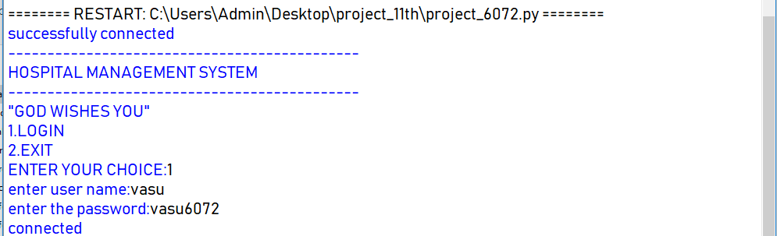

**After login:**

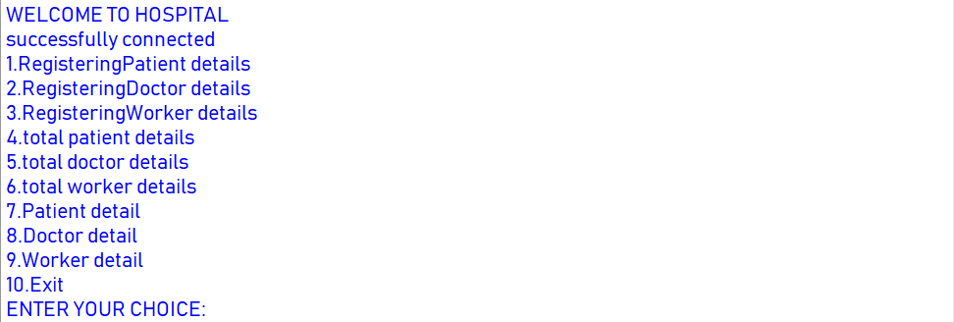

**After choosing choice:**

