IT IS 6200

Project 1: Safety of Information Flowing in the Internet

1. Screenshot of the packet dump out for steps (3), (4) and (5). Especially, we need you to capture the username and password you input in step (3) and (4), and also the text file content in step (5). The TA should be able to see the packet contents;

The username and passwords are visible in a TELENT session where as they are not visible in a SSH session

**Step 3:**

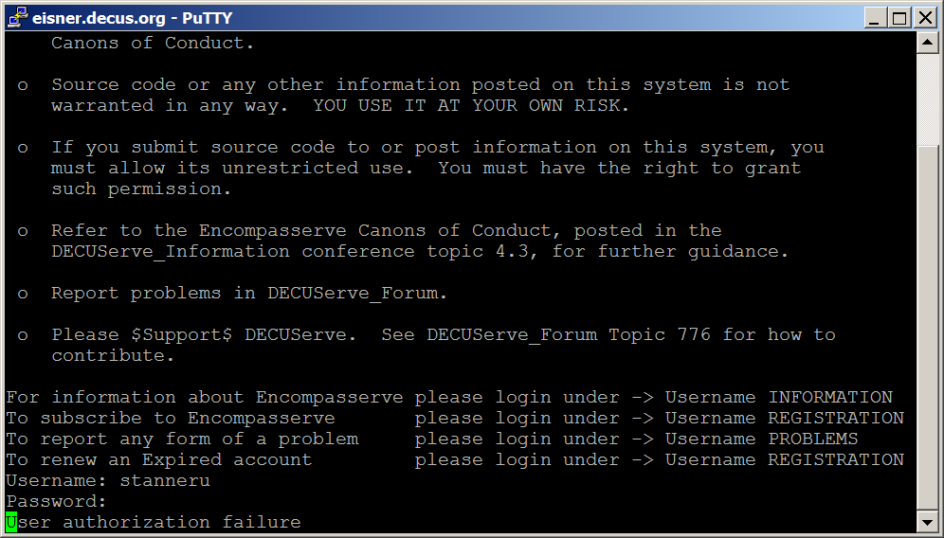

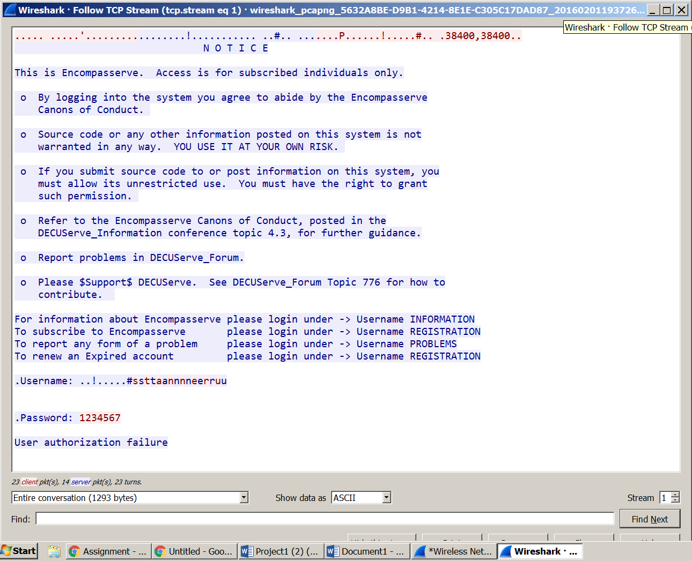

**Step 4:**

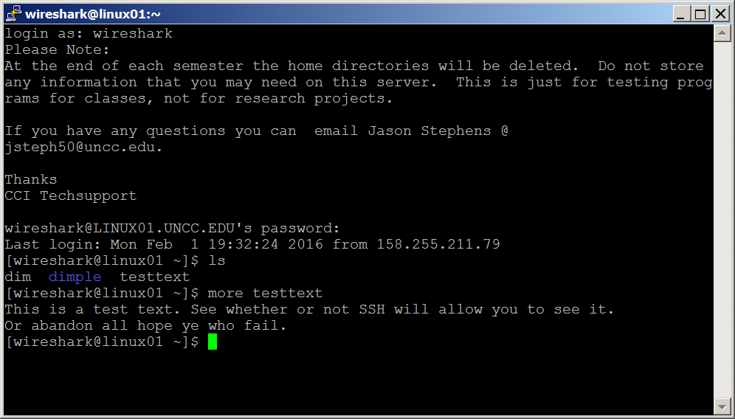

Step 5

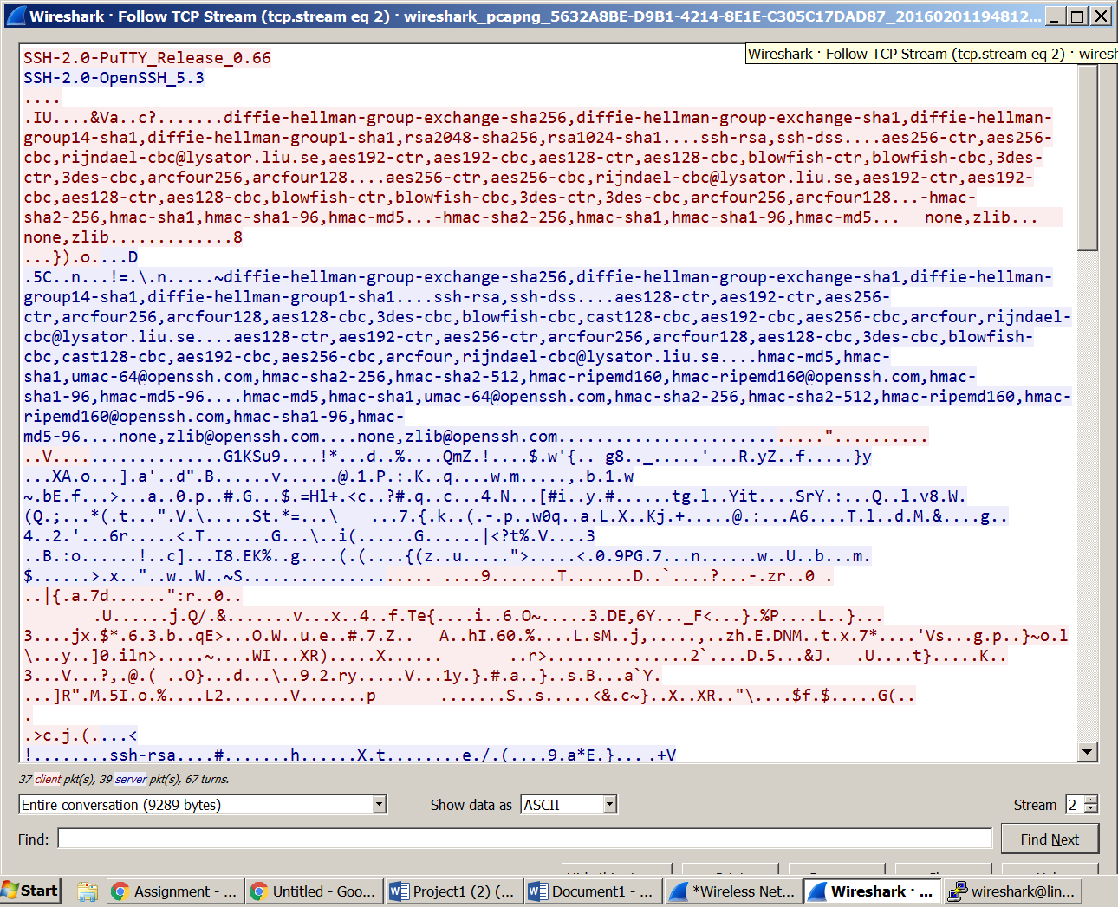

1. Shortly analyze the packet dump out and explain why SSH is more secure than TELNET.

As seen below SSH protocol uses encryption to protect the data passed between the local and remote servers.When an SSH exchnage is initiated via putty to a remote host, initial Key exchange happens and the packets are then encrypted and sent to the remote host.The channel is fully encrypted and the contents will not be visible

On the other hand TELNET does not encrypt traffic and the network packets can be intercepted during the exchnage with a remote host.

Based on the analysis mentioned we can conclude that SSH is more secure than TELNET.

SSH

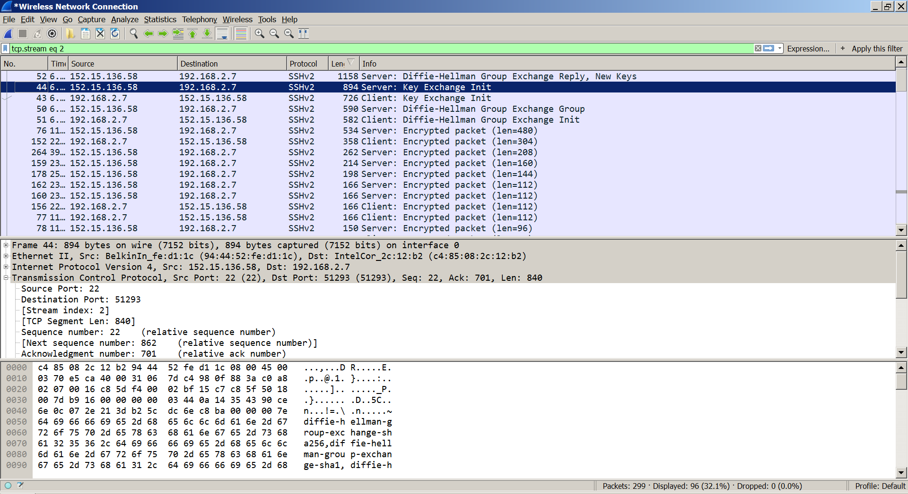

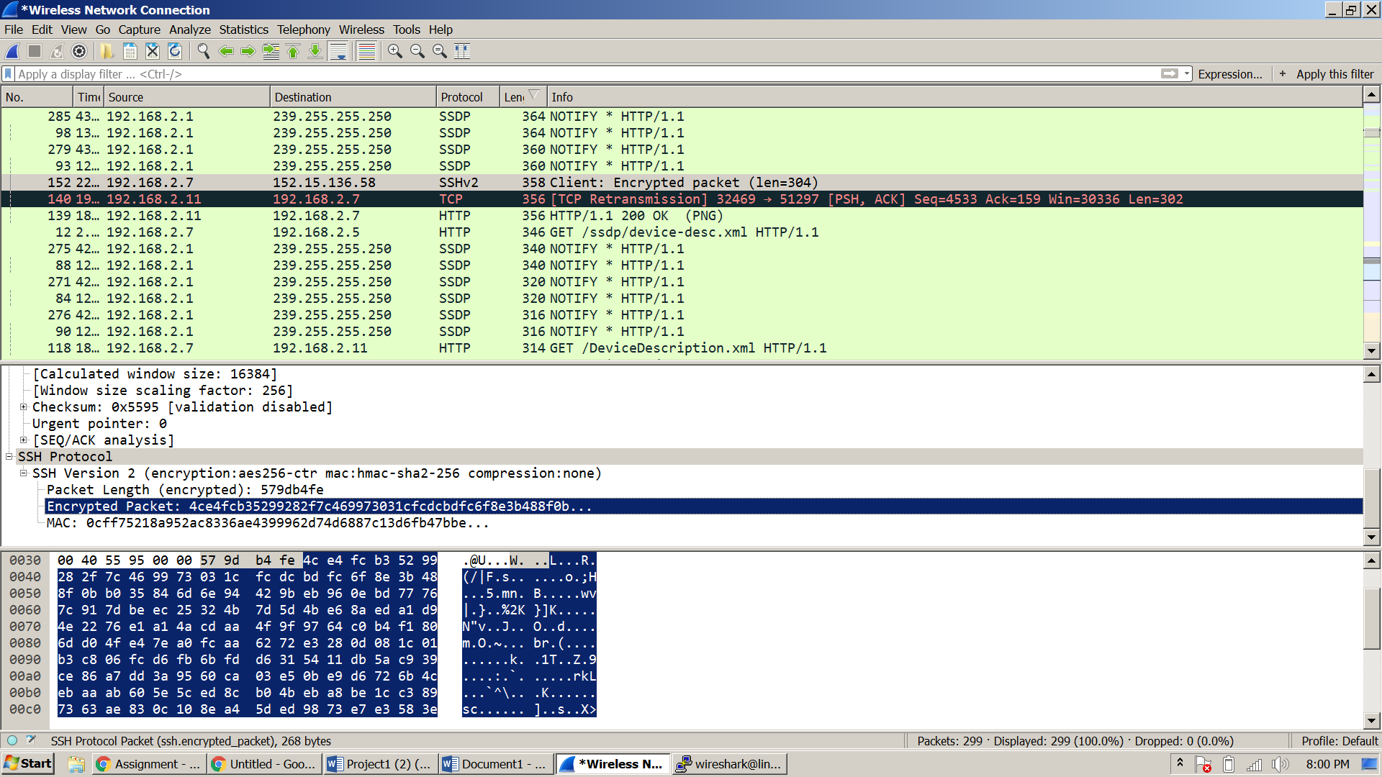

TELNET:

