1.

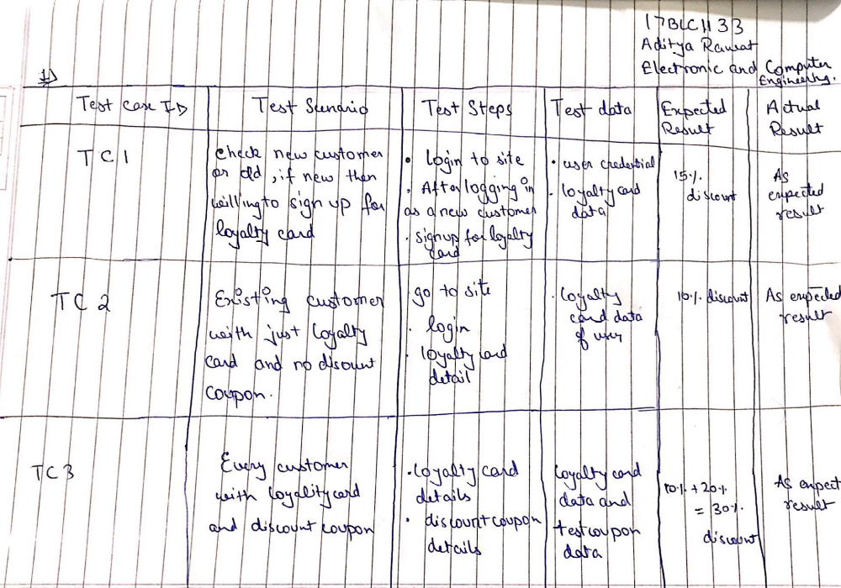

- I find this argument fairly reasonable up to an extend considering a few assumptions that the shop might be located at a prime location which is more reachable and fairly populated which helps the shop to grow more and more. Where as the other shop where Jenny’s Beauty Parlour is located might be less populated and might not be reachable to the public. There might be some other factor that the infrastructure of the new shop is not that good as compared the formerly located shop. Since beauty parlour is mostly used by women who generally doesn’t like to travel more since the shop might be located at a remote location. It is hard to say that Ronnie’s Auto must be doing good just by the fact that they want to open a big shop in an adjacent town. The reason for the same might be that they want to spread their business to other locations as well so that they can earn larger profits which makes more sense because it will automatically increase the number of customers. If all these factors were mentioned int the argument it would sound more logical and would have definitely helped in better evaluation for the conclusion.

- The first and foremost thing that I will check in a wireless mouse is its connectivity and if it fluid and good or not and if the buttons are clicky and in working condition and response rate should be 1ms. secondly, I will check the build quality of the mouse and find out if has any defects or not. I will also check if the mouse goes into low power mode if it is not in use for long time and should have an accessible switch to turn it on or off to save battery. I will also check the report rate of the mouse which means that how frequently does the mouse report to the computer. And if all the things go right, I can say that it is a good quality wireless mouse.

